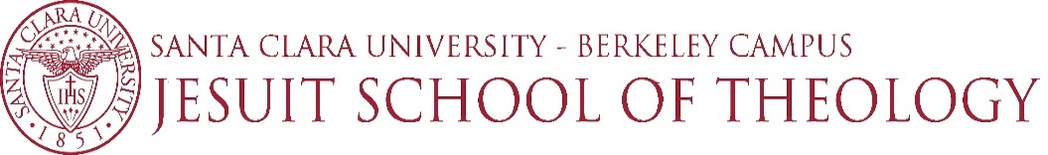

INSTRUCTOR | E. Fernandez
COURSE NAME | Mission, Church, and Cultures
COURSE NUMBER | RSST 3710
FALL 2022
[Sidebar Title]
[Sidebars are great for calling out important points from your text or adding additional info for quick reference, such as a schedule.
They are typically placed on the left, right, top or bottom of the page. But you can easily drag them to any position you prefer.
When you’re ready to add your content, just click here and start typing.]

AUTHOR | TITLE | PUBLISHER | (R)equired  /  (O)ptional | ISBN
Bevans, Stephen B. and Roger P. Schroeder | Constants in Context: A Theology of Mission for Today | Orbis Books | R | ISBN 1-57075-517-5(pbk.)
Bevans, Stephen B. | Models of Contextual Theology. Revised and Expanded Edition | Orbis Books | R | ISBN 1-57075-438-1 (pbk.)
Donovan, Vincent J. | Christianity Rediscovered | Orbis Books | R | ISBN 1-57075-462-4 (pbk.)
Bosch, David J. | Transforming Mission: Paradigm Shifts in the Theology of Mission | Orbis Books | 0 | ISBN 0-88344-719-3 (pbk.)

