Too many children in the United States have never seen their lives in print, nor have they ever been told their story is extraordinary, nor that they themselves are courageous.
—Sandra Cisneros, acclaimed author of The House on Mango Street
Taking Hold
by Francisco Jiménez

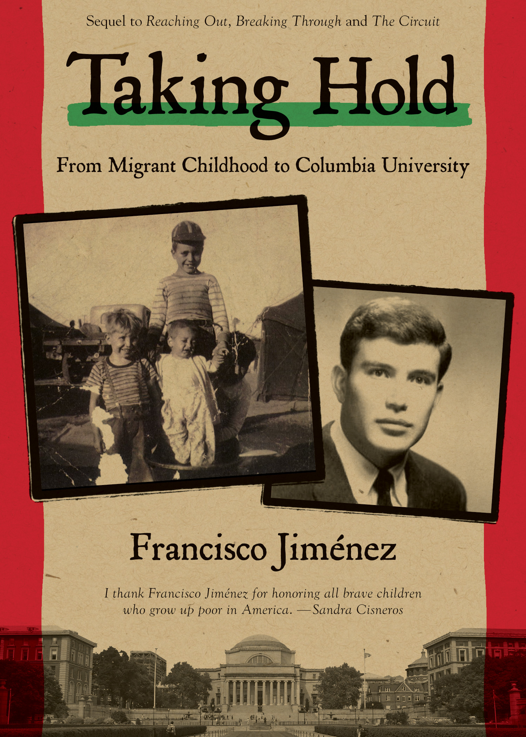
In this fourth book in his award-winning memoir series, Taking Hold: From Migrant Childhood to Columbia University, Francisco Jiménez leaves everything behind in California—a loving family, a devoted girlfriend, and the culture that shaped him—to attend Columbia University in New York. Carrying memories of years of poverty and prejudice with him, he enters into a world culturally different from his own. Will he find community? Will he be able to excel among his Ivy Leagues classmates? How will he support his family back home now that his devoted father is too ill to work?

Honest and moving, Francisco Jiménez’s memoir comes alive with telling details about the warmth and resilience of family and the quest for identity against seemingly impossible odds. Continuing the best-selling life stories told in The Circuit, Breaking Through, and Reaching Out, Francisco Jiménez chronicles his efforts and struggles as he continues his education at Columbia University.

Francisco Jiménez emigrated from Tlaquepaque, Mexico, to California, where he worked for many years in the fields with his family. He received both his master's degree and his Ph.D. from Columbia University and is now chairman of the Modern Languages and Literature Department at Santa Clara University. He lives in Santa Clara, California, with his family.

Taking Hold: From Migrant Childhood to Columbia University by Francisco Jiménez Clarion Books
April 7, 2015; $16.99 hardcover; 208 pages; Ages 14 and up; ISBN: 978-0-547-63230-8
Ebook SBN: 978-0-547-64569-8

Praise for Reaching Out, Breaking Through, and The Circuit

Reaching Out
- 2009 Pura Belpré Honor
- Notable Social Studies Trade Books for Young People 2009
“Rooted in the past, Jiménez’s story is also about the continuing struggle to make it in America, not only for immigrant kids but also for those in poor families who struggle to break free. Never melodramatic or self-important, the spare episodes will draw readers with the quiet daily detail of work, anger, sorrow, and hope." —Booklist, starred review
"[S]imply and eloquently told. An inspiring account of a remarkable journey." —Kirkus Reviews

Breaking Through
- 2002 Pura Belpré Honor for Narrative
- Americas Award
- ALA Best Book for Young Adults
- ALA Notable Book for Children
- Booklist Editors' Choice

"The images are powerful . . . this is a book for many readers, who may discover an America they didn't know was here."—Booklist, ALA, starred review

The Christmas Gift: El regalo de Navidad
- ALA Notable
"Told both in English and in Spanish, this bittersweet tale is base on an incident from Jiménez's childhood in a family of migrant farm workers."
—Publishers Weekly, starred review

The Circuit
"Highly recommended for both pleasure listening and for classroom use and discussion."
—School Library Journal

"Readers of this book will gain insight into...the lives of immigrant families."
—Book Links

