Latinxs and Lived Religion in the U.S.
Winter Quarter 2017
Tuesday & Thursday 12:10-1:50

NOTE: This course fulfills Santa Clara’s Core Requirement for RTC 1 and is an elective in the Latin American Studies Minor Program and in the Ethnic Studies Program
Professor: Socorro Castañeda-Liles, Ph.D.
Office: Kenna Hall 300E
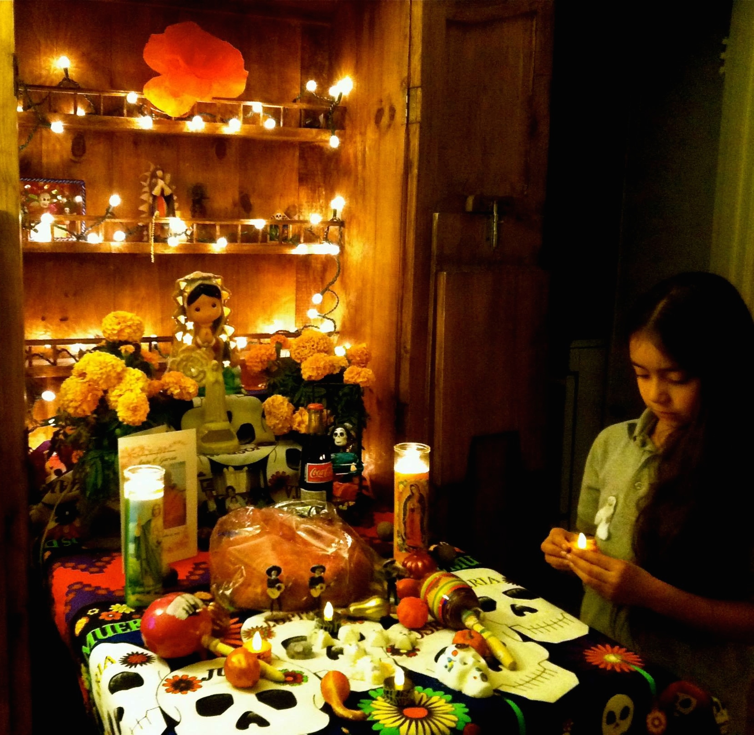
Phone: (408) 551-3181
Email: mscastanedaliles@scu.edu
Office Hours: Wednesdays 3:00-5:00 pm
Class: Kenna 214

Course Description: This course introduces students to the ethnic and religious diversity among Latinxs living in the United States. Students will be exposed to the ways in which Latinxs appropriate Christian, Indigenous, and Afro-Caribbean religions in everyday life. We will explore the ways that the materialization of Latinx devotional practices, unveil how they make religion meaningful and palpable for themselves in the context of the trials and tribulations of life in the United States. Through case studies, this course explores religious and spiritual practices as shaped by colonialism, race/ethnicity, class, gender, and migration.
The study of lived religion is a relatively new area in the Sociology of Religion. It is the study of the ways people experience the sacred in their lives and how religious experience is connected to larger social structures, both religious and secular. In this course students will analyze the ways that lived religion exists in the cultural, geographical and historical context of Latinxs in the U.S. This course specifically focuses on the fluidity and malleability of religious practices and how they adapt to and at the same time shape life itself. Lived religion is a way of, as historians Anne S. Brown and David D. Hall so aptly put it, “being religious [in a fashion] that is responsive to the needs that arise within social life” (Brown and Hall 1997, 57).
Core Curriculum Learning Objectives: [Adapted from Santa Clara’s Core Requirements for Religion, Theology, and Culture.]
This course fulfills Santa Clara’s Core Requirement for RTC 1.
1a. Students will be able to describe and compare the central religious ideas and practices from several religions or within one, and from at least two globally distinct regions. (Knowledge of Global Cultures; Complexity; Ambiguity)
1b. Students will be able to use critical approaches to reflect on their own beliefs and the religious dimensions of human existence (Critical thinking; Complexity; Reflection)
Department Objectives: [adapted from RS “Description of the Three Levels”]
- Students question and probe religion for what it reveals about human beings, their diverse societies, religions, convictions, and aspirations. Students use diverse materials and demonstrate formal postures of inquiry into religion and in order to go beyond simple description of religion to a reflective engagement with it.
- Students propose and investigate the ‘big questions’—that is, the meta-reflective questions that ask how and why we ask the questions that we do about religion.

COURSE GOALS: Rather than providing students with an exhaustive exposure to the various religious traditions among Latinxs living in the United States, this course introduces students to the ways in which Latinxs appropriate Christian, Indigenous, and Afro-Caribbean religions in their everyday lives. More specifically, through case studies, this course explores religious and spiritual practices as shaped by colonialism, race/ethnicity, class, gender, and migration.
STUDENT LEARNING ASSESSMENT & GRADING AT A GLANCE

Attendance and Participation 10 Points
*Equally balanced between both
Group-led facilitation 5 Points
Exam 1 20 Points
Exam 2 20 Points
Exam 3 20 Points
Ethnographic Final Paper 25 Points
TOTAL POINTS 100 Points
Grading Scale:
- 94 and above = A
- 90-93 = A-
- 87-89 = B+
- 84-86 = B
- 80-83 = B-
- 77-79 = C+
- 74-76 = C
- 70-73 = C-
- 67-69 = D+
- 64-66 = D
- 61-63 = D-
- 60 and below = F

Feedback: Students will receive feedback from the professor through comments on papers. If you have any further questions please come and see me during office hours. Students’ papers will be turned in two-weeks from the day they are due.

POLICIES:
- You are expected to attend every class session; participate in classroom and small group discussions; and demonstrate respect to your peers, people at your community placement, and the professor.

- Assignments that are handed in late will be penalized one-third grade per day (i.e. from an A to an A-, an A- to a B+, a B+ to a B, etc).

- You must do well in all assignments to pass the course. The dates and material in this syllabus may be subject to change, so listen carefully to announcements in class.
- Santa Clara University strongly believes in academic integrity and honesty; therefore, cheating, plagiarism, or other forms of academic dishonesty will not be tolerated in this course and the student may receive a failing grade. Please visit the following website for further information on Santa Clara University’s policy regarding academic integrity:
http://www.scu.edu/academics/bulletins/undergraduate/Academic-Integrity.cfm
- No laptops, electronic notebooks or i-pads allowed in class: If your cell phone/pad, electronic device or book is on your lap or on your desk, even if you are not using it, you will lose credit for class participation that day, which will hurt your over-all participation grade. They must be physically turned off and in a bag. If you are expecting a call/text, due to a family emergency (someone at the hospital), you need to let me know at the beginning of class.

- No Talking in class. If you are caught talking in class you will forfeit your attendance grade for the day.

- You are allowed to bring a drink and a snack as long as it does not disrupt classroom lectures and your participation in class discussions.

- Students requiring accommodations for disabilities must let the professor know on the first week of class. To request academic accommodations for a disability, students must be registered with Disabilities Resources, located in Benson 216. If you would like to register with Disabilities Resources, please visit their office in Benson 216 or call at 408-554-4109. You will need to register and provide documentation of a disability prior to receiving academic accommodations. For further instructions about the process to receive accommodations visit: http://www.scu.edu/advising/learning/disabilities/

PAPER EXPECTATIONS:
An A Paper is of high quality; that is, the student engages in a critical analysis by demonstrating knowledge of the concepts and topics covered in class. It introduces the reader to the topic before the in-depth analysis. Every paper should have a thesis statement. It integrates class readings and lectures in a clear, comprehensive, and creative way. The paper addresses ALL the points. It is spell-checked and all works are cited properly. It also has a separate page with the bibliography of the works cited. You will be uploading your papers via Camino.

NOTE: Wikipedia, websites, magazines (i.e., Times Magazine, News Week, and the National Geographic), and newspapers ARE NOT considered scholarly sources and will not be counted as such. You may choose to use the above material ONLY as additional supportive evidence. By scholarly sources I refer to academic journal articles and books. Check the handout that is on Camino under the “Files” tab.
YOU WILL LOSE POINTS IF I SEE THE FOLLOWING:
- No thesis statement
- Some of the statements are too general.
- Arguments are not complex and/or the student spends more time analyzing one aspect over the other.
- Outside sources are not fully integrated.
- The paper consists of mainly quotes from scholars and the student’s voice is lost.
- Student relies on Internet sources and not on academic material.
- You do not engage the concepts learned in class to support your argument.
- Sentences are circular and vague.
- Incomplete sentences.
- The analysis seems rushed and circular.
- Some arguments need further development.
- Personal opinions are not supported by academic evidence.
- The sources listed in the bibliography do not appear in the main text.
- Incomplete citations.
- The paper has no name.
- Student waits until the end of the paper to integrate readings. This is not acceptable. Remember you must weave your readings/academic sources throughout the paper.
- Questions on the assignments ARE NOT “FOOD FOR THOUGHT.” I expect you to answer every question.

EMAIL ETIQUETTE
- I have come across many emails from students that begin with:
  - “Hey Prof.”
  - “Hey Professor” or “Mrs./Ms./Mr.”
  - Or the message is not addressed at all.
As a general rule, if you email your professors your message should start with: “Dear Professor or Dear Dr. [Name of Professor],” and make sure you spell the professor’s name correctly.

PLAN accordingly
Computers crash or printers do not work; not to mention the cold and flu viruses that seem to kick in around the time assignments are due. Therefore, make sure you allocate the necessary time for each of your assignments.

STUDENT LEARNING ASSESSMENT & GRADING: DETAILED DESCRIPTION

ATTENDANCE & CLASS PARTICIPATION is worth 10 points—equally balanced between both (10% of total grade): I will take roll at random times during the quarter. Participation in class is an important component of the learning process. Therefore, you will be evaluated on the extent to which you participate in class.
Students must come to class ready to participate in discussion and engaged everyday. Students who consistently do not participate, play on their electronic devices or are unengaged will lose ½ point from their “Attendance & Participation” grade. Students may be eligible for excused absences (no more than 2) should an emergency arise, but you must give the professor 24-hour notice.
Persistent tardiness and early departure from class will hurt your participation grade. Staring out the window, sleeping in class, chattering with neighbors when not in group discussion, and or putting your head down means you will get no credit for attendance.
If you miss class, you are responsible for getting the notes and handouts from a fellow student who is part of your group. Do not ask me if you missed something important—EVERYTHING we learn in this class is IMPORTANT. Only if you have contacted all team members and no one has responded to you should you ask me for the material.
GROUP FACILITATION (5 points, worth 10 points): I will place you in groups of 3 or 4 members. This will be your small group for the quarter. Remember, 10 minutes is not much time. This is your opportunity to get creative. The group needs to upload the PowerPoint on Camino in the discussions folders by 10 pm the day before you are scheduled to facilitate class discussion. If you do not upload your presentation by 10 pm I will deduct points. Each group member must participate equally and you need to engage the class.
When you ask your questions you need to do it in a way that encourages students to respond with more than a yes/no answer. This means that you may need to do follow up questions if the students are giving you short answers or not answering at all. You will be graded on how well you engage the class in a critical discussion, and your power point (1 power point per group), and creativity. (Department Objectives 1 & 2)
Group Facilitation Format
- This assignment is not a reading report. You may do a short group introduction to the reading but no more than 2 minutes.
- Each student must select one theme addressed in the reading. What did you find most interesting and how does it connect back to topics address in class? It is ok if more than 1 student selects the same theme, but each must ask separate questions to the class. Your goal is to engage the students in a lively discussion.
- Ask open-ended questions. Each student must ask two questions, but each group member should have an extra question in case you are having difficulty engaging the students.
- Be creative! Some students have done jeopardy games.
- You can ask students to get in small groups to discuss the reading before you engage the whole class, but keep track of time.
- Each group member must participate equally.

THREE EXAMS (each worth 20 points): The exams are a major part of this course. Therefore, it is very important to keep up with the readings and lectures if you want to do well. The exams will be based on class readings and lectures. Professor will give the details in class.

Ethnographic Final Paper (25 Points)
Paper Requirements
- Length of paper: 1260 words
- Font Size: 12
- Font Type: Times New Roman
- Citation Style: Chicago Manual of Style (for a guideline see: http://www.chicagomanualofstyle.org/tools_citationguide.html (Links to an external site.)
- Spacing: Double
- Bibliography of works cited: On a separate page and it does not count as part of the 1260 words required.
- You must integrate three scholarly sources (some can be from our readings).
- Your name and date at the top of your first page should be single-spaced, and they do not count as part of the 1260 words.
- Due Date: TBA. You will be uploading your paper via Camino. I will set up a folder under the “Assignments” tab.
Lived religion is the study of the ways people experience the sacred in their lives. In this course we have focused specifically on the fluidity and malleability of religious practices and how they adapt to and at the same time shape life itself. We have read and discussed various aspects of Latinx lived religion. However, while reading about Latinx lived religion provides you with certain theoretical frameworks and case studies, it does not allow you to see first-hand how Latinxs experience the sacred.
Therefore, for this assignment you are to attend a service at one of the two Pentecostal churches below:
Option 1: Strong Towers Community Church (Assemblies of God Church)
Address: 826 N. 13th Street San Jose, CA
Day & Time of Service: TBA

Options 2: Central Apostolic Christian Church
Address: At the intersection of 5th Street and Santa Clara St. San Jose, CA
Day & Time of Service: Wednesdays 7:30-9:30pm
Parking: During the week, parking is free after 6:00 pm in the front of the church on the street. Parking structure located to the left of the front of the church offers free parking all day.

In your research paper you are to analyze how people experience the sacred at the church you attended. In your analysis please address ALL the questions below:
- What did attending the service teach you about how Latinxs experience the sacred?
- What was the service like? Please explain.
- Did people use all five senses (sight, hearing, taste, smell, touch) as they experienced the sacred before, during and/or after the Sunday service?
- Generally speaking, what was the gender and generation (age) breakdown?
- Describe the atmosphere at the service. Did the congregation have a gathering after the service? If so, were you invited? If you stayed for the gathering, what was it like?
- Did anyone approach you and/or did they share their story with you? If so, what did they say?
- If you are able, ask someone at the congregation how she/he found out about this church?
- Did this experience move you to reflect on your own religious upbringing or lack thereof? Why or why not?
- NOTE: You must draw on concepts and theories covered in class to explain your observations of the service.

NOTE: Five pages is not much space for the questions you are required to address. Therefore, think carefully before you write. Show that you can write concisely yet thoroughly, and that you can do careful critical analysis. This exercise will help you learn to analyze and address key points in a concise way—a writing skill that you will find useful in graduate school, grant writing, and other situations.
You must fully integrate your observations throughout your paper, and support them with scholarly sources and concepts learned in class. Avoid weak arguments. For example: “I saw a mother teaching her child how to do the sign of the cross—this is an example of the matriarchal core.” This statement reads more like a description without any grounded analysis, and it is not enough. It is also not enough to quote a reading and briefly discuss it without really engaging it with your observations. You need to have the readings and your observations “speak” to each other followed by your own analysis of how they compare/contrast.
Besides organization, clarity, and proper citation, I will grade you on the overall strength of your analysis. You must integrate three scholarly sources. Some can be from our readings, but most likely you will have to do a library search. Of course you may cite more sources. Please see the “What is a scholarly source” handout if you are not sure if the readings you selected are scholarly. (Fulfills RTC1 1b; Department Objective 1)

Course Outline

Week 1 Latinx Lived Religion

January 10 Classes Begin – Class introduction, syllabus, and expectations

January 12
READING: “Everyday Miracles: The study of lived religion” by Robert Orsi. (Camino)
READING: Bless Me Ultima Chapters: Intro, 1, and 2

Week 2 Theorizing Latinx Identities & Religious Experiences
January 17
READING: La Conciencia de la Mestiza: Toward a New Consciousness in Borderlands by Gloria Anzaldúa (Camino)
READING: “Who am I” by Virgilio Elizondo (Camino)

January 19
Presentation 1: READING: Bless Me Ultima Chapters: 3-5

Week 3 The Making of Girls: Religion and the Latina body
January 24 Exam 1

January 26
Presentation 2: READING: “Growing up Female” by Aída Hurtado (Camino)
Presentation 3: READING: Bless Me Ultima Chapters: 6-8

Week 4 Case Study
January 31 Case Study

February 2
Presentation 4: READING: Bless Me Ultima Chapters: 9-10
Discussion of Case Study

Week 5 A Café Con Leche Religious Imaginary
February 7
READING: "Our Lady of Guadalupe as a Cultural Symbol" in Mestizo
Worship by Virgilio Elizondo, p. 35-45 (Camino)
Presentation 5: READING: Bless Me Ultima Chapters: 11-13

February 9
READING: “Our Lady of Guadalupe and the Politics of Interpretation” by Socorro Castañeda-Liles (Camino)

Week 6 Los XV de Rubí—The Cultural Politics of Quinceañeras
February 14
READING “La Quinceañera”: Making Gender and Ethnic Identities (Camino)
Presentation 6: READING: Bless Me Ultima Ultima Chapters:14

Febraury 16 Exam 2

Week 7 Latinxs, Santería and Curanderismo
February 21
READING: “Soy una Curandera y Soy una Catolica”: The Poetics of a Mexican Healing Tradition by Luis D. León (Camino)
Presentation 7: READING: Bless Me Ultima Chapters: 15-17

February 23
READING: Santería, what is it? by Miguel de la Torre (Camino)
Presentation 8: READING: Bless Me Ultima Chapters 18-19

Week 8 Latinx Pentecostalism
February 28
READING: The Ladies Are Warriors: Latina Pentecostalism and Faith-Based Activism in New York City” by Elizabeth D. Ríos (Camino)
Presentation 9: READING: Bless Me Ultima Chapter 20

March 2
Presentation 10; READING: Allá en Guatemala: Transnationalism, Language, and Identity of a Pentecostal Guatemalan-American Young Woman (Camino)
Presentation 11: READING: Bless Me Ultima Ultima 21-22

Week 9 Popular Religious Practices and Political Activism
March 7
READING “Días de los Muertos: Public Ritual, Community Renewal, and Popular Religion in Los Angeles by Lara Medina and Gilbert R. Cadena (Camino)

March 9 Exam 3

Week 10 Legacy of our Abuelitas

March 14 Case Study: Bless Me Ultima
March 16 Case Study: Bless Me Ultima

R. Marie Griffith, 1997.
(Danielle Hervieu-Léger 1997).
Abuelitas is grannies in English.

