Education Specialist Mild to Moderate Support Needs TPEs Course Matrix
In the matrix below denote the candidates’ opportunity to learn and master the competencies listed. The required course names and numbers should go across the top of the matrix, replacing the “Course Title and Number” text below. For each competency, it should be noted when the candidate is introduced (I), practices (P), and is assessed (A) for the competency. These notations may occur under more than one course heading, each notation should link to a specific place in the syllabus within that course that demonstrates that this is occurring. (For an example, refer to the instructions for Program Review under the Course Matrix section on the CTC’s website.) In the matrices below, after each TPE competency is read, there will be 15 blank fields within which you can enter the respective notations. Please note you are not required to enter information in every blank field.

ELEMENTARY (Multiple Subject; MS) Program

TPE 1: Engaging and Supporting All Students in Learning ̶ Mild to Moderate Support Needs TPEs  Beginning teachers: | 221M- Effective Teaching for Students with Disabilities | 250-Ethics, Diversity, Reflection: Intro to TK - 12 teaching | 253- Typical & Atypical Development and learning  Learnings | 265-Assessing Elementary Student Learning | 258-Developing Positive Classroom Cultures | 252-Social Foundations of Education | 251-Technology for Elementary Teachers | 231A-Ethical Reflective Practicum in Special Education I | 231B-Ethical Reflective Practicum in Special Education II | 231C- Ethical Reflective Practicum in Special Education III | 231D-Ethical Reflective Practicum in Special Education IV | 257-English Language Development in Elementary Schools | 261-Teaching Reading in Elementary Schools | 262-Teaching Language Arts in Elementary Schools | 259A-Elementary Math Methods I | 259B-Elementary Math Methods II | 263-Elementary Methods in SS & Visual/Performing Arts | 264-Elementary Methods in Science, Health & PE | 240 – Mild Moderate Disabilities (New Course)
MM1.1 Demonstrate the ability to collaboratively develop and implement Individualized Education Programs (IEP), including instructional goals that ensure access to the California Common Core State Standards and/or California Preschool Learning Foundations, as appropriate, that lead to effective inclusion of students with disabilities in the general education core curriculum. | I  P |  | P |  |  |  | P |  | I  P  A | P  A |  | I  P |  |  | I | P | I  P | I  P | A
MM1.2 Demonstrate the ability to identify the appropriate supports of students with complex communication needs and design strategies in order to foster access and build comprehension, and develop appropriate language development goals within the IEPs for those students. (U1.6) | I  P |  |  |  |  |  | P |  | P | P |  | I |  | PA | I | P  A | P  A | P  A | P  A
MM1.3 Demonstrate knowledge of students’ language development across disabilities and the life span, including typical and atypical language development, communication skills, social pragmatics, language skills (e.g. executive functioning) and/or vocabulary/semantic development as they relate to the acquisition of academic knowledge and skills. (U1.6) |  |  | I |  |  |  |  |  |  |  |  | PA | I  P | I  P
MM1.4 Monitor student progress toward learning goals as identified in the academic content standards and the IEP/Individual Transition plan (ITP). (U1.4) | I | I |  |  |  |  |  |  |  | I  P | P  A |  |  |  |  | P  A | P  A | P  A | P  A
MM1.5 Demonstrate the ability to develop IEPs/ITPs with students and their families, including goals for independent living, post-secondary education, and/or careers, with appropriate connections between the school curriculum and life beyond high school. (U1.3) | I  P |  |  |  |  | PA |  |  |  |  |  |  |  |  |  |  |  |  | P  A
MM1.6 Facilitate and support students in assuming increasing responsibility for learning and self-advocacy based on individual needs, with appropriate transitions between academic levels in programs and developing skills related to career, college, independent living and community participation. (U1.3) | I  P |  | P A |  |  |  |  |  |  |  |  |  |  |  |  |  |  |  | P  A
MM1.7 Use strategies to support positive psychosocial development and self-determined behavior of students with disabilities. (U1.1) | I  P |  |  |  | PA |  |  |  | I | P | P |  |  |  | I | P  A | P  A | P  A

TPE 2: Creating and Maintaining Effective Environments for Student Learning ̶ Mild to Moderate Support Needs TPEs  Beginning teachers: | 221M- Effective Teaching for Students with Disabilities | 250-Ethics, Diversity, Reflection: Intro to TK - 12 teaching | 253- Typical & Atypical Development and learning  Learnings | 265-Assessing Elementary Student Learning | 258-Developing Positive Classroom Cultures | 252-Social Foundations of Education | 251-Technology for Elementary Teachers | 231A-Ethical Reflective Practicum in Special Education I | 231B-Ethical Reflective Practicum in Special Education II | 231C- Ethical Reflective Practicum in Special Education III | 231D-Ethical Reflective Practicum in Special Education IV | 257-English Language Development in Elementary Schools | 261-Teaching Reading in Elementary Schools | 262-Teaching Language Arts in Elementary Schools | 259A-Elementary Math Methods I | 259B-Elementary Math Methods II | 263-Elementary Methods in SS & Visual/Performing Arts | 264-Elementary Methods in Science, Health & PE | 240 – Mild Moderate Disabilities (New Course)
MM2.1 Develop accommodations and/or modifications specific to students with disabilities to allow access to learning environments, which may include incorporating instructional and assistive technology, and alternative and augmentative communication (AAC) procedures to optimize the learning opportunities and outcomes for all students, and move them toward effective inclusion in general education settings. (U2.2) | I  P |  | I |  |  |  | PA |  | P | P |  |  |  | P  A | I | P  A | P  A | P  A
MM2.2 Demonstrate the ability to support the movement, mobility, sensory and/or specialized health care needs required for students to participate fully in classrooms, schools and the community. As appropriate, organize a safe environment for all students that include barrier free space for independent mobility, adequate storage and operation of medical equipment and other mobility and sensory accommodations. (U2.3) | I  P |  | I |  | I |  | P |  | P  A | P  A |  |  |  |  |  |  |  |  | P  A
MM2.3 Demonstrate the ability to address functional limitations of movement and/or sensation for students with orthopedic impairments who may have a co-existing health impairment and/or intellectual disability and have difficulty accessing their education due to physical limitations. | I  PA |  | I |  | I P |  | P |  |  | P |  |  |  |  |  |  |  |  | P  A
MM2.4 Collaborate with families and appropriate related services personnel to support access to optimal learning experiences for students with mild to moderate support needs in a wide variety of general education and specialized academic instructional settings, including but not limited to the home, natural environments, educational settings in hospitals and treatment centers, and classroom and/or itinerant instructional delivery and/or consultation in public/nonpublic school programs. | I |  |  |  | I |  |  |  | I  P | P |  |  |  |  | P | A | P | A | P  A
MM2.5 Demonstrate knowledge of the communicative intent of students’ behavior as well as the ability to help students develop positive communication skills and systems to replace negative behavior. (U2.1/2.6) | I  P |  |  |  | I  P |  |  | I | P | P | P  A | PA
MM2.6 Demonstrate the ability to identify if a student’s behavior is a manifestation of his or her disability and, if so, to develop positive behavior intervention plans inclusive of the types of interventions and multi-tiered systems of supports that may be needed to address these behavior issues. (U2.6) | I  P |  |  |  | PA |  |  |  | P | P | P  A |  |  |  |  |  |  |  | P  A
MM2.7 Understand and access in a collaborative manner with other agency professionals the variety of interventions, related services and additional supports, including site-based and community resources and agencies, to provide integrated support for students with behavior, social, emotional, trauma, and/or mental health needs. (U2.4) | I |  |  |  | PA | I  P  A |  |  | I  P | I  P |  |  |  |  |  |  |  |  | P  A
MM2.8 Apply and collaboratively implement supports needed to establish and maintain student success in the least restrictive environment, according to students’ unique needs. | I  P |  | I |  | PA |  |  |  | I | I  P | A |  |  | P |  | P | P | P | P  A
MM2.9 Demonstrate the skills required to ensure that interventions and/or instructional environments are appropriate to the student’s chronological age, developmental levels, and disability-specific needs, including community-based instructional environments. (U2.5) | I  P |  | I |  |  | PA | PA |  |  |  |  |  |  |  |  | P  A | PA | PA
MM2.10 Implement systems to assess, plan, and provide academic and social skills instruction to support positive behavior in all students, including students who present complex social communication, behavioral and emotional needs. (U2.6) | I  P |  |  | PA | I |  |  |  | P | P | P |  |  |  |  | P  A | PA | PA
MM2.11 Demonstrate the knowledge, skills and abilities to understand and address the needs of the peers and family members of students who have sustained a traumatic brain injury as they transition to school and present with a change in function. | I |  | PA |  |  |  |  |  |  |  |  |  |  |  |  |  |  |  | P  A

TPE 3: Understanding and Organizing Subject Matter for Student Learning̶ Mild to Moderate Support Needs TPEs  Beginning teachers: | 221M- Effective Teaching for Students with Disabilities | 250-Ethics, Diversity, Reflection: Intro to TK - 12 teaching | 253- Typical & Atypical Development and learning  Learnings | 265-Assessing Elementary Student Learning | 258-Developing Positive Classroom Cultures | 252-Social Foundations of Education | 251-Technology for Elementary Teachers | 231A-Ethical Reflective Practicum in Special Education I | 231B-Ethical Reflective Practicum in Special Education II | 231C- Ethical Reflective Practicum in Special Education III | 231D-Ethical Reflective Practicum in Special Education IV | 257-English Language Development in Elementary Schools | 261-Teaching Reading in Elementary Schools | 262-Teaching Language Arts in Elementary Schools | 259A-Elementary Math Methods I | 259B-Elementary Math Methods II | 263-Elementary Methods in SS & Visual/Performing Arts | 264-Elementary Methods in Science, Health & PE | 240 – Mild Moderate Disabilities (New Course)
MM3.1 Effectively adapt, modify, accommodate and/or differentiate the instruction of students with identified disabilities in order to facilitate access to the Least Restrictive Environment (LRE). (U3.5) | I |  |  |  |  |  | PA |  |  |  |  |  | I | P  A | P | P  A | PA | PA
MM3.2 Demonstrate knowledge of disabilities and their effects on learning, skills development, social-emotional development, mental health, and behavior, and how to access and use related services and additional supports to organize and support effective instruction. (U3.2) | I |  |  |  |  |  |  |  | I  P | P |  |  |  | I | P |  |  | A | P  A
MM3.3 Demonstrate knowledge of atypical development associated with various disabilities and risk conditions (e.g. orthopedic impairment, autism spectrum disorders, cerebral palsy), as well as resilience and protective factors (e.g. attachment, temperament), and their implications for learning. | I  P |  | PA |  | I |  |  |  |  |  |  |  |  |  |  |  |  |  | P  A

TPE 4: Planning Instruction and Designing Learning Experiences for All Students ̶ Mild to Moderate Support Needs TPEs  Beginning teachers: | 221M- Effective Teaching for Students with Disabilities | 250-Ethics, Diversity, Reflection: Intro to TK - 12 teaching | 253- Typical & Atypical Development and learning  Learnings | 265-Assessing Elementary Student Learning | 258-Developing Positive Classroom Cultures | 252-Social Foundations of Education | 251-Technology for Elementary Teachers | 231A-Ethical Reflective Practicum in Special Education I | 231B-Ethical Reflective Practicum in Special Education II | 231C- Ethical Reflective Practicum in Special Education III | 231D-Ethical Reflective Practicum in Special Education IV | 257-English Language Development in Elementary Schools | 261-Teaching Reading in Elementary Schools | 262-Teaching Language Arts in Elementary Schools | 259A-Elementary Math Methods I | 259B-Elementary Math Methods II | 263-Elementary Methods in SS & Visual/Performing Arts | 264-Elementary Methods in Science, Health & PE | 240 – Mild Moderate Disabilities (New Course)
MM4.1 Demonstrate the ability to use assistive technology, augmentative and alternative communication (AAC) including low- and high-tech equipment and materials to facilitate communication, curriculum access, and skills development of students with disabilities. (U4.4) |  |  |  |  |  | P | I  P  A |  |  | P  A |  |  |  | I  P | I  P |  | I  P | I  P
MM4.2 Demonstrate the ability to use evidenced-based high leverage practices with a range of student needs, and determine a variety of pedagogical approaches to instruction, including scope and sequence, and unit and lesson plans, in order to provide students with disabilities equitable access to the content and experiences aligned with the state-adopted core curriculum. (U4.3) |  |  |  |  |  |  |  |  | I  P | I  P |  |  | I | PA | I | P  A | P  A | P  A
MM4.3 Demonstrate the ability to identify and use behaviorally based teaching strategies with the understanding that behaviors are communicative and serve a function. | I |  |  |  | I  P |  |  |  |  |  |  |  |  |  | PA | P  A | P  A | P  A
MM4.4 Demonstrate the ability to create short and long-term goals that are responsive to the unique needs of the student that meet the grade level requirements of the core curriculum, and systematically adjusted as needed to promote academic achievement within inclusive environments. (U4.1) | I |  |  |  |  |  |  |  |  |  |  |  |  |  | P  A |  | P  A | PA | P  A
MM4.5 Demonstrate knowledge of core challenges associated with the neurology of open or closed head injuries resulting in impairments and adjust teaching strategies based upon the unique profile of students who present with physical/medical access issues or who retain a general fund of knowledge, but demonstrate difficulty acquiring and retaining new information due to poor memory processing, as well as neuro behavioral issues (e.g., cognition; language; memory; attention; reasoning; abstract thinking; judgment; problem solving; sensory, perceptual, and motor abilities; psychosocial behavior; physical functions; information processing; and speech). | I |  |  |  |  |  |  |  |  |  |  |  |  |  |  |  | PA |  | P  A
MM4.6 Coordinate, collaborate, co-teach and communicate effectively with other service providers, including paraprofessionals, general education teachers, parents, students, and community agencies for instructional planning and successful student transitions. (U4.6) | I |  |  |  |  | I |  | I | P | A |  |  |  |  |  |  |  |  | P  A
MM4.7 Use person-centered/family centered planning processes, and strengths-based, functional/ecological assessments across classroom and non-classroom contexts that lead to students’ meaningful participation in standards-based curriculum, life skills curriculum, and/or wellness curriculum, and that support progress toward IEP goals and objectives. (U4.5) | I | I |  | PA |  |  |  |  | P | P |  |  |  |  |  | P  A | P  A | P  A

TPE 5: Assessing Student Learning ̶  Mild to Moderate Support Needs TPEs  Beginning teachers: | 221M- Effective Teaching for Students with Disabilities | 250-Ethics, Diversity, Reflection: Intro to TK - 12 teaching | 253- Typical & Atypical Development and learning  Learnings | 265-Assessing Elementary Student Learning | 258-Developing Positive Classroom Cultures | 252-Social Foundations of Education | 251-Technology for Elementary Teachers |  | 231A-Ethical Reflective Practicum in Special Education I | 231B-Ethical Reflective Practicum in Special Education II | 231C- Ethical Reflective Practicum in Special Education III | 231D-Ethical Reflective Practicum in Special Education IV | 257-English Language Development in Elementary Schools | 261-Teaching Reading in Elementary Schools | 262-Teaching Language Arts in Elementary Schools | 259A-Elementary Math Methods I | 259B-Elementary Math Methods II | 263-Elementary Methods in SS & Visual/Performing Arts | 264-Elementary Methods in Science, Health & PE | 240 – Mild Moderate Disabilities (New Course)
MM5.1 Apply knowledge of the purposes, characteristics, and appropriate uses of different types of assessments used to determine special education eligibility, progress monitoring, placement in LRE, and services. Candidates also apply knowledge of when and how to use assessment sources that integrate alternative statewide assessments, formative assessments, and formal/informal assessment results as appropriate, based on students’ needs. (U5.1/5.2) |  |  |  | I  P |  | PA |  |  |  |  | P | P |  |  | I  P  A |  | I  P  A | I  P  A | I  P  A
MM5.2 Each candidate utilizes assessment data to: 1) identify effective intervention and support techniques, 2) develop needed augmentative and alternative systems, 3) implement instruction of communication and social skills, 4) create and facilitate opportunities for interaction; 5) develop communication methods to demonstrate student academic knowledge; and 6) address the unique learning, sensory and access needs of students with physical/orthopedic disabilities, other health impairments, and multiple disabilities. |  |  |  | I  P |  |  | PA |  |  |  | P | P |  |  |  |  | I  P  A | I  P  A | I  P  A
MM5.3 Demonstrate knowledge of special education law, including the administration and documentation of assessments and how to hold IEP meetings according to the guidelines established by law. | I  P |  |  | PA |  |  |  |  |  | I  P |  |  |  |  |  |  |  |  |  | P  A
MM5.4 Demonstrate knowledge of requirements for appropriate assessment and identification of students whose cultural, ethnic, gender, or linguistic differences may be misunderstood or misidentified as manifestations of a disability. (U5.6) |  | I  P  A | I | PA |  | I  P |  |  |  | P |  |  |  |  |  |  |  |  |  | P  A
MM5.5 Demonstrate knowledge of second language development and the distinction between language disorders, disabilities, and language differences. | I | I  P  A |  |  |  | I  P |  |  |  | P |  |  | PA
MM5.6 Know how to appropriately administer assessments according to the established protocols for each assessment. Candidates also understand how to implement appropriate accommodations on assessments for students with disabilities that do not fundamentally alter the nature and/or content of what is being tested, and how to use AAC appropriately for facilitating the participation in the assessment of students with complex communications needs. (U5.2/5.4) |  |  |  | PA |  |  |  |  |  |  | P | P |  | I | I  P  A | I | P  A | I  P  A | I  P  A

TPE 6: Developing as a Professional Educator ̶  Mild to Moderate Support Needs TPEs  Beginning teachers: | 221M- Effective Teaching for Students with Disabilities | 250-Ethics, Diversity, Reflection: Intro to TK - 12 teaching | 253- Typical & Atypical Development and learning  Learnings | 265-Assessing Elementary Student Learning | 258-Developing Positive Classroom Cultures | 252-Social Foundations of Education | 251-Technology for Elementary Teachers | 231A-Ethical Reflective Practicum in Special Education I | 231B-Ethical Reflective Practicum in Special Education II | 231C- Ethical Reflective Practicum in Special Education III | 231D-Ethical Reflective Practicum in Special Education IV | 257-English Language Development in Elementary Schools | 261-Teaching Reading in Elementary Schools | 262-Teaching Language Arts in Elementary Schools | 259A-Elementary Math Methods I | 259B-Elementary Math Methods II | 263-Elementary Methods in SS & Visual/Performing Arts | 264-Elementary Methods in Science, Health & PE | 240 – Mild Moderate Disabilities (New Course)
MM6.1 Demonstrate the ability to coordinate and collaborate effectively with paraprofessionals and other adults in the classroom. (U6.4) | I  P |  |  |  |  |  |  | I | P | A |  |  |  |  |  |  |  |  | P  A
MM6.2 Identify and understand conflict resolution techniques that use communication, collaboration, and mediation approaches to address conflicts and disagreements that may arise during the facilitation of an IEP meeting or collaboration with other professionals. | I |  |  |  |  |  |  |  | I |  | P  A |  |  |  |  |  |  |  | P  A
MM6.3 Demonstrate knowledge of historical interactions and contemporary legal, medical, pedagogical, and philosophical models of social responsibility, treatment and education in the lives of individuals with disabilities. (U6.7) | I  P | I  P  A |  |  |  | I  P |  |  | I | P | A
MM6.4 Demonstrate knowledge of federal, state, and local policies related to specialized health care in educational settings. | I  P |  |  |  |  | I  P |  |  | I | P | A |  |  |  |  |  |  |  | P  A
MM6.5 Demonstrate knowledge of the unique experiences of families of students who are chronically ill, are hospitalized and/or in transition from hospitalization, and/or who have degenerative conditions. | I  P | I  P |  |  |  | I |  | I | P |  |  |  |  |  |  |  |  |  | P  A
MM6.6 Possess the knowledge that the diminishment or loss of previous abilities (learning, social, physical) may have significant, long-term effects on the self-concept and emotional well-being of the student who acquires a traumatic brain injury as well as on their family members, requiring the provision of appropriate supports and services to address these issues. | I |  |  |  |  |  |  | I |  | P | A |  |  |  |  |  |  |  | P  A

C7. Syllabus 221M.

Department of Education
MATTC Program
EDUC 221M Effective Teaching for Students with Disabilities (3 units)
Term Year

Professor: Harold Jules Hoyle, Ph.D. Course Meeting: Tues-Thurs, 4:30-7:30 pm
Office: Room 241, Guadalupe Hall Classroom: Virtual
Office Hours: By appointment Phone: 408-551-6010
Email: hhoyle@scu.edu

Mission and Goals of the Department of Education
Rooted in the Jesuit tradition at Santa Clara University, the mission of the Department of Education is to prepare professionals of competence, conscience, and compassion who will promote the common good as they transform lives, schools, and communities. Our core values of reflective practice, scholarship, diversity, ethical conduct, social justice, and collaboration guide both theory and practice.

Faculty, staff, and students in the Department of Education:

- Make student learning our central focus
- Engage continuously in reflective and scholarly practice
- Value diversity
- Become leaders who model ethical conduct and a commitment to social justice
- Seek collaboration with others in reaching these goals

MS/SS Teaching Credential Program Learning Goals (PLGs)
The PLGs represent our commitment to individuals who earn their MS/SS credential at Santa Clara University. The MS/SS faculty focus on ensuring each student will begin their teaching career ready to:

- Maximize learning for every student.
- Teach for student understanding.
- Make evidence-based instructional decisions informed by student assessment data.
- Improve your practice through critical reflection and collaboration.
- Create productive, supportive learning environments.
- Apply ethical principles to your professional decision-making

The PLGs guide our program. Therefore, all MS/SS teaching credential program course objectives are cross-referenced with the PLGs. (A fully elaborated version of the MS/SS PLGs can be found in the Teacher Candidate Handbook, Preservice Pathway.)

Course Description

EDUC 221M Effective Teaching for Students with Disabilities provides multiple and single subject teaching credential candidates with an introduction to creating positive and effective, inclusive, instructional environments for all learners, including students with disabilities. This course introduces the candidates to a range of strategies for learning about their students’ background knowledge, experiences, and interests and for identifying their academic, language, and social skill levels. Focused on the use of effective, inclusive teaching practices that enable all students to be successful, the course develops candidates’ ability to plan and implement flexible, standards-based instruction that will enable every student to learn every day. This course includes a study of types of disabilities according to IDEA 2004 and California rules and regulations, and criteria for identification for special education services, as well as an examination of the types of services provided in response to student needs. Candidates examine the population of students included for special education services, the continuum of services available, and different models of service delivery.

Course Objectives  This course will develop students’ knowledge of or skills with… |  | Standard/Goals Addressed
 |  | DG # | PLG # | TPE # | MMSN TPE #
1 | Engaging and supporting all students, including those with atypical development, linguistic, cultural, socio-economic differences, and students with identified disabilities in learning using a variety of appropriate instructional strategies to promote academic, behavioral and social emotional achievement. | 1, 2, 3, 4, 5 | 1, 2, 3, 4, 5, 6 | 1.4 | 1.7, 2.1, 2.4, 2.8-2.11, 3.1, 3.3
2 | Demonstrate the ability to develop and implement Individualized Education Programs (IEP), Individual Transition Plans (ITP) including instructional goals that ensure access to the Common Core State Standards and California Preschool Learning Foundations, as appropriate, that lead to effective inclusion of students with disabilities in the general education core curriculum. | 2, 3 | 1, 2, 3, 5, 6 | 2.1, 2.3, 2.4, 2.5 | 1.1, 1.2, 1.4, 1.5, 2.7, 6.1, 6.2
3 | Understanding and organizing academic, behavioral and social emotional subject matter in ways that enable all students to succeed. Introducing strategies to support positive psychosocial development, self-determined behavior, and functional analysis of behavior of students with linguistic, cultural, socio-economic differences, and students with identified disabilities. | 1, 2, 3, 4, 5 | 1, 2, 3, 5 | 3.5,3.6 | 1.6, 1.7, 2.4, 2.5, 2.8-2.112.6, 4.3
4 | Planning instruction and designing differentiated lessons for all students, including students with linguistic, cultural, socio-economic differences, and students with identified disabilities and Traumatic Brain Injury and accompanied physical limitations. | 1, 2, 3 | 1, 2, 3, 4, 5, 6 | 4.1, 4.2, 4.4, 4.5 | 4.3, 4.4, 4.5, 4.6, 6.1
5 | Introduced to the requirements of IDEA and Special Education assessments including those used for decisions in IEP meetings. Assessing individual student learning to make data-based decisions related to goals and interventions for those with linguistic, cultural, socio-economic differences, and students with identified disabilities, including students on the autism spectrum disorders. | 3 | 3 | 5.6, 5.8 | 5.3, 5.5, 6.3, 6.4
6 | Demonstrate the ability to address functional limitations of movement and/or sensation for students with orthopedic impairments who may have a co-existing health impairment and/or intellectual disability but have difficulty accessing their education die to physical limitations. | 3 | 3 |  | 2.2, 2.3, 6.5, 6.6
*DG=Department Goals; PLG=Program Learning Goal; TPE=Teaching Performance Expectation Standard

Required Texts

Student online environment for text: edge.sagepub.com/bryant

Other: Additional readings may be added in order to support students in attaining the learning outcomes of this course.
Recommended Texts for Improvement of Written Work for Graduate Students:
American Psychological Association (2010). Publication manual of the American Psychological Association (6th ed.). Washington, DC: American Psychological Association.

Strunk, W. & White, E. B. (2000). The elements of style (4th ed.). New York, NY: Longman.

Course Requirements/Assignments
Grades are based on a 500-point total. Distribution of points across assignments is as follows:

Course Requirements/Assignments  Professional Conduct (40% of grade)  Other Assignments (60% of grade) |  | Points | TPEs Assessed | MMSN TPE #
1 | Professional Conduct | 200-20% | 1.4, 2.1, 2.3, 2.4, 2.5, 3.5, 3.6, 4.1, 4.2, 4.4, 4.5, 5.6, 5.8 | 1.1, 1.2, 6.1
2 | Personal Experience with Diversity and Inclusion | 16-20% | 1.4, 2.1, 2.3 | 1.6, 1.7,4.7, 4.8, 6.6
3 | Weekly Participation | 10 @ 20 pts. = 90-20% | 1.4, 2.1, 2.3, 2.4, 2.5, 3.5, 3.6, 4.1, 4.2, 4.4, 4.5, 5.6, 5.8 | 1.6, 1.7, 2.3, 2.5, 2.6, 2.7, 3.1 3.2, 3.3, 4.3, 4.6, 5.3, 5.5, 6.1, 6.2, 6.3, 6.4, 6.5, 6.6
4 | Differentiated Instruction: Maximizing the Learning of All Students Project | 60-20% | 1.4, 2.1, 2.4, 2.5, 3.5, 3.6, 4.4, 5.8 | 1.6, 1.7, 2.1, 2.2, 4.3, 4.4, 4.5, 6.1, 6.6
5 | Instructional Unit Plan and Universal Design of Learning (UDL)  Lesson Plan Project  (Signature Assignment) | 125-20% | 1.4, 2.3, 2.4, 2.5, 3.5, 3.6, 4.1, 4.2, 4.4 | 1.4, 1.5, 1.6, 2.3, 2.4, 2.9, 2.10, 2.11, 5.3, 5.5. 6.1

Assignment 1: Professional Conduct
TPEs: 1.4, 2.1, 2.3, 2.4, 2.5, 3.5, 3.6, 4.1, 4.2, 4.4, 4.5, 5.6, 5.8
MMSN TPE: Introduce and Practice 1.1, 1.2, 6.1,

DUE: Each class meeting
The professional conduct requirement includes the six dimensions described below.

1. Attendance Participation.
Attendance and participation at all class sessions is a requirement of this course. For each class session you attend and participate in, 20 points will be entered for as part of your professional conduct grade.

Each of you will be granted one Emergency Release (ER) for the course. Your ER permits you to miss class and incur only half the grade penalty (loss of 10 points instead of 20). To use your ER, you must notify the instructor by email BEFORE the class session you will be missing. Good reasons for using an ER are for medical issues and family demands.

Students will be granted an excused absence to observe religious holidays that fall on our scheduled class day; please give the course instructor advance notice of these absences so that necessary accommodations can be made. Thank you.

2. Punctuality.
Coming to class Working through the modules on time and being ready to learn is a course expectation. Please sign in on the class attendance record when you arrive for class to receive credit for your on-time arrival for class. Knowing that there are times when unexpected circumstances arise that may result in late arrival, please note this on the sign in sheet. Depending on the time of your arrival may impact whether or not you receive the full 20 points for your Professional Conduct grade.

3. Preparation.
The quality of our class discussions and the depth of your learning depend directly on your preparation. Please be prepared for class based on the expectations outlined in the course syllabus and by the class norms.

4. Participation.
This requirement includes but is not limited to (a) engaging actively in all discussions and activities (this includes making contributions, listening actively, and withholding contributions to leave space to allow other classmates to participate), (b) completing all in-class learning activities and the end of class “exit ticket” assessments at the end of each class session by responding to the survey.

5. Responsible use of technology.
While our class is in session, please engage in activity that is directly related to what is taking place in our classroom. Electronic devices may be used during class to support learning. Please note that:

There are times that you will be asked to close your laptop or put away some other form of technology during class; when/if this occurs, please respond quickly and without protest to avoid further disruption of the class’s learning.

I strongly encourage all of you to assist each other in meeting these expectations for technology use. If someone sitting near you is using technology in an inappropriate manner during class, it is your responsibility to remind that classmate to stop.

If you would like more detailed clarification about the expectations regarding appropriate and inappropriate in-class technology use, please feel free to contact me for further information.

6. Communication.
Email using our SCU email address will be our primary means of communication outside of class. You must check your SCU email and our course’s Camino site every day to ensure you maintain a connection with the course content, your classmates, and your instructors.

Your Professional Conduct grade will be determined by analysis of evidence gathered through my ongoing observation and documentation throughout each quarter. If I have reason to feel you are not meeting the expectations spelled out in this syllabus, I will contact you privately to discuss the issue, to clarify the expectations as needed, and to offer my support in helping you reach these expectations. If I do not contact you with a concern, you can assume your performance is satisfying the course requirements. However, if you would like specific feedback on your professional conduct, you are welcome to contact me any time and I will be glad to share my assessment with you.

Assignment 2: Personal Experience with Diversity and Inclusion
TPEs: 1.4, 2.1, 2.3
MMSN TPE: Introduce and Practice 1.6, 1.7,4.7, 4.8, 6.1, 6.6
DUE: POINTS: 20 points
Reflection Paper.
This assignment requires you to identify, examine, and reflect upon an aspect of your personal identity as a learner that others have perceived as a “difference” or that may prevent you from fitting easily into typical learning groups, expectations, or preferences. Consider linguistic, cultural, socio-economic differences, and experience with students with identified disabilities. You will connect these reflections to your aspirations as a teacher and your plans to create a truly inclusive environment for students with disabilities. Assignment guidelines are above. This will be a 3-5-page paper.
Assignment details, guidelines and a rubric are available on Camino.

Assignment 3: Participation
TPEs: 1.4, 2.1, 2.3, 2.4, 2.5, 3.5, 3.6, 4.1, 4.2, 4.4, 4.5, 5.6, 5.8
4.7, 4.8
MMSN TPE: Introduce and Practice 1.6, 1.7, 2.7, 2.8, 4.6. 4.7, 4.8, 6.1, 6.2, 6.3, 6.4, 6.5, 6.6

Due: Each Session POINTS: 20 points for each action plan

Please make your way through the modules and let me know if you have any questions.

Assignment 4: Differentiated Instruction - Maximizing the Learning of All Students Project
TPEs: 1.4, 2.1, 2.4, 2.5, 3.5, 3.6, 4.4, 5.8
MMSN TPE: Introduce and Practice 1.6, 1.7, 2.1, 2.2, 4.3, 4.4, 4.5, 6.1, 6.6

DUE: POINTS: 60 points
Complete the IRIS Star Legacy Module on Differentiated Instruction. To view the module, go to http://iris.peabody.vanderbilt.edu/di/chalcycle.htm. Make two entries in the “Differentiated Instruction Discussion Board in Camino.” The entries are to reflect how you plan to integrate the differentiated instruction knowledge into designing lessons to meet the needs of your TK-12 students specifically for linguistic, cultural, socio-economic differences, and students with identified disabilities. You will need to integrate objectives and goals for a specific student with an identified disability. Assignment details, guidelines and a rubric will be available on the EDUC 221M Camino Assignment 4 portal.

Assignment 5: Instructional Unit Plan and Universal Design of Learning (UDL) Lesson Plan Project and IEP (Signature Assignment)
TPEs: 1.4, 2.3, 2.4, 2.5, 3.5, 3.6, 4.1, 4.2, 4.4
MMSN TPE: Introduce, Practice, and Assess 1.4, 1.5, 1.6, 2.3, 2.4, 2.9, 2.10, 2.11, 5.3, 5.5. 6.1

DUE: POINTS: 100 points
For Assignment 5, students will be expected to work collaboratively with a small group to 1) develop an instructional unit, and 2) prepare a series of universal design for learning lesson plans as part of the unit (http://cast.org/udl/index.html), and develop IEP goals for an identified student with a disability. Assignment details, guidelines and a rubric will be available on Camino.

Assessments & Grading Criteria
1. All written and oral assignments must reflect graduate-level standards. Written assignments are to be submitted at Microsoft Word or Pages documents so that feedback can be written in tracked changes and returned to you via the Camino assignment portal. Please attend to this feedback.
2. Attendance and participation in all class meetings is required. If you are going to be absent from class, you must email or call me to inform me of your absence. You will still be responsible for all missed content and in-class work.
3. Letter grades are assigned on the standard scale based upon a possible total of 500 points.

A | 94-100 | C+ | 77-79
A- | 90-93 | C | 74-76
B+ | 87-89 | C- | 70-73
B | 84-86 | D+ | 67-69
B- | 80-83 | D | 63-66

4. When assignments are done in groups all members of the group will receive the same grade, unless otherwise stated.

5. Final grades will reflect students’ contributions (e.g., attendance, class discussions, quality of presentation, ability to lead discussion groups, completion and quality of course assignments), critical thinking and ability/degree to which student integrates theory, research and practice.

6. All assignments are expected on their due dates and submitted online to the Camino assignment portal. No other submission of assignment format is acceptable. Extensions of due dates for extenuating circumstances for individual students will be considered if discussed with the instructor in advance of the due dates.

7. You are welcome to revise and resubmit an assignment for which you receive a grade lower than a B- (i.e., < 80%). Revised assignments must reflect revisions based on the instructor’s feedback to the original assignment and are to be submitted to the Camino portal for the assignment. Please discuss the assignment with the course instructor for any clarifications needed. All resubmissions are due on July 24, 2017 with the exception of Assignment 5. If Assignment 5 is to be resubmitted, please resubmit no later than July 28.

Canvas/Camino Course Management System
To access course materials and participate in online activities, please be sure to review Canvas (also known as Camino). Reminders, tools, readings and assignment descriptions will be made available through this online course management system. Your SCU username and password gets you access to Canvas/Camino.

Course Outline & Class Schedule *Course Plan Subject to Change
Course Meeting | Course  Topics | Course  Readings  (Complete before class) | Course  Assignments and TPE Alignment
Session 1 | - Overview of Course  - Foundations of Inclusive Education  - What do general education teachers need to know about special education?  - Every student. Every day. No exceptions. | - Course Syllabus (See Camino – Course Materials Module)  - Bryant, Bryant & Smith (2016) Chapter 1  - Edited version of Goldstein, L.S. (2004) (see Camino – Foundations of Inclusive Education Module)  Review of MMTPEs Introduce 1.4, 1.5, 1.6, 2.3, 2.4, 2.9, 2.10, 2.11, 5.3, 5.5. 6.1
Session 2 | - Historical Foundations  - Foundations of Inclusive Education  - Creating a Diverse Community of Learners  - IEP/ITP MMSE Introduce 1.4, 1.5, 1.6, 2.3, 2.4, 2.9, 2.10, 2.11, 5.3, 5.5. 6.1 | - Camino  - Dudley, Marley (2004) Social Construction of a learning disability. Journal of Learning Disabilities MMSE Introduce 1.4, 1.5, 1.6, 2.3, 2.4, 2.9, 2.10, 2.11, 5.3, 5.5. 6.1  - UNESCO Universal Declaration on Diversity 2002 MMSE Introduce 1.4, 1.5, 1.6, 2.3, 2.4, 2.9, 2.10, 2.11, 5.3, 5.5. 6.1 | TPEs: 1.4, 2.1, 2.3, 2.4, 2.5, 3.5, 3.6; 4.1, 4.2, 4.4
Session 3 | - Planning for Exceptional Learners  - Managing instruction in an inclusive classroom:  - Universal Design for Learning  - ADAPT Framework  - English Learners Differentiated Instruction | - Camino  Johnston, P, Nichols, J. (1995) Voices We Want to Hear and Voices we Don’t. Theory into Practice. Ohio State University. MMSE Introduce 1.4, 1.5, 1.6 Accommodations Manuel 2005 The Council of Chief State School Officers  - A COMPARISON of ADA, IDEA, and Section 504 (2015) Disability Rights Education and Defense Fund MMSE Introduce 5.3, 5.5. 6.1

Session 4 | -Dyscalculia  -ADHD | - Camino  DuPaul, G. Weyandt L. Janusis, G. (2011) ADHD Effective Classroom Interventions The Ohio State University MMSE Introduce 2.3, 2.4, 2.9, 2.10, 2.11  - Arroyos-Jurado, E. Savage, Todd,A (2008) Intervention Strategies for Serving Students With Traumatic Brain Injury. Intervention in School & Clinic  MMSE Introduce 2.3, 2.4, 2.9, 2.10, 2.11  Arroyos-Jurado, Elsa  Savage, Todd A.  Intervention in School & Clinic; March 2008, Vol. 43 Issue 4, p252-254

Session 5 | - Planning for Exceptional Learners  - Managing instruction in an inclusive classroom:  - Individual Education Plan (IEP)  - Collaborative partnership | - Camino  - Tobin, R Co-teaching LD kids Language Arts (2005) Canadian Journal of Education  - Evans-Santiago, B Lin, M (2016) Inclusion With Sensitivity. Young Children. | Assignment 2: Personal Experience with Diversity and Inclusion
Session 6 | - Planning for Exceptional Learners  - Managing instruction in an inclusive classroom:  - Assessing and Reporting Student Performance  - Multi-Tiered Systems of Support (MTSS) | - Camino  - Wormelli, R (2006) Accountability Assessment and Grading. American Secondary Education. MMSE Introduce, 5.3, 5.5. 6.1  IEP Goal Bank Medford Oregon MMSE Introduce, 1.4, 1.5, 1.6, 2.3, 2.4, 2.9, 2.10, 2.11
Session 7 | - Adaptations to Meet Individual Needs  - Behavioral and Social Achievement (Autism) | - Camino  High-Leverage Practices in Special Education CEC MMSE Introduce, 1.4, 1.5, 1.6, 2.3, 2.4, 2.9, 2.10, 2.11  Hall, L. J. Autism Spectrum Disorders: From Theory to Practice, 3rd Edition. Ch. 3 Effective Implementation of Evidence based Practices MMSE Introduce, 1.4, 1.5, 1.6, 2.3, 2.4, 2.9, 2.10, 2.1, 3.6, 4.3, 4.4, 4.5,
Session 8 | - Adaptations to Meet Individual Needs  - Common Core and Performance Accountability: Literacy | - Common Core Standards Initiative http://www.corestandards.org/the-standards  - Applications of the Common Core Standards to Students with Disabilities http://www.corestandards.org/assets/application-to-students-with-disabilities.pdf | Assignment 4: Differentiated Instruction - Maximizing the Learning of All Students Project

Session 9 | - Adaptations to Meet Individual Needs  - Common Core and Performance Accountability: Math; Content-Area Instruction and Study Skills | - Camino  - Harkins Monaco, E. (2020) Pursuing Academic and Functional Advancement: Goals, Services, and Measuring Progress. Teaching Exceptional Children  - Yell, M. Collins, J. Kumpiene, G. Bateman D.  - (2020) The Individualized Education Program: Procedural and Substantive Requirements. Teaching Exceptional Children  Yell, M . L. (2019). The Law and Special Education. Ch.4 The Individuals with Disabilities Education Act; Ch.5 Section 504 of the Rehabilitation Act of 1973. MMSE Introduce, 1.4, 1.5, 1.6, 2.3, 2.4, 2.9, 2.10, 2.1, 3.6, 4.3, 4.4, 4.5
Session 10 | - Course Wrap Up  - Group Presentations: Assignment 5 | - Camino | Assignment 5: Instructional Unit Plan and Universal Design for Learning (UDL) Lesson Plan Project

Academic Integrity
Academic Integrity Pledge
The Academic Integrity pledge is an expression of the University’s commitment to fostering an understanding of -- and commitment to -- a culture of integrity at Santa Clara University. The Academic Integrity pledge, which applies to all students, states:
I am committed to being a person of integrity. I pledge, as a member of the Santa Clara University community, to abide by and uphold the standards of academic integrity contained in the Student Conduct Code
Students are expected to uphold the principles of this pledge for all work in this class.

The University is committed to academic excellence and integrity. Students are expected to do their own work and to cite any sources they use according to the rules for citation in the 6th Edition of the Publication Manual of the American Psychological Association (APA, 2010). A student who is guilty of dishonest acts in an examination, paper, or other required work for a course, or who assists others in such acts, will receive a grade of F for the course. In addition, a student guilty of dishonest acts will be immediately dismissed from the University. Students that violate copyright laws, including those covering the copying of software programs, or who knowingly alter official academic records from this or any other institution, are subject to disciplinary action (SECP Graduate Bulletin, 2016-2017).

Additional Information
Disabilities Resources
If you have a disability for which accommodations may be required in this class, please contact Disabilities Resources, Benson 216, http://www.scu.edu/disabilities as soon as possible to discuss your needs and register for accommodations with the University. If you have already arranged accommodations through Disabilities Resources, please discuss them with me during my office hours. Students who have medical needs related to pregnancy may also be eligible for accommodations. While I am happy to assist you, I am unable to provide accommodations until I have received verification from Disabilities Resources. The Disabilities Resources office will work with students and faculty to arrange proctored exams for students whose accommodations include double time for exams and/or assisted technology. (Students with approved accommodations of time-and-a-half should talk with me as soon as possible). Disabilities Resources must be contacted in advance to schedule proctored examinations or to arrange other accommodations. The Disabilities Resources office would be grateful for advance notice of at least two weeks. For more information you may contact Disabilities Resources at 408-554-4109.

Accommodations for Pregnancy and Parenting
In alignment with Title IX of the Education Amendments of 1972, and with the California Education Code, Section 66281.7, Santa Clara University provides reasonable accommodations to students who are pregnant, have recently experienced childbirth, and/or have medically related needs. Pregnant and parenting students can often arrange accommodations by working directly with their instructors, supervisors, or departments. Alternatively, a pregnant or parenting student experiencing related medical conditions may request accommodations through Disability Resources.

Title IX
Santa Clara University upholds a zero-tolerance policy for discrimination, harassment and sexual misconduct. If you (or someone you know) have experienced discrimination or harassment, including sexual assault, domestic/dating violence, or stalking, I encourage you to tell someone promptly. For more information, please consult the University’s Gender-Based Discrimination and Sexual Misconduct Policy at http://bit.ly/2ce1hBb or contact the University's EEO and Title IX Coordinator, Belinda Guthrie, at 408-554-3043, bguthrie@scu.edu. Reports may be submitted online through https://www.scu.edu/osl/report/ or anonymously through Ethicspoint

Appendix

Differentiated Learning Discussion
Grading Rubric Assignment 4 MMSN TPE:Introduce, Practice, and Assess 1.4, 1.5, 1.6, 2.3, 2.4, 2.9, 2.10, 2.11, 5.3, 5.5. 6.1

Component and Standard | Exceeds Standards | Meets Standards | Approaches Standards | Does Not Meet Standards
Reflection on Planning | Includes clear and thoughtful rationale for selecting particular instructional activities. Potential misconceptions are clearly described. Descriptions are detailed and rationales are thoroughly explained. Clearly describes modifications for English learners and students with identified disabilities.  5 points | Includes clear and thoughtful rationale for selecting particular instructional activities. Potential misconceptions are described. Descriptions include some amount of detail and rationales are moderately explained. Describes modifications for English learners and students with identified disabilities.  4 points | Includes some rationale for selecting particular instructional activities. Potential misconceptions are mentioned. Descriptions lack detail and rationales are explained minimally. Minimally describes modifications for English learners and students with identified disabilities.  2.5 points | Does not include rationale for selecting particular instructional activities. Does not describe modifications for English learners and/or students with identified disabilities.  0 points
Reflection on Implementation | Description provides specific examples of what occurred during the differentiated instruction activity. Description thoroughly addresses how and if differentiated instruction activity fit into or align with existing classroom culture, norms and learning experiences. Clearly addresses how issues of status manifest in your facilitation of the differentiated instruction activitywith specific attention to English Learners and students with identified disabilities.  10 points | Description provides specific examples of what occurred during the differentiated instruction activity. Description moderately addresses how and if differentiated instruction activity fit into or align with existing classroom culture, norms and learning experiences. Addresses how issues of status manifest in your facilitation of the differentiated instruction activity with specific attention to English Learners and students with identified disabilities.  8 points | Description provides examples of what occurred during the differentiated instruction activity. Description minimally addresses how and if differentiated instruction activity fit into or align with existing classroom culture, norms and learning experiences. Minimally addresses how issues of status manifest in your facilitation of the differentiated instruction activity with some attention to English Learners and students with identified disabilities.  5 points | Description provides examples of what occurred during the differentiated instruction activity. Does not include reflections on what worked well, what was challenging, and what was surprising. Does not address how differentiated instruction activity fit into existing classroom culture, norms and learning experiences. Does not address how issues of status manifest in your facilitation of the differentiated instruction activity.  0 points
Analysis of differentiated instruction activity  Problem #1 | Description includes rich details about how the students might interact with the strategies the students used, and/or the level of thinking and understanding that is evidenced. Draws clear connections between students’ strategies.  5 points | Description includes moderate details about how the students might interact with the strategies. When appropriate, description names the strategy used, and/or the level of thinking and understanding evidenced. Draws moderate connections between students’ strategies.  4 points | Description includes details about how the students might interact with the strategies, but description is lacking in detail, categorization, or justification. Draws minimal connection between students’ strategies.  2.5 points | Description narrates how students might interact with the strategies, but description of student strategies are brief and generally lacking in detail. Does not draw connections between students’ strategies.  0 points
Next Steps | Includes thoughtful and rich reflection and rationale for next steps related to instruction. Reflection attends to at least three rich examples of what teacher anticipates doing next.  10 points | Includes thoughtful and moderate reflection and rationale for next steps related to instruction. Reflection attends to at least three examples of what teacher anticipates doing next. These examples are moderate in detail.  8 points | Includes reflection on next steps related to mathematics instruction. Reflection attends to fewer than three examples of what teacher anticipates doing next. These examples are minimal in detail.  5 points | Does not attend to next steps.  0 points
Connection to course readings and ideas | Draws on specific examples and key ideas from course readings to support the claims made. Connections to reading are well founded and relevant to author’s argument. Connections are made throughout the write-up.  10 points | Draws on specific examples and key ideas from course readings to support the claims made. Connections to readings are mostly relevant to author’s argument. Connections are made throughout the write-up.  8 points | Draws minimally on specific examples and key ideas from course readings to support the claims made. Connections to readings are not relevant to author’s argument.  5 points | No connections to course readings.  0 points

EDUC 221 M Assignment 5 UDL Lesson Plan Presentation Rubric MMSN TPE:Introduce, Practice, and Assess 1.4, 1.5, 1.6, 2.3, 2.4, 2.9, 2.10, 2.11, 5.3, 5.5. 6.1

Level | UDL Principles & Guidelines | UDL Lesson Plan Elements | Organization & Language | Presentation
Exceeds Expectations | ·Universal design for learning (UDL) principles and guidelines (Bryant et. al., 2017, p. 261) are clearly evident in the lesson plan presentation | ·Presents all of the required UDL Lesson Plan elements (http://udlexchange.cast.org/home) as well as other components clearly & concisely, allowing audience to follow line of reasoning | ·Organization of ideas is clear and logical with smooth transitions  · Utilizes precise academic vocabulary appropriately (free of “likes”)  ·Elocution has clear authoritative & enthusiastic voice | · Free of spelling, punctuation, grammar, pronunciation errors  · Active/attentive participation  · Body language (eye contact, poise, movement) demonstrates self-confidence that holds attention of audience  · Uses audio/visual aids without trouble that enhances presentation
Meets Expectations | · UDL principles and guidelines are mostly evident in the lesson plan presentation | · Presents most of the required elements clearly & concisely, allowing audience to follow line of reasoning | · Organization of ideas is logical  · Utilizes mostly precise academic vocabulary appropriately (few “likes”)  · Elocution is clear and can be heard by most classmates | · Minor spelling, punctuation, grammar, pronunciation errors  · Mostly Active/attentive participation  · Body language demonstrates self-confidence  · Uses audio/visual aids without trouble
Approaching Expectations | · UDL principles and guidelines are somewhat evident in the lesson plan presentation | · Presents some of the required elements clearly & concisely | · Organization of ideas is somewhat logical  · Utilizes mostly precise academic vocabulary appropriately (some “likes”)  · Elocution is low and can be heard by some classmates | · Some spelling, punctuation, grammar, pronunciation errors  · Some Active/attentive participation  · Body language demonstrates some self-confidence  · Uses some audio/visual aids with trouble
Minimum Expectations | · UDL principles and guidelines are vaguely evident in the lesson plan presentation | · Presents few of the required elements | · Logic to organization makes it difficult to follow  · Utilizes everyday vocabulary  · Elocution is low and cannot be heard by most classmates | · Several spelling, punctuation, grammar, pronunciation errors  · Off task behavior  · Body language demonstrates little self-confidence  · Doesn’t use audio/visual aids

C1. Syllabus EDUC 250
Department of Education
MATTC
EDUC 250- Ethics, Diversity, Reflection: Introduction to TK-12 Teaching
(2 units)
Summer Pre-session 2021

Instructors: Cheryl Bowen
Office: 246 Guadalupe Hall (Bowen)
Office Hours: Daily before/after class; other times by Zoom appointment Phone: Cheryl’s cell – (408) 828-1671
Email: cbowen@scu.edu
Course Meeting: June 14-18, 2021 (Monday-Friday)
1:00 pm -5:00 pm
Room: ONLINE

Mission and Goals of the Department of Education
Rooted in the Jesuit tradition at Santa Clara University, the mission of the Department of Education is to prepare professionals of competence, conscience, and compassion who will promote the common good as they transform lives, schools, and communities. Our core values of reflective practice, scholarship, diversity, ethical conduct, social justice, and collaboration guide both theory and practice.

Faculty, staff, and students in the Department of Education:
- Make student learning our central focus
- Engage continuously in reflective and scholarly practice
- Value diversity
- Become leaders who model ethical conduct and a commitment to social justice
- Seek collaboration with others in reaching these goals

MS/SS Teaching Credential Program Learning Goals (PLGs)
The PLGs represent our commitment to individuals who earn their MS/SS credential at Santa Clara University. The MS/SS faculty focus on ensuring each student will begin their teaching career ready to:

- Maximize learning for every student.
- Teach for student understanding.
- Make evidence-based instructional decisions informed by student assessment data.
- Improve your practice through critical reflection and collaboration.
- Create productive, supportive learning environments.
- Apply ethical principles to your professional decision-making

The PLGs guide our program. Therefore, all MS/SS teaching credential program course objectives are cross-referenced with the PLGs. (A fully elaborated version of the MS/SS PLGs can be found in the Teacher Candidate Handbook, Preservice Pathway.)

Course Description
This intensive five-day course orients credential candidates to the MATTC preliminary teaching credential program and to the teaching profession. Emphasis is placed on providing opportunities for candidates to learn and to practice the inquiry, thinking, and reflection skills that are the foundation for teachers’ ongoing professional development throughout their careers. Inclusive learning is a focus of the course

Course Objectives
Course Requirements/Assignments |  | Standard/Goals Addressed
 |  | DG | PLG | TPE | MMSN  TPE
1 | Expectations, requirements, and legal responsibilities for teaching credential candidates and practicing teachers in the state of California and begin the preparation to meet these obligations successfully. This includes monitoring student progress toward learning goals that are guided by content standards and students IEP/Individual Transition Plan. | 4, 6 | 4, 6 | 1.1, 2.2, 6.1, 6.2, 6.5, 6.6, 6.7 | 1.4
2 | Examining own experiences, assumptions, and beliefs about schooling, teaching, learning, culture, language, race/ethnicity, social class, dis/ability, opportunity, privilege, knowledge, power, and society and develop strategies (e.g., use person-centered/family centered planning processes, asset-based framework) for noticing and managing the impact of one’s own personal background on their professional practices to give access to the core curriculum, life skills curriculum, and wellness curriculum to all students (IEP-goal guided for students with disabilities). | 4, 6 | 4, 6 | 6.2 | 4.7, 5.4, 5.5, 6.3
3 | Understanding of the moral work of teaching and the ethical responsibilities teachers hold toward their students, their colleagues, and society. | 4, 6 | 4, 6 | 6.2, 6.3, 6.5, 6.6 | 1.4, 4.7, 6.5
4 | Developing inquiry, thinking, and reflection skills that are the foundation for teachers’ ongoing personal and professional development throughout their careers. | 4, 6 | 4, 6 | 6.1, 6.3, 6.4, 6.5, 6.6
*DG=Department Goals; PLG=Program Learning Goal; TPE=Teaching Performance Expectation Standard; Mild to Moderate Support Needs (MMSN) TPE.

Required Texts
- California Commission on Teacher Credentialing. (2016). California Teaching Performance Expectations. Sacramento, CA: California Department of Education. A short version of the TPEs is presented at the end of the syllabus. Download a fully elaborated version of the TPEs from http://www.ctc.ca.gov/educator-prep/TPA-files/TPEs-adopted-2016.pdf and the Mild to Moderate Support Needs Teaching Performance Comparison Chart.

- Fritzgerald, Andratesha. (2020). Antiracism and Universal Design for Learning: Building Expressways to Success. Wakefield, MA: CAST Professional Publishing.

- California Commission on Teacher Credentialing. (2016). California Teaching Performance Expectations. Sacramento, CA: California Department of Education.

- MATTC Program Credential Candidate Handbook

Course Requirements/Assignments
This class is offered on a Pass/No Pass basis. Students must meet all the expectations listed in this syllabus to earn a grade of Pass. All assignments must be completed and handed in on their due date.

Grades are based on a 290-point total. Distribution of points across assignments is as follows:

Course/Requirements/Assignments |  | Points | TPE | MMSN  TPE
1 | Professional Conduct | 200 | 6.1, 6.2, 6.3, 6.5, 6.6.
2 | Asynchronous Book Club Response & Discussion | 30 | 6.1, 6.2, 6.5 | 1.4, 4.7, 5.4, 5.5, 6.3
3 | Life Graph (Signature Assignment) | 30 | 6.1, 6.2, 6.3, 6.5, 6.6
4 | In Class Final Written Evaluation | 30 | 6.1, 6.2, 6.3, 6.5, 6.6 | 1.4, 4.7

1. Professional Conduct (200 pts) DUE: Daily
The professional conduct requirement includes the six dimensions described below.

Attendance
Regular attendance at all scheduled class meetings is a requirement in the MATTC program. You must use Zoom to join ALL online synchronous classes.

You will choose to attend ONE of the following synchronous class times. It doesn’t matter which class time you choose. They are both the same. You do not have to attend the same time each day.
1:00 pm – 2:30 pm
2:30 pm – 4:00 pm

I will hold office hours 4:00 pm – 5:00 pm each day. If you want to meet with me, please send me an email or text message.

You will complete one asynchronous module titled “Becoming an Antiracist Educator” on Wednesday, June 16th. There will be no class that day. You receive 40 Professional Conduct points for handing in your responses for this module.

Each of you will be granted one Emergency Release (ER) per course. Your ER excuses you from one class entirely without any point reduction. To use your ER, you must notify me by email or phone BEFORE class. Save your ER for medical issues, family demands, car trouble, etc.

• 1 unexcused absence – 40 points deducted from your final grade.
• 2 absences –80 points deducted from your final grade.
• 3 or more unexcused absences – You will be dropped

Students will not be penalized for absences due to the observance of religious holidays falling on scheduled class days; please give me advance notice of these absences so I can make the necessary accommodations.

Punctuality
Zooming into class on time and ready to learn is a course expectation. Please check-in on the Zoom Chat Box with your reflection at the beginning of class to receive credit for your on-time arrival to class. Knowing that there are times when unexpected circumstances arise that may result in late arrival, please inform me of your tardiness BEFORE class. The time of your arrival may impact whether you receive the full 40 Professional Conduct points.

Preparation
The quality of our class sessions and the depth of your learning depend directly on your preparation. Please be prepared for all synchronous and asynchronous classes based on the expectations outlined in the course syllabus and by the class norms.

Participation
This requirement includes but is not limited to (a) engaging actively in all discussions and activities, (b) making contributions, (c) listening actively, and withholding contributions to leave space to allow other classmates to participate, (d) completing all in-class learning activities.

Responsible Use of Technology
While our class is in session, please engage in activity that is directly related to what is taking place in our classroom. Video enabled electronic devices MUST be used during class to support learning.

Communication
Email using our SCU email address will be our primary means of communication outside of class. You must check your SCU email, the REDS Class Google Folder, and the Camino site every day to ensure you maintain a connection with the course content, your classmates, and your instructor.

Your Professional Conduct grade will be determined through my ongoing observation and documentation throughout the quarter.

If I have reason to feel you are not meeting the expectations spelled out in this syllabus, I will contact you privately to discuss the issue, to clarify the expectations as needed, and to offer my support in helping you reach these expectations.

If I do not contact you with a concern, you can assume your performance is satisfying the course requirements. However, if you would like specific feedback on your professional conduct, you are welcome to contact me at any time and I will be glad to share my assessment with you.

2. Asynchronous Book Club Response & Discussion (30 pts) DUE: 6/14, 6/15, 6/17
Individually, you will read, respond, and participate in an online discussion of selected chapters from the book Antiracism and Universal Design for Learning by, Andratesha Fritzgerald, EdS.

The book provides practical suggestions for making inclusion, antiracism, and the acceptance of differences the first and most important step in instruction for diverse classrooms.Your reading response must be posted in the Discussion Forum and must include the following. For full credit, you must also respond to at least two other reading responses

1 – CONNECTIONS
Provide three clear examples of personal connections you had with reading.
2 – QUESTIONS
Pose two questions that came to your mind while reading the selected chapters.

Assigned Reading Schedule

DUE Date | Reading Selection | Title
6/14 | Forward  Prologue  Chapter #1  Chapter #2  Chapter #3 | • Forward by Samaria Rice, mother of Tamir Rice  • Invitation to “Good Trouble”  • Antiracism and UDL Begin with Honor  • The Urban Teacher’s Reality  • Safety Checks on the UDL Expressway
6/15 | Chapter #4  Chapter #5 | • Building the UDL Expressway  • Engagement as License to Learn
6/17 | Chapter #6  Chapter #7  Chapter #8 | • Representation: Honoring by Invitation  • Action and Expression: Honoring by Releasing  • Failure as Feedback for Excellence

3. Signature Assignment—Life Graph (30 pts) DUE: 6/18
Following the format shown in our Google Drive select 8-12 critical incidents from your own life—incidents you believe played a decisive role on your path to becoming a teacher—and create a life graph that features visual representations (NO WORDS) of those incidents.

On Friday, June 18th you will present your Life Graph using PowerPoint slides in a small breakout room. For your Life Graph presentation, you will choose only 3 of your critical incidents and discuss their impact on your path to teaching. To earn full credit for this assignment, (a) your life graph must include 8-12 illustrations/drawings/symbols that represent critical incidents in your life; (b) your presentation must include a discussion of the impact of 3 of those critical incidents on your path to becoming a teacher; and (c) you will attend thoughtfully to the presentations given by your classmates. Please refer to the attached rubric on Camino for more information.

4. Written Evaluation (30 pts) DUE: 6/18
On Friday, June 18 you will complete a written evaluation of the content discussed during the week. You may use your notes or lectures to help you answer any of the questions. It will be a combination of recognition and recall and will be DUE BY MIDNIGHT.

Assessments & Grading Criteria
1. All written and oral assignments must reflect graduate-level standards. As a future teacher, you must be able to model communication skills for your students.

2. Attendance and participation in all class meetings is required. If you are going to be absent from class, you must email or call me to inform me of your absence. You will still be responsible for all missed content and in-class work.

3. Letter grades are assigned on the standard scale based upon a possible total of 290 pts.

A 94-100 C+ 77-79
A- 90-93 C 74-76
B+ 87-89 C- 70-73
B 84-86 D+ 67-69
B- 80-83 D 63-66

A grade below a C- is considered No Pass.

4. When assignments are done in pairs, both partners will receive the same grade, unless otherwise stated.

5. Final grades will reflect students’ contributions (e.g., attendance, class discussions, quality of presentation, ability to lead discussion groups, completion and quality of course assignments), critical thinking and ability/degree to which student integrates theory, research and practice.

6. All assignments are expected on their due dates in the room where our class meets. I cannot be responsible for papers submitted at other times or in other formats. Unless we have made special arrangements beforehand, late assignments will be docked 3 points for each day past the due date that they are submitted.

Canvas/Camino Course Management System
To access course materials and participate in Online activities, please be sure to review Canvas (also known as Camino). Reminders, tools, readings and assignment descriptions will be made available through this online course management system. Your SCU username and password gets you access to Canvas and the class Google Folder.

Disability Accommodations Procedure
If you have a disability for which accommodations may be required in this class, please contact Disabilities Resources, Benson 216, http://www.scu.edu/disabilities as soon as possible to discuss your needs and register for accommodations with the University.
While I am happy to assist you, I am unable to provide accommodations until I have received verification from Disabilities Resources.
The Disabilities Resources office will work with students and faculty to arrange proctored exams for students whose accommodations include double time for exams and/or assisted technology. (Students with approved accommodations of time-and-a-half should talk with me as soon as possible). Disabilities Resources must be contacted in advance to schedule proctored examinations or to arrange other accommodations. The Disabilities Resources office would be grateful for advance notice of at least two weeks. For more information, you may contact Disabilities Resources at 408-554-4109.

Accommodations for Pregnancy and Parenting
In alignment with Title IX of the Education Amendments of 1972, and with the California Education Code, Section 66281.7, Santa Clara University provides reasonable accommodations to students who are pregnant, have recently experienced childbirth, and/or have medically related needs. Pregnant and parenting students can often arrange accommodations by working directly with their instructors, supervisors, or departments. Alternatively, a pregnant or parenting student experiencing related medical conditions may request accommodations through Disability Resources.

Discrimination and Sexual Misconduct (Title IX)
Santa Clara University upholds a zero-tolerance policy for discrimination, harassment and sexual misconduct. If you (or someone you know) have experienced discrimination or harassment, including sexual assault, domestic/dating violence, or stalking, I encourage you to tell someone promptly. For more information, please consult the University’s Gender-Based Discrimination and Sexual Misconduct Policy at http://bit.ly/2ce1hBb or contact the University's EEO and Title IX Coordinator, Belinda Guthrie, at 408-554-3043, bguthrie@scu.edu.

Academic Integrity
The University is committed to academic excellence and integrity. Students are expected to do their own work and to cite any sources they use. A student who is guilty of dishonest acts in an examination, paper, or other required work for a course, or who assists others in such acts, will receive a grade of F for the course. In addition, a student guilty of dishonest acts will be immediately dismissed from the University. Students that violate copyright laws, including those covering the copying of software programs, or who knowingly alter official academic records from this or any other institution, are subject to disciplinary action (ECP Graduate Bulletin, 2020-2021)

RESPECT FOR DIVERSITY AGREEMENT

The following agreement is inspired by the work of Santa Clara University’s Racial Justice Coalition and the Showing Up for Racial Justice network.

I agree to value the perspectives of individuals from all backgrounds, reflecting the diversity of all my class colleagues. I broadly define diversity to include race, gender identity, national origin, ethnicity, religion, social class, age, sexual orientation, political preferences, and physical and learning ability. I will strive to make the classroom—in person or virtual—an inclusive learning environment for all learners.

I commit to the following principles and values:
1. Respect the dignity and essential worth of all individuals.
2. Esteem practices of inclusivity, integrity, and solidarity that celebrate racially diverse
identities and experiences.
3. Value the courage needed to engage in antiracist dialogue.
4. Strengthen agency and empowerment by embracing difference.
5. Reject bigotry, discrimination, violence, or intimidation of any kind.
6. Practice personal integrity and expect it from others.
7. Do the work to become an antiracist educator.

Discussion Norms
I agree to adhere to the following norms for all class discussions including breakout room and asynchronous conversations.

Ground Rules
• This is a safe and brave space.
• Ouch! Oops! If you say something that is hurtful and you realize it, you can say “oops” to acknowledge it. Also, if someone else says something harmful, you can say “ouch”, which lets everyone know that there’s something that needs to be discussed further. Getting Called Out: How to Apologize
• Take space, give space.
• What is said here stays here and what is learned here, leaves here.
• Challenge ideas, not individuals.

Permission Slip
• I give myself permission to be imperfect in regard to human diversity and issues of oppression.
• It is okay if I do not know all the answers or if at times my ignorance and misunderstandings become obvious.
• I have permission to ask questions that may appear simple or self-explanatory. I have permission to struggle with these issues and be upfront and honest about my feelings.
• I have the right to state my opinion.
• I do not feel guilty about who I am or what I know.
• I will respect the opinions of others, even if they are different from my own.

Course Outline & Class Schedule
Date | Due in today’s class | Discussion Topics
Mon  June 14 | DUE: Asynchronous Book Club Response & Discussion  Review course syllabus, rubrics, assignments | - Respect for Diversity Agreement  - Understanding myself.  - First Impressions.  - Personal Schema.  - Essential Question: Who am I and why do I want to be a teacher?
Tues  June 15 | DUE: Asynchronous Book Club  Response & Discussion | - MATTC Program Cornerstones  - Review TPEs, and the Mild to Moderate Support Needs (MMSN) Teaching Performance Expectations.  - Effective Teaching Practices  - Essential Question: What does influential teaching look like?
Wed  June 16 | DUE: Asynchronous Module  “Becoming an Antiracist Educator” | - Engage in vigilant self-awareness.  Center an antiracist, equity lens into your work to dismantle racist school policies and ensure that the needs of your culturally and linguistically special education students are met in a fully inclusive classroom setting. Introduce/Practice/Assess (MMSN TPEs 5.4, 5.5, Introduce/Practice 6.3)  - Essential Question: What does it mean to be an antiracist educator for all students including diverse students with identified learning disabilities?
Thurs  June 17 | DUE: Asynchronous Book Club  Response & Discussion | - Understanding the legal, moral and ethical elements of teaching  - Understanding the California State Standards  Monitoring student progress (Introduce  MMSN TPE 1.4) through person-centered/family centered strengths-based assessments (Introduce  - MMSN TPE 4.7)  - Provide guidance for families and schools that service chronically ill students (MMSN TPE 6.5)  - Essential Question: What does it look like to be an ethical teacher in a Special Education Setting?
Fri  June 18 | DUE Life Graph  DUE: Final Written Evaluation | - Final Written Evaluation (Practice TPE 1.4, Practice TPE 4.7)  - Life Graph Sharing  - Essential Question: What kind of teacher do I want to be?

Life Graph/Life Graph Presentation RUBRIC

STUDENT NAME ASSIGNMENT GRADE

LIFE GRAPH
• 8-12 visual representations of critical incidents on the path to becoming a teacher
• Completed graph available for presentation in class on Friday

Pass | COMMENTS/NOTES
No Pass

LIFE GRAPH PRESENTATION
• Explained the significance of 3 critical incidents
• Connected ONE critical incident with their decision to become a teacher
• Described how ONE critical incident will influence their future teaching practices

Pass | COMMENTS/NOTES
No Pass

PROFESSIONAL AWARENESS
• Presentation was focused, ideas were presented clearly
• Provided an appropriate amount of descriptive detail
• Completed presentation within the predetermined time limit
• Spoke using a volume level and pace that enabled classmates to connect with the presentation

Pass | COMMENTS/NOTES
No Pass

THOUGHTFUL, ATTENTIVE LISTENING
• Demonstrated respectful attention to classmates’ presentations

Pass | COMMENTS/NOTES
No Pass

Evidence of MM 1.4 - Introduce using a breakout room discussion.

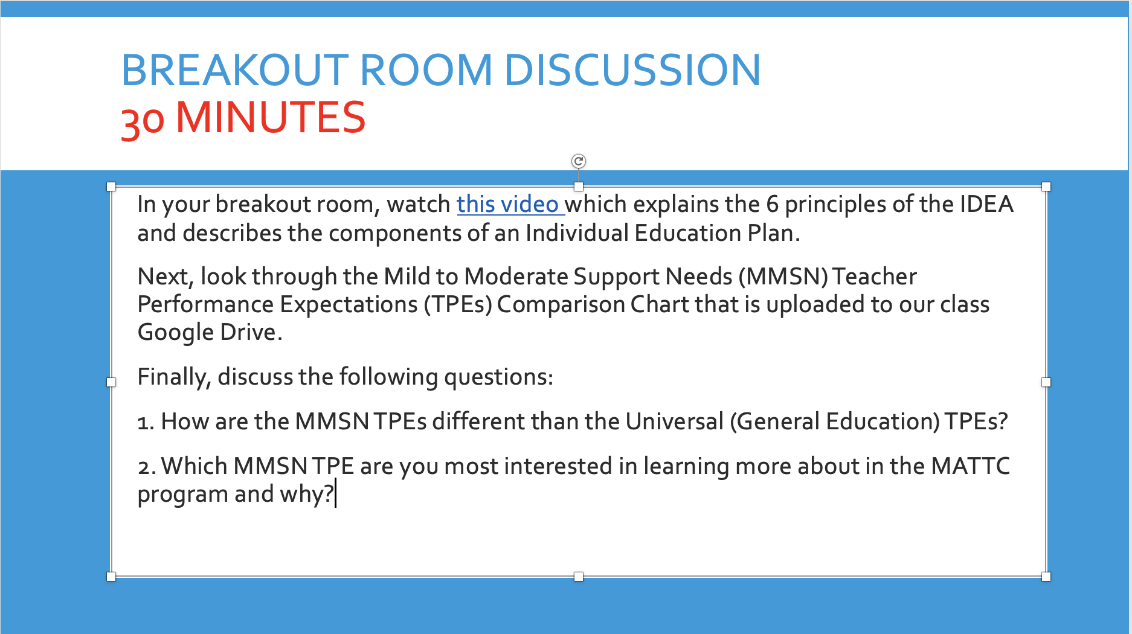

Evidence of MM 1.4 & 4.7 - Practice through student daily reflection assignment.
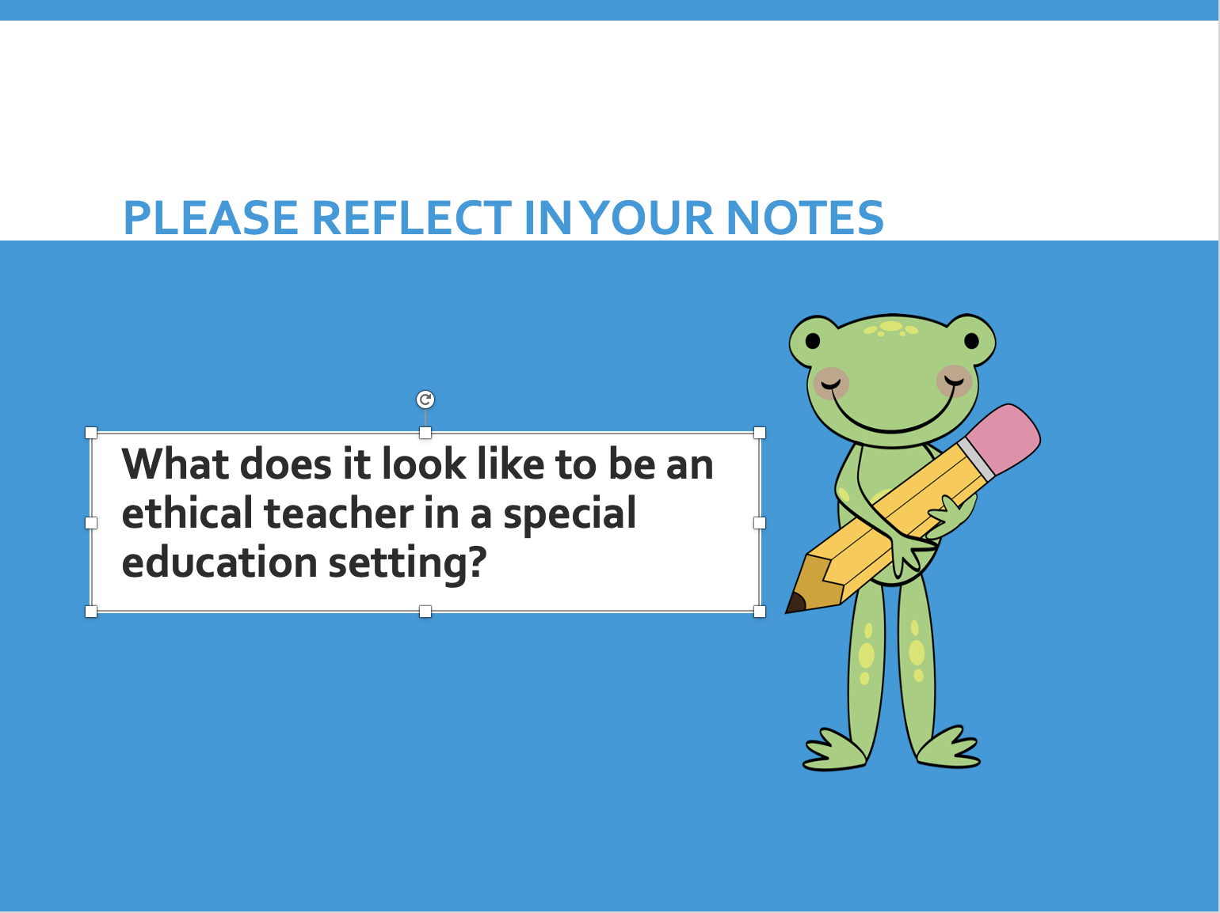

Evidence of MM 4.7, 6.5 - Introduce/Practice through breakout room discussion.

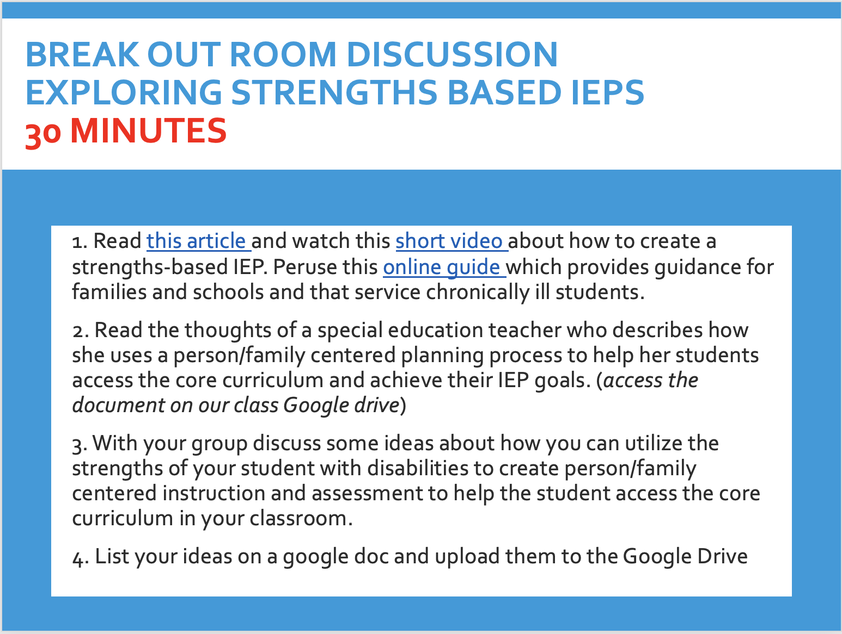

Evidence of MM 1.4, 4.7 - Practice through Final Written Evaluation

QUESTIONS:
- What’s included on an IEP?
- How are parents included in the development of an IEP?
- What are annual educational goals?
- What are accommodations and modifications?
- What is a Free Appropriate Public Education (FAPE)?
- What is a Transition Plan?
- How can you utilize the strengths of your student with disabilities to create person/family centered instruction to help him/her access the core curriculum in your classroom.

Evidence of MM 5.4, 5.5, 6.3 - Introduce, Practice, and Assess through Becoming An Antiracist Educator Asynchronous Module
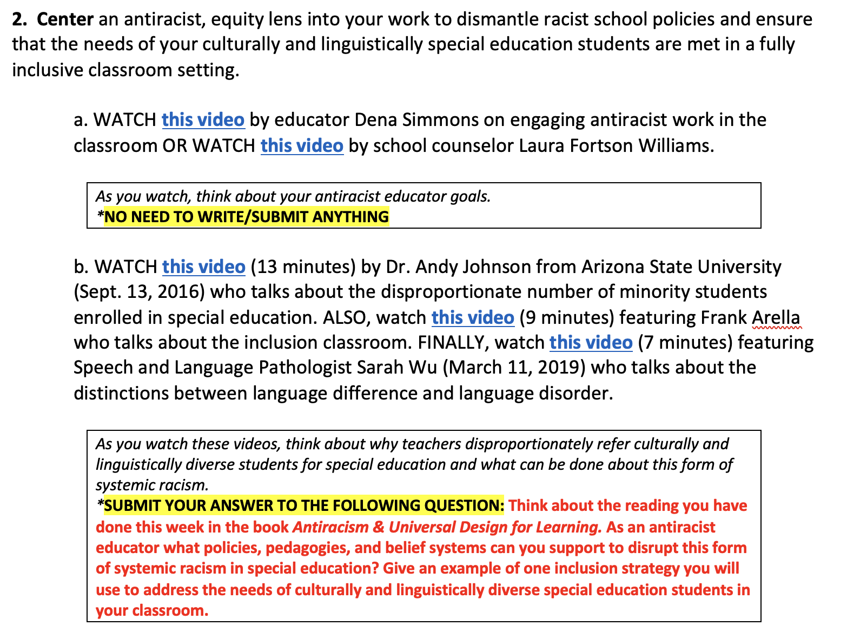

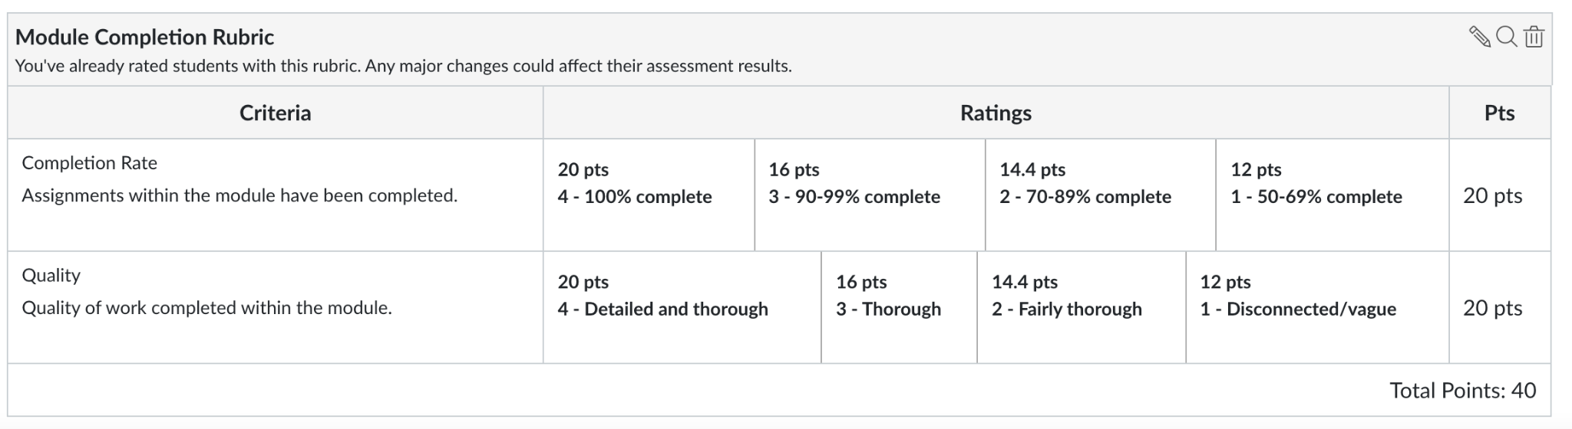

C2. Syllabus 253

Department of Education
MATTC
EDUC 253 (MS) (3 units)
Typical & Atypical Development and
Learning
Summer 2020
Professor: Keith Yocam
Office: Virtual (Asynchronous and Synchronous)
Class: Tuesday and Thursday: June 23 – July 23
Office Hours: Drop in times to be posted and by appointment
Email: kyocam@scu.edu

Mission and Goals of the Department of Education
Rooted in the Jesuit tradition at Santa Clara University, the mission of the Department of Education is to prepare professionals of competence, conscience, and compassion who will promote the common good as they transform lives, schools, and communities. Our core values of reflective practice, scholarship, diversity, ethical conduct, social justice, and collaboration guide both theory and practice.

Faculty, staff, and students in the Department of Education:
- Make student learning our central focus
- Engage continuously in reflective and scholarly practice
- Value diversity
- Become leaders who model ethical conduct and a commitment to social justice
- Seek collaboration with others in reaching these goals

MS/SS Teaching Credential Program Learning Goals (PLGs)
The PLGs represent our commitment to individuals who earn their MS/SS credential at Santa Clara University. The MS/SS faculty focus on ensuring each student will begin their teaching career ready to:
- Maximize learning for every student.
- Teach for student understanding.
- Make evidence-based instructional decisions informed by student assessment data.
- Improve your practice through critical reflection and collaboration.
- Create productive, supportive learning environments.
- Apply ethical principles to your professional decision-making

The PLGs guide our program. Therefore, all MS/SS teaching credential program course objectives are cross-referenced with the PLGs. (A fully elaborated version of the MS/SS PLGs can be found in the Teacher Candidate Handbook, Pre-Service Pathway.) The Teacher Performance Expectations (TPE) for California educators and Education Specialists TPEs for Mild Moderate Special Needs (MMSN) are also mapped on the course objectives.

Course Description

Drawing on both developmental and educational psychology, this course examines theories and patterns of typical and atypical development as this relate to teaching practices and educational programs. Students apply theories of cognitive, physical, and social/emotional and motivation to learning contexts among children, youth and early adulthood.

Students will be expected to fully engage in classroom exercises, literature circle groups, and whole-class discussions on the assigned readings.

Course Objectives
This course will develop students’ knowledge of or skills with… |  |  | Standard/Goals Addressed
 |  | DG # | PLG # | TPE# | MMSN  TPE#
1 | Understanding and applying knowledge of the characteristics of typical and atypical development of children and youth to help inform instruction to ensure that interventions and/or instructional environments are appropriate to the student’s chronological age, developmental levels, and disability-specific needs.  Demonstrate comprehensive knowledge of atypical development associated with various disabilities and risk conditions as well as resilience and protective factors and their implications for learning. | 1 | 2 | 4.2 | 2.9, 3.3
2 | Applying theories of development in creating productive learning environments to support the movement, mobility, sensory and specialized health care needs required for students with diverse cultural and linguistic backgrounds to participate fully in classrooms, schools and the community.  Demonstrate knowledge of students’ language development across disabilities | 2 | 4 | 2.2 | 2.2, 1.3
3 | Acquiring teaching and learning models that support students in assuming increasing responsibility for learning and self-advocacy based on individual needs through promotion of wide interaction models including incorporating instructional and assistive technology, and alternative and augmentative procedures to optimize the learning opportunities and outcomes for all students.  Facilitate and support students in assuming increasing responsibility for learning and self-advocacy based on individual needs. | 4 | 5 | 4.7 | 2.1, 1.6
4 | Understanding and describing the cultural nature of human development and be able to apply practices of culturally and linguistically responsive teaching to make subject matter relevant to student experiences.  Understand and address the needs of the peers and family members of students who have sustained a traumatic brain injury as they transition to school and present with a change in function.  Demonstrate knowledge of requirements for appropriate assessment and identification of students whose cultural, ethnic, gender, or linguistic differences | 3 | 1 | 4.7 | 2.11, 5.4
5 | Understanding and critiquing concepts and vocabulary associated with developmental and learning theories from students in TK-12 setting, including support of student motivation and supports needed to establish and maintain student success in the least restrictive environment, according to students’ unique needs. | 2 | 6 | 1.3 | 2.8
6 | Understanding of instructional strategies and accommodations for all students to meet their learning needs and assist with transition plans (e.g., IEP, 504 Plan, English Learning redesignation) Develop an Individualized Education Plan (IEP), including instructional goals that ensure access to the Common Core State Standards. | 3 | 3 | 2.5, 4.5 | 1.1
7 | Establishing and monitoring inclusive learning environments that are academically challenging and safe (e.g., emotional, health) with assistance of UDL and MTSS to provide access to instruction for all students who may have a co-existing health impairment and/or intellectual disability but have difficulty accessing their education due to physical limitations. | 1 | 5 | 1.4, 2.3 | 2.3
*DG=Department Goals; PLG=Program Learning Goal; TPE=Teaching Performance Expectation Standard; TPA=Teaching Performance Assessment; MMSN=TPEs for Mild Moderate Special Needs

Required Text
Slavin, R.E. (2018). Educational Psychology: Theory and Practice (12th ed.). New York: Pearson

Recommended Reading

Dell, A. D., Newton, D. A., Petroff, J. G. (2017). Assistive Technology in the Classroom: Enhancing the School Experiences of Students with Disabilities. NY: Pearson.

Heward, W. L., ALber-Morgan, S. R., Konrad, M. (2022). Exceptional Children: An Introduction to Special Education, 11th ed. NY: Pearson.

Resources:
Council for Exceptional Children- http://www.cec.sped.org Autism Speaks - http://www.autismspeaks.org
National Center for Learning Disabilities- www.ncld.org

Course Requirements and Assignments

There are four components for the course grade
Course Requirements and Assignments |  | Percentage of Course Grade | MM TPE  Assessed
1 | Class Attendance and Asynchronous Participation | 20% | 6.3
2 | Assignments & Discussions | 20% | 4.2; 2.2; 4.5
3 | - Midterm Options:  - Option 1: Caregiver Interview  Option 2: Field Interview/Consequences | 20% | 1.3; 2.5; 1.4
4 | - Signature Assignment:  ZPD Assignment | 40% | 4.7; 2.1; 2.3; 1.6, 1.1

Midterm​ Options:
Descriptions of the ​​midterm options will ​​be ​​available ​​in Assignments on ​​Camino.​​
- Option 1: Caregiver Interview
- Option 2: Field Interview/Consequences

Signature Assignment PowerPoint Slide Presentation – ZPD
This group assignment will give you the opportunity to interact with your peers in their zone of proximal development, using the concept of scaffolding. Your group will need to design a lesson that improves a skill or your group’s understanding of a concept. You are required to create several video clips of your scaffolding efforts.

Additionally, you will choose an IEP/504 Plan Snapshot Case Study of a Student With Disabilities (SWD). In your lesson design, incorporate recommended learning and technology accommodations and modifications based on the student’s IEP or 504 Plan that will improve the skill or understanding of your lesson concept. You will need to show instructional evidence in your video clips that you used specific accommodations and/or modifications that would facilitate learning and support your SWD in assuming increasing responsibility for learning and self-advocacy.
Finally, you will create a PowerPoint slide presentation that includes the following information.

Please review the Signature Assignment Rubric and upload your presentation on Camino and our class Google Drive.

1. Briefly describe all learners, including information about the SWD from their IEP.
2. Describe the task. What are you teaching? What makes you an expert in this field?
3. What will the SWD learner be able to do/know regarding the skill/concept?
4. What would be too difficult for the SWD learner with respect to the task?
5. Identify examples of your attempts to scaffold. Include clips from your recording that clearly show your efforts to scaffold. What did you do/say? How did the learners respond?
6. How would you scaffold the lesson for your SWD? What accommodations or modifications would you recommend to facilitate his/her learning and support self-efficacy?
7. Evaluate your attempts to scaffold. Were they effective/successful? (Yes/No/Partially?) Why or why not? What evidence supports your evaluation?
8. Were there any extenuating circumstances that impacted teaching & learning?
9. What do you think about the overall teaching experience? What worked/didn’t work? What modifications would you suggest?
MMSN TPEs ( Practice TPE 1.1, Practice/Assess TPE 1.6, Introduce TPE 2.1, Introduce TPE 2.3, )

Assessments & Grading Criteria

1. All written and oral assignments must reflect graduate-level standards. As a future teacher, you must be able to model communication skills for your students.

2. Attendance and participation in all class meetings are required. If you are going to be absent from class, you must email or call me to inform me of your absence. You will still be responsible for all missed content and in-class work.

3. Grades are assigned based on 100-point total. The distribution of points across assignments is as follows:
Assignment |  | Points
1 | Class Attendance and Participation | 20%
2 | Asynchronous Assignments & Discussion | 20%
3 | Mid Term Options | 20%
4 | *Signature Assignment  ZPD Assignment | 40%

Course Grading Criteria
The following grading rubric will be used to assess your class performance:
Exceeds expectations = **A Meets expectations = *B Below standards = C Unacceptable = D

** In order to earn an A on an assignment or project, a candidate’s independent, unassisted performance/product must clearly, consistently, and convincingly demonstrate high levels of proficiency in all aspects of the skills assessed. The performance/product must go beyond completion and accuracy by demonstrating strong evidence of original, creative thought and/or sophisticated insight into the students and the context.
* A candidate earns a B when s/he has fulfilled every requirement, and met every expectation.

Letter grades are assigned on the percentage scale:

A | 95-100% | C+ | 77-79%
A- | 90-94% | C | 73-76%
B+ | 87-89% | C- | 70-72%
B | 83-86% | D+ | 67-69%
B- | 80-82% | D | 63-66%

4. Assignments done in pairs/groups, each person will receive the same grade, unless otherwise stated.

5. Final grades will reflect students’ contributions (e.g., attendance, class discussions, quality of presentation, ability to lead discussion groups, completion and quality of course assignments), critical thinking and ability/degree to which student integrates theory, research and practice.

6. All assignments are expected on their due dates in the room where our class meets. I cannot be responsible for projects submitted at other times or in other formats. Unless we have made special arrangements beforehand, late assignments will be docked 3 points for each day past the due date that they are submitted.

Canvas/Camino Course Management System
To access course materials and participate in online activities, please be sure to review Canvas (also known as Camino). Reminders, tools, readings and assignment descriptions will be made available through this on-line course management system. Your SCU username and password gets you access to Canvas.

Attendance. Regular attendance at all class meetings is a requirement in this program. Any absences will proportionally affect the final grade. Please consult with the instructor if extraordinary circumstances will cause you to miss any portion of the class. You must notify the instructor by email or phone BEFORE class. Save your ER for medical issues, family demands, car trouble, etc.

Students will not be penalized for absences due to the observance of religious holidays that fall on our scheduled class day; please give me advance notice of these absences so I can make the necessary accommodations. All other absences are unexcused and will affect your grade.

Punctuality. Coming to class (and returning from breaks) on time is another course requirement.

Professional Conduct. If an instructor has reason to feel you are not meeting all the expectations spelled out below, s/he will contact you privately to discuss the issue, to clarify the expectations as needed, and to offer his/her support in helping you reach those expectations. If your instructor does not contact you with a concern, you can assume you are satisfying these requirements. However, if you would like specific feedback on your professional conduct during the quarter, you are welcome to contact your instructor at any time and s/he will be glad to share his/her assessment with you.

As we will read about and study in this course, everyone’s learning is enhanced by the quantity and quality of the interactions in the learning environment. Hence, your participation in whole class discussions, group work and pair group is essential for the success of this course.

While a class is in session, you should not engage in any activity not directly related to what is taking place in the classroom. Instructors reserve the right to ask you to close your laptop or put away some other form of technology at their discretion; when/if this occurs, please respond quickly and without protest to avoid further disruption of the class’s learning. Instructors also reserve the right to ignore your inappropriate use of technology in class and simply deduct points from your final grade. If you would like more detailed clarification about the expectations regarding appropriate and inappropriate in-class technology use, please feel free to contact your instructor for further information.

Note: Poor attendance and/or lack of punctuality will impact your final grade. A student with excellent participation on assignments and other aspects of professional conduct can earn a poor course grade as a result of excessive absence or chronic lateness.

Academic Integrity
The University is committed to academic excellence and integrity. Students are expected to do their own work and to cite any sources they use. A student who is guilty of dishonest acts in an examination, paper, or other required work for a course, or who assists others in such acts, will receive a grade of F for the course. In addition, a student guilty of dishonest acts will be immediately dismissed from the University. Students that violate copyright laws, including those covering the copying of software programs, or who knowingly alter official academic records from this or any other institution, are subject to disciplinary action (ECP Graduate Bulletin, 2018-2019).
Academic Integrity Pledge Santa Clara University is implementing an Academic Integrity pledge designed to deepen the understanding of and commitment to honesty and academic integrity.
The Academic Integrity Pledge states:
"I am committed to being a person of integrity. I pledge, as a member of the Santa Clara University community, to abide by and uphold the standards of academic integrity contained in the Student Conduct Code."
I ask that you affirm this pledge and apply these principles to your work in this class.
Department​​ of ​​Education ​​and​​ University ​​Resources
Academic​​ Action​​ Plan​​​ Students ​​who ​​are ​​struggling​​ to​​ meet​​ course​​ expectations​​will​​ be ​​placed on​​ an​​ Academic​​Action ​​Plan​​ (AAP).​​ The ​​purpose ​​of​​ the ​​AAP ​​is ​​to ​​document​​ the ​​areas​​ of difficulty,​​ the ​​support​​ to​​ be ​​provided,​​and​​ the ​​time ​​frame ​​in ​​which ​​the​​ student ​​must​​improve performance.​​ More​​ information​​ about​​ the​​ AAP ​​is​​available​​ in ​​the​​ MATTC​​ Handbook.

Disability Accommodations Procedure

If you have a disability for which accommodations may be required in this class, please contact Disabilities Resources, Benson 216, http://www.scu.edu/disabilities as soon as possible to discuss your needs and register for accommodations with the University. If you have already arranged accommodations through Disabilities Resources, please discuss them with me during my office hours. Students who have medical needs related to pregnancy may also be eligible for accommodations.

While I am happy to assist you, I am unable to provide accommodations until I have received verification from Disabilities Resources. The Disabilities Resources office will work with students and faculty to arrange proctored exams for students whose accommodations include double time for exams and/or assisted technology. (Students with approved accommodations of time-and-a-half should talk with me as soon as possible). Disabilities Resources must be contacted in advance to schedule proctored examinations or to arrange other accommodations. The Disabilities Resources office would be grateful for advance notice of at least two weeks. For more information, you may contact Disabilities Resources at 408-554-4109.

Accommodations for Pregnancy and Parenting

In alignment with Title IX of the Education Amendments of 1972, and with the California Education Code, Section 66281.7, Santa Clara University provides reasonable accommodations to students who are pregnant, have recently experienced childbirth, and/or have medically related needs. Pregnant and parenting students can often arrange accommodations by working directly with their instructors, supervisors, or departments. Alternatively, a pregnant or parenting student experiencing related medical conditions may request accommodations through Disability Resources.

Discrimination and Sexual Misconduct (Title IX)

Santa Clara University upholds a zero-tolerance policy for discrimination, harassment and sexual misconduct. If you (or someone you know) have experienced discrimination or harassment, including sexual assault, domestic/dating violence, or stalking, I encourage you to tell someone promptly. For more information, please consult the University’s Gender-Based Discrimination and Sexual Misconduct Policy at http://bit.ly/2ce1hBb or contact the University's EEO and Title IX Coordinator, Belinda Guthrie, at 408-554-3043, bguthrie@scu.edu. Reports may be submitted online through https://www.scu.edu/osl/report/ or anonymously through Ethicspoint https://www.scu.edu/hr/quick-links/ethicspoint/

In-Class Recordings

The Student Conduct Code (p. 13) prohibits students from “(m)aking a video recording, audio recording, or streaming audio/video of private, non-public conversations and/or meetings, inclusive of the classroom setting, without the knowledge and consent of all recorded parties,” except in cases of approved disability accommodations. The Student Conduct Code also prohibits the “falsification or misuse, including non-authentic, altered, or fraudulent misuse, of University records, permits, documents, communication equipment, or identification cards and government-issued documents.” Dissemination or sharing of any classroom recording without the permission of the instructor would be considered “misuse” and, therefore, prohibited. Violations of these policies may result in disciplinary action by the University. At the instructor’s discretion, violations may also have an adverse effect on the student’s grade.

EDUC 253 Course Outline and Class Schedule
Subject to change. Changes will be communicated via an in-class announcement, Camino, and/or email

Class Session & Date | Course Topics | Assignments/Homework
Session 1 – June 23 | Introductions  Course Overview  What is Developmentally Appropriate Practice?  MMSN TPEs (Introduce TPE 1.2 and TPE 2.2)  Ensure that interventions and/or instructional environments are in the least restrictive environment and are appropriate to the student’s chronological age, developmental levels, and disability-specific needs. | ** Pre-class Written Reflection  Robert E. Slavin, "Educational Psychology" Theory and Practice"  1.Chapter 1 – pp. 4-10 & pp. 14 - 16  2.Chapter 2 "Cognitive Development"  3.Discussions: Reading Response - Slavin, Chapter 2  4. Early Identification: Normal and Atypical Development. National Center for Learning Disabilities.
Session 2 – June 25 | Cognitive Development  MMSN TPE (Introduce TPE 2.1)  Incorporating instructional and assistive technology, and alternative and augmentative procedures to optimize the learning opportunities and outcomes for all students. | 1. Slavin, Chapter 3  2. Amy Dell, (2017). Assistive Technology in the Classroom: Enhancing the School Experiences of Students with Disabilities. (Ch 4 Technology to Support Universal Design for Learning and Differentiated Instruction (pg. 77-92)  3.Vialogues Activity  Empathy is a Verb – Michele Borba  https://www.vialogues.com/vialogues/play/57262/  4. Reading Response – Chapter 3
Session 3 – June 30 | Social, Moral, and Emotional Development  MMSN TPE (Introduce TPE 5.4  Demonstrate knowledge of requirements for appropriate assessment and identification of students whose cultural, ethnic, gender, or linguistic differences | 1.Slavin, Chapter 5  2. Reading Response – Chapter 5  3. Heward, Alber-Morgan, & Konrad, Exceptional Children: An Introduction to Special Education (ch. 6: Emotional or Behavioral Disorders)
Session 4 – July 2 | Behavioral and Social Theories of Learning | 1. Slavin, Chapter 6  2. Reading Response – Chapter 6  3. Read the short research article, "Building Students' Developmental Assets to Promote Health and School Success" by Peter C. Scales  4. Midterm Options (Camino) Due July 9
Session 5 – July 7 | Information Processing & Cognitive Theories of Learning  MMSN TPEs (Introduce TPE 1.3, Practice/Assess TPE 3.3)  Demonstrate comprehensive knowledge of atypical development associated with various disabilities and risk conditions as well as resilience and protective factors and their implications for learning. | 1. Slavin, Chapter 8  2. Heward, Alber-Morgan, & Konrad, Exceptional Children: An Introduction to Special Education (ch. 7 Autism Spectrum Disorders)  3. Reading Response - Chapter 8
Session 6 – July 9 | Student Centered & Constructivist Approaches to Instruction  MMSN TPE (Introduce TPE 2.3  Review UDL and MTSS Systems of support that support students with identified disabilities including students with functional limitations of movement and/or sensation for students with orthopedic impairments or other physical limitations. | 1. Slavin, Chapter 10  2. Reading Response – Chapter 10  3. Vialogues activity:  Carol Dweck - The power of believing that you can improve - TedX
Session 7 – July 14 | Motivating Students to Learn  MMSN TPEs (Introduce TPE 2.8, Introduce TPE 2.9)  Support of student motivation and the supports needed to establish and maintain student success in the least restrictive environment, according to students’ unique needs. | 1. Slavin, Chapter 4  2. Reading Response – Chapter 4  3. Heward, Alber-Morgan, & Konrad, Exceptional Children: An Introduction to Special Education (ch. 2 Planning and Providing Special Education Services)
Session 8 – July 16 | Student Diversity  MMSN TPEs (Practice/Assess TPE 2.11, Introduce TPE 5.4)  Demonstrate knowledge of requirements for appropriate assessment and identification of students whose cultural, ethnic, gender, or linguistic differences | 1. Slavin, Chapter 12 - Learners with Exceptionalities  2. Heward, Alber-Morgan, & Konrad, Exceptional Children: An Introduction to Special Education (ch. 1 The Purpose and Promise of Special Education  3. Heward, Alber-Morgan, & Konrad, Exceptional Children: An Introduction to Special Education (ch. 9 Deafness and Hearing Loss; Ch. 12. Low-Incidence Disabilities: Multiple Disabilities, Deaf-Blindness, and Traumatic Brain Injury)  4. Reading Response – Chapter 12
Session 9 – July 21 | Learners with Exceptionalities  MMSN TPE (Introduce TPE 2.2  Support the movement, mobility, sensory and specialized health care needs required to participate fully in classrooms, schools and the community.  MMSN TPE (Practice TPE 1.1)  Demonstrate the ability to collaboratively develop and implement an IEP including instructional goals to ensure access to core curriculum and that will lead to the inclusion of students with disabilities in general including students who have sustained a traumatic brain injury.  MMSN TPEs (Practice TPE 1.1, Practice/Assess 2.11)  = In class, students will review the IEP example on pages 324 & 325 in the Slavin’s text. Students will work in groups to complete two IEPs. One IEP will describe accommodations for a student with an identified learning disability. A second IEP will describe accommodations for a student with a traumatic brain injury (see below for activity)  MMSN TPE (Introduce TPE 1.3  In class, students will read an article on language development and discuss examples of accommodations they could include in their own classrooms.  (see below for activity) | 1. Signature Assignment - ZDP  2. Final Discussion
Session 10 – July 23 | Final Class | Signature Assignment Presentations
NOTE: The class will meet during the Finals week on July 21 & 23
Evidence of MMSN TPEs (Practice 1.1; Practice/Assess TPE 2.11; Practice/Assess TPE 3.3 through breakout room activity
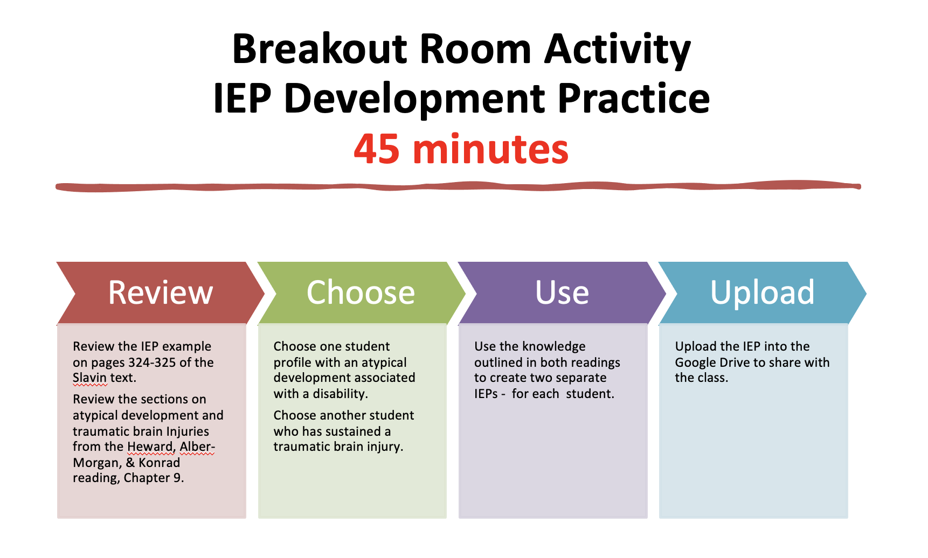
Evidence of MMSN TPEs (Practice/Assess TPE 2.11, Practice/Assess TPE 3.3) through Breakout Room activity

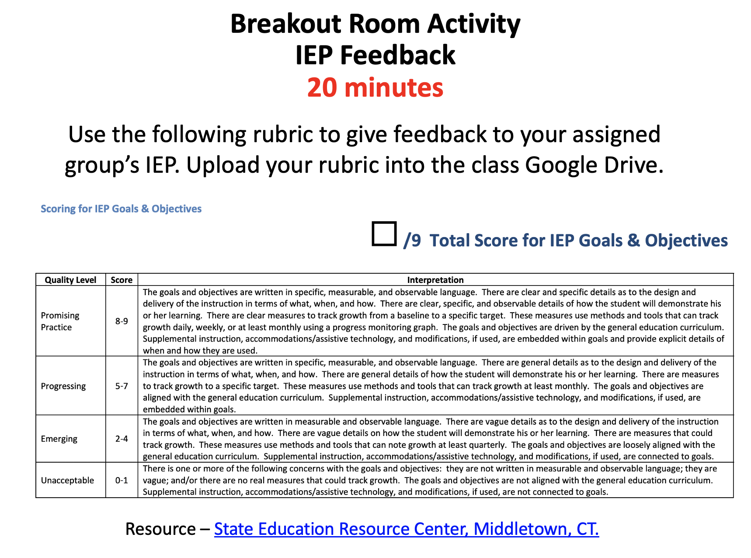

Evidence of MM 2.11; 3.3 Practice/Assess through Breakout Room Activity

Class Participation Rubric

 | 4 pts  Exceptional | 3 pts  Very Good | 2 pts  Acceptable | 1pt  Needs Improvement | 0 pts  Unacceptable
Peer Interaction | Actively supports, engages, and listens to peers. | Makes multiple attempts to successfully interact with peers | Makes a sincere effort to interact with peers | Limited but attempted interaction with peers | No peer interaction
Quality of Contribution | Plays an active role in discussion and IEP development. Each contribution includes analysis or synthesis of course materials, own experience, and/or colleagues comments. | Attempts to actively contribute to discussion and IEP development.  Most contributions include analysis or synthesis of course materials, own experience, and/or colleagues comments. | Makes a sincere effort to contribute to discussion and IEP development.  Some contributions include analysis or synthesis of course materials, own experience, and/or colleagues comments. | Comments are vague if given. Frequently demonstrates lack of interest. Contributions, when made, merely exhibit a basic understanding with no effort to analyze or synthesize. Comments are only superficially related to overall discussion. | No contributions are made to the discussion or IEP development.

Evidence of MMSN TPE (Introduce TPE 1.3) - through breakout room activity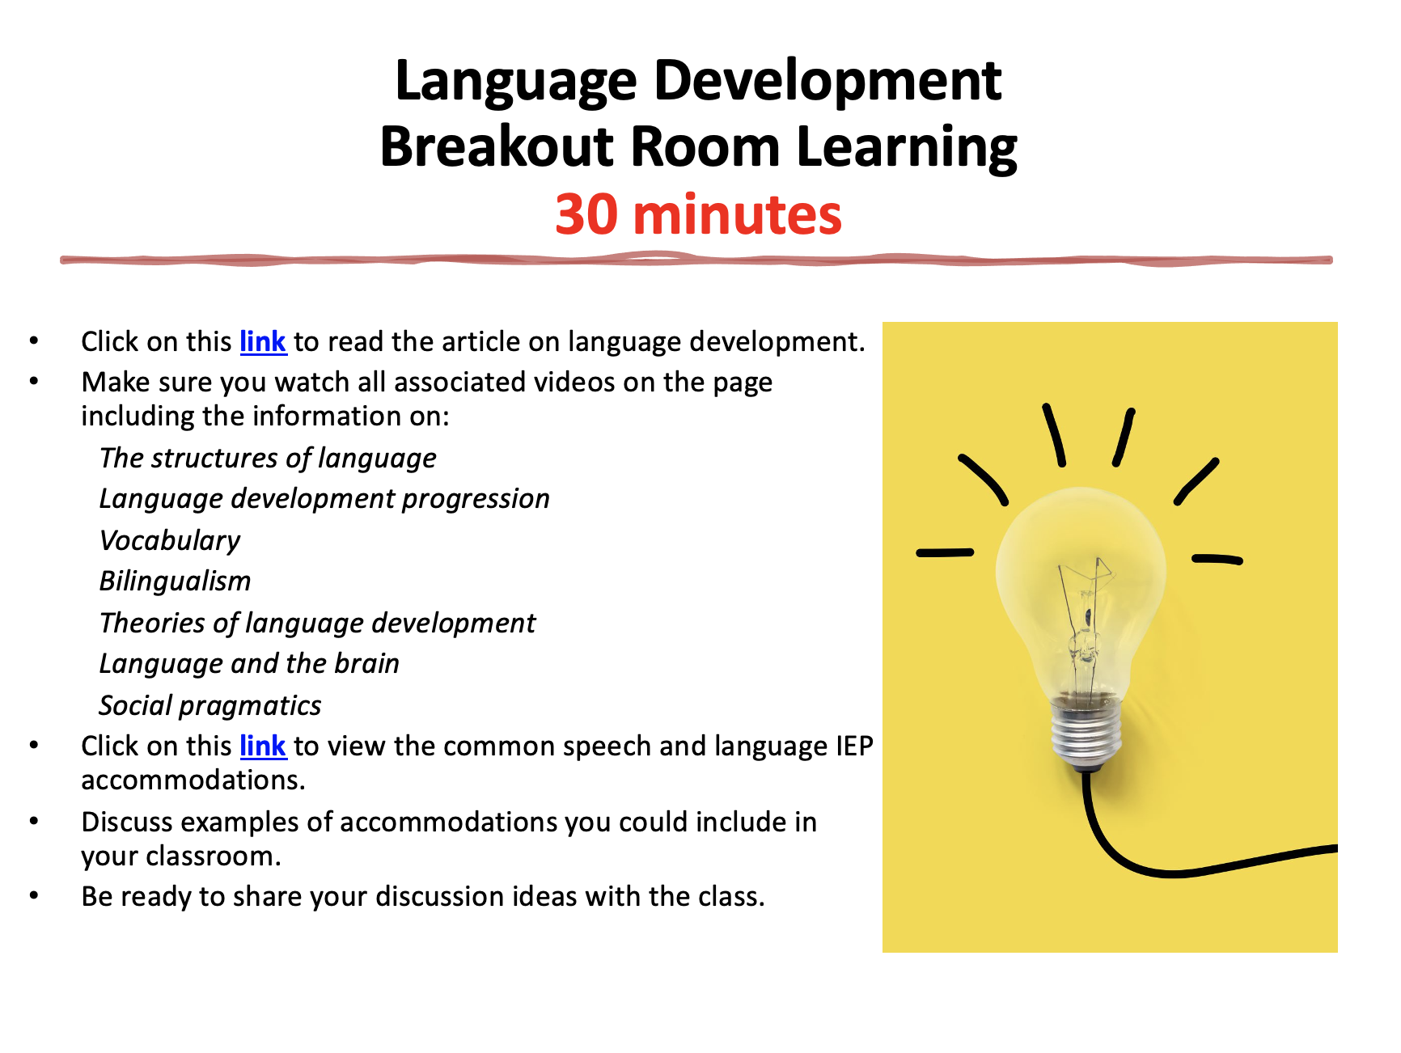

Evidence of MMSN TPEs ( Practice TPE 1.1, Practice/Assess TPE 1.6, Introduce TPE 2.1, Introduce TPE 2.3, )through signature assignment

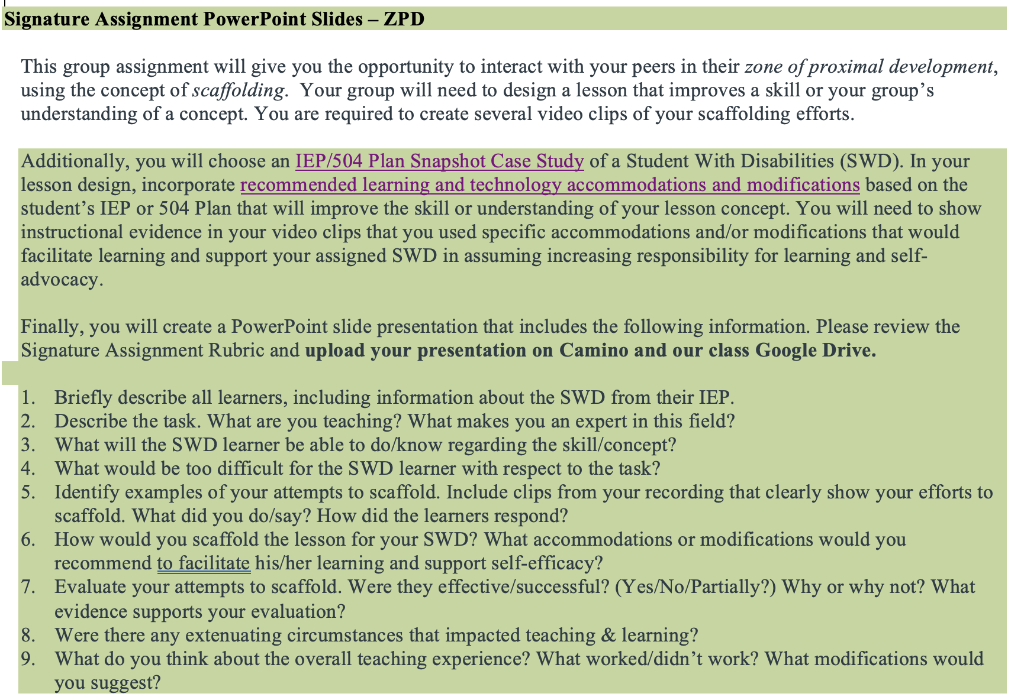

More Evidence of MMSN TPE (Practice/Assess TPE 1.6) - through signature assignment
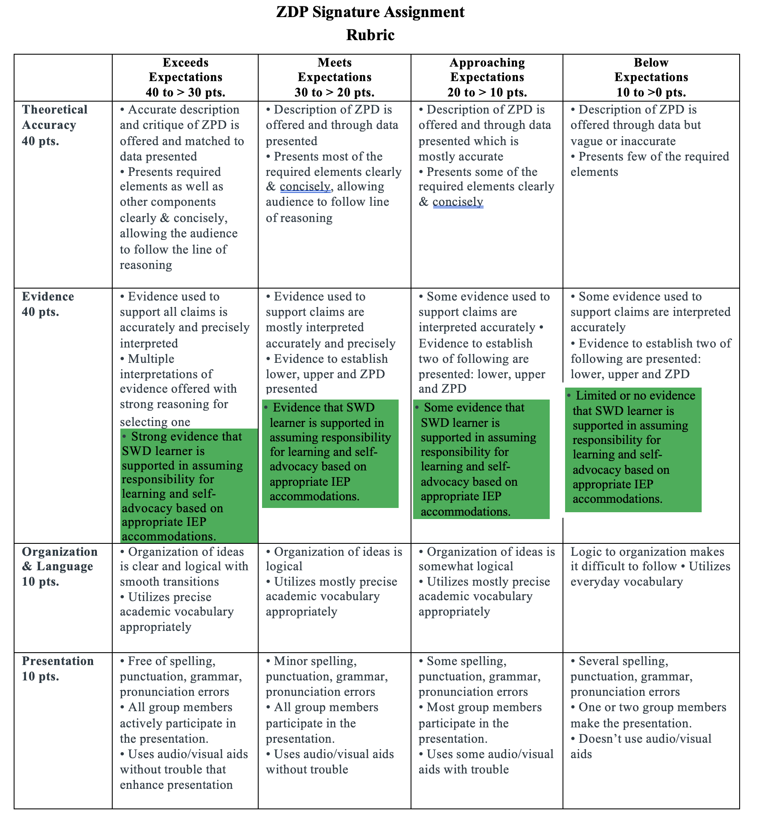

Evidence of MMSN TPE (Introduce TPE 2.1) through reading
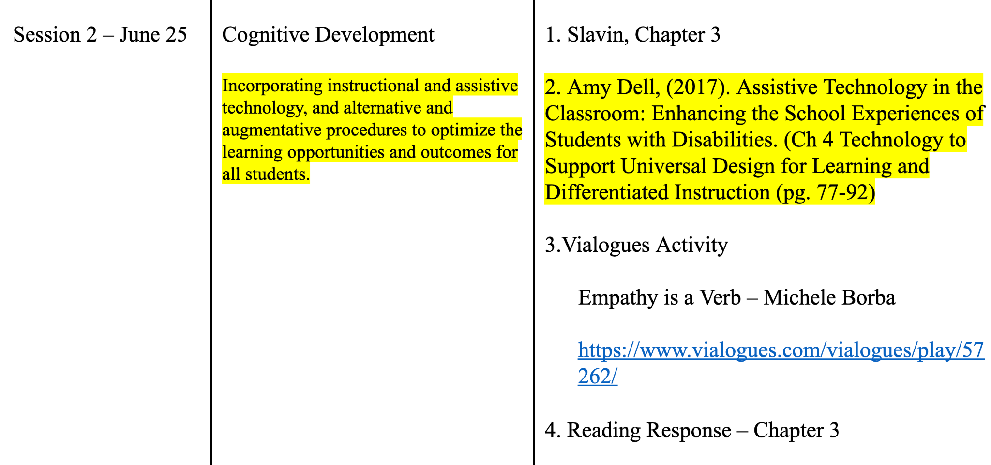

Evidence of MMSN TPE (Introduce TPE 2.3) - through Breakout Room Activity
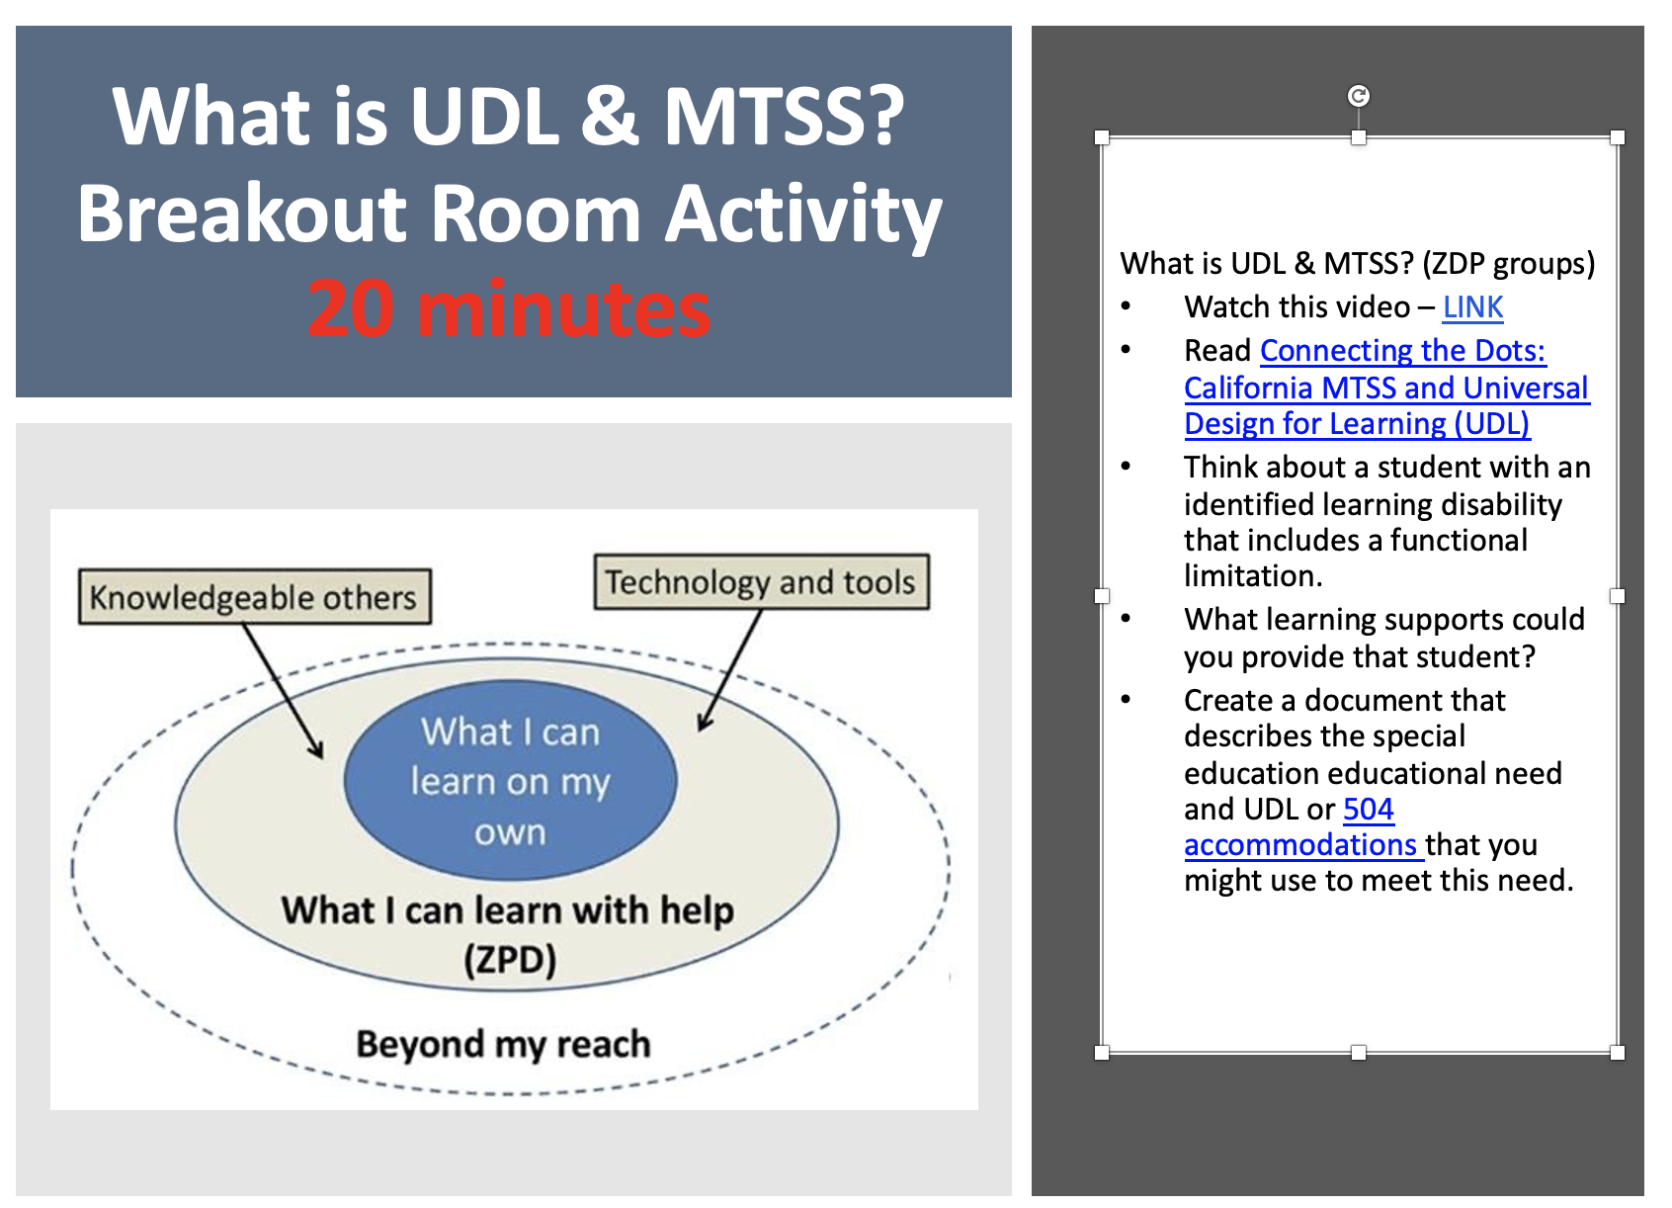

Evidence of MMSN TPEs (Introduce TPE 2.8 & 2.9) - through PowerPoint lecture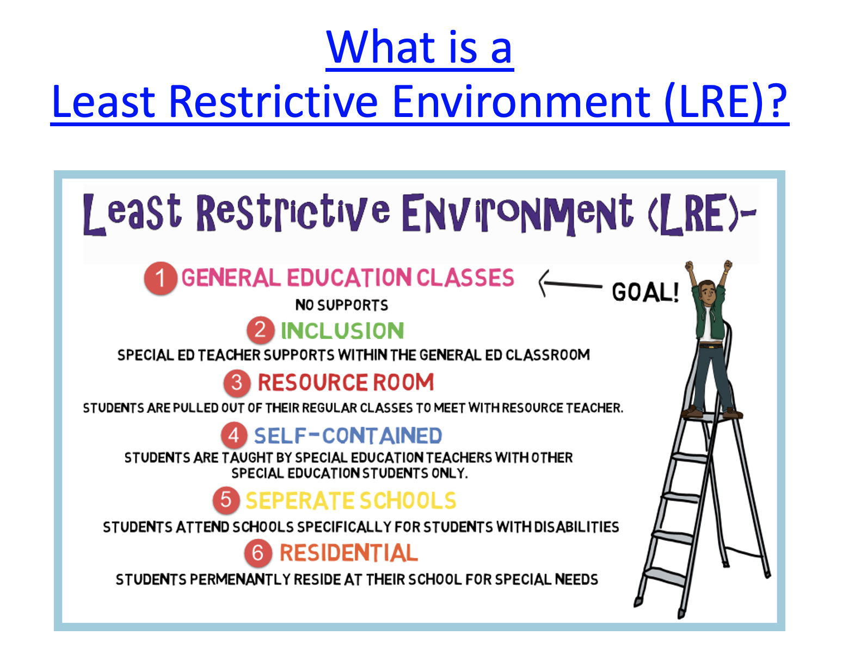
Evidence of MMSN TPE (Practice/Assess TPE 5.4 )- Introduce through a class discussion
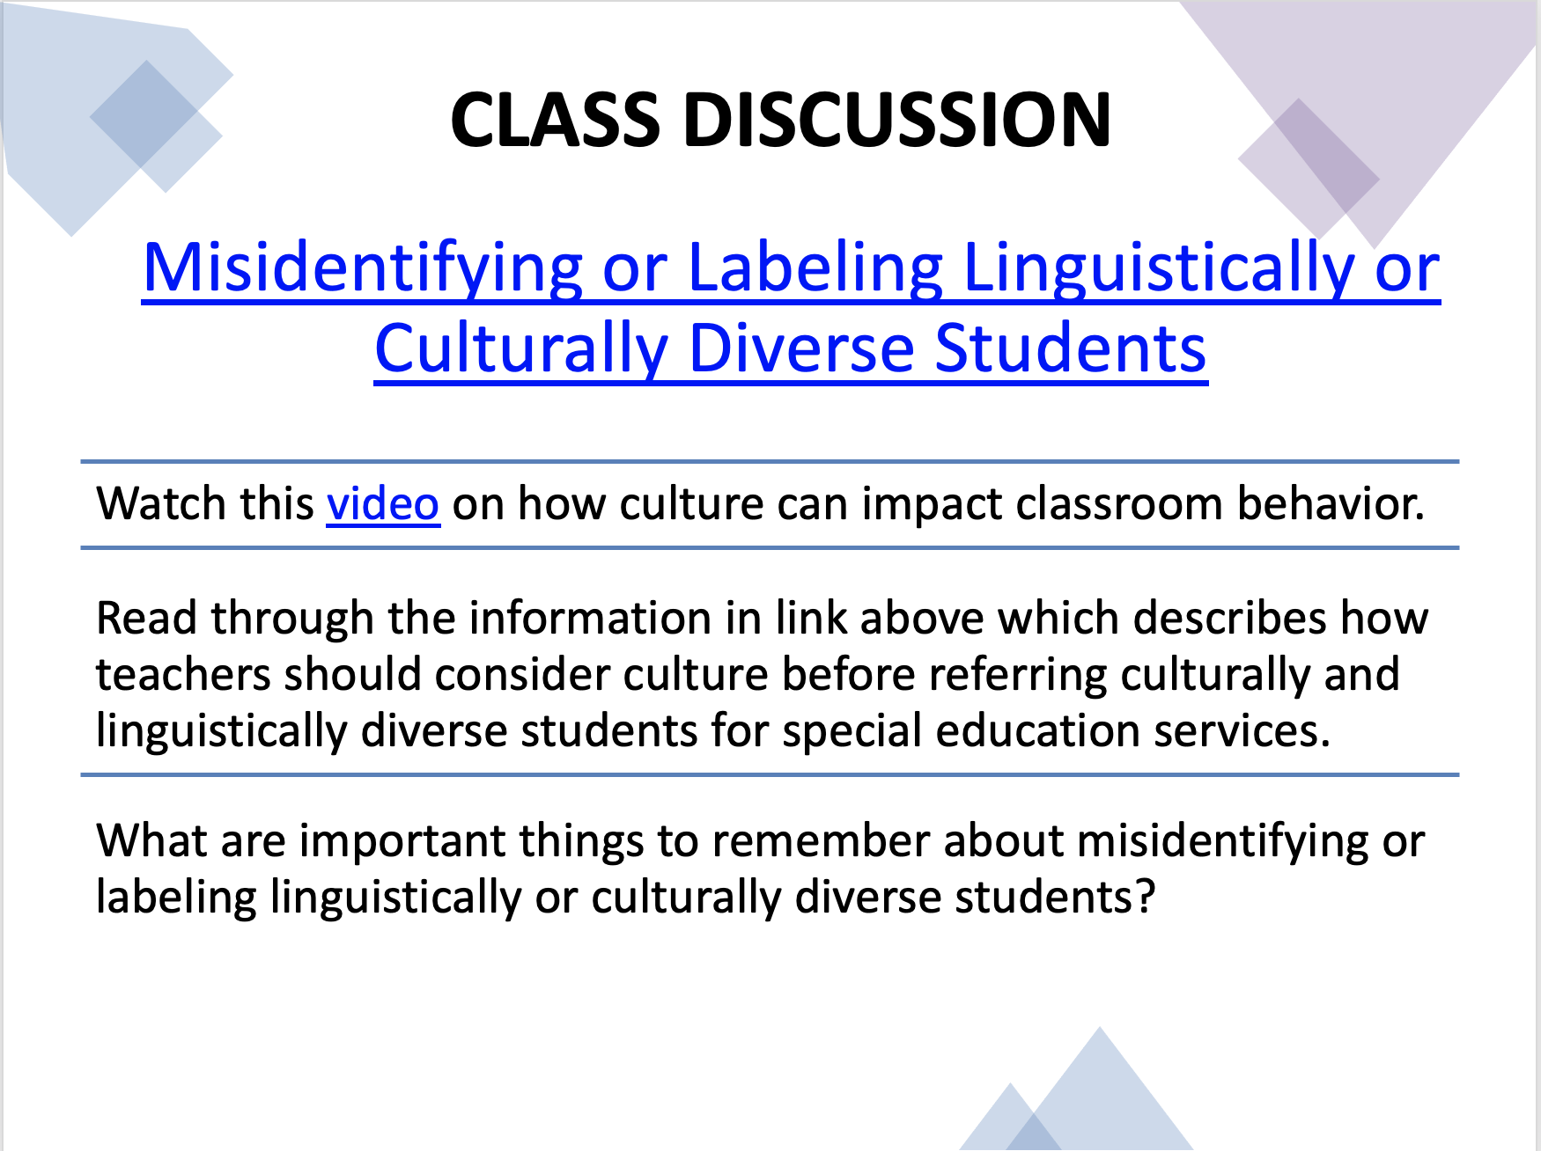

C10. Syllabus 265
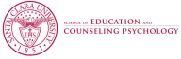
Department of Education
MATTC Program
EDUC 265 (3 units)
ASSESSING ELEMENTARY STUDENT LEARNING
Fall
Professor:
Course Meeting:
Office:
Classroom:
Office Hours:
Phone:
Email:

Mission and Goals of the Department of Education
Rooted in the Jesuit tradition at Santa Clara University, the mission of the Department of Education is to prepare professionals of competence, conscience, and compassion who will promote the common good as they transform lives, schools, and communities. Our core values of reflective practice, scholarship, diversity, ethical conduct, social justice, and collaboration guide both theory and practice.
Faculty, staff, and students in the Department of Education:
1. Make student learning our central focus
2. Engage continuously in reflective and scholarly practice
3. Value diversity
4. Become leaders who model ethical conduct and a commitment to social justice
5. Seek collaboration with others in reaching these goals
MS/SS Teaching Credential Program Learning Goals (PLGs)
The PLGs represent our commitment to individuals who earn their MS/SS credential at Santa Clara University. The MS/SS faculty focus on ensuring each student will begin their teaching career ready to:
1. Maximize learning for every student.
2. Teach for student understanding.
3. Make evidence-based instructional decisions informed by student assessment data.
4. Improve your practice through critical reflection and collaboration.
5. Create productive, supportive learning environments.
6. Apply ethical principles to your professional decision-making
The PLGs guide our program. Therefore, all MS/SS teaching credential program course objectives are cross-referenced with the PLGs. (A fully elaborated version of the MS/SS PLGs can be found in the Teacher Candidate Handbook, Pre-Service Pathway.)
Course Description
This course is designed to help you understand, integrate, and skillfully apply the principles of assessment for the elementary classroom. You will be taught how to develop assessments that align well to your lesson objectives and provide information about what your students have learned in terms of academic knowledge and social skills. Overall, this course will help you to understand the principles of assessments, construct valid assessments of student learning, recognize the strengths and limitations of various assessment types, and learn about the legal and ethical implications in the use of assessment data, particularly in the determination of special education eligibility and the monitoring of services and areas for growth identified in IEPs. At the end of this course, you will be able to develop, administer, score, and report a range of culturally and linguistically responsive diagnostic, formative, and summative assessments that will help all your students learn.
Course Objectives
This course will create opportunities to develop students’ knowledge of or skills with… |  | Standard/Goals Addressed
 |  | DG # | PLG # | TPE # | MMSN TPE#
1 | Understanding the relationship between learning and assessment decisions. | 1 | 1, 2 | 4.3, 5.1
2 | Developing, administering, scoring, and interpreting the results of a wide variety of assessments (formal, informal, diagnostic, formative, and summative) that will assist in making instructional decisions for all students, including those with IEPs. | 1, 2, 5 | 1, 2, 3, 4,  5 | 1.4, 4.1, 4.3, 5.1, 5.2, 5.3 | 5.1, 5.2
3 | Administer assessments according to the established protocols and with appropriate accommodations (e.g., use of AAC) to facilitate the participation of students with exceptionalities | 1, 2, 5 | 1, 2, 3, 4,  5 | 1.4, 4.1, 4.3 | 2, 5.2, 5.4
4 | Using the results of assessment in planning, teaching, developing curriculum, teaching social skills, determining eligibility for special education, evaluating learning interventions for students with exceptionalities, and making decisions regarding school improvement. | 1, 2, 5 | 1, 2, 3, 4,  5, 6 | 1.4, 4.1, 4.3, 5.1, 5.2, 5.3 | 2.6, 5.1, 5.2
45 | Developing a valid grading system. | 1, 2 | 1, 2, 5, 6 | 1.5, 6.1
6 | Communicating the results of assessment to students, parents, other educators, and lay audiences in person-centered, strengths-based, and culturally responsive ways. | 4, 5 | 4, 6 | 5.4, 5.5 | 2, 4.5
7 | Recognizing the unethical, illegal, and otherwise inappropriate uses of assessment, particularly by demonstrating knowledge of the legal requirements for administrating and documenting assessments for students with IEPs. | 4 | 6 | 6.5 | 3
8 | Identifying assessment procedures for English Language Learners (ELLs), with special attention to appropriate assessment and identification of students whose cultural, ethnic, gender, or linguistic differences may be misidentified as manifestations of a disability. | 1, 3 | 1, 2, 3, 4,  5 | 4.1, 4.3, 5.6, 5.7, 5.8 | 5.6
*DG=Department Goals; PLG=Program Learning Goal; TPE=Teaching Performance Expectation Standard

Required Text
Kritikos, E., McLoughlin, J. A., & Lewis, R. B. (2017). Assessing students with special needs (8th ed.). Prentice Hall.

Recommended Course Materials
Alvarez, L., Ananda, S., Walqui, A., Sato, E., & Rabinowitz, S. (2014). Focusing formative assessment on the needs of English language learners. San Francisco, CA: WestEd.
Black, P., & Wiliam, D. (1998). Inside the black box: Raising standards through classroom assessment. Phi Delta Kappan, 80, 139-148.
Ingram, E.L., & Nelson, C.E. (2006). Using discussions of multiple choice questions to help students identify misconceptions and reconstruct their understanding. The American Biology Teacher, 68(5), 275-279.
Montgomery, K. (2000). Classroom rubrics: Systematizing what teachers do naturally. The Clearing House, 73(6), 324-328.
Wiggins, G., & McTighe, J. (2005). Understanding by design (2nd ed.). Upper Saddle River, NJ: Pearson.
Course Requirements/Assignments
There are three major course components:
Course Requirements/Assignments |  | Percentage of  Grade | TPE  Assessed
1 | Readings and Resources Tasks | 30 | 1.4, 4.1, 4.3, 5.1, 5.2, 5.3, 5.4, 5.5, 5.6, 5.7
2 | Contributions and Participation within the Classroom Community | 25 | 1.4, 4.1, 4.3, 5.1, 5.2, 5.3, 5.4, 5.5, 5.6, 5.7
3 | Assessment Package | 45 | 1.4, 4.1, 4.3, 5.1, 5.2, 5.3, 5.6, 5.7

Readings and Resources Tasks
(30% of course grade)
You are expected to prepare for each class session by critically reading all of the required readings, completing all assigned tasks, and (when required) bringing a hard copy of your completed tasks to class. These tasks may include reviewing documents posted on Camino, accessing and analyzing assessment items available online, practicing skills learned in class, strengthening the skills required for assignments, and so on. Please refer to any assignment handouts that may be posted on Camino for additional details. Since many of these assignments will form the basis of in-class activities, they must be completed before class.
Contributions and Participation
(25% of course grade)
Your participation in our class activities and discussions is important not only for your own learning but also the learning of others. Sharing your ideas and questions with the group, as well as responding to those of your classmates, are critical to our work together. As a teacher, you need to do more than understand your own thinking –– you have to be able to track others’ thinking, figure out what others are saying, and determine whether and how they make sense. In this class, the “others” will be your classmates. But in the field and in the future, they will be your students, and sometimes your fellow teachers. Therefore, listening to and interacting with others in this class will explicitly help you develop dispositions and skills that matter for teaching. Professionally engaging with your classmates is crucial -- As a teacher, you will need to talk with students, families, colleagues, administrators, etc., so practice with supportive peers!
Signature Assignment—Assessment Package
(45% of course grade)
The main course objective is for you to learn how to develop, administer, and score a range of sound formative and summative assessments that will help all your elementary students learn. Towards that goal, you will develop an assessment package that contains the three elements listed below.

I. Learning Standards, Goals, Objectives, and Focal Students
1. 1-3 appropriate state and/or national standards
2. “Big” ideas and essential questions for the unit
3. 5-7 prioritized daily learning objectives/targets directly linked to the standards (including “unwrapping”) and big ideas/essential questions
4. Learning objectives/targets are written as measurable outcomes, containing verbs appropriate to the assessment type, and reflecting skill level in the standards
5. Select two students from your classroom: one emergent bilingual student and one student with exceptional learning needs. Write a brief overview of the strengths, abilities, and areas for growth for both students. Also share the learning goals and services listed in their IEPs (if they have one). Practice & Assess MMSN 2.10, 5.3

II. Methods
1. Statement of overall approach to assessment plan: design, components and timeline
2. Descriptions and rationales for at least two assessment methods/components of overall plan 3. Descriptions of student expectations for each assessment method/component
4. Description of diagnostic assessments and interpretation of their data for each focal student Practice & Assess MMSN 5.2, 5.6
5. Description and rationale of both the selection of assessment type (formal, informal, formative, etc.) and the assessment accommodations for each focal student, with special attention to how these accommodations the unique social and learning needs of the focal students. Practice & Assess MMSN 2.10, 3.3, 5.1, 5.2, 5.4, 5.6

III. Grading/Measurement Plan
1. Scoring criteria for graded assignments
2. Explanation of relative assignment weights
3. Rationale for weighting plan for all graded elements
4. Explanations for how forms of assessment will inform instruction for whole class
5. Explanations for how forms of assessment will inform interventions and formal instructional plans (e.g., IEPs) for focal students Practice & Assess MMSN 4.7, 5.2, 5.4
6. Explanation for assessment data and feedback will be shared with students, parents/guardians, and colleagues/ para instructors Practice & Assess MMSN 4.7

IV. Self-Assessment
1. Self-evaluation with written explanation of ratings using Assessment Package Self-Assessment, which will be posted on Camino.

Rubric for Signature Assignment
 | Exceeds or Meets Expectations | Approaches Expectations | Developing Understanding
Learning Standards, Goals, & Objectives | Teachers select relevant standards, identify big ideas and essential questions, and state clear, relevant, and measurable objectives | Teachers select standards that may not be relevant to the topic; struggle to clearly articulate big ideas or essential questions; and/or state objectives that may not be measurable or relevant. | Teachers are missing standards and/or big ideas and essential questions; and state objectives that are neither clear nor measurable.
Selection of Focal Students | Teachers accurately select an emergent bilingual student and student with disabilities as focal students; and write a thorough description that reviews the students’ strengths, abilities, and areas for growth, as well as summarizes the learning goals and special services articulate in the students’ IEPs or other school plans.  Practice & Assess MMSN 2.10, 5.3 | Teachers accurately select an emergent bilingual student and student with disabilities as focal students; and write a somewhat clear description that reviews students’ areas for growth, as well as summarizes dimensions of any IEPs or other school plans for each focal student. | Teachers are missing a focal student; and/or provide minimal details in their description of the focal student, omitting student areas for growth and any summary of the student’s IEP or other school plan.
Methods | Teachers provide a thorough explanation of their approach to assessment design; and provide a clear and detailed description and rationale for at least two pieces of their assessment package, along with an explanation of student expectations for those assessments. | Teachers provide a somewhat clear explanation of their approach to assessment design; and provide a fair description and rationale for at least two pieces of their assessment package. | Teachers write a minimal explanation of their approach to assessment design; and omit or provide minimal explanation for 1-2 pieces of their assessment package.
Assessment of Focal Students | Teachers supply a clear and thorough explanation of diagnostic assessments and interpretation of their data for each focal student; and a description and rationale for the selection of assessment type and the assessment accommodations for each focal student, with special attention to how these accommodations the unique social and learning needs of the focal students.  Practice & Assess MMSN 2.10, 3.3, 5.1, 5.2, 5.4, 5.5, 5.6 | Teachers supply a somewhat clear explanation of diagnostic assessments and interpretation of their data for each focal student; and a description of the selection of assessment type and the assessment accommodations for each focal student. | Teachers omit or provide minimal explanation of diagnostic assessments for each focal student; or give little attention to the selection of assessment type and the assessment accommodations for each focal student
Measurement Plan | Teachers provide a strong explanation for the scoring criteria for each assessment, along with explanation and rationale for weighted criteria; and provide a relevant plan for shaping future instruction based on the assessment results. | Teachers identify the scoring criteria for each assessment, with some details about the weighted criteria; and provide a somewhat relevant plan for shaping future instruction based on the assessment results. | Teachers omit or provide minimal description of the scoring criteria for each assessment; and omit or provide minimal explanation of how assessment results will shape future instruction.
Analysis of Focal Students’ Assessments | Teachers will provide a clear and detailed explanation for (a) how forms of assessment will inform interventions and formal instructional plans (e.g., IEPs) for focal students; and (b) how assessment data and feedback will be shared with students, parents/guardians, and colleagues/ para instructors.  Practice & Assess MMSN 4.7, 5.2, 5.4 | Teachers will provide a somewhat clear explanation for (a) how forms of assessment will inform interventions and formal instructional plans (e.g., IEPs) for focal students; and (b) how assessment data and feedback will be shared with students, parents/guardians, and colleagues/ para instructors. | Teachers omit or provide minimal explanation for (a) how forms of assessment will inform interventions and formal instructional plans (e.g., IEPs) for focal students; and (b) how assessment data and feedback will be shared with students, parents/guardians, and colleagues/ para instructors.

Professional Conduct and Performance Policies
If I have reason to feel you are not meeting all the expectations spelled out below, I will contact you privately to discuss the issue, to clarify the expectations as needed, and to offer my support in helping you reach those expectations. If I do not contact you with a concern, you can assume you are satisfying these requirements. However, if you would like specific feedback on your professional conduct during the quarter, you are welcome to contact me at any time and I will be glad to share my assessment with you.
Attendance. Regular attendance at all class meetings is a requirement in this program. Ten points will be deducted from your final grade for the course for each class session you missed. Each of you will be granted one Emergency Release (ER) per course. Your ER excuses you from one class session with (at most) half the grade penalty (loss of 2-5 points instead of 10). To use your ER you must notify me by email or phone BEFORE class. Save your ER for medical issues, family demands, car trouble, etc.
Students will not be penalized for absences due to the observance of religious holidays that fall on our scheduled class day; please give me advance notice of these absences so I can make the necessary accommodations. All other absences are unexcused and will affect your grade.
Because so much of the course content is learned through participation in class activities and other experiences, it is not possible to make up for missing a class session. However, there are ways you can engage with the content, join the conversation, and try to fill the knowledge gaps that are the result of your absence. If you must miss a class session, do the following things:
1. Complete and submit on time all assignments due for the class session.
2. Download and review the PowerPoint presentation and any handouts and discussion notes from class (all posted on Camino).
3. Talk with your classmates to get their sense of the main “takeaways” of the session.
Punctuality. Coming to class (and returning from breaks) on time is another course requirement. Your first late arrival will be excused; your second late arrival will cause 1 point to be deducted from your final course grade; your third late arrival will cause an additional 4 points to be deducted. More than three late arrivals indicate a serious problem; this situation will be dealt with at my discretion.

Note: Points lost due to absences and/or lack of punctuality are deducted from your final grade. A student with excellent grades on assignments and other aspects of professional conduct can earn a lower course grade as a result of excessive absence or chronic lateness.
Attendance and punctuality are the only policies with the immediate potential to impact your course grades. However, your instructors gather data documenting your adherence to the remaining policies listed here through ongoing observation and documentation. These data are a primary factor in our program’s assessment of your mastery of TPE 6- “Developing as a Professional Educator”
Responsible use of technology. As we read and study in this course, everyone’s learning is enhanced by the quantity and quality of the interactions in the learning environment. Hence, your participation in whole class discussions, group work and pair group are essential for the success of this course. While a class is in session, you should not engage in any activity not directly related to what is taking place in the classroom. Instructors reserve the right to ask you to close your laptop or put away some other form of technology at their discretion; when/if this occurs, please respond quickly and without protest to avoid further disruption of the class’s learning. Instructors also reserve the right to ignore your inappropriate use of technology in class and simply deduct points from your final grade. If you would like more detailed clarification about the expectations regarding appropriate and inappropriate in-class technology use, please feel free to contact me for further information.
Academic integrity. Santa Clara University insists on honesty and integrity from all members of its community; see https://www.scu.edu/academic-integrity/ for details. Students ae expected to do their own work and to cite any sources they use. A student who is guilty of dishonest acts in an examination, paper, or other required work for a course, or who assists others in such acts, will receive a grade of F for the course. In addition, a student guilty of dishonest acts will be immediately dismissed from the University. Students that violate copyright laws, including those covering the copying of software programs, or who knowingly alter official academic records from this or any other institution, are subject to disciplinary action (SECP Graduate Bulletin, 2017-2018 https://www.scu.edu/media/ecp-media-/-ecp media-2018/pdfs/Final---SECP-17-18.pdf).
Communication. Email and our Camino website will be our primary means of communication outside of class. You must check your SCU email account and Camino messages every day to ensure you maintain a connection with your classmates and me.
Assessments & Grading Criteria
• All written and oral assignments must reflect graduate-level standards. As a future teacher, you must be able to model communication skills for your students.
• Attendance and participation in all class meetings is required. If you are going to be absent from class, you must email or call me to inform me of your absence. You will still be responsible for any missed content.
• Final letter grades are assigned on the standard scale based upon a possible total of 100 points (once cumulative course points are converted).
A | 94-100 | C+ | 77-79
A- | 90-93 | C | 74-76
B+ | 87-89 | C- | 70-73
B | 84-86 | D+ | 67-69
B- | 80-83 | D | 63-66

• Assignments done in pairs, both partners will receive the same grade, unless otherwise stated.
• Final grades will reflect students’ contributions (e.g., attendance, class discussions, quality of presentation, ability to lead discussion groups, completion and quality of course assignments), critical thinking and ability/degree to which student integrates theory, research and practice.
• All assignments are expected on their due dates in the room where our class meets. I cannot be responsible for papers submitted at other times or in other formats. Unless we have made special arrangements beforehand, late assignments will be docked 3 points for each day past the due date that they are submitted.
Course Management System—Camino
To access course materials and participate in on-line activities, please be sure to review Camino. Reminders, tools, readings and assignment descriptions will be made available through this on-line course management system. Your SCU username and password gets you access to Canvas.
Department of Education and University Resources
Academic Action Plan Students who are struggling to meet course expectations will be placed on an Academic Action Plan (AAP). The purpose of the AAP is to document the areas of difficulty, the support to be provided, and the time frame in which the student must improve performance. More information about the AAP is available in the MATTC Handbook.
Disability Accommodations If you have a disability for which accommodations may be required in this class, please contact Disabilities Resources, Benson 216, http://www.scu.edu/disabilities as soon as possible to discuss your needs and register for accommodations with the University. If you have already arranged accommodations through Disabilities Resources, please discuss them with me during my office hours. Students who have medical needs related to pregnancy may also be eligible for accommodations.
While I am happy to assist you, I am unable to provide accommodations until I have received verification from Disabilities Resources. The Disabilities Resources office will work with students and faculty to arrange proctored exams for students whose accommodations include double time for exams and/or assisted technology. (Students with approved accommodations of time-and-a-half should talk with me as soon as possible). Disabilities Resources must be contacted in advance to schedule proctored examinations or to arrange other accommodations. The Disabilities Resources office would be grateful for advance notice of at least two weeks. For more information, you may contact Disabilities Resources at 408-554-4109.
Accommodations for Pregnancy and Parenting In alignment with Title IX of the Education Amendments of 1972, and with the California Education Code, Section 66281.7, Santa Clara University provides reasonable accommodations to students who are pregnant, have recently experienced childbirth, and/or have medically related needs. Pregnant and parenting students can often arrange accommodations by working directly with their instructors, supervisors, or departments. Alternatively, a pregnant or parenting student experiencing related medical conditions may request accommodations through Disability Resources.
Incomplete Grades Under certain extenuating circumstances, a student may request an Incomplete. See the School of Education and Counseling Psychology Bulletin for details. If you have any concerns about
your ability to fulfill the course requirements by the due dates, contact me right away to explain your situation.
Writing Support The HUB Writing Center (22 Benson Center) offers a variety of services, such as peer tutoring. For more details, please visit: http://www.scu.edu/provost/writingcenter/.
Title IX Santa Clara University upholds a zero-tolerance policy for discrimination, harassment and sexual misconduct. If you (or someone you know) have experienced discrimination or harassment, including sexual assault, domestic/dating violence, or stalking, I encourage you to tell someone promptly. For more information, please consult the University’s Gender-Based Discrimination and Sexual Misconduct Policy at http://bit.ly/2ce1hBb or contact the University's EEO and Title IX Coordinator, Belinda Guthrie, at
408-554-3043 or by email at bguthrie@scu.edu. Reports may be submitted online through https://www.scu.edu/osl/report/ or anonymously through Ethicspoint https://www.scu.edu/hr/quick links/ethicspoint/
Reporting Practices While I want you to feel comfortable coming to me with issues you may be struggling with or concerns you may be having, please be aware that there are some reporting requirements that are part of my job at Santa Clara University. For example, if you inform me of an issue of harassment, sexual violence, or discrimination, I will keep the information as private as I can, but I am required to bring it to the attention of the institution’s EEO and Title IX Coordinator. If you inform me that you are struggling with an issue that may be resulting in, or caused by, traumatic or unusual stress, I will likely inform the campus Student Care Team (SCU CARE).
If you would like to reach out directly to the Student Care Team for assistance, you can contact them at https://www.scu.edu/osl/culture-of-care/care-teams/. If you would like to talk to the Office of EEO and Title IX directly, they can be reached at 408-554-3043 or by email at bguthrie@scu.edu. Reports may be submitted online through https://www.scu.edu/osl/report/ or anonymously through Ethicspoint: https://www.scu.edu/hr/quick-links/ethicspoint/ Additionally, you can report incidents or complaints to the Office of Student Life (OSL), Campus Safety Services, and local law enforcement. For confidential support, contact the Counseling and Psychological Services office (CAPS), the YWCA, or a member of the clergy (for example, a priest or minister).
Finally, please be aware that if, for some reason, our interaction involves a disruptive behavior, a concern about your safety or the safety of others, or potential violation of University policy, I will inform the Office of Student Life. The purpose of this is to keep OSL apprised of incidents of concern, and to ensure that students can receive or stay connected to the academic support and student wellness services they need.

EDUC 265 Course Outline & Class Schedule
Subject to change. Changes will be communicated via in-class announcement, Camino, and/or email.
CLASS SESSION | TOPICS | TASKS/ASSIGNMENTS DUE
Class #1 | Course overview  Setting the context—Introduction to assessment and educational achievement  Introduction to Assessment Package | Introductory Survey
Class #2 | Backward design  Developing learning targets/objectives for Assessment Package and classroom instruction  Diagnostic assessment | Read Ch. 1 of Kritikos, McLoughlin, & Lewis (2017)  Introduce & Practice MMSN 5.1  Read selection from Wiggins & McTighe (2005)—Understanding by Design
Class #3 | The case for formative assessment and its differentiation  Knowing when to use appropriate formative assessments | Read Ch. 6 of Kritikos, McLoughlin, & Lewis (2017)  Introduce & Practice MMSN 5.2  Read article from Black & Wiliam (1998)—Inside the Black Box: Raising Standards Through Classroom Assessments
Class #4 | Types of summative assessments  Issues with summative assessment  Accommodating summative assessments | Read article from Ingram & Nelson (2006)—Using Discussions of Multiple Choice Questions to Help Students Identify Misconceptions and Reconstruct Their Understanding
Class #5 | Authentic assessment and assessment options  Analysis of student work  Developing rubrics | Read article from Montgomery (2000)— Classroom Rubrics: Systematizing What Teachers Do Naturally
Class #6 | Grading strategies and providing constructive feedback  Assessing social skills, particularly for students with exceptionalities, and using this information to determine opportunities for classroom interactions, academic assessments, and new learning opportunities/ interventions. | Read Ch. 8 & Ch. 10 of Kritikos, McLoughlin, and Lewis (2017) Introduce & Practice MMSN 5.2
Class #7 | Assessing students for potential exceptionalities  Legal and ethical issues of assessment and data  Legal requirements for assessing students with IEPs | Read Ch. 2 & 4 of Kritikos, McLoughlin, and Lewis (2017) Introduce & Practice MMSN 5.1, 5.3
Class #8 | Culturally and linguistically responsive assessments  Assessing culturally and linguistically diverse students for potential learning exceptionalities | Read Ch. 12 of Kritikos, McLoughlin, and Lewis (2017) Introduce & Practice MMSN 5.2, 5.4  Read section (pp. 17-23) from Alvarez, Ananda, Walqui, Sato, & Rabinowitz (2014)—Focusing Formative Assessment on the Needs of English Language Learners
Class #9 | Criteria for selecting most appropriate assessments  Assessment accommodations for students across the subject areas and on standardized testing and construction of assessment report | Read Ch. 5, 13, & 14 of Kritikos, McLoughlin, and Lewis (2017) Introduce & Practice MMSN 5.1, 5.2, 5.4
Class #10 | Student involvement in assessment  Assessing early elementary students with potential exceptional learning needs  Reporting student learning in person-centered, family-centered, and strengths-based ways  Collaboration with assessment | Read Ch. 3 & 9 of of Kritikos, McLoughlin, and Lewis (2017) ntroduce & Practice MMSN 5.1  Read article from Volante & Beckett (2011)—Formative Assessment and the Contemporary Classroom: Synergies and Tensions Between Research and Practice  Final Assessment Package Due

C14. Syllabus 258

Department of Education
MATTC Program
EDUC 258 Developing Positive Classroom Cultures
(3 units). (22183)
Winter - 2021
Professor: Bob Michels Course Meeting: Thursday – 5:00 PM – 8:00 PM
Office: GH 250 Classroom: Online
Office Hours: M/Th 4:00 PM – 5:30 PM or by appointment Phone: 415.310.6312 (cell)
Email: rmichels@scu.edu

Mission and Goals of the Department of Education
Rooted in the Jesuit tradition at Santa Clara University, the mission of the Department of Education is to prepare professionals of competence, conscience, and compassion who will promote the common good as they transform lives, schools, and communities. Our core values of reflective practice, scholarship, diversity, ethical conduct, social justice, and collaboration guide both theory and practice. Faculty, staff, and students in the Department of Education:
- Make student learning our central focus
- Engage continuously in reflective and scholarly practice
- Value diversity
- Become leaders who model ethical conduct and a commitment to social justice
- Seek collaboration with others in reaching these goals

MS/SS Teaching Credential Program Learning Goals (PLGs)
The PLGs represent our commitment to individuals who earn their MS/SS credential at Santa Clara University. The MS/SS faculty focus on ensuring each student will begin their teaching career ready to:
- Maximize learning for every student.
- Teach for student understanding.
- Make evidence-based instructional decisions informed by student assessment data.
- Improve your practice through critical reflection and collaboration.
- Create productive, supportive learning environments.
- Apply ethical principles to your professional decision-making

The PLGs guide our program. Therefore, all MS/SS teaching credential program course objectives are cross-referenced with the PLGs. (A fully elaborated version of the MS/SS PLGs can be found in the Teacher Candidate Handbook, Pre-Service Pathway.)

Course Description
Research data report that the number one reason teachers leave the classroom is because they cannot manage their students. This course will explore the importance of establishing a positive structured learning environment for students with disabilities by developing a successful classroom management model that is consistent with the California Standards for the Teaching Profession. Topics will include, but not be limited to, the following: motivation, managing time and physical space, and establishing rules and routines.

Course objectives
This course will develop students’ knowledge of or skills with… | Standard/Goals Addressed
 | DG # | PLG # | TPE # | MMSN TPE #
Examine elements of the classroom environment that minimize behavior problems with collaboration with families and appropriate related services personnel. | 1,2 | 5 | 2.1, 2.5 | 2.2, 2.3, 2.4, 2.7, 4.7
Identify effective classroom management principles that facilitate learning through development of positive student behavior, particularly students with complex social communication, behavioral and emotional needs and those on the autism spectrum disorder | 1, 2 | 1.5 | 1.3, 1.5, 1.8, 2.3, 6.6 | 2.2, 2.3, 2.5, 2.6, 2.10; 3.3
Design classroom rules, routines, and incentives appropriate for the grade level to be taught through understanding if student’s communicative intent in variety of contexts. | 1, 2 | 4, 5 | 1.2, 2.6 | 1.7, 2.4, 2.5, 2.6, 2.10
Review the essential components of various models for responding to discipline problems particularly through understanding students’ communicative intent by helping them develop positive communication skills and involving families. | 2, 4 | 4 | 2.1, 6.5 | 2.4, 2.5, 2.8
Develop a personal model for preventing and responding to discipline problems particularly to help positive psychosocial development and self-determined behavior of students with disabilities, by seeking to collaborate with support systems that involve family and related service personnel. | 4 | 5, 6 | 1.2, 6.5 | 1.7, 2.4, 2.6, 2.7, 2.8, 2.10
Discuss the relation between teacher expectations and student motivation (e.g., positive communication skills) and learning. | 2, 4, 5 | 1, 4 | 1, 3 | 2.6, 2.10, 4.3
Explore effective procedures for dealing with serious disruptive behavior problems by collaborating with other agency personnel. | 2, 3, 4 | 5, 6 | 1.2, 2.1 | 2.5, 2.7, 2.8, 2.10, 3.3,
Recognize cultural influences on behavior, and identify relevant approaches when relating to diverse students and their parents. Ensure the least restrictive environment according to student needs. | 3, 4 | 3, 5 | 1.2, 2.2, 2.5 | 2.8, 4.3, 4.7
Identify “Restorative Justice” resources available to promote school safety and reduce school violence through engagement with families. | 3, 4, 5 | 4, 5 | 2.3, 2.4, 6.5 | 2.4, 2.10, 4.7
Analyze specific “Mindfulness” interventions to promote the development of social competence with goal of supporting students with complex social communication, behavioral and emotional needs. | 1, 2, 4 | 5 | 2.1, 2.3 | 2.10, 4.3
*DG=Department Goals; PLG=Program Learning Goal; TPE=Teaching Performance Expectation Standard

Readings

Introduce MMSN TPE 2.2, 2.4, 2.10, 3.3; Introduce/Practice MMSN TPE 2.3, 2.5, 4.3

Required
Bryant, D. P., Bryant, B. R., & Smith, D. D. (2019). Teaching students with special needs in inclusive classrooms. Sage Publications.
Evertson, Carolyn M., Emmer, Edmund T. (2017). Classroom management for elementary teachers: Tenth Edition, Loose-Leaf Version. Boston, MA: Pearson Higher Ed ISBN 9780134027272
Simplican, S. C., Leader, G., Kosciulek, J., & Leahy, M. (2015). Defining social inclusion of people with intellectual and developmental disabilities: An ecological model of social networks and community participation. Research in developmental disabilities, 38, 18-29. https://doi.org/10.1016/j.ridd.2014.10.008
California Department of Education website, specialized programs: cde.ca.gov/sp/

Selected Book Club
Erwin, E.J. (2020). The Power of Presence: A Guide to Mindfulness Practices in Early Childhood. Lewisville, NC: Gryphon House, Inc.
Frey, N., Fisher, D. & Smith, D. (2019). All Learning is Social and Emotional. Alexandria, VA: ASCD
Herrera, S.G., Porter, L., & Barko-Alva, K. (2020). Equity in School-Parent Partnerships. New York, NY: Teachers College Press.
Jennings, P. (2019). The Trauma-Sensitive Classroom: Building Resilience with Compassionate Teaching. New York, NY: W.W.Norton & Company.
Quevedo Rerucha, Marisol (2021). Beyond the Surface of Restorative Practices: Building a Culture of Equity, Connection, and Healing. San Diego, CA: Dave Burgess Consulting Inc.
Steele, D.M., Cohn-Vargas, B. (2013). Identity Safe Classrooms, Grades K-5: Places to Belong and Learn. Thousand Oaks, CA: Corwin.
Recommended
Johnson, K.F. (2012). The new elementary teacher’s handbook: Flourishing in your first year, Second Edition. Thousand Oaks, CA: Corwin Press, Inc.
Nelson, Jane, Ed.D., Lott, Lynn, M.A., and Glenn, Stephen, Ph.D. (2000) Positive discipline in the classroom – Developing mutual respect, cooperation, and responsibility in your classroom, (Revised 3rd Edition) Roseville, CA: Prima Publishing ISBN 0-7615-2421-5

Course Assignments
Course/Requirements/Assignments |  | Points | Due Dates | TPE Assessed | MMSN*
1 | Professional Conduct | 200 | Each Session | 6.3, 6.5, 6.6
2 | Online Module Reading/Reflection | 125 | Session 1 to 6 | 1.2, 1.3, 1.5, 1.8, 2.2, 2.5, 2.6, 4.4, 4.5 | 2.2, 2.4, 2.6, 2.7, 2.10, 3.3, 4.7
3 | Professional Book Club | 20 | Weekly Signups | 1.2, 1.3, 1.5, 1.8, 2.2, 2.3, 2.5, 2.6, 4.4 4.5 | 2.2, 2.4, 2.6, 2.7, 2.10, 3.3
4 | Icebreaker/Energizer Activity | 60 | 2-3 presenters each class | 1.3, 1.5, 2.1, 2.2, 2.6 | 1.7, 2.8
5 | *Signature Assignment: Classroom Website | 120 | Last week | 1.2, 2.1, 2.2, 2.3, 2.4, 2.5, 2.6, 4.4, 4.5, | 1.7, 2.2, 2.3, 2.4, 2.5, 2.6, 2.7, 2.8, 2.10, 3.3, 4.3, 4.7
* See end of this syllabus for assignment and rubric aligned with MMSN TPEs

Course Assignments
1. Professional Conduct Due: Weekly
Attendance
Regular attendance at all class meetings is a requirement in this program. Ten points will be deducted from your final grade for each class session you miss. You will be granted one Emergency Release (ER) per course. Your ER excuses you from one class session with zero-point loss. To use your ER you must notify me by email or phone BEFORE class. Save your ER for medical issues, family demands, car trouble, etc.
• 1 unexcused absence – 20 points deducted from your final grade.
• 2 absences –40 points deducted from your final grade.
• 3 or more unexcused absences – You will be dropped
Students will not be penalized for absences due to the observance of religious holidays falling on scheduled class days; please give me advance notice of these absences so I can make the necessary accommodations.
Punctuality
Zooming into class on time and ready to learn is a course expectation. Knowing that there are times when unexpected circumstances arise that may result in late arrival, please text me ahead of time when this occurs.
Preparation
The quality of our class sessions and the depth of your learning depend directly on your preparation. Please be prepared for class based on the expectations outlined in the course syllabus and by the class norms.
Participation
This requirement includes but is not limited to (a) engaging actively in all discussions and activities (this includes making contributions, listening actively, and withholding contributions to leave space to allow other classmates to participate), (b) completing all in-class learning activities.
Responsible Use of Technology
While our class is in session, please engage in activity that is directly related to what is taking place in our classroom. Electronic devices will be used during class to support learning. Video enabled electronic devices MUST be used during class to support learning.
Communication
Email using our SCU email address will be our primary means of communication outside of class. You must check your SCU email and our course’s Camino site every day to ensure you maintain a connection with the course content, your classmates, and your instructors. Your Professional Conduct grade will be determined by analysis of evidence gathered through my ongoing observation and documentation throughout each quarter. If I have reason to feel you are not meeting the expectations spelled out in this syllabus, I will contact you privately to discuss the issue, to clarify the expectations as needed, and to offer my support in helping you reach these expectations.

2. Online Module Reading/Reflection
One of the hallmarks of a Jesuit education is the practice of reflection. Jesuit institutions have been known over the centuries for teaching people to think critically, to inform their consciences, and to cultivate habits of ongoing reflection and self-evaluation. For this assignment you will:

1. Individually complete the online modules throughout the quarter that are found in Camino.
2. Learn new information via reading, viewing materials and analyzing them. These readings and materials offer knowledge of disabilities and source of practices to create least restrictive environments and to apply the knowledge through community partnership with parents and related service personnel. Engaging in online modules facilitates us to reflect on and discuss how to organize classroom environments and principles in support of students with unique health/mental needs, how to develop positive communicative/behavioral skills and systems for the students, Each reflection should illustrate what you learned from the assignment and be at least three to four pages long. They are to be emailed to me on or before the due dates.

Introduce MMSN TPE 2.2, 2.4, 2.10, 3.3, 4.3 ; Practice/Assess MMSN TPE 2.6, 2.7

3. Professional Book Club 3-2-1 Response
Individually, you will participate in a professional book club using our text. Each book club will have no more than 3 members that will be randomly assigned at our first-class meeting. Each group will be given a chapter and be responsible to teach the entire class the highlights. Each member will facilitate ONE section to discuss using the 3-2-1 template (3: Things Discovered; 2: Connectons; 1: Question). This assignment is designed to offer each group more focused opportunities to investigate and share out the knowledge of learning development and behavior of students, including those with specialized and unique learning needs. You will share the knowledge you gained with other groups and discuss how schools and classroom teachers can help the students and their families empower themselves as crucial and contributing members in creating equitable and least restrictive learning environments.

Each Discussion Facilitator will complete a personal 3-2-1 Response Sheet BEFORE the book club meeting. During the meeting the facilitator will lead a discussion of what others in the group found interesting in the reading. The facilitator will encourage the group to share their own connections and questions. Toward the end of the discussion, the facilitator will lead the group to develop a Visual Representation of the group’s discussion. The Visual Representation can be a YouTube video, a poster, performance or a roleplay.

You will have 30 minutes to showcase a visual representation of the group’s ideas and to lead your discussion.

Introduce MMSN TPE 2.2, 2.4, 2.10, 3.3; Practice/Assess MMSN TPE 2.6, 2.7

4. Icebreaker/Energizer Activity Due: Sign up for date
What are Icebreakers and Energizers? Icebreakers are used to help people feel more comfortable interacting in groups. These icebreakers help the participants learn more about each other in a non-threatening way. They learn to trust and support each other during group work. Energizers are mostly short activities that stimulate thinking, a group’s interaction, or spark motivation in learning. We will develop examples of these activities for students with specialized and unique health/mental care needs, including but not limited to: students with orthopedic impairments, the autism spectrum disorder, behavioral and trauma issues.

Examples:
https://www.bookwidgets.com/blog/2016/10/15-fun-classroom-energizers-for-students
http://www.audubonelementary.org/ourpages/auto/2014/10/4/40838143/Energizers%20for%20the%20Classroom.pdf
https://www.scholastic.com/teachers/blog-posts/genia-connell/10-fun-back-school-activities-and-icebreakers/
https://www.icebreakers.ws/classroom-icebreakers

With a partner, you will:
1. Choose an icebreaker or energizer activity to foster an inclusive and caring classroom culture.
2. Engage the class in the activity. Explain when it would be used in an elementary classroom, purpose, and expectations after use.
3. Illustrate how the cebreaker and energizer activity can help students with special needs feel belong in the classroom.
4. 5-7 Minutes in length
5. Upload your Icebreaker/Energizer activity to me via email.

Practice/Assess MMSN TPE 1.7, 2.8

5. * Signature Assignment: Classroom Website
Individually, you will use http://www.weebly.com to develop a classroom website which describes yourself and how you will manage your classroom over the course of the year. You can make up the school and the grade. You must include all the elements listed below to receive full credit. For this assignment, you will develop a website that includes the following:

ELEMENTS
- Something about you
- Classroom characteristics including grade level, demographics, etc.
- Personal philosophy of classroom culture and values
- Rules, routines, and shared values you hope to create in the classroom space with your students
  - Rationale for including these rules, routines, and shared values
- Working with special needs students (including but not limited to: specific learning disabilities, speech or language impairments, autism, and other health impairment)
  - How you will create your classroom spaces, culture, and routines in ways to help English language learners and students with special needs feel belong.
- How parents can reach you
  - Anything parent would like to know about the class where their child will spend one year
  - Examples of how you will include and work with diverse parents and students
- How you will work with other professionals (including administration, colleagues, and related service personnel, professionals), including the cases where needs for collaboration arise regarding students with specific and unique health/mental care needs

Introduce MMSN TPE 2.2, 2.3, 2.4, 2.5, 2.10, 3.3, 4.3; Practice/Assess MMSN TPE 1.7, 2.6, 2.7, 2.8

Assessments & Grading Criteria
1. All written and oral assignments must reflect graduate-level standards. As a future teacher, you must be able to model communication skills for your students. Students must demonstrate the ability to speak and write clearly using correct grammar. If a student’s work contains grammar errors and/or is difficult to understand, each assignment will be reduced by up to one full letter grade (Points will be deducted). Students needing assistance with English Grammar are encouraged to visit the HUB.

2.Letter grades are assigned on the standard scale based upon a possible total of 100 points.

A | 94-100 | C+ | 77-79
A- | 90-93 | C | 74-76
B+ | 87-89 | C- | 70-73
B | 84-86 | D+ | 67-69
B- | 80-83 | D | 63-66

3. For assignments done in pairs/groups all will receive the same grade, unless otherwise stated.

4. Final grades will reflect students’ contributions (e.g., attendance, class discussions, quality of presentation, ability to lead discussion groups, completion and quality of course assignments), critical thinking and ability/degree to which student integrates theory, research and practice.

5.All assignments are expected on their due dates. No late work will be accepted.

Camino Course Management System
To access course materials and participate in on-line activities, please be sure to review the class Camino site. Reminders, tools, readings and assignment descriptions will be made available through this on-line course management system. Your SCU username and password give you access to Camino.

Disability Accommodations Procedure
If you have a disability for which accommodations may be required in this class, please contact Disabilities Resources, Benson 216, http://www.scu.edu/disabilities as soon as possible to discuss your needs and register for accommodations with the University. If you have already arranged accommodations through Disabilities Resources, please discuss them with me during my office hours. Students who have medical needs related to pregnancy may also be eligible for accommodations. While I am happy to assist you, I am unable to provide accommodations until I have received verification from Disabilities Resources. The Disabilities Resources office will work with students and faculty to arrange proctored exams for students whose accommodations include double time for exams and/or assisted technology. Disabilities Resources must be contacted in advance to schedule proctored examinations or to arrange other accommodations. For more information, you may contact Disabilities Resources at 408-554-4109.

Accommodations for Pregnancy and Parenting
In alignment with Title IX of the Education Amendments of 1972, and with the California Education Code, Section 66281.7, Santa Clara University provides reasonable accommodations to students who are pregnant, have recently experienced childbirth, and/or have medically related needs. Pregnant and parenting students can often arrange accommodations by working directly with their instructors, supervisors, or departments. Alternatively, a pregnant or parenting student experiencing related medical conditions may request accommodations through Disability Resources.

Discrimination and Sexual Misconduct (Title IX)
Santa Clara University upholds a zero-tolerance policy for discrimination, harassment and sexual misconduct. If you (or someone you know) have experienced discrimination or harassment, including sexual assault, domestic/dating violence, or stalking, I encourage you to tell someone promptly. For more information, please consult the University’s Gender-Based Discrimination and Sexual Misconduct Policy at http://bit.ly/2ce1hBb or contact the University's EEO and Title IX Coordinator, Belinda Guthrie, at 408-554-3043, bguthrie@scu.edu. Reports may be submitted online through https://www.scu.edu/osl/report/ or anonymously through Ethicspoint https://www.scu.edu/hr/quick-links/ethicspoint/

Academic Integrity
The University is committed to academic excellence and integrity. Students are expected to do their own work and to cite any sources they use. A student who is guilty of dishonest acts in an examination, paper, or other required work for a course, or who assists others in such acts, will receive a grade of F for the course. In addition, a student guilty of dishonest acts will be immediately dismissed from the University. Students that violate copyright laws, including those covering the copying of software programs, or who knowingly alter official academic records from this or any other institution, are subject to disciplinary action (ECP Graduate Bulletin, 2019-2020).

Course Calendar

Date | Topic | Assignments
1/7 | INTRODUCTION TO COURSE  Instructor Introduction  - Icebreaker Activity –  My Me Bag  - Syllabus Review  - Online Learning Environment Overview  - Set up Weebly account  Class Sign-ups  - Professional Book Club  - Icebreaker/Energizer Activity  Book Club Meeting #1  Meeting Preparation Sign Up  https://www.lauracandler.com/wp-content/uploads/2018/07/CBCLesson2.mp4  - Select parts of chapter each person is responsible for  - Select weekly 3-2-1 Discussion Facilitators  Instructor Lecture: Take Notes!  Understanding Student Behavior: Practical classroom management (APA Video )–  https://www.youtube.com/watch?v=yCETWG43krY  Introduce MMSN TPE 2.2, 2.4, 2.10  Camino E-learning * Start Module #1 | Due: 1/14  Module #1 – “My Year as a Teacher”  Do: Book Club  1. Reading  2. Book Club 3-2-1 Response  Prepare: Icebreaker/Energizer Activity  Read: California department of education website (Special education section) – Common Core resources for special education https://www.cde.ca.gov/sp/se/cc/  Introduce MMSN TPE 2.2, 2.4, 2.10
1/14 | FIRST YEAR AS A TEACHER : Engaging Family & Establishing Professional Partnerships  DUE: Module #1 – My Year as a Teacher - /Reflection  Icebreaker/Energizer Activity  Book Club 3-2-1 Response  Book Club Meeting #2  1. Confirm reading for next meeting  2. Book Club Discussion  Presentation Chapter 2 from text: Bryant (2019) Chapter 2 diversity of appropriate services to students with special needs  Introduce MMSN TPE 2.2, 2.4, 2.10, 3.3  Camino E-learning  * Start Module #2 | Due: 1/21  Do: Book Club  1. Reading  2. Book Club 3-2-1 Response  Prepare: Icebreaker/Energizer Activity  Read: California department of education website (Special education section) – Family involvement and partnerships https://www.cde.ca.gov/sp/se/fp/  Practice/Assess MMSN TPE 2.6, 2.7
1/21 | MOTIVATION & THE CLASSROOM MOSAIC  Book Club Meeting #3  1. Confirm reading for next meeting  2. Book Club 3-2-1 Response  INSTRUCTOR WORKSHOP – The Learning Classroom  * Group viewing  1. Video – The First 9 Months: First Year Teacher  https://www.youtube.com/watch?v=_785XzjW3D8  1hr. 20 min.  - Video – The Classroom Mosaic – Culture and Learning (28 min)  https://www.learner.org/series/the-learning-classroom-theory-into-practice/the-classroom-mosaic-culture-and-learning/  What role does culture play in learning?  How can teachers develop culturally responses practices?  Supports needed to establish and maintain student success in the least restrictive environment, according to students’ unique needs.  Practice/Assess MMSN TPE 1.7, 2.6, 2.7, 2.8  Camino E-learning  * Start Module #3 | Due: 1/28  Do: Book Club  1. Reading  2. Book Club 3-2-1 Response  Finish: Module #2 – Making the Grade  Read: Bryant et al (2019). Ch. 1 and 5 Inclusive teaching as responsive education, Understanding learners with special needs  Introduce MMSN TPE 2.2, 2.4, 2.10, 3.3, 4.3
1/28 | WHAT WE DO TEACHING RULES/PROCEDURES  DUE: Module #2 – Making the Grade/ Reflection  Icebreaker/Energizer Activity  Book Club Discussion Handout  INSTRUCTOR WORKSHOP – The Learning Classroom  * Group viewing  1. Video – Expectations for Success – Motivation and Learning (28 min)  https://www.learner.org/series/the-learning-classroom-theory-into-practice/expectations-for-success-motivation-and-learning/  What motivates us to learn?  How can teachers create motivating learning environments?  Presentation of Chapter 2 of text  In Class Activity  Working with your partners, develop a plan for the following topics: We will gather after 20 minutes to find common themes – how to make it work.  * Managing Student Work  * Supports needed to establish and maintain student success in least restrictive environment  * Use strategies to support positive psychosocial development and self-determined behavior with students with disabilities.  * Creating a Positive Climate  * Teaching Rules and Procedures on the first day of school)  * Collaborate with Parents/Guardians  Practice/Assess MMSN TPE 1.7, 2.6, 2.7, 2.8 | Due: 2/4  Work on Module #3 – 75 Digital Tools\  Work on Your Website  Read: Bryant et al (2019) Chapter 3. Developing collaborative partnerships in schools and with families  Introduce MMSN TPE 2.2, 2.3, 2.4, 2.5
2/4 | UNIVERSAL ACCESS TO LEARNING  In Class Project Based Learning (PBL) Activity  Universal Design for Learning (UDL)  * What is it?  * Why is it valuable?  * How do teachers use it?  * How to use UDL while working with special needs students  INSTRUCTOR WORKSHOP – Universal Design for Learning  1. Video: “UDL In a Nutshell”  https://www.youtube.com/watch?v=gmGgplQkrVw  2. Video “UDL in Action in the Classroom”  https://www.understood.org/en/school-learning/for-educators/universal-design-for-learning/video-see-udl-in-action-in-the-classroom  3.Video “Principals and Practice”  https://www.pinterest.com/pin/162974080236217550/  With a Partner – Design a UDL lesson on how to make a peanut butter and jelly sandwich for a 4th grader. You have 30 minutes to do this and some of you will be presenting your lesson to the entire class. You can use any form you desire to make this presentation. Remember to make include students with special needs.  Practice/Assess MMSN TPE 2.6, 2.7, 2.8, 4.3 | Due: 2/11  Work on Module #3 – 75 Digital Tools  Do: Book Club  1. Reading  2. Book Club 3-2-1 Response  Prepare: Icebreaker/Energizer Activity  Read: Bryant et al (2019) Chapter 10. Promoting positive behavior and facilitating social skills  Introduce MMSN TPE 2.2, 2.3, 2.4, 2.5
2/11 | MAINTAINING ACCEPTANCE/RESPECT  DUE: Icebreaker/Energizer Activity  Book Club Discussion Handout  Book Club Meeting #4  1. Confirm reading for next meeting  2. Book Club 3-2-1 Response  Presentation of Chapter 3 from Text  Instructor Lecture:  Preventing Bullying in the Classroom  Go to Camino to obtain materials  * Using strategies to support positive psychosocial development and self-determined behavior of students with disabilities  * Identify “Restorative Justice” resources available to promote school safety and reduce school violence.  Camino E-learning  * Start Module #4  Practice/Assess MMSN TPE 1.7, 2.6, 2.7, 2.8 | Due: 2/18  Finish: Module #3– 75 Digital Tools  Work On: Class Website  Prepare: Icebreaker/Energizer Activity  Read:  - Simplican et al. (2015) Defining social inclusion of people with intellectual and developmental disabilities: An ecological model of social networks and community participation.  - comprehensive breakdown of school personnel  Introduce MMSN TPE 2.2, 2.3, 2.4, 2.5
2/18 | IMPLEMENTING RESTORATIVE JUSTICE  DUE: Module #3 – Digital Tools and Apps  Icebreaker/Energizer Activity  Book Club Meeting #4  1. Confirm reading for next meeting  2. Book Club 3-2-1 Response  Camino E-learning  * Work on Class Website | Due: 2/25  Work On: Class Website  Do: Book Club  1. Reading  2. Book Club 3-2-1 Response  Prepare: Icebreaker/Energizer Activity  Read: Wheeler: Ch. 3. Ensuring Ethical Practices in the Delivery of PBIS  Introduce MMSN TPE 2.5, 2.10, 3.3, 4.3
2/25 | AUTISM SPECTRUM DISORDER  Icebreaker/Energizer Activity  DUE: Icebreaker/Energizer Activity  Book Club Discussion Handout  Book Club Meeting #5  1. Confirm reading for next meeting  2. Book Club 3-2-1 Response  INSTRUCTOR WORKSHOP:  - Signs & Symptoms of Autism Spectrum Disorder  Video:  Autism  Types of Autism Spectrum Disorders  Autism by the numbers | Due: 3/4  Work On: Class Website  Do: Book Club  1. Reading  2. Book Club 3-2-1 Response  Prepare: Icebreaker/Energizer Activity  Reading: Autism Spectrum Disorder: CDC Definitions  Strategies for Classroom Management for students with autism.  Introduce MMSN TPE 2.2, 2.3, 2.4, 2.5, 2.10, 3.3, 4.3
3/4 | WHAT IS IT REALLY LIKE?  DUE: Icebreaker/Energizer Activity  Guest Speaker: “What Years of Teaching Has Taught Me Working With Special Needs Students”  Ms. Bettina Lee  Special Education Teacher, Los Altos-Mountain View School District  * Providing student success in least restrictive environment  * Working with agencies and community resources  * Developing positive behavior intervention plans  Practice/Assess MMSN TPE 1.7, 2.6, 2.7, 2.8  Book Club Meeting #6  1. Confirm reading for next meeting  2. Book Club 3-2-1 Response | Due: 3/11  Finish: Complete Website  Prepare: Icebreaker/Energizer Activity  Prepare to share with class food representing your culture  Read: Wheeler: Ch. 8. Evaluating Positive Behavioral Interventions & Supports  Introduce MMSN TPE 2.2, 2.3, 2.4, 2.5, 2.10, 3.3, 4.3
3/11 | LAST CLASS  Online: Final Course Evaluation  Last Book Club Meeting  1. Confirm reading for next meeting  2. Book Club 3-2-1 Response  Presentation of Chapter 5 from Text  Describe your favorite food  DUE: Icebreaker/Energizer Activity  Classroom Website Sharing | Enjoy Your Break!  See you next quarter!  SPRING 2021

Assignment Excerpts with MMSN additions:

Assignment modified 1. Online module reading/reflection
1. Assignment components: Activities, instructions, and instructional slides will integrate MMSN expectations.
- In each of slides introduced, the instructor will be sure to specifically encourage teacher candidates to plan and implement ways to foster the sense of belonging and equitable, and still academically successful, learning experiences of students with health/mental care needs

Below are examples of modules that attend to different aspects of creating classroom cultures in support of equitable and and least restrictive environments.

1. classroom procedures and routines, and bullying.
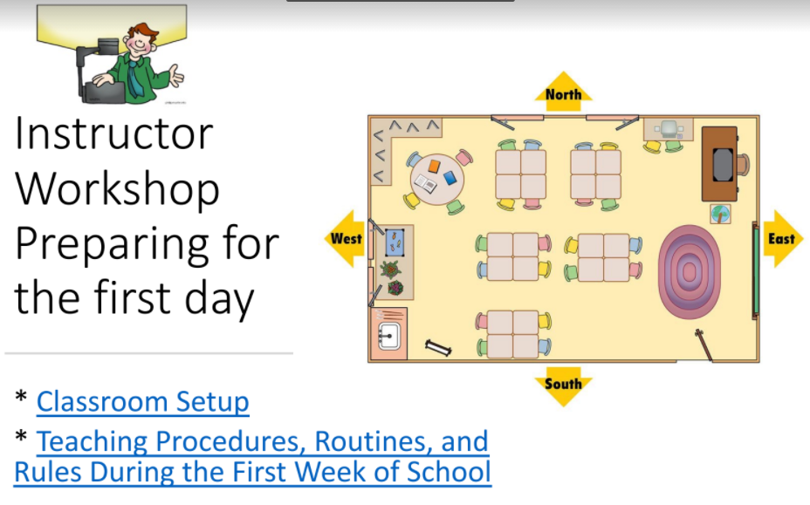 | 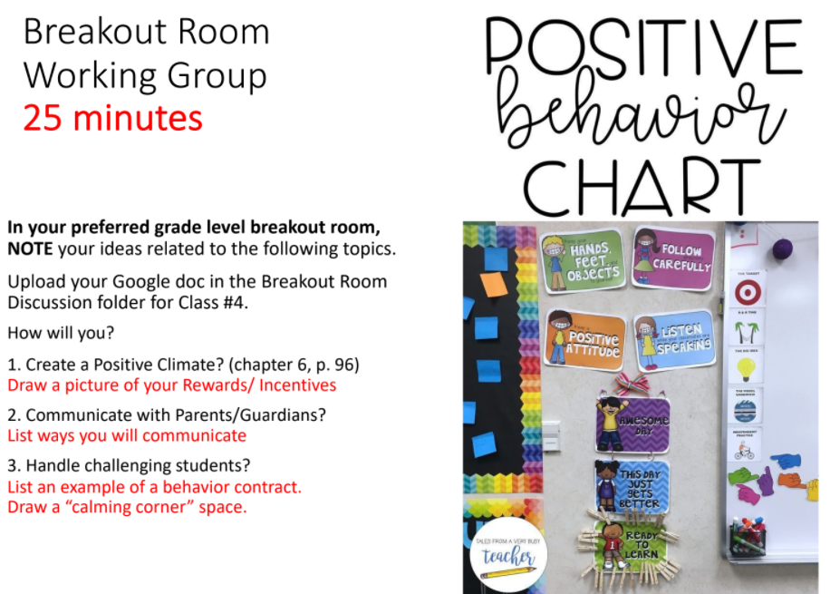 | 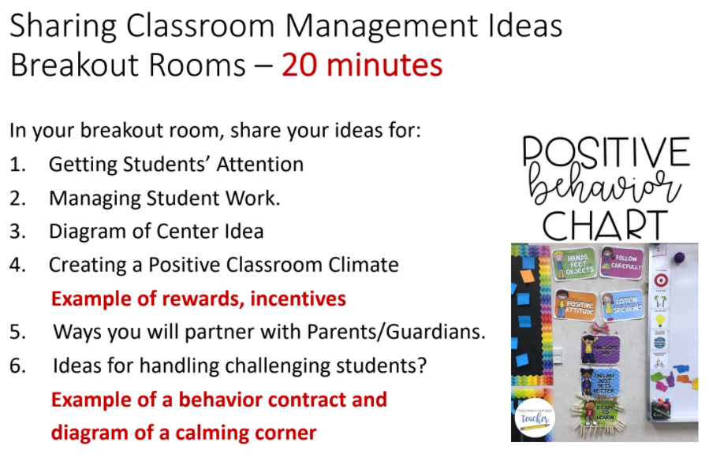
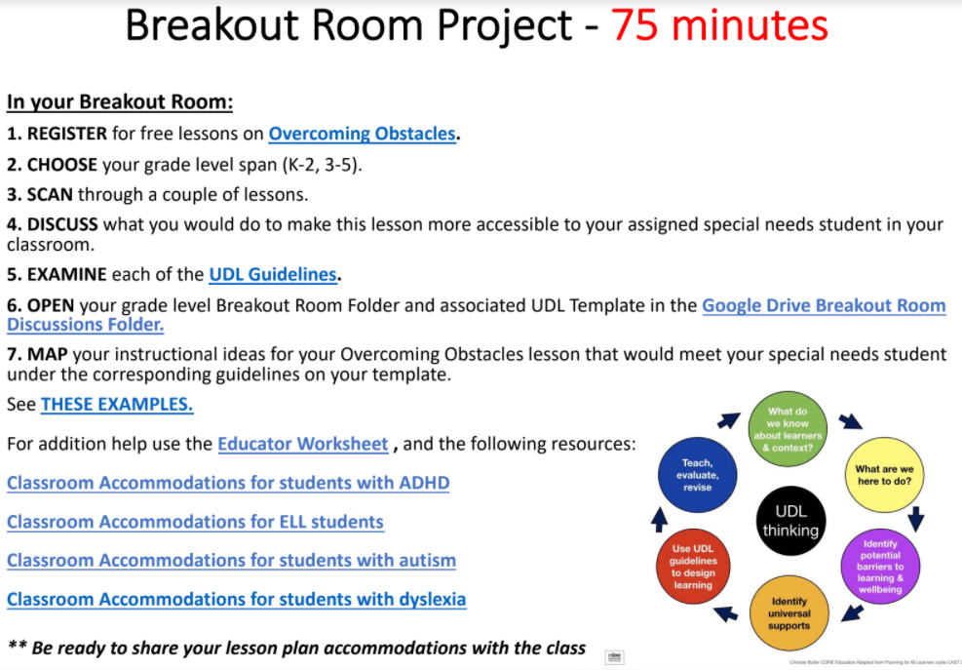 | 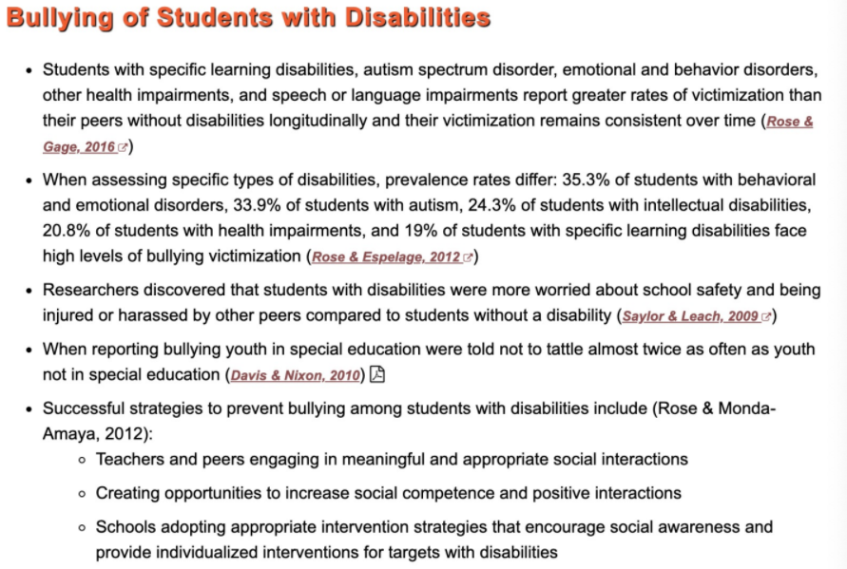 | 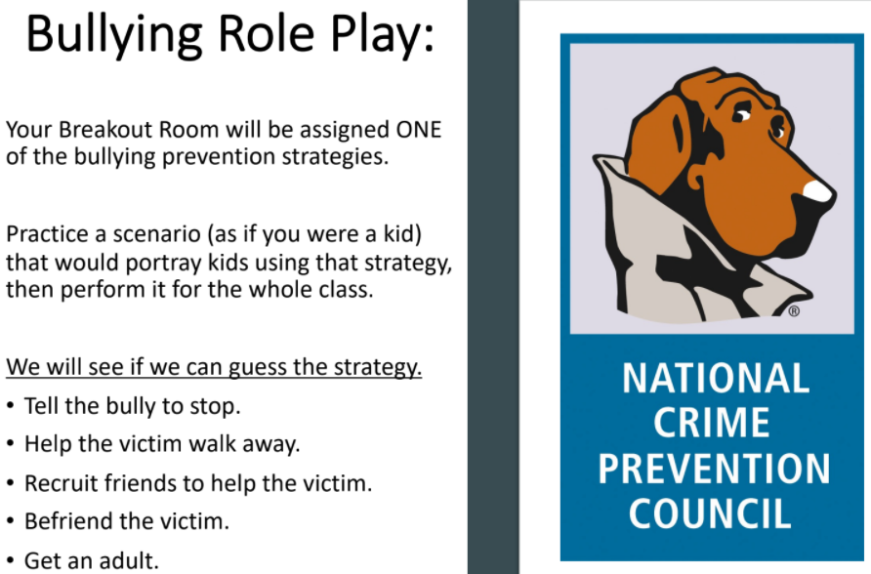

2. Modules for communication with parents and related school personnel
- An example of the instructional prompts in these modules:
  - How will you ensure person-centered/family centered planning processes, and strengths-based, functional/ecological approach aimed at students’ meaningful participation in classrooms, when they are run by standards-based curriculum, life skills curriculum, and/or wellness curriculum, and when IEP objectives are set out?
  - How will you involve parents? specifically in which strategies? Consider and build upon the following strategies.
    - Ask for parents’ insights to understand students’ learning/home environment
    - Set and calibrate expectations for student performance in consistent dialogue with parents and students.
    - Increase frequency of contacts with parents and personnel responsible for taking care of the students.
  - Whom can you reach out to offer better and multi-tiered support for your students with special needs?
  - How will you work with the community members to support access to optimal learning experiences for students with mild to moderate support needs?
  - What kind of support system do you consider your placement school has established?
  - What are ways to partner with parents who would bring lived knowledge of their children and their needs?
- Introduce MMSN TPE 2.2, 2.4, 2.10

3. Modules for designing and rearranging physical classroom spaces.
- An example of the instructional prompts in these modules:
  - Let’s imagine and visualize the physical classroom space in a way to explicitly support equitable learning opportunities for every student.
    - How do you describe ‘equitable,’ in regards to the physical classroom space?
    - Consider the students with different learning goals and experiences, including those with health/mental caring needs. How will you create the space for them?
      - Which physical components (consider your placement classroom/school) should be renovated?
      - Which physical and material components do you suggest to newly install?
      - If you identify the need for additional budgets, what would they be? With whom should you discuss the issue?
    - Present your design idea for creating equitable classroom environments. Make the idea to be present in a specific, practical, and critical way.
      - Why do the design components matter?
      - How do you expect your students to navigate the space? What does their routine look like?
- Introduce MMSN TPE 3.3, 4.3

2. Rubric applied to assessing the assignment (applied to every module)
Criteria | Ratings
Completion Rate | 15pts  100% | 10pts  90-99% | 9pts  70-89% | 7.5pts  50-69%
Quality of work completed within each module  Practice/Assess MMSN TPE 2.6, 2.7 | 15pts  Identifying the places where knowledge of and supportive practices for students with special needs can be applied into establishing classroom culture and management plans. | 10pts  Identifying in general the places where knowledge of and supportive practices for students with special needs can be applied. | 9pts  Fairly understanding and discussing knowledge of and supportive practices for students with special needs. | 7.5pts  Vaguely understanding on knowledge of and supportive practices for students with special needs.

Assignment modified 2. Professional Book Club

1. Assignment components: Book club assignment worksheet states how their book reflection will be connected to their practices.
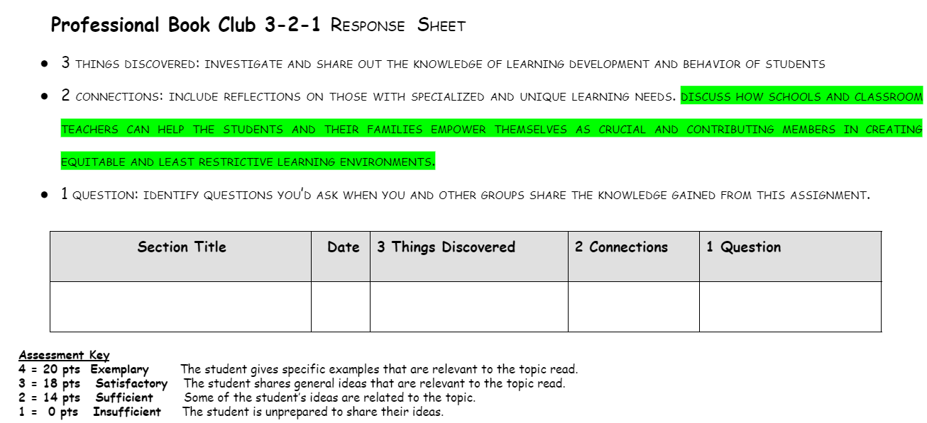

Introduce MMSN TPE 2.2, 2.4, 2.10, 3.3

2. Rubric applied to assessing the assignment

Criteria | Ratings
Completion Rate | 15pts  100% | 10pts  90-99% | 9pts  70-89% | 7.5pts  50-69%
Quality of work completed within each module  Practice/Assess MMSN TPE 2.6, 2.7 | 20 pts  Exemplary - The student gives specific examples that are relevant to the topic read, particularly taking into account the cases of an ELL student and a student with and identified disability. | 16 pts  Satisfactory  The student shares general ideas that are relevant to the topic read. | 12 pts  Sufficient  Some of the student’s ideas are related to the topic. | 8 pts  Insufficient -The student is unprepared to share their ideas.

Assignment modified 3. Classroom websites (signature assignment)

1. Assignment components: Activities, instructions, and instructional slides will integrate MMSN expectations.
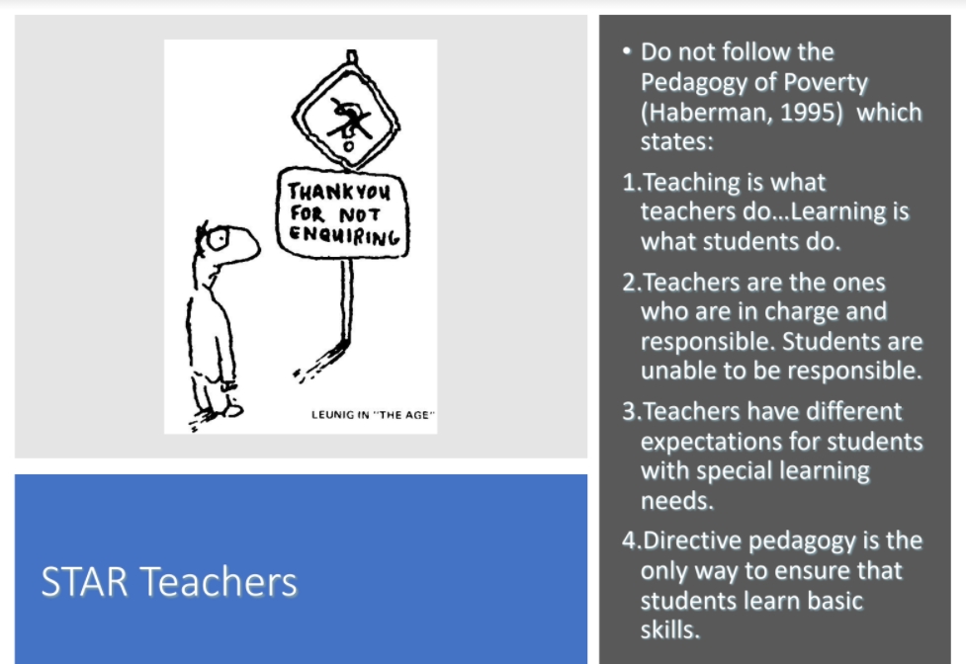 | 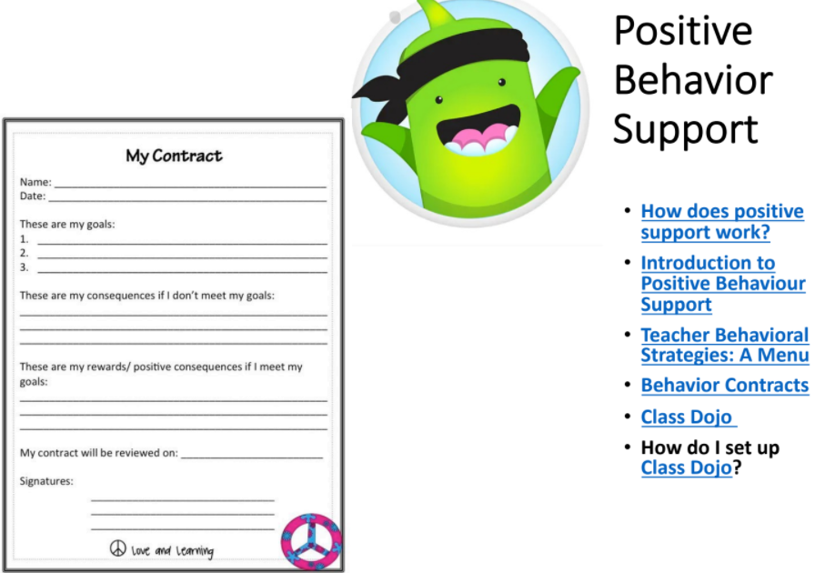 | 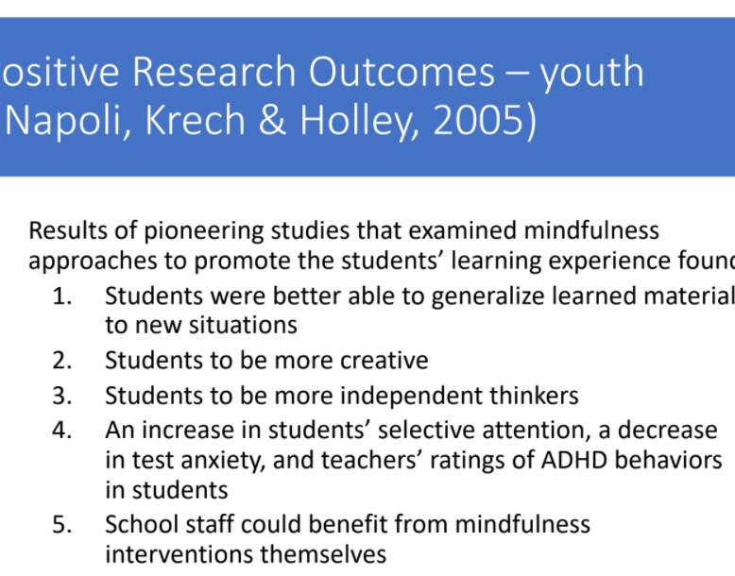
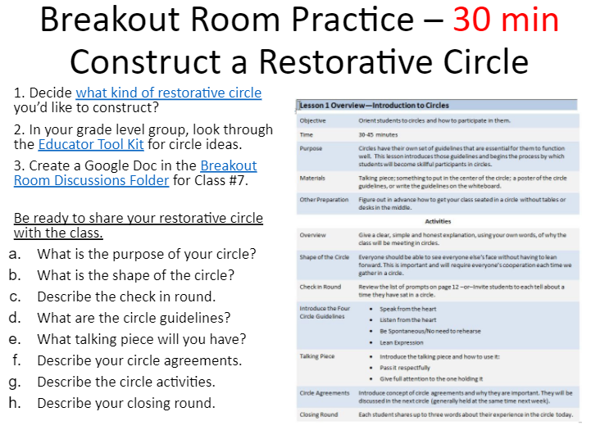 | 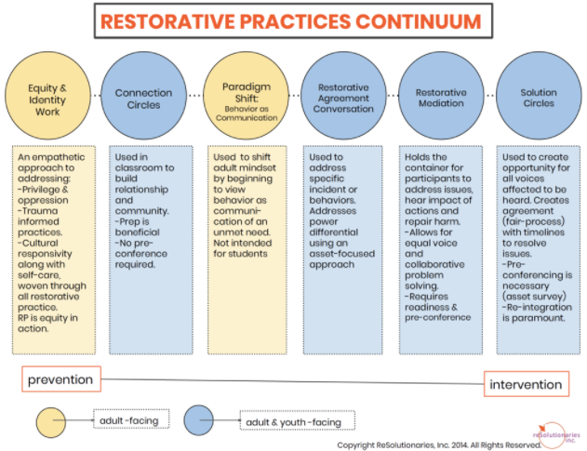 | 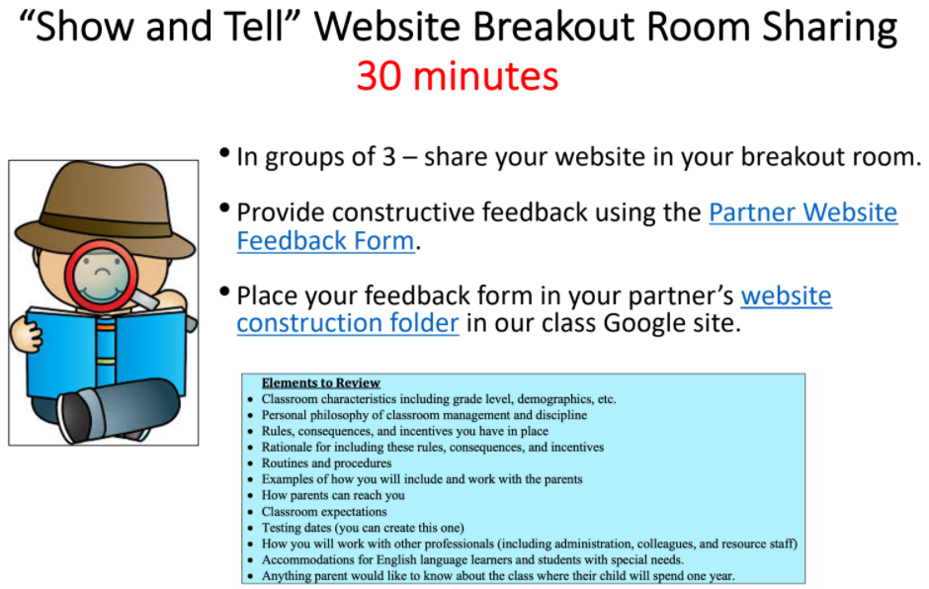

2. Rubric applied to assessing the assignment

Criteria | Ratings
Classroom  characteristics | Clearly describes grade level/subject area, number of students, demographics on more than 2 student characteristics (i.e. – % free/reduced lunch, ELL, race, ethnicity, or gender)  20 pts | Generally describes demographics on 2 student characteristics.  16 pts | Only includes grade level and number of students 12 pts | Only includes grade level  8 pts
Personal  philosophy about classroom culture and values | Clearly describes the philosophy of classroom culture and values. Includes conditions that encourage learning.  20 pts | Generally describes the philosophy of classroom culture and values.  16 pts | Minimally describes the philosophy of classroom culture and values.  12 pts | The philosophy of classroom culture and values is limited in scope and application.  8 pts
Values, rules, and routines | Clearly describes each of the rules, routines, and values that constitute your classroom culture. Include how each of the values inform rules, and then routines of students’ daily classroom lives.  20 pts | Generally describes values, rules, and routines, including each step of routines.  16 pts | Minimally describes values, rules, and routines.  12 pts | Incompletely describes values, rules, and routines.  8 pts
Working with special needs students  Introduce MMSN TPE 2.2, 2.3, 2.4, | Clearly describes adaptations for ELLs and 2 other special populations. Include specific strategies for adaptations at the level of classroom rules and routines.  20 pts | Generally describes adaptations for ELLs and 2 special populations.  16 pts | Minimally describes adaptations for ELLs and 1 special population.  12 pts | Incompletely describes adaptations for ELLs and 1 special population.  8 pts
Parent interaction  Introduce MMSN TPE 2.5, 2.10, 3.3, 4.3 | Describes 3 specific opportunities for parent partnership AND 3 methods for parent communication, including those for parents with ELL students and students in special needs.  20 pts | Describes 2 specific opportunities for parent partnership AND 2 methods for parent communication, including those for parents with ELL students and students in special needs.  16 pts | Describes 1 specific opportunity for parent partnership AND 1 method for parent communication.  12 pts | Incompletely describes specific opportunities or methods for parent communication.  8 pts
Collaboration with professionals  Practice/Assess MMSN TPE 1.7, 2.6, 2.7, 2.8 | Describes 3 specific ways to collaborate with 3 specific professionals (e.g., administrators, related service personnel in school, and community service providers), including those who will offer systems in support of ELL students and students with special needs.  20 pts | Describes 2 specific ways to collaborate with 2 specific professionals (e.g., administrators, related service personnel in school, and community service providers), including those who will offer systems in support of ELL students and students with special needs.  16 pts | Describes 1 specific way to collaborate with 1 specific professional (e.g., administrators, related service personnel in school, and community service providers).  12 pts | Incompletely describes specific ways to collaborate with professionals.  8 pts

C33. Syllabus 252

Department of Education
MATTC Program
EDUC 252 Social Foundations of Education (3 units)
Spring 20XX
Professor: Course meeting:
Office: Guadalupe Hall, Rm Classroom: ESH TBD
Phone: Office Hours: 60 min before class or by appointment
Email:

Mission and Goals of the Department of Education
Rooted in the Jesuit tradition at Santa Clara University, the mission of the Department of Education is to prepare professionals of competence, conscience, and compassion who will promote the common good as they transform lives, schools, and communities. Our core values of reflective practice, scholarship, diversity, ethical conduct, social justice, and collaboration guide both theory and practice.

Faculty, staff, and students in the Department of Education:
- Make student learning our central focus.
- Engage continuously in reflective and scholarly practice.
- Value diversity.
- Become leaders who model ethical conduct and a commitment to social justice.
- Seek collaboration with others in reaching these goals.

MS/SS Teaching Credential Program Learning Goals (PLGs)
The PLGs represent our commitment to individuals who earn their MS/SS credential at Santa Clara University. The MS/SS faculty focus on ensuring that each student will begin their teaching career ready to:

- Maximize learning for every student.
- Teach for student understanding.
- Make evidence-based instructional decisions informed by student assessment data.
- Improve your practice through critical reflection and collaboration.
- Create productive, supportive learning environments.
- Apply ethical principles to your professional decision-making

The PLGs guide our program. Therefore, all MS/SS teaching credential program course objectives are cross-referenced with the PLGs. (A fully elaborated version of the MS/SS PLGs can be found in the Teacher Candidate Handbook, Pre-Service Pathway.)

Course Description
The goal of this course is to examine the historical, social, philosophical, and legal foundations of American education. We explore the impact of these various influences on the current state of education for students with disabilities, as well as consider the future of education in a diverse society. This course provides an opportunity to reflect on our roles as educators and the manner in which we will work to improve the educational experience for all students, particularly students with disabilities.

Course Objectives
This course will develop students’ knowledge of or skills with…
 |  | DG # |  | PGL# | TPEs | MMSN  TPE #
1 | Analyze the historical, social, cultural foundations that shape education in the US | 2 |  | 1 | 1.1, 1.3, 6.7
2 | Collaboratively synthesize and critique legislation (e.g., proposition 227, Every Student Success Act [ESSA]) and policies that affect schools and teaching conditions | 5 |  | 4 | 1.1, 1.3, 1.5, 6.7
3 | Explain and interpret various structural (e.g., systemic racism) and organizational issues (e.g., assessment practices) impact schooling and educational opportunities. | 4 |  | 4 | 1.1, 1.3, | 4.1
4 | Examine educational inequities based on race, class, gender and identified learning disabilities, and evaluate the impact on student achievement and opportunities both in and out of school, particularly English Learners (ELs), students of color, and students with dis/abilities. | 3 |  | 1, 2 | 3.5, 3.6, 4.3 | 1.5, 5.1, 5.4, 5.5, 6.3, 6.4, 6.5
5 | Identify pedagogical practices that appropriately provide access to rigorous learning opportunities, foster high expectations of achievement for all students, particularly for ELs, students of color, and students with dis/abilities, and cultivate relationships with community resources within and outside of school (especially social service agencies that provide support for students with social, emotional, and/or mental health needs) | 1, 3 |  | 5 | 2.1, 2.2, 3.5, 3.6 | 1.5, 2.7, 2.9, 4.1, 4.6, 5.4
6. | Examine, analyze and reflect on personal beliefs and attitudes around gender, class, race, dis/abilities and language issues | 2 |  | 6 | 2.3; 4.3, 6.1

Required Texts

All texts will be made available via Camino.

Recommended Texts
Ladson-Billings, G. (2009). The Dreamkeepers: Successful teachers of African American children. San Francisco, CA: Jossey-Bass.
Noguera, P. A. (2008). The trouble with black boys…and other reflection on race, equity, and the future of public education. San Francisco, CA: Jossey-Bass.

Suggested Texts for Writing Improvement:
American Psychological Association (2010). Publication manual of the American Psychological Association (6th ed.). Washington, DC: American Psychological Association.

Strunk, W. & White, E. B. (2000). The elements of style (4th ed.). New York, NY: Longman.

Additional required readings will be placed on the EDUC 252/277 Social Foundations of Education K-12 Learning Management System: Camino/Canvas (https://camino.instructure.com/courses) in topical Modules.
Course Standards and Grading Policy
- All written and oral assignments must reflect graduate-level standards. As a future teacher, you must be able to model communication skills for your students.

- Attendance and participation in all class meetings is required. If you are going to be absent from class, you must email or call the instructor to inform her of your absence before the absence unless it is an emergency (e.g, death of immediate family member, serious illness or accident). In the case of an emergency, please contact the instructor within 24 hours to tell him/her the reason for your absence. You will still be responsible for all missed content and in-class work but will not receive credit for class participation.

3. Letter grades are assigned on the standard scale based upon a possible total of 200 points.

A | 94-100% | C+ | 77-79%
A- | 90-93% | C | 74-76%
B+ | 87-89% | C- | 70-73%
B | 84-86% | D+ | 67-69%
B- | 80-83% | D | 63-66%

- With regard to assignments that are completed in groups, all members of the group will receive the same grade, unless otherwise stated.

- Final grades will reflect students’ contributions (e.g., attendance, class participation, quality of presentation, ability to lead discussion groups, completion and quality of course assignments), critical thinking and ability/degree to which student integrates theory, research and practice.

- All assignments are expected to be submitted by the due date through the Camino Assignment portal. Assignments will not be accepted through any other format or means. Unless special arrangements have been made beforehand, late assignments will not be accepted. For any assignment that you receive less than a ‘B’ grade, you are welcome to resubmit the assignment based on the instructor’s feedback. Resubmissions of assignments are due by a date agreed upon by the student and instructor and must be clearly identified as a resubmission of an assignment.

Course Assessments
Grades are based on a 200-point total. The distribution of points across assignments is as follows:

Assignment  (Attendance & Participation = 50% of grade; other assignments = 50% of grade) |  | Points | TPE Alignment | MMSN TPE Alignment
1 | Attendance & Participation | 100 | 1.1, 1.3, 1.5, 2.1, 2.2, 4.3, 6.1, 6.7
2 | Literature Circles | 30 | 1.1, 1.3, 1.5, 2.1, 2.2, 4.3, 6.1, 6.7 | 1.5, 4.1, 5.1, 5.4, 5.5, 6.3, 6.4, 6.5
3 | Reflection Paper | 30 | 1.1, 1.3, 2.1, 2.2, 3.5, 3.6, 4.3 | 1.5, 4.1, 5.1, 5.4, 5.5, 6.3, 6.4, 6.5
4 | Collaborative Community Study  (signature assignment) | 40 | 2.1, 2.2, 3.5, 3.6, 4.3, 6.1 | 1.5, 2.7, 4.1, 4.6 5.1, 5.4, 5.5, 6.3, 6.4, 6.

1. Attendance and Participation
Being present in class, participating in class, and being on time to class is vital to your learning and to the learning of others. For that reason, please make arrangements to attend all classes as scheduled for the quarter and to be on time for class. You are required to sign in for class on the sign in sheet at the beginning of class and complete a critical incident at the end of each class that will be available from the instructor. Your signature on the sign in sheet and completion of the critical incident at the end of class will ensure that you receive credit for the class periods that you attend and in which you participate. Extenuating circumstances (e.g., severe illness, death of a close family member) may result in the need for a class absence or being late. Please contact the course instructor prior to the absence via an email or a phone call so that your absence will be noted. If there is an emergency and it is not possible to contact the instructor prior to class, you are responsible to contact the instructor within 24 hours by email or phone to let her know why you were absent from class. Please be sure to review the course materials in the Module for the missed class in Camino for the date of the class.

Please Note:
Data documenting your adherence to the policies listed here are gathered by your instructor through ongoing observation and documentation.

If an instructor has reason to feel you are not meeting all the expectations spelled out below, s/he will contact you privately to discuss the issue, to clarify the expectations as needed, and to offer his/her support in helping you reach those expectations. If your instructor does not contact you with a concern, you can assume you are satisfying these requirements. However, if you would like specific feedback on your professional conduct during the quarter, you are welcome to contact your instructor at any time and s/he will be glad to share his/her assessment with you.

As we will read about and study in this course, everyone’s learning is enhanced by the quantity and quality of the interactions in the learning environment. Hence, your participation in whole class discussions, group work and pair group is essential for the success of this course.

While a class is in session, you should not engage in any activity not directly related to what is taking place in the classroom. Instructors reserve the right to ask you to close your laptop or put away some other form of technology at their discretion; when/if this occurs, please respond quickly and without protest to avoid further disruption of the class’s learning. Instructors also reserve the right to ignore your inappropriate use of technology in class and simply deduct points from your final grade. If you would like more detailed clarification about the expectations regarding appropriate and inappropriate in-class technology use, please feel free to contact your instructor for further information.

2. Literature Circles (LC) (Practice and Assess MMSN TPEs 1.5, 4.1, 5.1, 5.4, 5.5, 6.3, 6.4, 6.5)
A common book discussion routine used in reading programs is the Literature Circle-an instructional approach where students come together in small temporary groups formed by book choice that meet on a regular and predictable schedule to (re)read and discuss readings. Students use notes to guide both their reading and discussion and this discussion is generated by students. The teacher’s role in literature circles is that of facilitator.

Each student will be responsible to lead 1 Literature Circle on the readings. Your handout should outline the assigned readings with the asterisked headings listed below under the Handout Components heading. You should collaborate with LC group on the LC handout, and you will be responsible for facilitating a LC and for uploading the handout under Assignments in Camino (to receive credit). The Literature Circle Discussion Format outlines how the literature circle would unfold. Please bring 6 copies of your LC handout so you can share them with your LC discussion group. Be creative on how you want to facilitate the discussion around the main ideas of the article.

Handout Components | Literature Circle Discussion Format
*Author’s Message. To zero in on the topic for discussion, write down your version of the author’s main message. Include 1 quote that was memorable for you. | Allocation of Time. Budget time taking into consideration the number of themes from the reading that must be discussed.
*Definition of terms. List all the words of which you are unsure and define them in your own words (include examples where appropriate) | Discussion of Major Themes and Subtopics. During discussion of text recall that you are discussing what the author had to say (e.g., what influences can be attributed to his/her thoughts? what does the author say are limitations or strengths?)  Be creative on how your group wants to facilitate the discussion on the assigned reading.
*Integration of Material with other Knowledge. It is a well-documented fact of learning theory that unassociated facts are difficult to recall. Make connections of the learning in the assignment to ideas/concepts acquired in previous meetings or other learning situations. How do these ideas parallel or contradict other theories or readings you have done? | As a group create an image, quote or other form that captures your group’s understanding of the reading.  Feel free to be creative on how you want to present/share/engage around the main ideas.
*Application of the Material. Make a conscious effort to assess the possible applications and implications of the material to learning settings. How might these notions help shape your pedagogy? Bring to class a tangible instructional connection (e.g., book, lesson from curricula, video).

3. Reflection Research Paper. Practice and Assess MMSN TPEs 1.5, 4.1, 5.1, 5.4, 5.5, 6.3, 6.4, 6.5)
This 5-page reflection and research paper requires you to consider your own experiences as a student. How do you think class, gender, language, race, religion, sexual orientation, immigrant status, and/or disability have influenced your experience as an elementary, middle or high school student? Choose two of the above aspects of your identity to write about in depth (with concrete examples), and integrate readings (i.e., literature/research) from class and other classes to consider how school has shaped/influenced these identity markers. In writing your paper, consider the privileges and/or disadvantages of each aspect you choose. Privileges can serve to distance you from your students or can be used to empower them. Keep in mind that this is a graduate level paper and the expectations for writing are to follow APA (2010) and Strunk and White (2000).

4. Collaborative Community Study. (Practice and Assess MMSN TPEs 1.5, 2.7, 4.1, 4.6 5.1, 5.4, 5.5, 6.3, 6.4, 6.5)
Enacting Culturally Responsive Pedagogy requires an understanding of the communities where the students of teachers live and make their curricula relevant to students’ lives outside of school. This community study will allow you to better understand the communities around you. In groups and in lieu of the week 8 regularly scheduled meeting time, you will speak with members of the school community (e.g., students, families of students, staff, etc.), visit with a member of one external community organization (e.g., minister at a house of worship, director of YMCA, local shop owners, etc.), and connect with a member of a social service agency that provides support for students (particularly those with exceptionalities) with social, emotional, and/or mental health needs.

While you will have some input into the community you will visit, challenge yourself to move beyond your comfort zone to explore a community you are unfamiliar with. When you conduct the community visit, please exercise caution, traveling in groups and walking around the neighborhood during daylight hours whenever possible.

The questions to guide your community study include:

- Where is this neighborhood? What are the demographics of this neighborhood? Language(s) spoken?
- What are the community’s assets that support and enhance the healthy development of the youth that live there?
- What community resources exist to meet students’/ families’ social, emotional, psychological, and/or spiritual needs?
- What are the community's concerns regarding the development (academic, social, emotional) of youth from the community?
- What do members of this urban community expect teachers to do in their classrooms to be effective, thoughtful practitioners?
- What are the implications of your findings on what you will do as a teacher in the classroom? What will you take away from this experience?
- Based on your interactions with community members, describe the structural inequalities that appear in the community and threaten the opportunities of youth from the community? Pay particular attention to inequalities relate to race, gender, identified dis/ability, sexual orientation, and language.

Your small group will present your findings on the last day of class. Think creatively about how you will present this information. A few ideas: Power point presentation, film, digital story. In your 10-minute multi-media presentation address the questions detailed above and ensure every group member participates. Your grade for the collaborative community study will be based on a group grade for the presentation.

Rubric for Collaborative Community Study
Criteria | Meets or Exceeds Expectations | Approaches Expectations | Shows Emerging Understanding
Neighborhood Demographics | Clearly and thoroughly identifies the racial, socioeconomic, and linguistic demographics of the neighborhood. | Somewhat clearly identifies the racial, socioeconomic, and linguistic demographics of the neighborhood. | Vaguely identifies the racial, socioeconomic, or linguistic demographics of the neighborhood.
Community Assets | Clearly and thoroughly identifies multiple various community assets that support the healthy development of youth. | Clearly identifies 1-2 community assets that support the healthy development of youth. | Vaguely identifies (or omits mention of) a community asset that supports the healthy development of youth.
Community Social Services | Clearly and thoroughly identifies multiple social services that provide support for students (particularly those with exceptionalities) with social, emotional, and/or mental health needs | Clearly identifies 1-2 social services that provide support for students (particularly those with exceptionalities) with social, emotional, and/or mental health needs | Vaguely identifies (or omits mention of) a social service that provide support for students (particularly those with exceptionalities) with social, emotional, and/or mental health needs
Community Concern | Clearly and thoroughly discusses any concerns that community members have regarding the academic, social, and/or emotional development of youth | Discusses in fair detail any concerns that community members have regarding the academic, social, or emotional development of youth | Vaguely discusses (or omits discussion of) any concerns that community members have regarding the academic, social, or emotional development of youth
Expectations for Teaching | Clearly and thoroughly discusses community members’ expectations for effective teaching in the school | Discusses in fair detail community members’ expectations for effective teaching in the school | Vaguely discusses (or omits discussion of) community members’ expectations for effective teaching in the school
Application | Clearly and thoroughly identifies multiple ways that the newly gained knowledge will be leveraged for culturally sustaining and/or SEL supportive teaching | Clearly identifies 1-2 ways that the newly gained knowledge will be leveraged for culturally sustaining and/or SEL supportive teaching | Vaguely identifies (or omits mention of) how newly gained knowledge will be leveraged for culturally sustaining and/or SEL supportive teaching
Structural Inequities | Clearly and thoroughly describes the structural inequalities that appear in the community and threaten the opportunities of youth from the community | Describes in fair detail structural inequalities that appear in the community and threaten the opportunities of youth from the community | Vaguely describes (or omits discussion of) structural inequalities that appear in the community and threaten the opportunities of youth from the community

Academic Integrity
Academic Integrity Pledge
The Academic Integrity pledge is an expression of the University’s commitment to fostering an understanding of -- and commitment to -- a culture of integrity at Santa Clara University. The Academic Integrity pledge, which applies to all students, states:
I am committed to being a person of integrity. I pledge, as a member of the Santa Clara University community, to abide by and uphold the standards of academic integrity contained in the Student Conduct Code
Students are expected to uphold the principles of this pledge for all work in this class.

The University is committed to academic excellence and integrity. Students are expected to do their own work and to cite any sources they use according to the rules for citation in the 6th Edition of the Publication Manual of the American Psychological Association (APA, 2010). A student who is guilty of dishonest acts in an examination, paper, or other required work for a course, or who assists others in such acts, will receive a grade of F for the course. In addition, a student guilty of dishonest acts will be immediately dismissed from the University. Students that violate copyright laws, including those covering the copying of software programs, or who knowingly alter official academic records from this or any other institution, are subject to disciplinary action (SECP Graduate Bulletin, 2016-2017).

Additional Information
Disabilities Resources

If you have a disability for which accommodations may be required in this class, please contact Disabilities Resources, Benson 216, http://www.scu.edu/disabilities as soon as possible to discuss your needs and register for accommodations with the University. If you have already arranged accommodations through Disabilities Resources, please discuss them with me during my office hours. Students who have medical needs related to pregnancy may also be eligible for accommodations.

While I am happy to assist you, I am unable to provide accommodations until I have received verification from Disabilities Resources. The Disabilities Resources office will work with students and faculty to arrange proctored exams for students whose accommodations include double time for exams and/or assisted technology. (Students with approved accommodations of time-and-a-half should talk with me as soon as possible). Disabilities Resources must be contacted in advance to schedule proctored examinations or to arrange other accommodations. The Disabilities Resources office would be grateful for advance notice of at least two weeks. For more information you may contact Disabilities Resources at 408-554-4109.

Accommodations for Pregnancy and Parenting

In alignment with Title IX of the Education Amendments of 1972, and with the California Education Code, Section 66281.7, Santa Clara University provides reasonable accommodations to students who are pregnant, have recently experienced childbirth, and/or have medically related needs. Pregnant and parenting students can often arrange accommodations by working directly with their instructors, supervisors, or departments. Alternatively, a pregnant or parenting student experiencing related medical conditions may request accommodations through Disability Resources.

Santa Clara University upholds a zero-tolerance policy for discrimination, harassment and sexual misconduct. If you (or someone you know) have experienced discrimination or harassment, including sexual assault, domestic/dating violence, or stalking, I encourage you to tell someone promptly. For more information, please consult the University’s Gender-Based Discrimination and Sexual Misconduct Policy at http://bit.ly/2ce1hBb or contact the University's EEO and Title IX Coordinator, Belinda Guthrie, at 408-554-3043, bguthrie@scu.edu. Reports may be submitted online through https://www.scu.edu/osl/report/ or anonymously through Ethicspoint https://www.scu.edu/hr/quick-links/ethicspoint/

Course Meeting | Course  Topics | Course  Readings | Course  Assignments
1 | Introductions  Purpose of Schooling  (Part 1)  Online Class | ONLINE COURSE – SEE CAMINO SITE  Before Reading, jot down your thoughts about what you think the purpose of schooling should be. Return to your response after you read the chapters.  Oaks, J., Lipton, M., Anderson, L. & Stillman J. (2013). Teaching to change the World. Chapter 2. History & Culture: How Expanding Expectations and Powerful Ideologies Shape Schooling in the US. (Access via SCU library: https://sculib.scu.edu/record=b2824785) | Due by 11:00pm Sunday 4/7/19 pm on Camino:  Answer Questions on Discussion Post and Respond to One of Your Classmates
2 | Purpose of Schooling  (Part 2)  &  Structural Variables Impacting Education: Historical, Economic, Sociopolitical | ESSENTIAL QUESTIONS: What systemic issues influence students’ experiences in school?  Editorial Projects in Education Research Center. (2011, July 7). Issues A-Z: Achievement Gap. Education Week. http://www.edweek.org/ew/issues/achievement-gap/  Ladson-Billings, G. (2006). From the achievement gap to the education debt: Understanding achievement in U.S. schools. Educational Researcher, 35(7), 3-12.  Gutierrez, R. (2008). Gap Gazing Fetish. Journal for Research in Mathematics Education, 38(4), 357-364.  Pak, K., & Parsons, A. (2020). Equity gaps for students with disabilities. Penn GSE Perspectives on Urban Education, 17. Introduce & Practice MMSN TPE 5.1, 6.3, 6.4, 6.5
3 | Legislations and Policies of Education | Before Reading, jot down the education policies, legislations you are familiar with (e.g., NCLB; Brown v. Board of Education). Return to your response after you read. Prepare to share with the Literature Circle Group.  Oaks, J., Lipton, M., Anderson, L. & Stillman J. (2013). Teaching to change the World. Chapter 4. Policy and Law: Rules That Schools Live By (Access via SCU library: https://sculib.scu.edu/record=b2824785)  National Council on Disability. (2018). IDEA series: The segregation of students with disabilities. Washington, D.C. https:// ncd.gov/sites/default/files/NCD_Segregation-SWD_508.pdf Introduce & Practice MMSN TPE 5.1, 6.3, 6.4, 6.5
4 | Structural Variables Impacting Education: Tracking, School Choice, and Health Care Access | Before Reading, think back to your schooling experience. What “track” or group do you recall being placed in? What impact did this have on you? Return to your response after you read. Prepare to share in class.  Oaks, J., Lipton, M., Anderson, L. & Stillman J. (2013). Teaching to change the World. Chapter 10. School Structure: Sorting Students and Opportunities to Learn (Access via SCU library: https://sculib.scu.edu/record=b2824785)  * Ravitch, D. (2016) The Death and Life of the Great American School System. Chapter 7. Choice: The Story of an Idea.  American Federation of Teachers. (2009). The medically fragile child: Caring for children with special health care needs in the school setting. Washington, DC: AFT. [Ch. 1] Introduce MMSN TPE 2.7, 5.4, 5.5  Handout for Santa Clara County Mental Health Services (see appendix)  Center for Disease Control & Prevention. (2021). Improving access to children’s access to mental health services. Accessed from: https://www.cdc.gov/childrensmentalhealth/access.html Introduce MMSN TPE 2.7 | Literature Circles Leaders Group A
Course Meeting | Course  Topics | Course  Readings | Course  Assignments
5 | Cultural Frames of Reference | Before Reading, jot down the knowledge base that exists within your family and/or community. What are the skill sets that exist that you think teachers could use to extend student understanding? Return to your response after you read. Prepare to share in class.  Pollock, M. (2008). Everyday antiracism: Getting real about race in school. pgs. 293-308  *Moll, L. C., Amanti, C., Neff, D. & Gonzalez, N. (1992). Funds of Knowledge for Teaching: Using a Qualitative Approach to Connect Homes and Classrooms. | Literature Circle Leaders: Group B
6 | Immigration, Language & Education | Before you read, think back to the educational (or travel) experiences you have had outside of the US. What was difficult for you? What did you wish knew before arriving in the host country? Write down your thoughts. Return to your response after you read. Prepare to share in class.  Pollock, M. (2008). Everyday antiracism: Getting real about race in school. pgs. 97-111  * Suárez-Orozco, C., Suárez-Orozco, M. M., & Todorova, I. (2009). Learning a new land. Chapter 2. Networks of Relationships  Counts, J., Katsiyannis, A., & Whitford, D. K. (2018). Culturally and linguistically diverse learners in special education: English learners. NASSP Bulletin, 102(1), 5-21.  Introduce & Practice MMSN TPE 2.9, 4.1, 5.4, 5.5 | Literature Circle Leaders: Group C  Due: 11pm day before class. Reflection/Research Paper on Camino  Bring a hard or electronic copy to share in class
7 | Teaching for Social Justice - Multilingualism & Cultural Diversity | Before you read, reflect a bit about what it means to you to teach for social justice? Write down your thoughts. Return to your response after you read. Prepare to share in class.  Love, Bettina. (2019). Dear White Teachers: You Can't Love Your Black Students If You Don't Know Them. Education Week.  Ladson-Billings (2009). Chapter 3.  * Ladson-Billings (2009). Chapter 4  Annamma, S. A., Connor, D., & Ferri, B. (2013). Dis/ability critical race studies (DisCrit): Theorizing at the intersections of race and dis/ability. Race Ethnicity and Education, 16(1), 1–31. https://doi.org/10.1080/13613324.2012.730511 (excerpts) Introduce MMSN TPE 2.9  In preparation for field work interviews:  Hollingsworth, H. L. (2001). We need to talk: Communication strategies for effective collaboration. Teaching Exceptional Children, 33(5), 4-8. Introduce & Practice MMSN TPE 2.7, 4.6  Sears, J. A., Peters, B. L., Beidler, A. M., & Murawski, W. W. (2021). Using relationships to advocate with, for, and to families. TEACHING Exceptional Children, 53(3), 194-204. Introduce & Practice MMSN TPE 1.5 | Literature Circle Leaders: Group D
8  (Week of May 20th) | Field Work | We will not meet on this day, but you will use this day to interview community members, take pictures and create a plan as to how teachers might team up with the community to optimize learning for all students.
9 | Enacting Culturally Responsive and Sustaining Teaching | Before you read, jot down what you think “culture” means. Revisit your response after you read. Prepare to share in class.  Pollock, M. (2008). Everyday antiracism: Getting real about race in school. pgs. 217-234  * Paris, D. (2012). Culturally sustaining pedagogy: A needed change in stance, terminology, and practice. Educational Researcher, 41(3), 93-97. ○  * Ladson-Billings, G. (2014). Culturally relevant pedagogy 2.0: aka the remix. Harvard Educational Review, 84(1), 74-84. | Be prepared to share video and readings in small groups  Literature Circles Leaders: Group E
10 | Collaborative Community Project Presentations & Course Conclusion | Due: Collaborative Community Project
Appendix – Handout of Santa Clara County Mental Health Resources

C3. Syllabus 251

Department of Education
MATTC
EDUC 251 (MS) (3 units)
Technology for TK-12 Teachers
[Term]
Modality:

Professor: (Pronouns: ) https://www.mypronouns.org/
Physical Office: Guadalupe Hall
Virtual Office: Anywhere!
Office Hours: Wednesday 10 a.m. – 12:00 p.m. and by appointment
Email:

Mission and Goals of the Department of Education
Rooted in the Jesuit tradition at Santa Clara University, the mission of the Department of Education is to prepare professionals of competence, conscience, and compassion who will promote the common good as they transform lives, schools, and communities. Our core values of reflective practice, scholarship, diversity, ethical conduct, social justice, and collaboration guide both theory and practice.

Faculty, staff, and students in the Department of Education:
- Make student learning our central focus
- Engage continuously in reflective and scholarly practice
- Value diversity
- Become leaders who model ethical conduct and a commitment to social justice
- Seek collaboration with others in reaching these goals

MS/SS Teaching Credential Program Learning Goals (PLGs)
The PLGs represent our commitment to individuals who earn their MS/SS credential at Santa Clara University. The MS/SS faculty focus on ensuring each student will begin their teaching career ready to:
- Maximize learning for every student.
- Teach for student understanding.
- Make evidence-based instructional decisions informed by student assessment data.
- Improve your practice through critical reflection and collaboration.
- Create productive, supportive learning environments.
- Apply ethical principles to your professional decision-making

The PLGs guide our program. Therefore, all MS/SS teaching credential program course objectives are cross-referenced with the PLGs. (A fully elaborated version of the MS/SS PLGs can be found in the Teacher Candidate Handbook, Pre-Service Pathway.)

Course Description
This course is designed to acquaint teacher credential candidates with learning theories, practices, hardware, software applications, and web resources that are useful in integrating technology (including assistive technology) into the daily practice of K-12 teachers, whether working in-person or online. The course meets the requirements identified in the technology standard for teacher preparation for the State of California. The guiding philosophy for the course is Constructivism, instantiated in the design of collaborative, project-based learning activities that capitalize on the full potential of educational technologies. Students will be expected to fully engage in virtual classroom exercises, group projects, and small-group and whole-class discussions on the assigned readings and activities.

Course Learning Objectives
By the end of this course, students will… |  |  |  | Standard/Goals Addressed
 |  |  | DG # |  | PLG # | TPE# | MMSN  TPE #
1 | … Know how to integrate constructivist learning principles into their designs of meaningful and authentic learning experiences for all their students. |  | 1 |  | 1, 5 | 1.1, 3.8
2 | … Know how to design learning experiences that enhance student achievement through meaningful use of technology |  | 1 |  | 2 | 2.2, 3.8
3 | … Know how to choose from a variety of media types (text, graphics, audio, video, web) to make student learning visible |  | 1, 3 |  | 2, 5 | 1.7, 3.4
4 | … Demonstrate they can develop and monitor students’ ability to communicate, collaborate, create, and think critically through effective and appropriate use of technology tools including the ability to use assistive technology, augmentative and alternative communication (AAC) |  | 1, 5 |  | 1, 4 | 2.2, 3.7 | 2.2, 2.3, 4.1
5 | …Know how to identify and use appropriate technology tools that support the design and interpretation formative and summative assessments of student learning, including rubrics and electronic portfolios that develop accommodations and modifications that incorporate assistive technology |  | 4 |  | 3 | 1.8, 4.3, 5.1 | 1.1, 1.2,2.1, 2.9, 3.1
6 | … Explain of the value of coding (programming) for students’ development of thinking and problem-solving skills |  | 1 |  | 2 | 4.8
7 | … Identify and use in their lesson/unit designs, appropriate technology tools, and resources, informed by the Universal Design for Learning (UDL) framework, to address the learning needs of all students, including unique learning, sensory and access needs of students with physical/orthopedic disabilities, other health impairments, and multiple disabilities |  | 1, 3, 4 |  | 1 | 1.6, 3.6, 4.4, | 2.9, 3.1, 5.2
8 | … How to apply the TPACK model (Technological Pedagogical Content Knowledge) to plan their own professional development |  | 2 |  | 4, 6 | 6.3
9 | … Demonstrate to students the responsible use of technology, awareness of safety and security issues when using technology, basic knowledge of copyright laws and why they are important, and the social, psychological, and ethical issues surrounding the role of technology in society |  | 4 |  | 2, 6 | 3.7
10 | … Design and create an electronic portfolio that showcases their knowledge and skills, including the ability to integrate the CA Common Core State Standards into their lessons/units |  | 1, 3, 4 |  | 2, 4, 6 | 1.1, 2.2, 3.4, 4.3, 5.1, 6.3
 |  | *DG=Department Goals; PLG=Program Learning Goal; TPE=Teaching Performance Expectation Standard; TPA=Teaching Performance Assessment

Required Text

- Gonzalez, J. (2020). The teacher’s guide to tech 2020. Cult of Pedagogy [online]. Available at: https://teachersguidetotech.com/guide/ ($25)

Recommended Texts
- Grant, K., & Perez, L. (2018). Dive into UDL. Immersive Practices to Develop Expert Learners. Portland, OR: International Society for Technology in Education. Available at https://id.iste.org/resources/product?id=4112&format=Book&name=Dive+into+UDL ($35.99)
Dell, A. D., Newton, D. A., Petroff, J. G. (2017). Assistive Technology in the Classroom: Enhancing the School Experiences of Students with Disabilities. NY: Pearson. MMSN TPEs (Practice/Assess TPE 2.9, Practice/Assess TPE 3.1, Practice/Assess TPE 5.2)

Course Activities and Assignments

Course Activities and Assignments |  |  | %  Weight | TPE  Assessed | MMSN
1 | Weekly Online Discussions  Purpose: Reflection, Critical Thinking, Application, Community Building | 15 |  | 6.2 | 4.1
2 | Weekly Synchronous and Asynchronous Learning Experiences  Purpose: Practice with new tools & resources, Collaboration, Community Building | 15 |  | 2.2, 3.6, 4.8, 3.7 | 2.1
3 | Group Curriculum Assignment  Purpose: Collaborating with a small group of peers to develop a curriculum that includes technologies and pedagogies introduced in the course, as well as adaptations and modifications informed by UDL for ELs and students with identified disabilities. | 30 |  |  | 1.1, 1.2, 2.9, 3.1, 4.1, 5.2
3 | Signature Assignment: Course ePortfolio  Purpose: Creation, Synthesis, Practice, Reflection, Planning for Self-Driven Professional Learning | 40 |  | 6.3, 6.1, 3.8 | 5.2

1. Weekly Discussions. Every week, you will post replies to the questions posed (e.g., How does IDEA define an Assistive technology device? What are some examples you have seen at your placement?) MMSN TPEs ( Introduce/PracticeAccess TPE 4.1)
by the instructor in the online Discussions forum in Camino. In addition, you will have to post a reply to at least one of your peers’ postings each week. Postings must adhere to the provided guidelines for meaningful and respectful participation in online discussions. Each weekly posting and reply is worth three points as shown in the Discussions Rubric.
Discussions Rubric
Criteria | 3 Points | 2 Points | 1 Point | 0 points
Weekly Discussion Postings and Replies | On Time Posting and at least one Reply | On Time Posting and no Reply | Late Posting and no Reply | No Posting and no Reply

2. Weekly In-Class Multimedia Learning Experiences. Every week, you will be introduced to a variety of learning applications (see examples below). You will collaborate on the design of grade level or content learning activities that enhance student achievement through meaningful use of technology.
- Podcast. Working in teams of two, you will create a 5-minute podcast on a topic agreed upon with the instructor, connected to the assigned readings and other activities
- Video. Working in teams of three, you will script and produce a 3-minute video on a topic agreed upon with the instructor, focused on a time-dependent process, procedure, or phenomena. A project checklist and storyboard template will be provided.
- Self-directed Professional Development plan. You will create a document that outlines your personal and professional development plan following the TPACK model (Technological Pedagogical Content Knowledge).

- Group Curriculum Project. Working in subject matter teams, groups will develop a curriculum design and build on it throughout the quarter (e.g., identify appropriate assessments, develop a rubric, consider “gamifying” the learning activities or including a game or simulation as part of it, define accommodations for one or more categories of students with special needs based on the Universal Design for Learning (UDL) framework. Please refer to the Group Curriculum Assignment Description document available in Camino.
MMSN TPEs ( Practice TPE 1.1, Practice TPE 2.1, Practice/Assess TPE 2.9, Practice/Assess TPE 3.1, Practice/Assess TPE 4.1,Practice/Assess TPE 5.2)

4. Signature Assignment—Course ePortfolio. You will create and submit an individual “ePortfolio” document that incorporates at least four or more examples of the work products generated in class—both alone and in group projects, such as Podcasts or QuickTime movies—as well as links to other products (files, websites) that cannot be integrated directly. A detailed rubric will be provided.
The ePortfolio document will be created as a PowerPoint, Keynote, Google Slides Presentation, or website. Students have full creative control over the design and content of their ePortfolio document.
ePortfolio Requirements include:
- Design of learning experiences that enhance student achievement through meaningful use of technology that address the unique learning, sensory and access needs of students with physical/orthopedic disabilities, other health impairments, and multiple disabilities
- Know how to choose from a variety of media types (text, graphics, audio, video, web) to make student learning visible including the use assistive technology, augmentative and alternative communication (AAC)
- Articulate how you are able to monitor students’ ability to communicate, collaborate, create, and think critically through effective and appropriate use of technology tools
- Demonstrate that you know how to identify and use in your lesson/unit designs appropriate technology tools and resources, informed by the Universal Design for Learning (UDL) framework, to address the learning needs of all students including developing accommodations and modifications that incorporate assistive technology
- Show multiple examples of your ability to integrate the California Common Core State Standards into your lessons/units
- Demonstrate your ability to apply the TPACK model (Technological Pedagogical Content Knowledge) to plan your own professional development
Please review the detailed assignment description and the ePortfolio rubric for additional details about expectations.
In addition: Class activities and discussions. Students will work individually and collaborative in class to apply various pedagogical approaches to the design of learning activities that incorporate technologies. Students will engage in class discussions on current education issues and topics from homework readings.

4. Final. The final for the class will meet on the 11th session of the course during Finals Week. The final will include short presentations for each student’s ePortfolio in small groups and application of the electronic peer review process within Camino to two fellow students’ ePortfolios.

Assessments & Grading Criteria

1. All written and oral assignments must reflect graduate-level standards. As a future teacher, you must be able to model excellent communication skills for your students.

2. Attendance and participation in all class meetings are required. If you are going to be absent from class, you must email or call me prior to the start of class to inform me of your absence. You will still be responsible for all missed content and in-class work.

3. Grades are assigned based on 110-point total. The distribution of points across assignments is as follows:
Assignment |  | Points
1 | Weekly Online Discussions & Homework Assignments | 30
2 | Weekly In-Class Synchronous and Asynchronous Activities | 30
3 | Group Curriculum Project MMSN TPEs ( Practice TPE 1.1, Practice TPE 2.1, Practice/Assess TPE 2.9, Practice/Assess TPE 3.1, Practice/Assess TPE 4.1,Practice/Assess TPE 5.2) | 50
4 | *Course ePortfolio | 50
* Key Assignment

Course Grading Criteria
The following grading rubric will be used to assess your class performance:
Exceeds expectations = **A Meets expectations = *B Below standards = C Unacceptable = D

** In order to earn an A on an assignment or project, a candidate’s independent, unassisted performance/product must clearly, consistently, and convincingly demonstrate high levels of proficiency in all aspects of the skills assessed. The performance/product must go beyond completion and accuracy by demonstrating strong evidence of original, creative thought and/or sophisticated insight into the students and the context.
* A candidate earns a B when s/he has fulfilled every requirement, and met every expectation.

- Letter grades are assigned on the standard scale based upon a possible total of 100 points.

A | 95-100 | C+ | 77-79
A- | 90-94 | C | 73-76
B+ | 87-89 | C- | 70-72
B | 83-86 | D+ | 67-69
B- | 80-82 | D | 63-66

- All assignments are expected on their due dates in the room where our class meets. I cannot be responsible for projects submitted at other times or in other formats. Unless we have made special arrangements beforehand, late assignments will be docked 3 points for each day past the due date that they are submitted.

- Final grades will reflect students’ contributions (e.g., attendance, class discussions, quality of presentation, ability to lead discussion groups, completion and quality of course assignments), critical thinking and ability/degree to which student integrates theory, research and practice.

- All assignments are expected on their due dates. Late Discussion postings are docked 1 full point value. Late ePortfolio submissions will have a 10% deduction for each day late past the due date.

Canvas/Camino Course Management System
To access course materials and participate in online activities, please be sure to review Camino (also known as Canvas). Reminders, tools, readings and assignment descriptions will be made available through this on-line course management system. Your SCU username and password gets you access to Canvas.

Respect for Diversity
I value the perspectives of individuals from all backgrounds, reflecting the diversity of our students. I broadly define diversity to include race, gender identity, national origin, ethnicity, religion, social class, age, sexual orientation, political preferences, and physical and learning ability. I strive to make the classroom—in person or virtual—an inclusive learning environment for all students. I affirm a commitment to the following principles and values and encourage you to do so as well:
- Respect for the dignity and essential worth of all individuals
- Promote a culture of respect in the university community
- Respect the privacy, property, and freedom of others
- Reject bigotry, discrimination, violence or intimidation of any kind
- Practice personal and academic integrity, and expect it of others
- Promote the diversity of ideas, opinions, and backgrounds that is central to university life.

Attendance. Regular attendance at all class meetings is a requirement in this program. “Attendance” will consist of participation in synchronous (real-time) and asynchronous activities during scheduled class times. Any absences will proportionally affect the final grade. Please consult with the instructor if extraordinary circumstances will cause you to miss any portion of the class. You must notify the instructor by email or phone BEFORE class. Save your Emergency Release (ER) for medical issues, family demands, car trouble, etc.

Students will not be penalized for absences due to the observance of religious holidays that fall on a scheduled class day; please give me advance notice of these absences so I can make the necessary accommodations. All other absences are unexcused and will affect your grade.

Punctuality. Logging into class sessions (and returning from breaks) on time is another course requirement.

Professional Conduct. If your instructor has reason to feel you are not meeting all the expectations spelled out below, s/he will contact you privately to discuss the issue, to clarify the expectations as needed, and to offer his/her support in helping you reach those expectations. If your instructor does not contact you with a concern, you can assume you are satisfying these requirements. However, if you would like specific feedback on your professional conduct during the quarter, you are welcome to contact your instructor at any time and s/he will be glad to share his/her assessment with you.

As we will read about and study in this course, everyone’s learning is enhanced by the quantity and quality of the interactions in the learning environment. Hence, your participation in whole class discussions, group work, and pair groups is essential for the success of this course. Students are expected to have their audio muted until needed and their video on with their names visible at all times during synchronous class sessions.

While a class is in session, you should not engage in any activity not directly related to what is taking place in the classroom. Instructors reserve the right to ask to contact you individually if she/he considers you are making inappropriate use(s) of technology that may be disrupting the class flow and/or distracting your classmates. Instructors also reserve the right to ignore your inappropriate use of technology in class and simply deduct points from your final grade. If you would like more detailed clarification about the expectations regarding appropriate and inappropriate in-class technology use, please feel free to contact your instructor for further information.

Note: Poor attendance and/or lack of punctuality will impact your final grade. A student with excellent participation, timey assignments, and other aspects of professional conduct can earn a poor course grade as a result of excessive absences or chronic lateness.

Academic Integrity
The University is committed to academic excellence and integrity. Students are expected to do their own work and to cite any sources they use. A student who is guilty of dishonest acts in an examination, paper, or other required work for a course, or who assists others in such acts, will receive a grade of F for the course. In addition, a student guilty of dishonest acts will be immediately dismissed from the University. Students that violate copyright laws, including those covering the copying of software programs, or who knowingly alter official academic records from this or any other institution, are subject to disciplinary action (ECP Graduate Bulletin, 2018-2019).

Academic Integrity Pledge
Santa Clara University is implementing an Academic Integrity pledge designed to deepen the understanding of and commitment to honesty and academic integrity.
The Academic Integrity pledge is an expression of the University’s commitment to fostering an understanding of—and commitment to—a culture of integrity at Santa Clara University. The Academic Integrity pledge, which applies to all students, states:

I am committed to being a person of integrity. I pledge, as a member of the Santa Clara University community, to abide by and uphold the standards of academic integrity contained in the Student Conduct Code.
Students are expected to uphold the principles of this pledge for all work in this class. For more information about Santa Clara University’s academic integrity pledge and resources about ensuring academic integrity in your work, see www.scu.edu/academic-integrity.
I ask that you affirm this pledge and apply these principles to all your work in this course.

Office of Accessible Education (formerly Disabilities Resources)
If you have a documented disability for which accommodations may be required in this class, please contact the Office of Accessible Education (Benson 1, http://www.scu.edu/oae, 408-554-4109) as soon as possible to discuss your needs and register for accommodations with the University. If you have already arranged accommodations through OAE, please discuss them with me during my office hours within the first two weeks of class.

To ensure fairness and consistency, individual faculty members are required to receive verification from the Office of Accessible Education before providing accommodations. OAE will work with students and faculty to arrange proctored exams for students whose accommodations include double time for exams and/or assistive technology. Students with approved accommodations of time-and-a-half should talk with me as soon as possible. The Office of Accessible Education must be contacted in advance (at least two weeks’ notice recommended) to schedule proctored examinations or to arrange other accommodations.

Accommodations for Pregnancy and Parenting
In alignment with Title IX of the Education Amendments of 1972, and with the California Education Code, Section 66281.7, Santa Clara University provides reasonable accommodations to students who are pregnant, have recently experienced childbirth, and/or have medically related needs. Pregnant and parenting students can often arrange accommodations by working directly with their instructors, supervisors, or departments. Alternatively, a pregnant or parenting student experiencing related medical conditions may request accommodations through the Office of Accessible Education.

Discrimination and Sexual Misconduct (Title IX)
Santa Clara University upholds a zero-tolerance policy for discrimination, harassment, and sexual misconduct. If you (or someone you know) have experienced discrimination or harassment, including sexual assault, domestic/dating violence, or stalking, I encourage you to tell someone promptly. For more information, please consult the University’s Gender-Based Discrimination and Sexual Misconduct Policy at http://bit.ly/2ce1hBb or contact the University's EEO and Title IX Coordinator, Belinda Guthrie, at 408-554-3043, bguthrie@scu.edu or titleixadmin@scu.edu (URL: https://www.scu.edu/title-ix/).
Reports may be submitted online through https://www.scu.edu/osl/report/ or anonymously through Ethicspoint https://www.scu.edu/hr/quick-links/ethicspoint/

In-Class Recordings
All synchronous class sessions in this course using the Zoom platform will be recorded and made available in the course’s Camino site by the instructor. Please note: The Student Conduct Code (p. 13) prohibits students from “(m)aking a video recording, audio recording, or streaming audio/video of private, non-public conversations and/or meetings, inclusive of the classroom setting, without the knowledge and consent of all recorded parties,” except in cases of approved disability accommodations. The Student Conduct Code also prohibits the “falsification or misuse, including non-authentic, altered, or fraudulent misuse, of University records, permits, documents, communication equipment, or identification cards and government-issued documents.” Dissemination or sharing of any class recording without the permission of the instructor would be considered “misuse” and, therefore, prohibited. Violations of these policies may result in disciplinary action by the University. At the instructor’s discretion, violations may also have an adverse effect on the student’s grade.

Selected Resources:
- New teachers: Technology-integration basics. Edutopia.
- Common Sense Media: Latino and Common Sense Media: Education
- Common Sense Media: Wide Open School
- Technology Tools for Teachers. EdTechTeacher
- Newsela. Nonfiction literacy and current events.
- Legends of Learning for Teachers. Educational games categorized by topics and grade levels.
- The Right Tool for the Job: Improving Reading and Writing in the Classroom. Thomas B. Fordham Institute.
- Council for Exceptional Children- http://www.cec.sped.org
- Autism Speaks - http://www.autismspeaks.org
- National Center for Learning Disabilities- www.ncld.org

MMSN TPEs (Practice/Assess TPE 2.2, Practice TPE 2.3, Introduce/Practice/Access TPE 4.1)

Education Periodicals: Professional Associations:
Education Week National Association for the Education of Young Children THE Journal National Science Teachers Association
Education World National Council of Teachers of Mathematics
International Society for Technology in Education

Additional Information & Resources:

- Brookings Institution: The ethical algorithm. A conversation with authors Michael Kearns and Aaron Roth. (January 14, 2020). Audio recording: https://www.brookings.edu/wp-content/uploads/2020/01/20200114_FALK_Al_Bias.mp3

EDUC251 / 276
Technology for TK-12 Teachers
Rubric for the Group Curriculum Design Project Assignment

CRITERIA | Excellent | Good | Minimally Acceptable | Unacceptable | Points
Requirements | All requirements are met and exceeded | All requirements are met | Minimum effort demonstrated | Little effort demonstrated | 6
Curriculum Design Summary | A well-developed paragraph that describes and summarizes the lesson presented in the Curriculum Design. | A paragraph that describes and summarizes the lesson presented in the Curriculum Design. | Paragraph that minimally describes and summarizes the lesson presented in the Curriculum Design. | No Overview paragraph. | 5
Common Core Standards | Relevant Standard (Common Core, NGSS, Others) for the student learning activity. Provides the Standard, number, domain, and text. | Standard identified (Common Core, NGSS, Others) for the student learning activity. Provides the Standard, number, domain, and text. | Standard (Common Core, NGSS, Others) for the student learning activity. Missing is the Standard, number, domain, and text. | No Standard included. | 5
Technology(ies) used for the Learning Design | Well-developed description of technology used in the design and how the teacher and students will use it for teaching and learning. | Good description of technology used in the design and how the teacher and students will use it for teaching and learning. | Poor description of technology used in the design and how it might be used for teaching and learning. | No technology described or how they might be used with students. | 8
Universal Design for Learning (UDL) MMSN TPEs (Practice/Assess TPE 2.9, Practice/Assess TPE 3.1, Practice/Assess TPE 5.2) | The learning design is annotated with one or more examples of adaptations and accommodations based on the UDL framework that is focused on a particular type of student disability and how the student will benefit. | The learning design describes one example of adaptation and accommodation based on the UDL framework that is focused on a particular type of student disability and how the student might benefit. | An adaptation or accommodation is poorly described based on the UDL framework that is focused on a particular type of student disability and how a student might benefit. | No example of an adaptation and accommodation based on the UDL framework that is focused on a particular type of student disability and how the student might benefit is included. | 6
Blended or Flipped Classroom Ideas | The learning design includes a well-developed description of how the Standard might taught in a Blended or Flipped Classroom approach. | The learning design includes a description of how the Standard might be in a Blended or Flipped Classroom approach. | The learning design includes a poor description of how the Standard might taught in a Blended or Flipped Classroom approach. | No Blended or Flipped classroom approach is included. | 5
Games & Simulations | Descriptions and links to learning games and simulations that address the Standard. | Description and link to a learning game or simulation that address the Standard. | A learning game or simulation is identified that addresses the Standard. | No learning game or simulation that addresses the Standard is included. | 5
Assessment | A thoughtful and meaningful assessment plan that addresses the Standard. | A good assessment plan that addresses the Standard. | An adequate assessment plan that addresses the Standard. | No assessment plan is included. | 5
Presentation | Presentation includes a title and team members with photos. | Presentation includes a title and team members with photos. | Presentation includes a title. | No title slide. | 2
Content | 2 to >1.0 pts  Content is well developed and logically organized. Text has no spelling or grammar errors. | 1 to >0.5 pts  Content is developed and organized. Text has only a few spelling and/or grammar errors. | 0.5 to >0.0 pts  Content is somewhat developed and organized. Text has a noticeable number of spelling and/or grammar errors. | 0 pts  Content is poorly developed and organized. Text has many spelling and/or grammar errors. | 3
TOTAL POINTS |  |  |  |  | 50

EDUC251 / 276
Technology for TK-12 Teachers
Weekly Planner

Prior to Session 1: | Session 1: | Prior to Session 2: | Session 2: | Prior to Session 3: | Session 3:
OUTSIDE OF CLASS | IN CLASS | OUTSIDE OF CLASS | IN CLASS | OUTSIDE OF CLASS | IN CLASS
Post your self-introduction video to Camino discussion | Welcome & Introductions; Review of Camino/Google apps/Zoom/Constructivist theory and practice | See Homework page in Camino for Module 1: 3 readings, 1 Vialogue activity, posting to Discussion forum | What is learning? What is teaching? WebQuest on GenZ students. Use assistive technology, augmentative and alternative communication (AAC.) MMSN TPEs (Practice/Assess TPE 2.2, Practice TPE 2.3, Introduce/Practice/Access TPE 4.1) | See Homework page in Camino for Module 2: 2 readings, posting to Discussion forum | Using audio podcasts to  promote learning, engagement,  and student voice assistive  technology, augmentative and  alternative communication (AAC)  Develop accommodations and  modifications that incorporate  assistive technology for  assessment. MMSN TPEs ( Practice TPE 1.1, Practice TPE 2.1, Practice/Assess TPE 2.9, Practice/Assess TPE 3.1, Practice/Assess TPE 4.1,Practice/Assess TPE 5.2)
> | > | > | > | > | >
Prior to Session 4: | Session 4: | Prior to Session 5: | Session 5: | Prior to Session 6: By | Session 6:
OUTSIDE OF CLASS | IN CLASS | OUTSIDE OF CLASS | IN CLASS | OUTSIDE OF CLASS | IN CLASS
See Homework page in Camino for Module 3: 2 readings, posting to Camino Discussion forum | Bloom's Taxonomy of Learning Objectives; planning a collaborative video project; work on ePortfolio | See Homework page in Camino for Module 4: complete the free online course, "(K-12/HE) Copyright for Educators" offered on the Canvas Network; posting to Camino Discussion forum | Creating a collaborative video project as a technology that can be used as assistive technology, augmentative and alternative communication (AAC). MMSN TPEs (Practice/Assess TPE 2.2, Practice TPE 2.3, Introduce/Practice/Access TPE 4.1) | See Homework page in Camino for Module 5: 2 readings, 1 Vialogues activity; posting to Camino Discussion forum | Games for Learning
> | > | > | > | > | >
Prior to Session 7: | Session 7: | Prior to Session 8: | Session 8: | Prior to Session 9: | Session 9:
OUTSIDE OF CLASS | IN CLASS | OUTSIDE OF CLASS | IN CLASS | OUTSIDE OF CLASS | IN CLASS
See Homework page in Camino for Module 6: 6 short readings; posting to Camino Discussion forum | Anti-Racist education; Equity and Access for students with disabilities and English Language Learners; the Universal Design for Learning (UDL) framework. Apply UDL to address the unique learning, sensory and access needs of students with physical/orthopedic disabilities, other health impairments, and multiple disabilities. MMSN TPEs (Practice/Assess TPE 2.9, Practice/Assess TPE 3.1, Practice/Assess TPE 5.2) | See Homework page in Camino for Module 7: 1 reading, watch 1 6.5-minute video; posting to Camino Discussion forum | Designing remote/blended learning experiences. | See Homework page in Camino for Module 8: 1 online activity, 2 readings, posting to Camino Discussion forum | Teaching and learning coding;  more on remote learning  (Nearpod, PearDeck)
> | > | > | > | > | >
Prior to Sesion 10: | Session 10: | Prior to Session 11: | Session 11:
OUTSIDE OF CLASS | IN CLASS | OUTSIDE OF CLASS | IN CLASS
See Homework page in Camino for Module 9: 4 short readings, 1 online activity, posting to Camino Discussion forum | Technological Pedagogical Content Knowledge (TPACK) framework for self-directed professional development; Surprise activity | See Homework page in Camino for Module 10: Write final reflection, submit ePortfolio | ePortfolio peer reviews; digital video showcase
> | > | > | !!!

EDUC251 / 276
Technology for TK-12 Teachers
E-Portfolio Rubric
CATEGORY | Exceeds Expectations | Meets Expectations | Below Expectations | Unacceptable
Requirements | All requirements are met and exceeded | All requirements are met | Minimum effort demonstrated | Little effort demonstrated
Table of Contents | Includes table of contents of all the technology examples with navigation links from the TOC to the examples and back to the TOC. Includes links to relevant external resources. | Includes table of contents of all the technology examples with navigation links from the TOC to the examples and back to the TOC. | Includes table of contents with no navigation links. | No table of contents.
Introduction | Introduction includes name, education, relevant experiences preparing to be a teacher, and desired grade level/s or subjects wanting to teach. | Introduction includes name and desired grade level/s or subjects wanting to teach. | Introduction only includes name. | No Introduction.
Technology and Learning Activities | Includes more than 4 class-introduced descriptions of technologies used in class, each with a well-developed lesson outline (as introduced in class) and how it might be used in a student learning activity. | Includes 4 class-introduced descriptions of technologies used in class, each with a well-developed lesson outline (as introduced in class) and how it might be used in a student learning activity. | Includes three or fewer class-introduced examples of technology learning activities with poorly developed descriptions on how they might be used with students. | Only 1-2 class-introduced examples of technology learning activities with no or poor descriptions on how they might be used with students.
Common Core Standards | Appropriate and meaningful connections to relevant Common Core standards for each student learning activity. Provides CCSS number, domain, and standard. | Appropriate connections to relevant Common Core standards for each student learning activity. Provides CCSS number, domain, and standard. | Few or irrelevant connections to Common Core standards. Limited or incorrect identification of CCSS number, domain, and standard. | No connection to the Common Core standards.
Content | Content is well developed and logically organized. Text has no spelling or grammar errors. | Content is developed and organized. Text has only a few spelling and/or grammar errors. | Content is somewhat developed and organized. Text has a noticeable number of spelling and/or grammar errors. | Content is poorly developed and organized. Text has many spelling and/or grammar errors.
Universal Design for Learning (UDL)  MMSN TPEs (Practice/Assess TPE 2.9, Practice/Assess TPE 3.1, Practice/Assess TPE 5.2) | Each learning activity is annotated with two or more examples of adaptations/modifications based on the UDL framework, including use of assistive technologies. | Each learning activity is annotated with one example of adaptations/modifications based on the UDL framework, including use of assistive technologies. | Not all learning activities are annotated with one example of adaptations/modifications based on the UDL framework, and does not address assistive technologies. | None of the learning activities are annotated with one example of adaptations/modifications based on the UDL framework

C35 Syllabus 231a

Department of Education
MATTC
EDUC 231a (2 units)
Ethical Reflective Practicum Special Education

Summer 2021

Professor: Cynthia Pizzo Course Meeting: Thursdays, 1:30-3:30 pm
Office: Guadalupe Hall 249 Classroom:
Office Hours:
Email: cpizzo@scu.edu Cell Phone: 408 891-6947

Mission and Goals of the Department of Education
Rooted in the Jesuit tradition at Santa Clara University, the mission of the Department of Education is to prepare professionals of competence, conscience, and compassion who will promote the common good as they transform lives, schools, and communities. Our core values of reflective practice, scholarship, diversity, ethical conduct, social justice, and collaboration guide both theory and practice.

Faculty, staff, and students in the Department of Education:
- Make student learning our central focus
- Engage continuously in reflective and scholarly practice
- Value diversity
- Become leaders who model ethical conduct and a commitment to social justice
- Seek collaboration with others in reaching these goals

MS/SS Teaching Credential Program Learning Goals (PLGs)
The PLGs represent our commitment to individuals who earn their MS/SS credential at Santa Clara University. The MS/SS faculty focus on ensuring each student will begin their teaching career ready to:
- Maximize learning for every student.
- Teach for student understanding.
- Make evidence-based instructional decisions informed by student assessment data.
- Improve your practice through critical reflection and collaboration.
- Create productive, supportive learning environments.
- Apply ethical principles to your professional decision-making

The PLGs guide our program. Therefore, all MS/SS teaching credential program course objectives are cross-referenced with the PLGs. (A fully elaborated version of the MS/SS PLGs can be found in the Teacher Candidate Handbook, Pre-Service Pathway.)

Course Description
This class is the first in a series of four field experience courses designed to introduce teacher credential candidates to curriculum, instruction and classroom practices in the public schools at the PK-8th grade levels. The main focus of the clinical practicum seminar is to support students as they complete their student teaching experience. This seminar focuses on the Teacher Performance Expectations (TPEs), and MMSN TPEs as indicated in the course objectives. The seminar, in combination with classroom teaching, will provide students the opportunity to discuss instructional strategies and methodologies, as well as challenges and issues in public education, particularly programs for students with disabilities. It will also provide classroom-based support while students complete the California Teacher Performance Assessments (CalTPAs) and the Education Specialist Exam.

Course Objectives
This course will develop students’ knowledge of or skills with… |  | Standard/Goals Addressed
 |  | DG # | PLG # | TPE # | MMSN TPE #
1 | Continuous reflection on your moral and ethical core, identity, and life experiences in relationship to the moral and ethical core of your teaching practice. | 2, 4 | 4, 6 | 6.2, 6.5
2 | Familiarizing yourself with a school, including its community and culture. | 1, 4 | 1, 5 | 1.1, 6.4,
3 | Through observation, familiarizing yourself with a variety of classroom management and classroom organization strategies. | 1, 2 | 1, 4, 5 | 2.2, 2,6
4 | Effective and respectful communication and professional rapport with students, teachers, and staff to assist with | 4 | 4, 5 | 1.2, 2.6, 5.4, 6.4 | 1.4, 2.5,
5 | Exploring and understanding contemporary issues in teaching relating to state adopted standards, professional ethics, rights, responsibilities student diversity, and the unique experiences of students with disabilities and their families. | 4 | 6 | 3.1, 6.6, 6.7 | 2.5, 6.5, 6.6
6 | Independently and in collaboration with others, identifying and describing strategies and resources that serve English language learners, students with disabilities, and students in underperforming groups. | 1, 3 | 1, 3, 5 | 1.2, 1.6, 2.4, 3.4, 3.6, 4.4- 4.6, 5.6-5.8 | 4.6
7 | Collaborating with colleagues—including education specialists, paraprofessionals and general education teachers—and classmates, analyzing the complexities of ethical teaching in diverse classrooms, in particular diversity of culture, language, ability, and socioeconomic status. | 4, 5 | 4, 6 | 6.1, 6.2, 6.3 | 4.6, 6.1, 6.5. 6.6
8 | Engaging in professional inquiry, establishing professional learning goals, and improving professional practice. | 2 | 4 | 6.3
*DG=Department Goals; PLG=Program Learning Goal; TPE=General Education Teaching Performance Expectation; MMSN TPE=Mild to Moderate Support Needs Teaching Performance Expectation

Course Requirements/Assignments
Grades are based on a 485-point total. Distribution of points across assignments is as follows:

Assignment |  | Course Objectives | Assessment  Value
1 | Class attendance & participation | 1-8 | 20%
2 | Field Experience: Observation in student teaching placement for the morning hours, Monday through Thursday | 2-6, 8 | 35%
3 | Online Module Reflections | 1,2,5,7,8 | 20%
4 | Signature Assignments  - Introduction Letter or Video  - Campus Orientation Project  - School Profile  - Master Teacher & Field Supervisor Interviews | 1-8 | 25%

Canvas/Camino Course Management System
To access course materials and participate in online activities, please review Camino. Announcements, tools, readings, and assignment descriptions will be made available through this online course management system.

Your SCU username and password gets you access to Camino.

Final grades will reflect students’ contributions (e.g., attendance, class discussions, quality of presentation, ability to lead discussion groups, completion and quality of course assignments), critical thinking and ability/degree to which student integrates theory, research and practice.

Course Assignments

1. Class attendance and participation

The professional conduct requirement includes the six dimensions described below.

Attendance
Regular attendance at all scheduled class meetings is a requirement in the MATTC program. Optional make up work is offered pending instructor approval. Each of you will be granted one Emergency Release (ER) per course. Your ER excuses you from one class entirely without any point reduction. To use your ER you must notify me by email or phone BEFORE class. Save your ER for medical issues, family demands, car trouble, etc.

- 1 unexcused absence – 40 points deducted from your final grade.
- 2 absences –80 points deducted from your final grade.
- 3 or more unexcused absences – You will be dropped

Students will not be penalized for absences due to the observance of religious holidays falling on scheduled class days; please give me advance notice of these absences so I can make the necessary accommodations.

Punctuality
Zooming into class on time and ready to learn is a course expectation. Please check-in in using the instructor’s class prompt in the Zoom Chat Box at the beginning of class to receive credit for your on-time arrival to class. Knowing that there are times when unexpected circumstances arise that may result in late arrival, please note this in the Chat Box with an “ET” (excused tardy). Depending on the time of your arrival may impact whether or not you receive the full 40 points for your Professional Conduct grade.

Preparation
The quality of our class sessions and the depth of your learning depend directly on your preparation. Please be prepared for class based on the expectations outlined in the course syllabus and by the class norms.

Participation
This requirement includes but is not limited to (a) engaging actively in all discussions and activities (this includes making contributions, listening actively, and withholding contributions to leave space to allow other classmates to participate, (b) completing all in-class learning activities.

Responsible Use of Technology
While our class is in session, please engage in activity that is directly related to what is taking place in our classroom. Video enabled electronic devices MUST be used during class to support learning.

Communication
Email using our SCU email address will be our primary means of communication outside of class. You must check your SCU email, the Class Google Folder, and the Camino site every day to ensure you maintain a connection with the course content, your classmates, and your instructor. Your Professional Conduct grade will be determined through my ongoing observation and documentation throughout the quarter. If I have reason to feel you are not meeting the expectations spelled out in this syllabus, I will contact you privately to discuss the issue, to clarify the expectations as needed, and to offer my support in helping you reach these expectations. If I do not contact you with a concern, you can assume your performance is satisfying the course requirements. However, if you would like specific feedback on your professional conduct, you are welcome to contact me at any time and I will be glad to share my assessment with you.

2. Online Module Reading/Reflection/Weekly Journal

One of the hallmarks of a Jesuit education is the practice of reflection. Jesuit institutions have been known over
the centuries for teaching people to think critically, to inform their consciences, and to cultivate habits of ongoing reflection and self-evaluation.

The purpose of each module is to provide an overview of TPEs 1-3/MMSN TPEs 4.6, 6.5, 6.6.
TOPIC | MODULE
TPE 1/ Intro/Pract  MMSN4.6 | Module #1/ Engaging and Supporting All Students
TPE 2/ Intro/Practice  MMSM 6.5 | Module #2/ Creating Effective Environments
TPE 3/ Intro/Practice  MMSM 6.6 | Module #3/ Organizing Subject Matter

You will keep a weekly journal reflecting on what you experienced in your placement. Write/Sketch out insights gained through observations, conversations with your master teacher(s), field supervisor, students, parents, etc. Address the following questions:
What worked well in the classroom?
What did not work well?
What did you learn about your teaching?
Were there things you would have done differently?

Things to include:
- classroom management strategies
- classroom organization
- maintaining a safe classroom environment
- planning instruction that meets the academic and social-emotional needs of a diverse group of students, including English learners and students with disabilities.
- moral and ethical core of your teaching practice
- materials used
- differentiated instruction
- grouping of students
- your observations
- Thoughts from Education Specialist/paraprofessional discussions

You will be assessed with the formative assessment tool found in the MATTC handbook (pg.56)
3. Signature Assignment (Teacher Toolkit) Requirements. The purpose of the Signature Assignment for this course, referred to as the Teacher Toolkit, is to collect evidence of your ongoing development toward meeting Program Learning Goals and California Teaching Performance Expectations. The Teacher Toolkit for this quarter consists of 4 elements: (1) Introduction Letter/Video, (2) Campus Orientation Project, (3) School Profile, and (4) Master Teacher and Field Supervisor Interviews.
1. Introduction Letter – You will write a letter (or create a video) to formally introduce yourself to your students and their parents/guardians and paraprofessionals/education specialists (as needed), explain your role as a student teacher at your placement site. (Introduce/Practice MMSN 4.6)

2. Campus Orientation Project – This element of the toolkit has been designed to help you become more familiar with the faculty, staff, and physical layout of your school site. In particular, you should become familiar with the general education teachers within your department, paraprofessionals, and education specialists working with special education students with whom you will be working throughout the year. A template will be provided. (Introduce/Practice MMSN 4.6)

3. School Profile – This element of the toolkit has been designed to help you become more familiar with the demographics, specific strengths and challenges, and resources of your school site. A template will be provided.
4. Master Teacher and Field Supervisor Interviews – This final element of the toolkit should be used to help you get to know your Master Teacher and University Field Supervisor, the individuals who will support and guide you throughout your field experience. A set of interview questions will be provided, and additional questions will be generated in class. Some question will specifically focus on how master teachers support students with disabilities. Evidence of your interviews may be submitted in the form of a transcript, written notes, or—with permission from each individual—an audio recording or video, as well as a post-interview reflection.
Disability Accommodations

If you have a disability for which accommodations may be required in this class, please contact Disabilities Resources, as soon as possible to discuss your needs and register for accommodations with the University. If you have already arranged accommodations through Disabilities Resources, please discuss them with me during my office hours. Disabilities Resources must be contacted in advance to schedule proctored examinations or to arrange other accommodations. For more information, you may contact Disabilities Resources at 408-554-4109.

Accommodations for Pregnancy and Parenting

In alignment with Title IX of the Education Amendments of 1972, and with the California Education Code, Section 66281.7, Santa Clara University provides reasonable accommodations to students who are pregnant, have recently experienced childbirth, and/or have medically related needs. Pregnant and parenting students can often arrange accommodations by working directly with their instructors, supervisors, or departments. Alternatively, a pregnant or parenting student experiencing related medical conditions may request accommodations through Disability Resources.

Discrimination and Sexual Misconduct (Title IX)

Santa Clara University upholds a zero-tolerance policy for discrimination, harassment and sexual misconduct. If you (or someone you know) have experienced discrimination or harassment, including sexual assault, domestic/dating violence, or stalking, I encourage you to tell someone promptly. For more information, please consult the University’s Gender-Based Discrimination and Sexual Misconduct Policy or contact the University's EEO and Title IX Coordinator, Belinda Guthrie, at 408-554-3043, bguthrie@scu.edu. Reports may be submitted online or anonymously through EthicsPoint.
Academic Integrity

The University is committed to academic excellence and integrity. Students are expected to do their own
work and to cite any sources they use. A student who is guilty of dishonest acts in an examination, paper, or other required work for a course, or who assists others in such acts, will receive a grade of F for the course.
A student guilty of dishonest acts will be immediately dismissed from the University. (ECPPM Graduate Bulletin, 2021-2022).

Respect for Diversity

I value the perspectives of individuals from all backgrounds, reflecting the diversity of our students. I broadly define diversity to include race, gender identity, national origin, ethnicity, religion, social class, age, sexual orientation, political preferences, and physical and learning ability. I strive to make the classroom—in person or virtual—an inclusive learning environment for all students.

I affirm a commitment to the following principles and values and encourage you to do so as well:

• Respect the dignity and essential worth of all individuals.
• Esteem practices of inclusivity, integrity, and solidarity that celebrate racially diverse identities and experiences.
• Value the curiosity and courage needed to engage in antiracist dialogue.
• Strengthen agency and empowerment by embracing difference.
• Reject bigotry, discrimination, violence or intimidation of any kind.
• Practice personal and academic integrity, and expect it of others
• Do the work to become an antiracist educator.

Meeting | Course Topics | Course Readings | Assignments
Class  #1 | - Introductions  - Questions &  - Syllabus Review  - Placement Questions & Concerns  - TPE/MMSN Introduction |  | Do: Module #1  Weekly Journal
Class  #2 | - Check-In  - Questions & Concerns  - Module #1 Discussion  - MATTC Handbook Part 1 | - Wong, H. K & Wong, R. T. (2018). The First Days of School: How to Be an Effective Teacher. Unit A Basic Understandings-The Teacher (pages 2-45) | Do: Module #2  Weekly Journal  Introduction Letter/Video to Parents
Class  #3 | - Check-In  - Placement Questions & Concerns  - Module #2 Discussion  - MATTC Handbook Part 2 | - Wong, H. K & Wong, R. T. (2018). The First Days of School: How to Be an Effective Teacher. Unit B First Characteristic-Positive Expectations (pages 48-90)  Providing services for students with disabilities in out of school settings (speakers: Psychologist, orthopedist, speech and language specialist) (Introduce MMSN 4.6, 6.1)  - Special Education Guidance for COVID 19 | Do: Module #3  Weekly Journal  School Profile
Class  #4 | - Check-In  - Placement Questions & Concerns  - Module #3 Discussion  - Work on scripts and videos | - Wong, H. K & Wong, R. T. (2018). The First Days of School: How to Be an Effective Teacher. Unit D Third Characteristic-Lesson Mastery (pages 220-288)  Understanding the unique needs of students & their families (e.g., ELLs, students learning from home, students who are chronically ill or hospitalized and students with disabilities) (Introduce MMSN 6.5)  - Supporting Students with Disabilities at School and Home: A guide for teachers to Support Families and Students | Do: Weekly Journal  Campus Orientation Project  Master Teacher & Field Supervisor Interviews  Create: Questions & Concerns List about CalTPA #1
Class  #5 | - Check-In  - Placement Questions & Concerns  - CalTPA Cycle #1  Questions  - Review Fall-Quarter Placement Requirements/Expectations | Collaborating with Colleges to Support all students (e.g., ELLs, students with disabilities, and student with other academic/social-emotional needs) (Introduce MMSN 6.1)  - Reviewing CalTPA Cycle#1 Expectations

 | Assignment | Exceeds | Meets | Approaches | Does Not Meet
1 | Introduction Letter  (Introduce/Practice MMSN 4.6) | The letter/video meets expectations and a separate reflection is included, describing how the letter/video was distributed to students and parents, as well as any feedback that was received from your students, parents, paraprofessionals, Education Specialist, or Master Teacher. | The letter/video is a clear and professionally written/presented introduction to students, paraprofessionals, Education Specialist and parents describing your role as a student teacher at your placement site. The letter does not exceed one page and is free from spelling and grammatical errors (or the video does not exceed 2 minutes). | The letter/video is an introduction to your role as a student teacher at your placement site, but could use some minor revisions to increase clarity, professionalism, and/or errors in spelling/grammar. Presented to students, paraprofessionals, Education Specialist | The letter/video is incomplete, unclear, and/or written in an unprofessional manner. The letter/video does not clearly describe your role as a student teacher at your placement site and/or includes multiple errors in spelling and/or grammar.
2 | Campus Orientation Project  (Introduce/Practice MMSN 4.6) | The project meets expectations and includes additional information, photos, and/or documents beyond those required to show an in depth understanding, as well as a connection to the physical school site and the people on campus. | The project includes all required information, documents, and/or photos. The project is organized and demonstrates a clear understanding of your physical school site and the people on campus. | The project is missing 1-2 required elements. The project is mostly organized and demonstrates a general understanding of your physical school site and the people on campus. | Three or more of the required elements of the project are missing. The project is disorganized and does not demonstrate an understanding of your physical school site or the people on campus.
3 | School Profile | The data collection meets expectations and includes useful information beyond what was required. The reflection meets expectations and includes relevant thoughts beyond those requested in the prompt. | The data collection is complete for all required elements of the template. At least two of the suggested resources were used, and the information is current and accurate. The reflection is clear and thoughtful, and addresses each question in the prompt. | The data collection is mostly complete, only one source was used, and/or some of the information is inaccurate/outdated. The reflection is somewhat unclear, superficial, or does not address all the questions in the prompt. | Four or more of the required elements of the school profile are missing, or the information is inaccurate/outdated. The reflection is incomplete, unclear, or does not address the questions in the prompt.
4 | Master Teacher and Field Supervisor Interviews | Interviews contain a variety of thoughtful questions. Questions elicited in-depth, detailed responses that led to reflections on your own experience, perspectives, and goals. | Interviews contain a variety of questions that allowed you to become acquainted with your MT and FS, and begin establishing these important relationships. | One of the two interviews is incomplete; however, the completed interview contains a variety of questions that allowed you to become acquainted with your MT/FS. | Interviews contain very few questions that allowed you to become acquainted with your MT and FS, and/or questions elicited only superficial information.

C36 Syllabus 231b

Department of Education
Master of Arts and Credential Program
EDUC 231b (4 unit)
Ethical Reflective Practicum in Special Education
Fall 2021

Instructor: Dr. Cyndy Pizzo Course Meeting:
Email: Classroom:
Phone: (408) 551-XXXX Office Hours:

Mission and Goals of the Department of Education
Rooted in the Jesuit tradition at Santa Clara University, the mission of the Department of Education is to prepare professionals of competence, conscience, and compassion who will promote the common good as they transform lives, schools, and communities. Our core values of reflective practice, scholarship, diversity, ethical conduct, social justice and collaboration guide both theory and practice.

Faculty, staff, and students in the Department of Education:

- Make student learning our central focus
- Engage continuously in reflective and scholarly practice
- Value diversity
- Become leaders who model ethical conduct and a commitment to social justice
- Seek collaboration with others in reaching these goals

MS/SS Teaching Credential Program Learning Goals (PLGs)
The PLGs represent our commitment to individuals who earn their MS/SS credential at Santa Clara University. The MS/SS faculty focuses on ensuring each student will begin his or her teaching career ready to:

- Maximize learning for every student.
- Teach for student understanding.
- Make evidence-based instructional decisions informed by student assessment data.
- Improve your practice through critical reflection and collaboration.
- Create productive, supportive learning environments.
- Apply ethical principles to your professional decision-making

The PLGs guide our program. Therefore, all MS/SS teaching credential program course objectives are cross-referenced with the PLGs. (A fully elaborated version of the MS/SS PLGs can be found on page 9 of the MATTC Program Credential Candidate Handbook.)

Course Description:
This class is the second in a series of four field experience courses designed to introduce teacher credential candidates to curriculum, instruction and classroom practices in the public schools at the 6-12th grade levels. The main focus of the clinical practicum seminar is to support students as they complete their student teaching experience. This seminar focuses on the Teacher Performance Expectations (TPEs), and MMSN TPEs as indicated in the course objectives. The seminar, in combination with classroom teaching, will provide students the opportunity to discuss instructional strategies and methodologies, as well as challenges and issues in public education, particularly programs for students with disabilities. It will also provide classroom-based support while students complete the California Teacher Performance Assessments (CalTPAs) and the Education Specialist Exam.
Course Objectives
This course will develop students’ knowledge of or skills with… |  | Standard/Goals Addressed
 |  | DG # | PLG # | TPE # | MMSN TPE #
1 | Continuous reflection on your moral and ethical core, identity, and life experiences in relationship to the moral and ethical core of your teaching practice. | 2, 4 | 4, 6 | 6.2, 6.5
2 | Becoming an integral part of the school community and culture. | 1, 4 | 1, 5 | 1.1, 6.4
3 | Through observation, reflection, and guided practice, familiarizing yourself with a variety of classroom management and classroom organization strategies, including strategies for organizing a safe physical environment for students with disabilities and promoting students’ positive psychosocial development and behavior. | 1, 2 | 1, 4, 5 | 2.2, 2.3, 2.6 | 1.7, 2.2, 2.5, 2.6
4 | Maintaining a professional rapport and effectively and respectfully communicating with students, parents, teachers, and staff, including the use of conflict resolution techniques when needed. | 4 | 4, 5 | 1.2, 2.6, 5.4, 6.4 | 6.1, 6.2
5 | Exploring and understanding contemporary issues (ITP), policies and laws in education/teaching related to state adopted standards, professional ethics, rights, responsibilities, student diversity, and individuals with disabilities. | 4 | 6 | 3.1, 6.6, 6.7 | 1.4, 5.3,5.4, 5.5,6.3, 6.4
6 | Independently and in collaboration with others, identifying and describing strategies and resources that serve English language learners, students with disabilities, and students in underperforming groups, as well as demonstrating the ability to collaboratively develop and implement IEPs. | 1, 3 | 1, 3, 5 | 1.2, 1.6, 2.4, 3.4, 3.6, 4.4, 4.6, 5.6-5.8 | 1.1, 1.2, 2.1, 2.4,2.7, 2.8, 2.10, 3.1, 3.2, 4.2, 4.6, 5.3
7 | Collaborating with colleagues—including education specialists, paraprofessionals and general education teachers—and classmates, analyzing the complexities of ethical teaching in diverse classrooms, in particular diversity of culture, language, ability, and socioeconomic status. | 4, 5 | 4, 6 | 6.1, 6.2, 6.3 | 2.4, 2.7,3.2, 4.6, 6.1
8 | Engaging in professional inquiry, establishing professional learning goals, and improving professional practice. | 2 | 4 | 6.3
*DG=Department Goals; PLG=Program Learning Goal; TPE=General Teaching Performance Expectation; MMSN TPE=Mild to Moderate Support Needs Teaching Performance Expectation
Course Requirements/Assignments
Assignment |  | Assessment value | Course Objective Assessed
1 | Class attendance and participation | 20% | 1-8
2 | Field Experience: Observation in student teaching placement for the morning hours, Monday through Thursday; Approval for Advancement to Student Teaching from Master Teacher and University Field Supervisor | 35% | 2-6, 8
3 | Reflections | 20% | 1, 3, 6
4. | Signature Assignment: Teacher Toolkit  - Classroom Demographics Report  - Counselor & Education Specialist Interviews  - ITP Plan  - Alternate School Observation, Summary and Reflection  - Lesson Plan | 25% | 1-8

1. Attendance and Participation Being present in class, being on time to class, and participating in class is vital to your learning and to the learning of others. For that reason, please make arrangements to attend and be on time for all classes as scheduled for the quarter. You will be asked to sign in for class by responding to each session’s opening prompt using the Zoom chat feature and completing an exit question at the end of each class. Your typed response in the chat and completion of the exit question will ensure that you receive credit for the class sessions that you attend and in which you participate. Extenuating circumstances may result in the need for a class absence or tardiness. Each student will be granted one emergency absence per course, excusing you from one class session with (at most) half the grade penalty. To use your excused absence, please notify me by email or phone BEFORE class. If there is an emergency and it is not possible to contact me prior to class, you are responsible for contacting me within 24 hours by email or phone to let me know why you were absent from class. Please be sure to review any course materials in the Module on Camino for the missed class date.

Excessive tardiness may also result in a grade penalty (loss of points) as it may affect class participation. Students will not be penalized for absences due to the observance of religious holidays that fall on our scheduled class day; please give me advance notice of these absences so I can make the necessary accommodations. All other absences are unexcused and will affect your grade.
Field Experience During fall quarter, you are expected to observe in your student-teaching placement for the morning hours, at least four days each week. You are expected to slowly take on daily responsibility for working with small groups, supporting individual students with disabilities and English learners, helping with grading, creating new instructional materials, observing an IEP meeting (ITP meeting as well if done separately), and doing other typical teacher tasks. Over time, you should have opportunities to teach using your Master Teacher’s lesson plans, then move on to co-planning lessons or lesson sequences, and finally teaching your own lessons to the students. You will submit a Clinical Practice Log monthly and short videos of your teaching throughout the quarter. Along with observations and teaching, your Clinical Practice Log should specifically note IEP/ITP, parent, department, and/or staff meeting attendance/participation. At the end of fall quarter, you, your Master Teacher, and your Field Supervisor will complete the Approval for Advancement to Student Teaching form. You will be assessed with the formative assessment tool found in the MATTC handbook (pg.56). Introduce/Practice/Assess MMSN 1.1; Introduce 2.8; Introduce/Practice 2.4, 3.2, 4.2, 5.3; Practice 1.6, 2.5, 2.6, 2.10, 5.4, 5.5, 6.1)

Reflections Each week you will submit a one-page reflection on your field experience, with a particular focus on classroom management, maintaining a safe classroom environment, and setting goals and planning instruction that meets the academic and social-emotional needs of a diverse group of students, including English learners and students with disabilities. Reflections on various topics (e.g., contemporary issues in education, policies, laws, conflict with colleagues, and the treatment and education of individuals with disabilities) discussed in class or explored through readings/videos will also be assigned.
Signature Assignment (Teacher Toolkit) Requirements. The purpose of the Signature Assignment for this course, referred to as the Teacher Toolkit, is to collect evidence of your ongoing development toward meeting Program Learning Goals and California Teaching Performance Expectations. The Teacher Toolkit for this quarter consists of 4 elements: (1) Classroom Demographics Report, (2) Counselor Interview & Education Specialist Interviews, (3) Alternate School Observation, and (4) Lesson Plan.
1. Classroom Demographics Report – Complete a profile of the two class periods you are scheduled to teach during winter quarter, including descriptions of the assets and learning needs of an English learner, a student identified as having a disability with an IEP, ITP or 504 plan, and a student in need of additional academic or emotional support, (all who are taught in your general education classroom). A template will be provided. (Practice 5.4, 5.5, 6.5)

2. Counselor & Education Specialist Interviews – Interview one counselor and one Special Education teacher or aide at your school site to learn more about their roles and the ways in which you can best coordinate and work collaboratively with each other and paraprofessionals/classroom aids to support students. Introduce/Practice MMSN 2.4, 2.7, 3.2; Practice 6.1).A basic set of questions will be provided; however you will be expected to add questions of your own. You may submit your interview as a transcript/written notes, or—with permission from the participant—an audio recording or video.
3. Alternate School Focused Observation – During fall quarter, you will spend four days observing at an alternate school site (arrangements will be made through this course). You will document your daily observations, as well as summarize and reflect on the week.
4. CalTPA Lesson Plan – you will write a lesson plan as explained in the current version of the CalTPA Assessment Guide. All elements of the template should be complete, including learning and language development goals, and specific strategies and adaptations for English learners and students with special needs according to IEP specifications, including the organization of physical classroom space when applicable. Introduce/Practice MMSN 4.2; Practice 5.4, 5.4; Practice/Assess 2.2)

Teacher Toolkit Rubric: Fall 2020
 | Assignment | Exceeds | Meets | Approaches | Does Not Meet
1 | Counselor & Education Specialist Interviews  (Introduce/Practice MMSN 2.4, 2.7, 3.2; Practice 6.1). | Interviews contain a variety of thoughtful questions about the counselor’s/education specialist’s role, as well as how you can best work collaboratively to support all students in your classroom. Questions elicited in-depth, detailed responses that led to insights into areas for your own professional development. | Interviews contain a variety of questions about the counselor’s/education specialist’s role, as well as how you can best work collaboratively to support all students in your classroom. | Interviews contain very few questions about the counselor’s/education specialist’s role and how you can best work collaboratively to support all students in your classroom, and/or questions elicit only superficial information. | Interviews are missing and/or questions do not address the counselor’s/education specialist’s role and how you can best work collaboratively to support all students in your classroom.
2 | Classroom Demographics Report  (Practice 5.4, 5.5, 6.5) | Classroom demographics report is complete (includes ITP) and a written reflection is included regarding how these demographics impact the learning environment and teaching responsibilities. | Classroom demographics report is complete (includes ITP) and includes accurate information that can be used as teaching responsibilities increase. | Classroom demographics report is mostly complete and/or includes some information that may not be relevant. | Classroom demographics report is either missing or mostly incomplete. Irrelevant and/or inappropriate student information is included.
3 | Alternate School Focused Observation, Summary and Reflection | Expectations are met and significant detail is included regarding teaching strategies. The summary and reflection include questions for further observation/inquiry. | The observation, summary and reflection address all elements described in the assignment. The reflection includes similarities and differences to your current placement and how you might incorporate any new teaching strategies into your current placement. | The observation, summary and reflection address most of the elements described in the assignment. The reflection may not include a clear comparison to your current placement and/or only one or two teaching strategies are noted. | The observation, summary and reflection lack most or all of the elements described in the assignment. The reflection does not include comparisons to your current placement and teaching strategies are missing.
4 | CalTPA Lesson Plan  (Introduce/Practice MMSN 4.2; Practice 5.4, 5.4; Practice/Assess 2.2) | In addition to meeting expectations, the lesson plan is well organized, incorporating strategies that promote productive and inclusive student learning. There is a clear focus on student engagement. | All elements of the CalTPA lesson plan template are complete (including learning and language development goals, and specific strategies and adaptations for English learners and students with special needs according to IEP specifications and including the organization of physical classroom space when applicable), the candidate has peer and/or self-assessed using the CalTPA rubric, and any revisions are documented. | Most elements of the CalTPA lesson plan template are complete. Peer feedback is not rubric-based, and/or changes are not documented. | The lesson plan is either missing or does not follow the CalTPA lesson plan template. Feedback is missing.

Assessment/Grading Criteria
Pass/Fail grade will be based on: 1) satisfactory completion of course requirements and 2) quality of performance and mastery of assignments determined by me, your Master Teacher and your University Field Supervisor. You must fulfill all field experience requirements. Overall performance must be equivalent of a "B-" or above to earn a passing grade.

- All written and oral assignments must reflect graduate-level standards. As a future teacher, you must be able to model effective communication skills for your students.

Professional Conduct and Performance Policies
If I have reason to feel you are not meeting all the expectations spelled out below, I will contact you privately to discuss the issue, to clarify the expectations as needed, and to offer my support in helping you reach those expectations. If I do not contact you with a concern, you can assume you are satisfying these requirements; however, if you would like specific feedback on your professional conduct during the quarter, you are welcome to contact me at any time and I will be glad to share my assessment with you.

Communication. Email and our Camino website will be our primary means of communication outside of class. You must check your SCU email account and Camino messages every day to ensure you are receiving important information and updates from SCU faculty, staff, and classmates.

Responsible Use of Technology. Everyone’s learning is enhanced by the quantity and quality of the interactions in the learning environment. Hence, your participation in whole-class discussions, group work and pairs is essential for the success of this course. While a class is in session, you should not engage in any activity not directly related to what is taking place in the classroom. Instructors also reserve the right to ignore your inappropriate use of technology in class and simply deduct points from your final grade. If you would like more detailed clarification about the expectations regarding appropriate and inappropriate in-class technology use, please feel free to contact me for further information.

Academic integrity. The Academic Integrity pledge is an expression of the University’s commitment to fostering an understanding of—and commitment to—a culture of integrity at Santa Clara University. The Academic Integrity pledge, which applies to all students, states:

I am committed to being a person of integrity. I pledge, as a member of the Santa Clara University community, to abide by and uphold the standards of academic integrity contained in the Student Conduct Code.

Students are expected to uphold the principles of this pledge for all work in this class. For more information about Santa Clara University’s academic integrity pledge and resources about ensuring academic integrity in your work, see www.scu.edu/academic-integrity.

Department of Education and University Resources
Academic Action Plan Students who are struggling to meet course expectations will be placed on an Academic Action Plan (AAP). The purpose of the AAP is to document the areas of difficulty, the support to be provided, and the time frame in which the student must improve performance.

Incomplete Grades Under certain extenuating circumstances, a student may request an Incomplete. See the School of Education and Counseling Psychology Bulletin for details. If you have any concerns about your ability to fulfill the course requirements by the due dates, contact me right away to explain your situation.

Writing Support The HUB Writing Center offers a variety of services, such as peer tutoring. For more details, please visit: http://www.scu.edu/provost/writingcenter/.

Accessible Education If you have a documented disability for which accommodations may be required in this class, please contact the Office of Accessible Education (oae@scu.edu, http://www.scu.edu/oae) as soon as possible to discuss your needs and register for accommodations with the University. If you have already arranged accommodations through OAE, please be sure to request your accommodations through your myOAE portal and discuss them with me during my office hours within the first two weeks of class.

To ensure fairness and consistency, individual faculty members are required to receive verification from the Office of Accessible Education before providing accommodations. OAE will work with students and faculty to arrange proctored exams for students whose accommodations include double time for exams and/or assistive technology. Students with approved accommodations of time-and-a-half should talk with me as soon as possible. The Office of Accessible Education must be contacted in advance (at least two weeks notice recommended) to schedule proctored examinations or to arrange other accommodations.

In light of COVID-19, unless otherwise stated, exams will be administered online. Students with approved testing accommodations should contact me (at least two weeks notice recommended) prior to an exam date to notify me of their intent to use their testing accommodations on the upcoming exam to ensure their accommodations are effectively implemented.

Accommodations for Pregnancy and Parenting Santa Clara University does not discriminate against any student on the basis of pregnancy or related medical conditions. Absences due to medical conditions relating to pregnancy and child-birth will be excused for as long as deemed medically necessary by a student’s doctor, and students will be given the opportunity to make up missed work. Students needing accommodations can often arrange accommodations by working directly with their instructors, supervisors, or departments. Students needing accommodations can also seek assistance with accommodations from the Office of Office of Accessible Education (OAE) or from the Office of Equal Opportunity and Title IX Office. The following link provides information for students and faculty regarding pregnancy rights. https://www.scu.edu/title-ix/resources/pregnancy/pregnancy.

Discrimination, Harassment and Sexual Misconduct (Title IX) SCU faculty are committed to helping create a safe and open learning environment for all students. If you (or someone you know) have experienced any form of discrimination, harassment or sexual misconduct, including sexual assault, dating or domestic violence, or stalking, know that help and support are available, I encourage you seek support and report incidents to the Director of Equal Opportunity and Title IX Coordinator, Belinda Guthrie, at 408-554-3043, bguthrie@scu.edu. For more information about reporting options and resources at Santa Clara University and in the community, please visit https://www.scu.edu/title-ix/. If you wish to speak with a confidential resource, please visit https://www.scu.edu/title-ix/resources/student/.

Reporting Practices While I want you to feel comfortable coming to me with issues you may be struggling with or concerns you may be having, please be aware that there are some reporting requirements that are part of my job at Santa Clara University. For example, if you inform me of an issue of harassment, sexual violence, or discrimination, I will keep the information as private as I can, but I am required to bring it to the attention of the institution’s EEO and Title IX Coordinator. If you inform me that you are struggling with an issue that may be resulting in, or caused by, traumatic or unusual stress, I will likely inform the campus Student Care Team (SCU CARE).

If you would like to reach out directly to the Student Care Team for assistance, you can contact them at www.scu.edu/osl/report. If you would like to talk to the Office of EEO and Title IX directly, they can be reached at 408-554-3043 or by email at bguthrie@scu.edu. Reports may be submitted online through www.scu.edu/osl/report or anonymously through Ethicspoint: https://www.scu.edu/hr/quick-links/ethicspoint/. Additionally, you can report incidents or complaints to the Office of Student Life (OSL), Campus Safety Services, and local law enforcement. For confidential support, contact the Counseling and Psychological Services office (CAPS), the YWCA, or a member of the clergy (for example, a priest or minister).

Finally, please be aware that if, for some reason, our interaction involves a disruptive behavior, a concern about your safety or the safety of others, or potential violation of University policy, I will inform the Office of Student Life. The purpose of this is to keep OSL apprised of incidents of concern, and to ensure that students can receive or stay connected to the academic support and student wellness services they need.

Diversity, Inclusion, and Wellness It is my intent that students from all diverse backgrounds and perspectives be well served by this course, that students’ learning needs be addressed both in and out of class, and that the diversity that students bring to this class be viewed as a resource, strength and benefit. It is my intent to present materials and activities that are respectful of diversity: gender, sexuality, disability, age, socioeconomic status, ethnicity, race, and culture. Your suggestions are encouraged and appreciated. Please let me know ways to improve the effectiveness of the course for you personally or for other students or student groups. In addition, if any of our class meetings conflict with your religious events, please let me know so that we can make arrangements for you.

This course affirms people of all gender expressions and gender identities. If you go by a different name than what is on the class roster, please let me know. Using correct gender pronouns is important to me, so I encourage you to share your pronouns with me and correct me if I make a mistake. If you have any questions or concerns, please do not hesitate to contact me. For more on personal pronouns see www.mypronouns.org

To support your well-being, the following resources are available to you:
https://www.scu.edu/wellness/
The Wellness center provides resources to aid and promote student well-being. It is home to three student groups: the Peer Health Educators, the Violence Prevention Educators, and the Collegiate Recovery Program.

https://www.scu.edu/cowell/counseling-and-psychological-services-caps/
Santa Clara students are provided counseling sessions at no cost with Counseling and Psychological Services. Due to COVID-19, in Fall 2020 these services will be offered remotely. See website for details and eligibility.

https://www.scu.edu/osl/culture-of-care/
If you are concerned for the mental or physical welfare of one of your peers, the Compassionate and Responsive Educators website provides resources for recognizing and helping someone in distress.

Learning Online
Use of Classroom Recordings Entire online class meetings, or portions of them, may be recorded and made available on Camino. As is stated in the Student Conduct Code: “...Dissemination or sharing of any classroom recording without the permission of the instructor would be considered “misuse” and, therefore, prohibited. Violations of these policies may result in disciplinary action by the University. At the instructor’s discretion, violations may also have an adverse effect on the student’s grade.”

Copyright Statement Materials in this course are protected by United States copyright laws. I am the copyright holder of the materials I create, including notes, handouts, slides, and videos. You may make copies of course materials for your own use and you may share the materials with other students enrolled in this course. You may not publicly distribute the course materials without my written permission.

Technology Support SCU can provide you with technology assistance, and you can also reach out to our providers directly for questions. For Camino support, contact caminosupport@scu.edu or call 408-551-3572. You can also use the help button within the Camino platform (on the left hand navigation) for 24/7 support via chat or phone.

For Zoom assistance, contact Media Services at mediaservices@scu.edu or 408-554-4520. You can also get 24/7 support from Zoom by calling 1-888-799-8854.

For SCU network and computing support, contact the SCU Technology Help Desk at techdesk@scu.edu or 408-554-5700. They can provide support for MySCU Portal, Duo, ecampus, hardware and software issues, and more.

EDUC 231B Class Schedule and Course Outline
Subject to change. Changes will be communicated via in-class announcement, Camino, and/or email.

Class Session & Date | Course Topics & In-Class Activities | Assignments Due
Session 1  September 24th | - Check-In  - Highlights & Checklist for Fall Quarter Field Placement  - Syllabus Review  - Classroom Space & Access Introduce MMSN 2.1)
Session 2  October 1st | - Check-In  - TPA Prep  - Providing services for students with disabilities in out of school settings (speakers: Psychologist, orthopedist, speech and language specialist)  Introduce/Practice MMSN 2.7) | · Reading(s) Posted on Camino  CalTPA/Ed Specialist Exam – Date & Time TBD  Reflection #1 (Due Sunday)
Session 3  October 8th | - Check-In  - Classroom Demographics Report Reflection/Discussion  - Supporting positive psychosocial development and classroom culture in the classroom (guest speaker)  (Introduce MMSN 1.7) | Reading(s) Posted on Camino  Classroom Demographics Report (IEP/504)  Reflection #2 (Due Sunday)
Session 4  October 15th | - Check-In  - TPA/Ed. Specialist Exam Overview | · Reading(s) Posted on Camino  Video #1  Reflection #3 (Due Sunday)
Session 5  October 22nd | - Check-In  - Counselor Interview Reflection/Discussion  - Individual Transition Plan. (Practice MMSN 2.5; 2.6) | Reading(s) Posted on Camino  Counselor Interview  Reflection #4 (Due Sunday)  ITP Plan & the Law
Session 6  October 29th | - Check-In  - TPA Prep | Reading(s) Posted on Camino  Lesson Plan  Video #2  Reflection #5 (Due Sunday)
Session 7  November 5th | - Check-In  - Education Specialist Interview Reflection/Discussion  - Lesson Planning | · Reading(s) Posted on Camino  Video #3  Education Specialist Interview Reflection #6 (Due Sunday)
Session 8  November 12th | - Check-In  - TPA/Ed Specialist Exam Prep | Reading(s) Posted on Camino  Video #4  Reflection #7 (Due Sunday)
Session 9  November 19th | - Check-In  Communication Strategies/Conflict Resolution with Colleagues and Parents (Introduce MMSN 6.2) | Reading(s) Posted on Camino  Video #5  Reflection #8 (Due Sunday)
Session 10  December 10th | - Check-In  - Alternate School Observation Reflection  - Winter Quarter Field Placement | Reading(s) Posted on Camino  Alternate School Observation Reflection #9 (Due Sunday)

C37 Syllabus 231c

Department of Education
MATTC
EDUC 231c (6 units)
Ethical Reflective Practicum in Special Education
Winter 2022
Professor: |  | Cynthia Pizzo | Course Meeting: |  | Thursday 1:30-3:30
Office: |  | Guadalupe Hall 249 | Classroom:
Office Hours: |  |  | Office Phone:
Email: |  | cpizzo@scu.edu | Cell Phone: |  | (408) 891-6947

Mission and Goals of the Department of Education
Rooted in the Jesuit tradition at Santa Clara University, the mission of the Department of Education is to prepare professionals of competence, conscience, and compassion who will promote the common good as they transform lives, schools, and communities. Our core values of reflective practice, scholarship, diversity, ethical conduct, social justice and collaboration guide both theory and practice.

Faculty, staff, and students in the Department of Education:

- Make student learning our central focus
- Engage continuously in reflective and scholarly practice
- Value diversity
- Become leaders who model ethical conduct and a commitment to social justice
- Seek collaboration with others in reaching these goals

MS/SS Teaching Credential Program Learning Goals (PLGs)
The PLGs represent our commitment to individuals who earn their MS/SS credential at Santa Clara University. The MS/SS faculty focuses on ensuring each student will begin his or her teaching career ready to:

- Maximize learning for every student.
- Teach for student understanding.
- Make evidence-based instructional decisions informed by student assessment data.
- Improve your practice through critical reflection and collaboration.
- Create productive, supportive learning environments.
- Apply ethical principles to your professional decision-making.
The PLGs guide our program. Therefore, all MS/SS teaching credential program course objectives are cross-referenced with the PLGs. (A fully elaborated version of the MS/SS PLGs can be found in the Teacher Candidate Handbook, Pre-Service Pathway.)

Course Description:
This class is the third in a series of four field experience courses designed to introduce teacher credential candidates to curriculum, instruction and classroom practices in the public schools at the 6-12th grade levels. The main focus of the clinical practicum seminar is to support students as they complete their student teaching experience. This seminar focuses on the Teacher Performance Expectations (TPEs), and MMSN TPEs as indicated in the course objectives. The seminar, in combination with classroom teaching, will provide students the opportunity to discuss instructional strategies and methodologies, as well as challenges and issues in public education, particularly programs for students with disabilities. It will also provide classroom-based support while students complete the California Teacher Performance Assessments (CalTPAs) and the Education Specialist Exam.
Course Objectives
This course will develop students’ knowledge of or skills with… |  | Standard/Goals Addressed
 |  | DG # | PLG # | TPE # | MMSN TPE #
1 | Continuous reflection on your lessons, instruction and the moral and ethical core of your teaching practice. | 2, 4 | 4, 6 | 6.1-6.4
2 | Maintaining a professional rapport and effectively and respectfully communicating with students, parents, teachers, and staff, including the use of conflict resolution techniques when needed. | 4 | 4, 5 | 1.2, 2.6, 5.4, 6.4 | 6.1, 6.2
3 | Creating and maintaining a safe and fair learning environment that supports the physical and social psychological well being of all students. | 1, 3, 4 | 1, 5 | 1.6, 2.1, 2.2, 2.3, 2.6 | 1.5, 2.2, 2.3, 2.5, 2.6, 4.7
4 | Using a range of curricular materials and resources to increase student engagement and demonstrating the ability to adapt materials to meet the needs of English Learners and students with identified disabilties. | 1 | 1, 2 | 3.4 | 1.1, 1.2, 2.1, 3.1, 4.1,
5 | Using formative and summative assessments to measure students’ academic performance and progress (ITP progress included), and demonstrating the ability to adapt assessments to better assess progress on language and learning goals for English learners and students with identified disabilities. | 1 | 3 | 1.8, 5.5 | 1.1, 1.4, 1.2,2.1, 2.10, 3.1, 4.2, 5.1, 5.2, 5.6
6 | Planning and presenting (both independently and collaboratively) classroom instruction for two class periods that is responsive to student diversity of culture, language, and ability. | 1, 3 | 1 ,2 | 1.6, 2.2 3.4, 5.5 | 4.6, 6.1
7 | Developing a repertoire of effective teaching strategies. | 1 | 1, 2 | 1.6, 1., 2.1, 2.2 5.5
8 | Collaborating with colleagues—including education specialists, paraprofessionals and general education teachers—and classmates, analyzing the complexities of ethical teaching in diverse classrooms, in particular diversity of culture, language, ability, and socioeconomic status. | 4, 5 | 4, 6 | 6.1, 6.2, 6.3 | 2.3, 2.4, 2.7, 2.8, 4.6, 6.1
9 | Exploring and understanding contemporary issues, policies and laws in education/teaching related to state adopted standards, professional ethics, rights, responsibilities, student diversity, and individuals with disabilities. | 4 | 6 | 3.1, 6.6, 6.7 | 6.3, 6.4
*DG=Department Goals; PLG=Program Learning Goal; TPE=Teaching Performance Expectation; MMSN TPE=Mild to Moderate Support Needs Teaching Performance Expectation

Course Requirements/Assignments
Assignment |  | Assessment Value | Course Objective(s) Assessed
1 | Class Attendance and Participation | 20% | 1-9
2 | Field Experience: Full participation in student teaching placement for two periods; Minimum one afternoon of planning and observation; Four Formative Evaluations completed by your Master Teacher and University Supervisor (total of eight); and Satisfactory Summative Evaluations from Master Teacher and University Supervisor | 35% | 2-8
3 | Reflections | 20% | 1, 3,9
4 | Signature Assignment: Teacher Toolkit  - Parent Communication Examples  - Classroom Management & Discipline Plan (revised)  - Current Resume  - Assessment Analysis  - Strategies for organizing a safe environment for students with disabilities  - Positive behavior management for students with disabilities  See specific directions and rubric for more information. | 25% | 1-8

1. Class Attendance and Participation Being present in class, being on time to class, and participating in class is vital to your learning and to the learning of others. For that reason, please make arrangements to attend and be on time for all classes as scheduled for the quarter. You will be asked to sign in for class by responding to each session’s opening prompt using the Zoom chat feature and completing an exit question at the end of each class. Your typed response in the chat and completion of the exit question will ensure that you receive credit for the class sessions that you attend and in which you participate. Extenuating circumstances may result in the need for a class absence or tardiness. Each student will be granted one emergency absence per course, excusing you from one class session with (at most) half the grade penalty. To use your excused absence, please notify me by email or phone BEFORE class. If there is an emergency and it is not possible to contact me prior to class, you are responsible for contacting me within 24 hours by email or phone to let me know why you were absent from class. Please be sure to review any course materials in the Module on Camino for the missed class date.

Excessive tardiness may also result in a grade penalty (loss of points) as it may affect class participation. Students will not be penalized for absences due to the observance of religious holidays that fall on our scheduled class day; please give me advance notice of these absences so I can make the necessary accommodations. All other absences are unexcused and will affect your grade.
Field Experience During winter quarter, you are expected to be present at your student-teaching placement five days per week, teaching two class periods and observing and/or preparing during another two class periods. You should participate in parent and IEP meetings held for students in your classes, ensure to discuss the ITP. Though you may sometimes teach using your Master Teacher’s lesson plans, you should have opportunities to co-plan lessons or lesson sequences with your Master Teacher, as well as teach your own lessons to the students. You will submit your Clinical Practice Log monthly and short videos of your teaching throughout the quarter. At the end of winter quarter, you, your Master Teacher, and your Field Supervisor will complete the Mid-Program Review/Continuation in Student Teaching form. You will be assessed with the formative assessment tool found in the MATTC handbook (pg.56). Practice & Assess MMSN 1.1, 2.2, 4.1; Practice 1.2, 1.4, 1.7, 2.1, 2.3, 2.4, 2.5, 2.6, 2.10, 4.7, 5.1, 5.2, 5.6, 6.6; Introduce & Practice 2.8, 4.2; Assess 4.6, 6.1
Reflections Each week you will submit a one-page reflection on your field experience, with a particular focus on planning and delivering instruction that meets the academic and social-emotional needs of a diverse group of students, including English learners and students with disabilities. Reflections on various topics (e.g., contemporary issues in education, policies, laws, conflict with colleagues, supporting positive classroom climate , and social psychological well being, collaborating with colleagues to support students with identified disabilities, etc.) discussed in class or explored through designated readings/videos will also be assigned. (Practice MMSN 2.5, 2.8, 2.10, 3.2, 6.3, 6.6)

See end of document for rubric to assess reflections.
Signature Assignment (Teacher Toolkit) Requirements. The purpose of the Signature Assignment for this course, referred to as the Teacher Toolkit, is to collect evidence of your ongoing development toward meeting Program Learning Goals and California Teaching Performance Expectations. The Teacher Toolkit for this quarter consists of 4 elements: (1) Parent Communication Examples, (2) Classroom Management/Discipline Plan, (3) Current Resume, and (4) Assessment Analysis.
1. Parent Communication Examples – Provide two examples of professional communication you had with parents/guardians during this quarter. It can be any form of communication used to support student success, share expectations, and/or elaborate on student progress (e.g., email, letter, classroom newsletter, class blog, telephone call log, etc.). (Practice MMSN 2.4)

2. Classroom Management and Discipline Plan – Describe your classroom management and discipline plan. You may update/revise your work from EDUC 283. Include revisions/additions in a different color, and include a written reflection in which you explain what is working well and reasons for any changes. Be sure to incorporate responses to the following questions.
- What behavior expectations did you establish (and/or keep from your Master Teacher) for your classroom? How were those expectations communicated to students?
- What specific norms, procedures, and/or routines helped maintain a positive, inclusive and effective classroom environment?
- What did you do to support positive relationships between you and your students, as well as among students?
- How did you make students feel safe to communicate in your classroom?
- How did you handle discipline issues?
- What is the evaluation of your positive behavioral intervention plan?
(Practice MMSN 2.1, 2.5, 2.6, 6.6)

3. Current Resume – Include the final draft of your resume that you will use for your job search. A rough draft will be due in class for peer review.
4. Assessment Analysis – Choose one assessment (formative or student self-assessment) you administer during the quarter to analyze. Note, this should not be the same assessment used for your CalTPA or Ed Specialist exam.

Formative Assessment Analysis
Analyze the results of a formative assessment you administer this quarter, and choose 2-3 student samples (names removed but include students with disabilities) to share that reflect trends in your analysis. Also write a short narrative that includes the following:
- A copy of the formative assessment and/or assessment directions
- A description of the formative assessment and how it fit into the lesson/unit of study, including the standards and objectives it addressed
- A description of what you learned (e.g., types and patterns of errors, unexpected misunderstandings, high levels of prior knowledge) based on student work analysis
- A description of how you will monitor student thinking and how this analysis will guide (or guided) your subsequent instruction
- Examples of how you would modify the assessment to support students with disabilities and describe how modifications align with IEP. (Practice MMSN 1.4, 5.1, 5.2, 5.6)

OR

Student Self-Assessment Analysis
Analyze the results of a student self-assessment from this quarter, and choose 2-3 student samples (names removed but include students with disabilities in your analysis) that reflect trends in your analysis. Also write a short narrative that includes the following:
- A copy of the assessment and/or assessment directions
- A description of the assessment and how it fit into your lesson/unit of study, including standards and objectives it addressed
- A description of how this assessment did/did not accurately reflect students’ mastery of standards/objectives
- A description of what you learned based on student self-assessment
- A description of how this analysis will guide (or guided) your subsequent instruction
- Examples of how you would modify the assessment to support students with disabilities and describe how modifications align with IEP. (Practice MMSN 1.4, 5.1, 5.2, 5.6)

See end of document for Teacher Toolkit Grading Rubric.
Assessment/Grading Criteria
Pass/Fail grade will be based on: 1) satisfactory completion of course requirements and 2) quality of performance and mastery of assignments determined by me, your Master Teacher and your University Field Supervisor. You must fulfill all field experience requirements. Overall performance must be equivalent of a "B-" or above to earn a passing grade.

- All written and oral assignments must reflect graduate-level standards. As a future teacher, you must be able to model effective communication skills for your students.

Professional Conduct and Performance Policies
If I have reason to feel you are not meeting all the expectations spelled out below, I will contact you privately to discuss the issue, to clarify the expectations as needed, and to offer my support in helping you reach those expectations. If I do not contact you with a concern, you can assume you are satisfying these requirements; however, if you would like specific feedback on your professional conduct during the quarter, you are welcome to contact me at any time and I will be glad to share my assessment with you.

Communication. Email and our Camino website will be our primary means of communication outside of class. You must check your SCU email account and Camino messages every day to ensure you are receiving important information and updates from SCU faculty, staff, and classmates.

Responsible Use of Technology. Everyone’s learning is enhanced by the quantity and quality of the interactions in the learning environment. Hence, your participation in whole-class discussions, group work and pairs is essential for the success of this course. While a class is in session, you should not engage in any activity not directly related to what is taking place in the classroom. Instructors also reserve the right to ignore your inappropriate use of technology in class and simply deduct points from your final grade. If you would like more detailed clarification about the expectations regarding appropriate and inappropriate in-class technology use, please feel free to contact me for further information.

Academic integrity. The Academic Integrity pledge is an expression of the University’s commitment to fostering an understanding of—and commitment to—a culture of integrity at Santa Clara University. The Academic Integrity pledge, which applies to all students, states:

I am committed to being a person of integrity. I pledge, as a member of the Santa Clara University community, to abide by and uphold the standards of academic integrity contained in the Student Conduct Code.

Students are expected to uphold the principles of this pledge for all work in this class. For more information about Santa Clara University’s academic integrity pledge and resources about ensuring academic integrity in your work, see www.scu.edu/academic-integrity.

Department of Education and University Resources
Academic Action Plan Students who are struggling to meet course expectations will be placed on an Academic Action Plan (AAP). The purpose of the AAP is to document the areas of difficulty, the support to be provided, and the time frame in which the student must improve performance.

Incomplete Grades Under certain extenuating circumstances, a student may request an Incomplete. See the School of Education and Counseling Psychology Bulletin for details. If you have any concerns about your ability to fulfill the course requirements by the due dates, contact me right away to explain your situation.

Writing Support The HUB Writing Center offers a variety of services, such as peer tutoring. For more details, please visit: http://www.scu.edu/provost/writingcenter/.

Accessible Education If you have a documented disability for which accommodations may be required in this class, please contact the Office of Accessible Education (oae@scu.edu, http://www.scu.edu/oae) as soon as possible to discuss your needs and register for accommodations with the University. If you have already arranged accommodations through OAE, please be sure to request your accommodations through your myOAE portal and discuss them with me during my office hours within the first two weeks of class.

To ensure fairness and consistency, individual faculty members are required to receive verification from the Office of Accessible Education before providing accommodations. OAE will work with students and faculty to arrange proctored exams for students whose accommodations include double time for exams and/or assistive technology. Students with approved accommodations of time-and-a-half should talk with me as soon as possible. The Office of Accessible Education must be contacted in advance (at least two weeks notice recommended) to schedule proctored examinations or to arrange other accommodations.

In light of COVID-19, unless otherwise stated, exams will be administered online. Students with approved testing accommodations should contact me (at least two weeks notice recommended) prior to an exam date to notify me of their intent to use their testing accommodations on the upcoming exam to ensure their accommodations are effectively implemented.

Accommodations for Pregnancy and Parenting Santa Clara University does not discriminate against any student on the basis of pregnancy or related medical conditions. Absences due to medical conditions relating to pregnancy and child-birth will be excused for as long as deemed medically necessary by a student’s doctor, and students will be given the opportunity to make up missed work. Students needing accommodations can often arrange accommodations by working directly with their instructors, supervisors, or departments. Students needing accommodations can also seek assistance with accommodations from the Office of Office of Accessible Education (OAE) or from the Office of Equal Opportunity and Title IX Office. The following link provides information for students and faculty regarding pregnancy rights. https://www.scu.edu/title-ix/resources/pregnancy/pregnancy.

Discrimination, Harassment and Sexual Misconduct (Title IX) SCU faculty are committed to helping create a safe and open learning environment for all students. If you (or someone you know) have experienced any form of discrimination, harassment or sexual misconduct, including sexual assault, dating or domestic violence, or stalking, know that help and support are available, I encourage you seek support and report incidents to the Director of Equal Opportunity and Title IX Coordinator, Belinda Guthrie, at 408-554-3043, bguthrie@scu.edu. For more information about reporting options and resources at Santa Clara University and in the community, please visit https://www.scu.edu/title-ix/. If you wish to speak with a confidential resource, please visit https://www.scu.edu/title-ix/resources/student/.

Reporting Practices While I want you to feel comfortable coming to me with issues you may be struggling with or concerns you may be having, please be aware that there are some reporting requirements that are part of my job at Santa Clara University. For example, if you inform me of an issue of harassment, sexual violence, or discrimination, I will keep the information as private as I can, but I am required to bring it to the attention of the institution’s EEO and Title IX Coordinator. If you inform me that you are struggling with an issue that may be resulting in, or caused by, traumatic or unusual stress, I will likely inform the campus Student Care Team (SCU CARE).

If you would like to reach out directly to the Student Care Team for assistance, you can contact them at www.scu.edu/osl/report. If you would like to talk to the Office of EEO and Title IX directly, they can be reached at 408-554-3043 or by email at bguthrie@scu.edu. Reports may be submitted online through www.scu.edu/osl/report or anonymously through Ethicspoint: https://www.scu.edu/hr/quick-links/ethicspoint/. Additionally, you can report incidents or complaints to the Office of Student Life (OSL), Campus Safety Services, and local law enforcement. For confidential support, contact the Counseling and Psychological Services office (CAPS), the YWCA, or a member of the clergy (for example, a priest or minister).

Finally, please be aware that if, for some reason, our interaction involves a disruptive behavior, a concern about your safety or the safety of others, or potential violation of University policy, I will inform the Office of Student Life. The purpose of this is to keep OSL apprised of incidents of concern, and to ensure that students can receive or stay connected to the academic support and student wellness services they need.

Diversity, Inclusion, and Wellness It is my intent that students from all diverse backgrounds and perspectives be well served by this course, that students’ learning needs be addressed both in and out of class, and that the diversity that students bring to this class be viewed as a resource, strength and benefit. It is my intent to present materials and activities that are respectful of diversity: gender, sexuality, disability, age, socioeconomic status, ethnicity, race, and culture. Your suggestions are encouraged and appreciated. Please let me know ways to improve the effectiveness of the course for you personally or for other students or student groups. In addition, if any of our class meetings conflict with your religious events, please let me know so that we can make arrangements for you.

This course affirms people of all gender expressions and gender identities. If you go by a different name than what is on the class roster, please let me know. Using correct gender pronouns is important to me, so I encourage you to share your pronouns with me and correct me if I make a mistake. If you have any questions or concerns, please do not hesitate to contact me. For more on personal pronouns see www.mypronouns.org

To support your well-being, the following resources are available to you:
https://www.scu.edu/wellness/
The Wellness center provides resources to aid and promote student well-being. It is home to three student groups: the Peer Health Educators, the Violence Prevention Educators, and the Collegiate Recovery Program.

https://www.scu.edu/cowell/counseling-and-psychological-services-caps/
Santa Clara students are provided counseling sessions at no cost with Counseling and Psychological Services. Due to COVID-19, in Fall 2020 these services will be offered remotely. See website for details and eligibility.

https://www.scu.edu/osl/culture-of-care/
If you are concerned for the mental or physical welfare of one of your peers, the Compassionate and Responsive Educators website provides resources for recognizing and helping someone in distress.

Learning Online
Use of Classroom Recordings Entire online class meetings, or portions of them, may be recorded and made available on Camino. As is stated in the Student Conduct Code: “...Dissemination or sharing of any classroom recording without the permission of the instructor would be considered “misuse” and, therefore, prohibited. Violations of these policies may result in disciplinary action by the University. At the instructor’s discretion, violations may also have an adverse effect on the student’s grade.”

Copyright Statement Materials in this course are protected by United States copyright laws. I am the copyright holder of the materials I create, including notes, handouts, slides, and videos. You may make copies of course materials for your own use and you may share the materials with other students enrolled in this course. You may not publicly distribute the course materials without my written permission.

Technology Support SCU can provide you with technology assistance, and you can also reach out to our providers directly for questions. For Camino support, contact caminosupport@scu.edu or call 408-551-3572. You can also use the help button within the Camino platform (on the left hand navigation) for 24/7 support via chat or phone.

For Zoom assistance, contact Media Services at mediaservices@scu.edu or 408-554-4520. You can also get 24/7 support from Zoom by calling 1-888-799-8854.
For SCU network and computing support, contact the SCU Technology Help Desk at techdesk@scu.edu or 408-554-5700. They can provide support for MySCU Portal, Duo, ecampus, hardware and software issues, and more.

EDUC 231C Class Schedule and Course Outline
Subject to change. Changes will be communicated via in-class announcement, Camino, and/or email.

Class Session  & Date | Course Topics | Assignment(s) Due
Session 1 | - Check-In  - Course Overview  - Professional Communication with Parents | - Weekly Reflection  - CalTPA/Ed Specialist Exam Workshop – Date & Time TBD
Session 2 | - Self-Assessment / Check-In  - TPA/Ed Specialist Exam Prep  - Providing services for students with disabilities in out of school settings (speakers: Psychologist, orthopedist, speech and language specialist) Practice MMSN 2.4; Introduce & Practice 2.7) | - Weekly Reflection  - Students with Disabilities Services (Practice MMSN 2.4; Introduce & Practice 2.7)
Session 3 | - Self-Assessment / Check-In  Transition Planning Introduce & Practice MMSN 1.4) | - Weekly Reflection  - Secondary Transition Planning  (Introduce & Practice MMSN 1.4)
Session 4 | - Self-Assessment / Check-In  - TPA/Ed Specialist Exam Prep | - Weekly Reflection  - Video #1
Session 5 | - SPED paraprofessionals and Ed Specialist collaborations (Practice MMSN 2.4, 6.1; Introduce & Practice 2.7)  - Getting Hired Part II: The Resume | - Weekly Reflection  - Assessment Analysis  - Paraeducators and Collaborations Practice MMSN 2.4; Introduce & Practice 2.7)
Session 6 | - Self-Assessment / Check-In  - TPA/ Ed Specialist Exam Prep  - Student Services Q&A | - Weekly Reflection  - Resume
Session 7 | - Self- Assessment / Check-In  - Getting Hired Part III: The Interview | - Weekly Reflection
Session 8 | - Self-Assessment / Check-In  - SPED Policies & Law Practice MMSN 6.3) | - Weekly Reflection  - Video #2  - Special Education Law  (Practice MMSN 6.3)
Session 9 | - Self-Assessment / Check-In | - Weekly Reflection  - Parent Communication Examples
Session 10 | - Self-Assessment / Check-In  - TPA/ Ed Specialist Exam Prep  - Spring Quarter Preview | - Weekly Reflection  - Classroom Management & Discipline Plan (revised)
 |  | - Santa Clara County Teacher Recruitment Fair – Date & Time TBD

Reflection Assignment Rubrics

Score | 1 | 2 | 3 | 4
 | Unsatisfactory | Basic | Proficient | Distinguished
Addressing topic: the reflection addressed the topic | Does not address topic | Moderately addresses topic. | Addresses topic | Clearly addresses topic
Organization and clarity: reflection is organized and clearly articulates main point | Not clearly written and not organized | Moderately written and organized | Clearly written and organized | Very clearly written and very well organized.
Theory to practice: reflection attends to theories/readings and makes connections to practice. | Does not draw connections between theory/readings and practice. | Draws some connections between theory/readings and practice. | Draws clear connections between theory/readings and practice. | Draws very clear connections between theory/readings and practice.

Teacher Toolkit Rubric: Winter 2021

 | Assignment | Exceeds | Meets | Approaching | Does Not Meet
1 | Parent Communication Examples  MMSN 2.4 | Meets expectations and includes a response from parent/guardian, includes parents of students with disabilities. | Two examples of parent communication are included. Communication has a professional tone and format. The clear purpose of the communication is to support student learning. Includes parents of students with disabilities. | Only one example of parent communication is included. Communication has a somewhat professional tone and format. The purpose of the communication is unclear. | Examples of parent communication are missing, or examples are unprofessional in tone and format and the purpose does not support student learning.
2 | Classroom Management & Behavior Management Plan  MMSN 2.1, 2.5, 2.6, 6.6 | Plan is clearly written and meets all expectations. In addition, student feedback is included regarding their impressions of the learning environment. Positive behavioral interventions & supports | Plan is clearly written and addresses all areas of consideration (i.e., current classroom expectations /norms/procedures/routines and how those are communicated to students, steps taken to support positive relationships in the classroom, and discipline plan). Updates/revisions are clear and logically explained in the reflection. Positive behavioral interventions & supports | Plan is included with updates/revisions, but only some areas of consideration are included and/or the reflection is vague and/or not specific to your classroom. Vague Positive behavioral interventions & supports | The plan is included without updates/revisions and/or the reflection is missing.
3 | Current Resume | Resume meets expectations and includes revision based on professional feedback (e.g., Career Center, principal, HR professional). | Resume is complete, professionally written and formatted, and appropriate to the field and your level of experience. | Resume is improperly formatted, or missing relevant information. | Resume is incomplete or missing.
4 | Assessment Analysis  MMSN 1.4, 5.1, 5.2, 5.6 | Meets expectations, shows a deep understanding for student learning, and includes additional reflection regarding the way(s) in which subsequent instruction was impacted. | An assessment analysis (one formative or one student-self assessment) is included. The analysis includes a copy of the assessment and/or its directions, a description of how the assessment fits into the current unit of study, a data analysis, 2-3 student samples that reflect the data analysis, and a description of how the analysis will guide future instruction and/or unit planning. Clearly describes modification for English Learners and students with disabilities. | An assessment analyses is included, but is not clearly a formative or student self-assessment. Some elements are missing, incomplete, or unclear. Less than 2 student samples are included. | Analysis is missing, student work is not included, and/or multiple elements of the analysis are missing or lacking clear information.

C38 Syllabus 231d

Department of Education
Master of Arts and Credential Program
EDUC 231d (6 units)
Ethical Reflective Practicum in Special Education
Spring 2022
Professor: |  | Cynthia Pizzo | Course Meeting: |  | Thursday 4:00-6:00 pm
Office: |  | Guadalupe Hall 249 | Classroom:
Office Hours: |  |  | Office Phone: |  | (408) 551-3526
Email: |  | cpizzo@scu.edu | Cell Phone: |  | (408) 891-6947

Mission and Goals of the Department of Education
Rooted in the Jesuit tradition at Santa Clara University, the mission of the Department of Education is to prepare professionals of competence, conscience, and compassion who will promote the common good as they transform lives, schools, and communities. Our core values of reflective practice, scholarship, diversity, ethical conduct, social justice and collaboration guide both theory and practice.

Faculty, staff, and students in the Department of Education:

- Make student learning our central focus
- Engage continuously in reflective and scholarly practice
- Value diversity
- Become leaders who model ethical conduct and a commitment to social justice
- Seek collaboration with others in reaching these goals

MS/SS Teaching Credential Program Learning Goals (PLGs)
The PLGs represent our commitment to individuals who earn their MS/SS credential at Santa Clara University. The MS/SS faculty focuses on ensuring each student will begin his or her teaching career ready to:

- Maximize learning for every student.
- Teach for student understanding.
- Make evidence-based instructional decisions informed by student assessment data.
- Improve your practice through critical reflection and collaboration.
- Create productive, supportive learning environments.
- Apply ethical principles to your professional decision-making.

The PLGs guide our program. Therefore, all MS/SS teaching credential program course objectives are cross-referenced with the PLGs. (A fully elaborated version of the MS/SS PLGs can be found in the Teacher Candidate Handbook, Pre-Service Pathway.)

Course Description:
This class is the fourth in a series of four field experience courses designed to introduce teacher credential candidates to curriculum, instruction and classroom practices in the public schools at the 6-12th grade levels. The main focus of the clinical practicum seminar is to support students as they complete their student teaching experience. This seminar focuses on the Teacher Performance Expectations (TPEs) as indicated in the course objectives. The seminar, in combination with classroom teaching, will provide students the opportunity to discuss instructional strategies and methodologies, as well as challenges and issues in public education. It will also provide classroom-based support while students complete the California Teacher Performance Assessment (CalTPA).
Course Objectives
This course will develop students’ knowledge of or skills with… |  | Standard/Goals Addressed
 |  | DG # | PLG # | TPE # | MMSN TPE #
1 | Continuous reflection on your lessons, instruction and the moral and ethical core of your teaching practice. | 2, 4 | 4, 6 | 6.1-6.4
2 | Developing a repertoire of strategies for managing student behavior that creates and maintains a safe and fair learning environment that supports the physical and social psychological well being of all students. | 1, 3, 4 | 1, 5, 6 | 1.8, 2.1, 2.6 | 1.7, 2.5, 2.6
3 | Using technology to support learning, engage students, promote digital citizenship, and assess learning. | 1 | 1 | 3.6, 3.7, 3.8, 4.8, 5.4
4 | Using a range of curricular materials and resources to increase student engagement and demonstrating the ability to modify materials to meet the needs of English Learners and students with identified disabilities. | 1 | 1, 2 | 3.4 | 2.1
5 | Understanding the policies related to specialized health care in education settings, and the legal and ethical responsibilities of a professional educator. | 4 | 6 | 2.3, 2.4, 6.5, 6.6 | 6.3, 6.4
6 | Exploring and understanding contemporary issues in teaching relating to state adopted standards, professional ethics, rights, responsibilities student diversity, and the unique experiences of students with disabilities and their families. | 4 | 6 | 3.1, 6.6, 6.7 | 6.5, 6.6
7 | Planning and presenting classroom instruction that is culturally and linguistically responsive. | 1,3 | 1,2 | 1.6; 2.2; 3.4; 5.5
8 | Developing a repertoire of effective strategies for teaching and monitoring student progress toward learning goals, and demonstrating the ability to adapt assessments to better assess progress on language and learning goals for English Learners and students with identified disabilities. | 1 | 1,2 | 1.6; 1.8; 2.1; 2.2; 5.5 | 1.4, 2.1, 2.10, 5.1, 5.2, 5.6
9 | Collaborating with colleagues—including education specialists, paraprofessionals and general education teachers—and classmates, analyzing the complexities of ethical teaching in diverse classrooms, in particular diversity of culture, language, ability, and socioeconomic status. | 4, 5 | 4, 6 | 6.1; 6.2; 6.3; | 2.8
10 | Engaging in professional inquiry, establishing professional learning goals, and improving professional practice. | 2 | 4 | 6.3
11 | Maintaining a professional rapport and effectively and respectfully communicating with students, parents, teachers, and staff, including the use of conflict resolution techniques when needed. | 4 | 4, 5 | 1.2, 2.6, 5.4, 6.4 | 4.7, 6.2
*DG=Department Goals; PLG=Program Learning Goal; TPE=Teaching Performance Expectation; MMSN TPE=Mild to Moderate Support Needs Teaching Performance Expectation
Course Requirements/Assignments
Assignment |  | Assessment value | Course Objective Assessed
1 | Class Attendance and Participation | 20% | 1-11
2 | Field Experience: Full participation in student teaching placement for three class periods; Four lesson observations completed by Master Teacher and University Supervisor (total of eight); and Satisfactory Summative Evaluations from Master Teacher and University Supervisor | 35% | 2-4, 7-11
3 | Reflections & Teaching Circle Participation | 20% | 1, 2, 5, 6, 9, 10
4. | Signature Assignment:  Differentiation Reflection and Task  Individual Development Plan  See specific directions and rubric for more information. | 25% | 1, 2, 5, 6, 9, 10

Class Attendance and Participation Being present in class, being on time to class, and participating in class is vital to your learning and to the learning of others. For that reason, please make arrangements to attend and be on time for all classes as scheduled for the quarter. You will be asked to sign in for class by responding to each session’s opening prompt using the Zoom chat feature and completing an exit question at the end of each class. Your typed response in the chat and completion of the exit question will ensure that you receive credit for the class sessions that you attend and in which you participate. Extenuating circumstances may result in the need for a class absence or tardiness. Each student will be granted one emergency absence per course, excusing you from one class session with (at most) half the grade penalty. To use your excused absence, please notify me by email or phone BEFORE class. If there is an emergency and it is not possible to contact me prior to class, you are responsible for contacting me within 24 hours by email or phone to let me know why you were absent from class. Please be sure to review any course materials in the Module on Camino for the missed class date.
Excessive tardiness may also result in a grade penalty (loss of points) as it may affect class participation. Students will not be penalized for absences due to the observance of religious holidays that fall on our scheduled class day; please give me advance notice of these absences so I can make the necessary accommodations. All other absences are unexcused and will affect your grade.
Field Experience During spring quarter, you are expected to be present at your student-teaching placement five days per week, teaching three class periods and observing and/or preparing during another class period. You should continue to participate in parent and IEP meetings held for students in your classes. Though you may sometimes teach using your Master Teacher’s lesson plans, you should have opportunities to co-plan lessons or lesson sequences with your Master Teacher, as well as teach your own lessons to the students. You will submit your Clinical Practice Log monthly and short videos of your teaching throughout the quarter. Your Master Teacher and Field Supervisor will each observe and formatively evaluate your teaching 4 times during the quarter with focus on conflict resolution strategies employed. At the end of spring quarter, you, your Master Teacher, and your Field Supervisor will complete the Completion of Clinical Practice Field Placement form. (Practice MMSN 1.7, 2.10, 4.7, 5.1, 5.2, 5.6; Practice & Assess 1.4, 2.5, 2.6, 2.8; Assess 6.1, 6.6)

Reflections and Teaching Circle Participation Each week, you will submit a one-page reflection on your field experience, with a particular focus on establishing classroom environment, planning instruction that meets the academic and social-emotional needs of a diverse group of students, including English learners and students with disabilities, collaborating with colleagues to support English Learners and students with identified disabilities, the historical and legal responsibilities for supporting students with identified disabilities, and furthering understanding of specialized health care in the school or district assigned. Reflections on these and other various topics discussed in class or explored through readings/videos, will be assigned. You will also participate in a series of “teaching circle” reflective discussions with your peers, leading at least one discussion. (Practice MMSN 2.5, 2.6; Assess 6.3)

See end of document for rubric for reflections and teaching circle assignment.
Signature Assignment Requirements. The purpose of the Signature Assignment for this course, referred to as the Teacher Toolkit, is to collect evidence of your ongoing development toward meeting Program Learning Goals and California Teaching Performance Expectations. The Teacher Toolkit for this quarter consists of 2 elements: (1) Differentiation Reflection and Task, and (2) Individual Development Plan.
Differentiation Task – Teachers are expected to meet the diverse needs of all of their students. With that in mind, you will demonstrate your ability to differentiate classroom instruction by choosing an upcoming lesson plan, or a lesson that you’ve already taught and identifying how you could differentiate (through content, process, and product). Explain the specific learning needs you would be addressing with these changes. (Practice MMSN 2.1)

The rubric for the Differentiation Task is at the end of the syllabus.
Individual Development Plan – The California Commission on Teacher Credentialing (CTC) expects that you leave the SCU MATTC program with an Individual Development Plan (IDP), which you create in collaboration with your Master Teacher and Field Supervisor, for use during your Induction program. Your IDP will include recommendations for growth and professional development.

Assessment/Grading Criteria
Pass/No Pass grade will be based on: 1) satisfactory completion of course requirements and 2) quality of performance and mastery of assignments determined by me, your Master Teacher and your University Field Supervisor. You must fulfill all field experience requirements. Overall performance must be equivalent of a "B-" or above to earn a passing grade.

- All written and oral assignments must reflect graduate-level standards. As a future teacher, you must be able to model effective communication skills for your students.

Professional Conduct and Performance Policies
If I have reason to feel you are not meeting all the expectations spelled out below, I will contact you privately to discuss the issue, to clarify the expectations as needed, and to offer my support in helping you reach those expectations. If I do not contact you with a concern, you can assume you are satisfying these requirements; however, if you would like specific feedback on your professional conduct during the quarter, you are welcome to contact me at any time and I will be glad to share my assessment with you.

Communication. Email and our Camino website will be our primary means of communication outside of class. You must check your SCU email account and Camino messages every day to ensure you are receiving important information and updates from SCU faculty, staff, and classmates.

Responsible Use of Technology. Everyone’s learning is enhanced by the quantity and quality of the interactions in the learning environment. Hence, your participation in whole-class discussions, group work and pairs is essential for the success of this course. While a class is in session, you should not engage in any activity not directly related to what is taking place in the classroom. Instructors also reserve the right to ignore your inappropriate use of technology in class and simply deduct points from your final grade. If you would like more detailed clarification about the expectations regarding appropriate and inappropriate in-class technology use, please feel free to contact me for further information.

Academic integrity. The Academic Integrity pledge is an expression of the University’s commitment to fostering an understanding of—and commitment to—a culture of integrity at Santa Clara University. The Academic Integrity pledge, which applies to all students, states:

I am committed to being a person of integrity. I pledge, as a member of the Santa Clara University community, to abide by and uphold the standards of academic integrity contained in the Student Conduct Code.

Students are expected to uphold the principles of this pledge for all work in this class. For more information about Santa Clara University’s academic integrity pledge and resources about ensuring academic integrity in your work, see www.scu.edu/academic-integrity.

Department of Education and University Resources
Academic Action Plan Students who are struggling to meet course expectations will be placed on an Academic Action Plan (AAP). The purpose of the AAP is to document the areas of difficulty, the support to be provided, and the time frame in which the student must improve performance.

Incomplete Grades Under certain extenuating circumstances, a student may request an Incomplete. See the School of Education and Counseling Psychology Bulletin for details. If you have any concerns about your ability to fulfill the course requirements by the due dates, contact me right away to explain your situation.

Writing Support The HUB Writing Center offers a variety of services, such as peer tutoring. For more details, please visit: http://www.scu.edu/provost/writingcenter/.

Accessible Education If you have a documented disability for which accommodations may be required in this class, please contact the Office of Accessible Education (oae@scu.edu, http://www.scu.edu/oae) as soon as possible to discuss your needs and register for accommodations with the University. If you have already arranged accommodations through OAE, please be sure to request your accommodations through your myOAE portal and discuss them with me during my office hours within the first two weeks of class.

To ensure fairness and consistency, individual faculty members are required to receive verification from the Office of Accessible Education before providing accommodations. OAE will work with students and faculty to arrange proctored exams for students whose accommodations include double time for exams and/or assistive technology. Students with approved accommodations of time-and-a-half should talk with me as soon as possible. The Office of Accessible Education must be contacted in advance (at least two weeks notice recommended) to schedule proctored examinations or to arrange other accommodations.

In light of COVID-19, unless otherwise stated, exams will be administered online. Students with approved testing accommodations should contact me (at least two weeks notice recommended) prior to an exam date to notify me of their intent to use their testing accommodations on the upcoming exam to ensure their accommodations are effectively implemented.

Accommodations for Pregnancy and Parenting Santa Clara University does not discriminate against any student on the basis of pregnancy or related medical conditions. Absences due to medical conditions relating to pregnancy and child-birth will be excused for as long as deemed medically necessary by a student’s doctor, and students will be given the opportunity to make up missed work. Students needing accommodations can often arrange accommodations by working directly with their instructors, supervisors, or departments. Students needing accommodations can also seek assistance with accommodations from the Office of Office of Accessible Education (OAE) or from the Office of Equal Opportunity and Title IX Office. The following link provides information for students and faculty regarding pregnancy rights. https://www.scu.edu/title-ix/resources/pregnancy/pregnancy.

Discrimination, Harassment and Sexual Misconduct (Title IX) SCU faculty are committed to helping create a safe and open learning environment for all students. If you (or someone you know) have experienced any form of discrimination, harassment or sexual misconduct, including sexual assault, dating or domestic violence, or stalking, know that help and support are available, I encourage you seek support and report incidents to the Director of Equal Opportunity and Title IX Coordinator, Belinda Guthrie, at 408-554-3043, bguthrie@scu.edu. For more information about reporting options and resources at Santa Clara University and in the community, please visit https://www.scu.edu/title-ix/. If you wish to speak with a confidential resource, please visit https://www.scu.edu/title-ix/resources/student/.

Reporting Practices While I want you to feel comfortable coming to me with issues you may be struggling with or concerns you may be having, please be aware that there are some reporting requirements that are part of my job at Santa Clara University. For example, if you inform me of an issue of harassment, sexual violence, or discrimination, I will keep the information as private as I can, but I am required to bring it to the attention of the institution’s EEO and Title IX Coordinator. If you inform me that you are struggling with an issue that may be resulting in, or caused by, traumatic or unusual stress, I will likely inform the campus Student Care Team (SCU CARE).

If you would like to reach out directly to the Student Care Team for assistance, you can contact them at www.scu.edu/osl/report. If you would like to talk to the Office of EEO and Title IX directly, they can be reached at 408-554-3043 or by email at bguthrie@scu.edu. Reports may be submitted online through www.scu.edu/osl/report or anonymously through Ethicspoint: https://www.scu.edu/hr/quick-links/ethicspoint/. Additionally, you can report incidents or complaints to the Office of Student Life (OSL), Campus Safety Services, and local law enforcement. For confidential support, contact the Counseling and Psychological Services office (CAPS), the YWCA, or a member of the clergy (for example, a priest or minister).

Finally, please be aware that if, for some reason, our interaction involves a disruptive behavior, a concern about your safety or the safety of others, or potential violation of University policy, I will inform the Office of Student Life. The purpose of this is to keep OSL apprised of incidents of concern, and to ensure that students can receive or stay connected to the academic support and student wellness services they need.

Diversity, Inclusion, and Wellness It is my intent that students from all diverse backgrounds and perspectives be well served by this course, that students’ learning needs be addressed both in and out of class, and that the diversity that students bring to this class be viewed as a resource, strength and benefit. It is my intent to present materials and activities that are respectful of diversity: gender, sexuality, disability, age, socioeconomic status, ethnicity, race, and culture. Your suggestions are encouraged and appreciated. Please let me know ways to improve the effectiveness of the course for you personally or for other students or student groups. In addition, if any of our class meetings conflict with your religious events, please let me know so that we can make arrangements for you.

This course affirms people of all gender expressions and gender identities. If you go by a different name than what is on the class roster, please let me know. Using correct gender pronouns is important to me, so I encourage you to share your pronouns with me and correct me if I make a mistake. If you have any questions or concerns, please do not hesitate to contact me. For more on personal pronouns see www.mypronouns.org

This continues to be a strange time, and we are all anxious. So take care, especially now. Do your best in this class (and all of your classes). And cut yourself a break. Be kind to others and yourself. Get plenty of sleep, drink lots of water, move, get outside, and pay attention to beauty that isn’t coming to you on a screen. Eat good food; enjoy friends and family; look for opportunities to connect with others in new ways; pray, meditate or otherwise attend to your spirit. And ask for help when you need it. Lots of folks, including me, are here to support you. These resources may be especially helpful:

https://www.scu.edu/wellness/
The Wellness center provides resources to aid and promote student well-being. It is home to three student groups: the Peer Health Educators, the Violence Prevention Educators, and the Collegiate Recovery Program.

https://www.scu.edu/cowell/counseling-and-psychological-services-caps/
Santa Clara students are provided counseling sessions at no cost with Counseling and Psychological Services. See website for details and eligibility.

https://www.scu.edu/osl/culture-of-care/
If you are concerned for the mental or physical welfare of one of your peers, the Compassionate and Responsive Educators website provides resources for recognizing and helping someone in distress.

Learning Online
Use of Classroom Recordings Entire online class meetings, or portions of them, may be recorded and made available on Camino. As is stated in the Student Conduct Code: “...Dissemination or sharing of any classroom recording without the permission of the instructor would be considered “misuse” and, therefore, prohibited. Violations of these policies may result in disciplinary action by the University. At the instructor’s discretion, violations may also have an adverse effect on the student’s grade.”

Copyright Statement Materials in this course are protected by United States copyright laws. I am the copyright holder of the materials I create, including notes, handouts, slides, and videos. You may make copies of course materials for your own use and you may share the materials with other students enrolled in this course. You may not publicly distribute the course materials without my written permission.

Technology Support SCU can provide you with technology assistance, and you can also reach out to our providers directly for questions. For Camino support, contact caminosupport@scu.edu or call 408-551-3572. You can also use the help button within the Camino platform (on the left hand navigation) for 24/7 support via chat or phone.

For Zoom assistance, contact Media Services at mediaservices@scu.edu or 408-554-4520. You can also get 24/7 support from Zoom by calling 1-888-799-8854.

For SCU network and computing support, contact the SCU Technology Help Desk at techdesk@scu.edu or 408-554-5700. They can provide support for MySCU Portal, Duo, ecampus, hardware and software issues, and more.

EDUC 231D Class Schedule and Course Outline
Subject to change. Changes will be communicated via in-class announcement, Camino, and/or email.

Class Session & Date | Course Topics & In-Class Activities | Assignments Due
Session 1 | - Review Spring Quarter Expectations  - Teaching Circle (Introduction)
Session 2 | ASYNCHRONOUS CLASS SESSION  - Self-Care and Mindfulness in the Classroom | Reflection 1
Session 3 | ASYNCHRONOUS CLASS SESSION  - Specialized Health Care in Education | Reflection 2
Session 4 | - Concurrent Teaching  - Teaching Circle | Reflection 3
Session 5 | - Parent Engagement  (Guest: Jaime Koo -  Parent Engagement Support, Santa Clara County Office of Education—Focus families of students with disabilities  - Teaching Circle | Reflection 4
Session 6 | - Individual Development Plan  - Teaching Circle | Reflection 5
Session 7 | - Induction (Guests)  - Teaching Circle | Reflection 6
Session 8 | - Assessing and Monitoring the progress toward learning goals of students with disabilities Practice MMSN 1.4)  - Teaching Circle | Reflection 7
Session 9 | Differentiation (Modifying instruction) & Conflict resolution techniques  - (Practice & Assess MMSN 6.2)  - Teaching Circle | Reflection 8
Session 10 | - End-of-Year Reflection  - MT & FS Evaluations | Individual Development Plan Due 6/4

Reflection and Teaching Circle Assignment Rubrics

Score | 1 | 2 | 3 | 4
 | Unsatisfactory | Basic | Proficient | Distinguished
Addressing topic: the reflection addressed the topic | Does not address topic | Moderately addresses topic. | Addresses topic | Clearly addresses topic
Organization and clarity: reflection is organized and clearly articulates main point | Not clearly written and not organized | Moderately written and organized | Clearly written and organized | Very clearly written and very well organized.
Theory to practice: reflection attends to theories/readings and makes connections to practice. | Does not draw connections between theory/readings and practice. | Draws some connections between theory/readings and practice. | Draws clear connections between theory/readings and practice. | Draws very clear connections between theory/readings and practice.

Differentiation Task Rubric

Score | 1 | 2 | 3 | 4
 | Does Not Meet Expectations | Approaches Expectations | Meets Expectations | Exceeds Expectations
MMSN 2.1 | Attempts to incorporate differentiation strategies do not clearly address specific learning needs. | A strategy for differentiation of content, process, and/or product (but not all three) is described; the lesson plan is not clearly referenced; and/or the learning need each strategy addresses is not clearly identified/explained. | A lesson plan is clearly referenced. A strategy for differentiation of content, process, and product is described. The learning need that each strategy addresses is clearly identified/explained. | A lesson plan is clearly referenced. Multiple strategies for differentiation of content, process and product are described. The learning need (as identified from a specific focus students’ IEP) that each strategy addresses is clearly identified/explained.

C29. Syllabus 231i

Department of Education Master of Arts and Credential Program
EDUC 231i (2 units)
Ethical Reflective Practicum Summer II 2020

Professor:
Office Hours: By appt.
Email:
Course Meeting: Th 5:00-7:00pm
Classroom: Virtual

Mission and Goals of the Department of Education
Rooted in the Jesuit tradition at Santa Clara University, the mission of the Department of Education is to prepare professionals of competence, conscience, and compassion who will promote the common good as they transform lives, schools, and communities. Our core values of reflective practice, scholarship, diversity, ethical conduct, social justice and collaboration guide both theory and practice.

Faculty, staff, and students in the Department of Education:

- Make student learning our central focus
- Engage continuously in reflective and scholarly practice
- Value diversity
- Become leaders who model ethical conduct and a commitment to social justice
- Seek collaboration with others in reaching these goals

MS/SS Teaching Credential Program Learning Goals (PLGs)
The PLGs represent our commitment to individuals who earn their MS/SS credential at Santa Clara University. The MS/SS faculty focuses on ensuring each student will begin his or her teaching career ready to:

- Maximize learning for every student.
- Teach for student understanding.
- Make evidence-based instructional decisions informed by student assessment data.
- Improve your practice through critical reflection and collaboration.
- Create productive, supportive learning environments.
- Apply ethical principles to your professional decision-making.

The PLGs guide our program. Therefore, all MS/SS teaching credential program course objectives are cross-referenced with the PLGs. (A fully elaborated version of the MS/SS PLGs can be found in the Teacher Candidate Handbook, Pre-Service Pathway.)

Course Description:
This class is the first in a series of four field experience courses designed to introduce teacher credential candidates to curriculum, instruction and classroom practices in the public schools at the 6-12th grade levels. The main focus of the clinical practicum seminar is to support students as they complete their student teaching experience. This seminar focuses on the Teacher Performance Expectations (TPEs), and MMSN TPEs as indicated in the course objectives. The seminar, in combination with classroom teaching, will provide students the opportunity to discuss instructional strategies and methodologies, as well as challenges and issues in public education, particularly programs for students with disabilities. It will also provide classroom-based support while students complete the California Teacher Performance Assessments (CalTPAs) and the Education Specialist Exam.
Course Objectives
This course will develop students’ knowledge of or skills with… |  | Standard/Goals Addressed
 |  | DG # | PLG # | TPE # | MMSN TPE #
1 | Continuous reflection on your moral and ethical core, identity, and life experiences in relationship to the moral and ethical core of your teaching practice. | 2, 4 | 4, 6 | 6.2, 6.5
2 | Familiarizing yourself with a school, including its community and culture. | 1, 4 | 1, 5 | 1.1, 6.4,
3 | Through observation, familiarizing yourself with a variety of classroom management and classroom organization strategies. | 1, 2 | 1, 4, 5 | 2.2, 2,6
4 | Effective and respectful communication and professional rapport with students, teachers, and staff to assist with the Individual Transition Plan. | 4 | 4, 5 | 1.2, 2.6, 5.4, 6.4 | 1.4, 2.5,
5 | Exploring and understanding contemporary issues in teaching relating to state adopted standards, professional ethics, rights, responsibilities student diversity, and the unique experiences of students with disabilities and their families. | 4 | 6 | 3.1, 6.6, 6.7 | 2.5, 6.5, 6.6
6 | Independently and in collaboration with others, identifying and describing strategies and resources that serve English language learners, students with disabilities, and students in underperforming groups. | 1, 3 | 1, 3, 5 | 1.2, 1.6, 2.4, 3.4, 3.6, 4.4- 4.6, 5.6-5.8 | 4.6
7 | Collaborating with colleagues—including education specialists, paraprofessionals and general education teachers—and classmates, analyzing the complexities of ethical teaching in diverse classrooms, in particular diversity of culture, language, ability, and socioeconomic status. | 4, 5 | 4, 6 | 6.1, 6.2, 6.3 | 4.6, 6.1, 6.5. 6.6
8 | Engaging in professional inquiry, establishing professional learning goals, and improving professional practice. | 2 | 4 | 6.3
*DG=Department Goals; PLG=Program Learning Goal; TPE=General Education Teaching Performance Expectation; MMSN TPE=Mild to Moderate Support Needs Teaching Performance Expectation
Course Requirements/Assignments
Assignment |  | Assessment value | Course Objective Assessed
1 | Class attendance and participation | 20% | 1-8
2 | Field Experience: Observation in student teaching placement for the morning hours, Monday through Thursday | 35% | 2-6, 8
3 | Reflections | 20% | 1, 5, 7, 8
4. | Signature Assignment: Teacher Toolkit  - Introduction Letter  - Campus Orientation Project  - School Profile  - Master Teacher and Field Supervisor Interviews | 25% | 1-8

Class Attendance and Participation Being present in class, being on time to class, and participating in class is vital to your learning and to the learning of others. For that reason, please make arrangements to attend and be on time for all classes as scheduled for the quarter. You will be asked to sign in for class by responding to each session’s opening prompt using the Zoom chat feature and completing an exit question at the end of each class. Your typed response in the chat and completion of the exit question will ensure that you receive credit for the class sessions that you attend and in which you participate. Extenuating circumstances may result in the need for a class absence or tardiness. Each student will be granted one emergency absence per course, excusing you from one class session with (at most) half the grade penalty. To use your excused absence, please notify me by email or phone BEFORE class. If there is an emergency and it is not possible to contact me prior to class, you are responsible for contacting me within 24 hours by email or phone to let me know why you were absent from class. Please be sure to review any course materials in the Module on Camino for the missed class date.

Excessive tardiness may also result in a grade penalty (loss of points) as it may affect class participation. Students will not be penalized for absences due to the observance of religious holidays that fall on our scheduled class day; please give me advance notice of these absences so I can make the necessary accommodations. All other absences are unexcused and will affect your grade.
Field Experience During summer session, you are expected to observe in your student-teaching placement for the morning hours, at least four days each week, progressing toward fall-quarter expectations. As you move into fall quarter, you will be expected to slowly take on daily responsibility for working with small groups, supporting individual students with disabilities (monitoring Individual Transition Plan (ITP)) and English learners, helping with grading, creating new instructional materials, and doing other typical teacher tasks (Introduce MMSN 4.6).
Over time, you should have opportunities to teach using your Master Teacher’s lesson plans, then move on to co-planning lessons or lesson sequences, and finally teaching your own lessons to the students. You will submit your Clinical Practice Log monthly. You will be assessed with the formative assessment tool found in the MATTC handbook (pg.56).
Reflections Each week you will submit a one-page reflection on your field experience, with a particular focus on establishing classroom environment and planning instruction that meets the academic and social-emotional needs of a diverse group of students, including English learners and students with disabilities. Reflections on various topics discussed in class or explored through course readings/videos will also be assigned.
Signature Assignment (Teacher Toolkit) Requirements. The purpose of the Signature Assignment for this course, referred to as the Teacher Toolkit, is to collect evidence of your ongoing development toward meeting Program Learning Goals and California Teaching Performance Expectations. The Teacher Toolkit for this quarter consists of 4 elements: (1) Introduction Letter/Video, (2) Campus Orientation Project, (3) School Profile, and (4) Master Teacher and Field Supervisor Interviews.
1. Introduction Letter – You will write a letter (or create a video) to formally introduce yourself to your students and their parents/guardians and paraprofessionals/education specialists (as needed) and explain your role as a student teacher at your placement site. (Introduce MMSN 4.6)

2. Campus Orientation Project – This element of the toolkit has been designed to help you become more familiar with the faculty, staff, and physical layout of your school site. In particular, you should become familiar with the general education teachers within your department, paraprofessionals, and education specialists with whom you will be working throughout the year. A template will be provided. (Introduce MMSN 4.6)

3. School Profile – This element of the toolkit has been designed to help you become more familiar with the demographics, specific strengths and challenges, and resources of your school site. A template will be provided.
4. Master Teacher and Field Supervisor Interviews – This final element of the toolkit should be used to help you get to know your Master Teacher and University Field Supervisor, the individuals who will support and guide you throughout your field experience. A set of interview questions will be provided, and additional questions will be generated in class. Evidence of your interviews may be submitted in the form of a transcript, written notes, or—with permission from each individual—an audio recording or video, as well as a post-interview reflection.

 | Assignment | Exceeds | Meets | Approaches | Does Not Meet
1 | Introduction Letter  Introduce/Practice MMSN 4.6) | The letter/video meets expectations and a separate reflection is included, describing how the letter/video was distributed to students and parents, as well as any feedback that was received from your students, parents, paraprofessionals, Education Specialist, or Master Teacher. | The letter/video is a clear and professionally written/presented introduction to students, paraprofessionals, Education Specialist and parents describing your role as a student teacher at your placement site. The letter does not exceed one page and is free from spelling and grammatical errors (or the video does not exceed 2 minutes). | The letter/video is an introduction to your role as a student teacher at your placement site, but could use some minor revisions to increase clarity, professionalism, and/or errors in spelling/grammar. Presented to students, paraprofessionals, Education Specialist | The letter/video is incomplete, unclear, and/or written in an unprofessional manner. The letter/video does not clearly describe your role as a student teacher at your placement site and/or includes multiple errors in spelling and/or grammar.
2 | Campus Orientation Project  Introduce/Practice MMSN 4.6) | The project meets expectations and includes additional information, photos, and/or documents beyond those required to show an in depth understanding, as well as a connection to the physical school site and the people on campus. | The project includes all required information, documents, and/or photos. The project is organized and demonstrates a clear understanding of your physical school site and the people on campus. | The project is missing 1-2 required elements. The project is mostly organized and demonstrates a general understanding of your physical school site and the people on campus. | Three or more of the required elements of the project are missing. The project is disorganized and does not demonstrate an understanding of your physical school site or the people on campus.
3 | School Profile | The data collection meets expectations and includes useful information beyond what was required. The reflection meets expectations and includes relevant thoughts beyond those requested in the prompt. | The data collection is complete for all required elements of the template. At least two of the suggested resources were used, and the information is current and accurate. The reflection is clear and thoughtful, and addresses each question in the prompt. | The data collection is mostly complete, only one source was used, and/or some of the information is inaccurate/outdated. The reflection is somewhat unclear, superficial, or does not address all the questions in the prompt. | Four or more of the required elements of the school profile are missing, or the information is inaccurate/outdated. The reflection is incomplete, unclear, or does not address the questions in the prompt.
4 | Master Teacher and Field Supervisor Interviews | Interviews contain a variety of thoughtful questions. Questions elicited in-depth, detailed responses that led to reflections on your own experience, perspectives, and goals. | Interviews contain a variety of questions that allowed you to become acquainted with your MT and FS, and begin establishing these important relationships. | One of the two interviews is incomplete; however, the completed interview contains a variety of questions that allowed you to become acquainted with your MT/FS. | Interviews contain very few questions that allowed you to become acquainted with your MT and FS, and/or questions elicited only superficial information.

Assessment/Grading Criteria
Pass/No Pass grade will be based on: 1) satisfactory completion of course requirements and 2) quality of performance and mastery of assignments determined by me, your Master Teacher and your University Field Supervisor. You must fulfill all field experience requirements. Overall performance must be equivalent of a "B-" or above to earn a passing grade.

- All written and oral assignments must reflect graduate-level standards. As a future teacher, you must be able to model effective communication skills for your students.

Professional Conduct and Performance Policies
If I have reason to feel you are not meeting all the expectations spelled out below, I will contact you privately to discuss the issue, to clarify the expectations as needed, and to offer my support in helping you reach those expectations. If I do not contact you with a concern, you can assume you are satisfying these requirements; however, if you would like specific feedback on your professional conduct during the quarter, you are welcome to contact me at any time and I will be glad to share my assessment with you.

Communication. Email and our Camino website will be our primary means of communication outside of class. You must check your SCU email account and Camino messages every day to ensure you are receiving important information and updates from SCU faculty, staff, and classmates.

Responsible Use of Technology. Everyone’s learning is enhanced by the quantity and quality of the interactions in the learning environment. Hence, your participation in whole-class discussions, group work and pairs is essential for the success of this course. While a class is in session, you should not engage in any activity not directly related to what is taking place in the classroom. Instructors also reserve the right to ignore your inappropriate use of technology in class and simply deduct points from your final grade. If you would like more detailed clarification about the expectations regarding appropriate and inappropriate in-class technology use, please feel free to contact me for further information.

Academic integrity. The Academic Integrity pledge is an expression of the University’s commitment to fostering an understanding of—and commitment to—a culture of integrity at Santa Clara University. The Academic Integrity pledge, which applies to all students, states:

I am committed to being a person of integrity. I pledge, as a member of the Santa Clara University community, to abide by and uphold the standards of academic integrity contained in the Student Conduct Code.

Students are expected to uphold the principles of this pledge for all work in this class. For more information about Santa Clara University’s academic integrity pledge and resources about ensuring academic integrity in your work, see www.scu.edu/academic-integrity.

Department of Education and University Resources
Academic Action Plan Students who are struggling to meet course expectations will be placed on an Academic Action Plan (AAP). The purpose of the AAP is to document the areas of difficulty, the support to be provided, and the time frame in which the student must improve performance.

Incomplete Grades Under certain extenuating circumstances, a student may request an Incomplete. See the School of Education and Counseling Psychology Bulletin for details. If you have any concerns about your ability to fulfill the course requirements by the due dates, contact me right away to explain your situation.

Writing Support The HUB Writing Center offers a variety of services, such as peer tutoring. For more details, please visit: http://www.scu.edu/provost/writingcenter/.

Accessible Education If you have a documented disability for which accommodations may be required in this class, please contact the Office of Accessible Education (oae@scu.edu, http://www.scu.edu/oae) as soon as possible to discuss your needs and register for accommodations with the University. If you have already arranged accommodations through OAE, please be sure to request your accommodations through your myOAE portal and discuss them with me during my office hours within the first two weeks of class.

To ensure fairness and consistency, individual faculty members are required to receive verification from the Office of Accessible Education before providing accommodations. OAE will work with students and faculty to arrange proctored exams for students whose accommodations include double time for exams and/or assistive technology. Students with approved accommodations of time-and-a-half should talk with me as soon as possible. The Office of Accessible Education must be contacted in advance (at least two weeks notice recommended) to schedule proctored examinations or to arrange other accommodations.

In light of COVID-19, unless otherwise stated, exams will be administered online. Students with approved testing accommodations should contact me (at least two weeks notice recommended) prior to an exam date to notify me of their intent to use their testing accommodations on the upcoming exam to ensure their accommodations are effectively implemented.

Accommodations for Pregnancy and Parenting Santa Clara University does not discriminate against any student on the basis of pregnancy or related medical conditions. Absences due to medical conditions relating to pregnancy and child-birth will be excused for as long as deemed medically necessary by a student’s doctor, and students will be given the opportunity to make up missed work. Students needing accommodations can often arrange accommodations by working directly with their instructors, supervisors, or departments. Students needing accommodations can also seek assistance with accommodations from the Office of Office of Accessible Education (OAE) or from the Office of Equal Opportunity and Title IX Office. The following link provides information for students and faculty regarding pregnancy rights. https://www.scu.edu/title-ix/resources/pregnancy/pregnancy.

Discrimination, Harassment and Sexual Misconduct (Title IX) SCU faculty are committed to helping create a safe and open learning environment for all students. If you (or someone you know) have experienced any form of discrimination, harassment or sexual misconduct, including sexual assault, dating or domestic violence, or stalking, know that help and support are available, I encourage you seek support and report incidents to the Director of Equal Opportunity and Title IX Coordinator, Belinda Guthrie, at 408-554-3043, bguthrie@scu.edu. For more information about reporting options and resources at Santa Clara University and in the community, please visit https://www.scu.edu/title-ix/. If you wish to speak with a confidential resource, please visit https://www.scu.edu/title-ix/resources/student/.

Reporting Practices While I want you to feel comfortable coming to me with issues you may be struggling with or concerns you may be having, please be aware that there are some reporting requirements that are part of my job at Santa Clara University. For example, if you inform me of an issue of harassment, sexual violence, or discrimination, I will keep the information as private as I can, but I am required to bring it to the attention of the institution’s EEO and Title IX Coordinator. If you inform me that you are struggling with an issue that may be resulting in, or caused by, traumatic or unusual stress, I will likely inform the campus Student Care Team (SCU CARE).

If you would like to reach out directly to the Student Care Team for assistance, you can contact them at www.scu.edu/osl/report. If you would like to talk to the Office of EEO and Title IX directly, they can be reached at 408-554-3043 or by email at bguthrie@scu.edu. Reports may be submitted online through www.scu.edu/osl/report or anonymously through Ethicspoint: https://www.scu.edu/hr/quick-links/ethicspoint/. Additionally, you can report incidents or complaints to the Office of Student Life (OSL), Campus Safety Services, and local law enforcement. For confidential support, contact the Counseling and Psychological Services office (CAPS), the YWCA, or a member of the clergy (for example, a priest or minister).

Finally, please be aware that if, for some reason, our interaction involves a disruptive behavior, a concern about your safety or the safety of others, or potential violation of University policy, I will inform the Office of Student Life. The purpose of this is to keep OSL apprised of incidents of concern, and to ensure that students can receive or stay connected to the academic support and student wellness services they need.

Diversity, Inclusion, and Wellness It is my intent that students from all diverse backgrounds and perspectives be well served by this course, that students’ learning needs be addressed both in and out of class, and that the diversity that students bring to this class be viewed as a resource, strength and benefit. It is my intent to present materials and activities that are respectful of diversity: gender, sexuality, disability, age, socioeconomic status, ethnicity, race, and culture. Your suggestions are encouraged and appreciated. Please let me know ways to improve the effectiveness of the course for you personally or for other students or student groups. In addition, if any of our class meetings conflict with your religious events, please let me know so that we can make arrangements for you.

This course affirms people of all gender expressions and gender identities. If you go by a different name than what is on the class roster, please let me know. Using correct gender pronouns is important to me, so I encourage you to share your pronouns with me and correct me if I make a mistake. If you have any questions or concerns, please do not hesitate to contact me. For more on personal pronouns see www.mypronouns.org

To support your well-being, the following resources are available to you:
https://www.scu.edu/wellness/
The Wellness center provides resources to aid and promote student well-being. It is home to three student groups: the Peer Health Educators, the Violence Prevention Educators, and the Collegiate Recovery Program.

https://www.scu.edu/cowell/counseling-and-psychological-services-caps/
Santa Clara students are provided counseling sessions at no cost with Counseling and Psychological Services. See website for details and eligibility.

https://www.scu.edu/osl/culture-of-care/
If you are concerned for the mental or physical welfare of one of your peers, the Compassionate and Responsive Educators website provides resources for recognizing and helping someone in distress.

Learning Online
Use of Classroom Recordings Entire online class meetings, or portions of them, may be recorded and made available on Camino. As is stated in the Student Conduct Code: “...Dissemination or sharing of any classroom recording without the permission of the instructor would be considered “misuse” and, therefore, prohibited. Violations of these policies may result in disciplinary action by the University. At the instructor’s discretion, violations may also have an adverse effect on the student’s grade.”

Copyright Statement Materials in this course are protected by United States copyright laws. I am the copyright holder of the materials I create, including notes, handouts, slides, and videos. You may make copies of course materials for your own use and you may share the materials with other students enrolled in this course. You may not publicly distribute the course materials without my written permission.

Technology Support SCU can provide you with technology assistance, and you can also reach out to our providers directly for questions. For Camino support, contact caminosupport@scu.edu or call 408-551-3572. You can also use the help button within the Camino platform (on the left hand navigation) for 24/7 support via chat or phone.

For Zoom assistance, contact Media Services at mediaservices@scu.edu or 408-554-4520. You can also get 24/7 support from Zoom by calling 1-888-799-8854.

For SCU network and computing support, contact the SCU Technology Help Desk at techdesk@scu.edu or 408-554-5700. They can provide support for MySCU Portal, Duo, ecampus, hardware and software issues, and more.

EDUC 231i (Summer) Class Schedule and Course Outline
Subject to change. Changes will be communicated via in-class announcement, Camino, and/or email.

Class Session & Date | Course Topics & In-Class Activities | Assignment(s) Due
Session 1 | - Introductions  - Course Syllabus Review  - Introduction to Field Placement & Student Handbook Review  - Reflection #1/Discussion
Session 2 | - Check-In  - Reflection #2/Discussion  - School Climate  Collaborating with Colleagues to Support All Students (e.g., ELLs, students with disabilities, and students with other academic/social-emotional needs) Introduce MMSN 4.6, 6.1) | - Support for students with Disabilities as they head to College  - Introduction Letter/Video to Parents
Session 3 | - Check-In  - Reflection #3/Discussion  - Classroom Climate & Communication  Understanding the Unique Needs of Students & Their Families (e.g., ELLs, students learning from home, students with disabilities, students who are chronically ill or hospitalized)  (Introduce MMSN 6.5)  - Learning About Your Placement Site | - Supporting Students with Disabilities at School and Home: A guide for teachers to Support Families and Students  Introduce MMSN 6.5; 6.6)
Session 4 | - Check-In  - Reflection #4/Discussion  - Providing services for students with disabilities in out of school settings (speakers: Psychologist, orthopedist, speech and language specialist)  (Introduce MMSN 4.6, 6.1) | - Special Education Guidance for COVID 19  - School Profile
Session 5 | - Check-In  - Reflection #5/Discussion  - Review Fall-Quarter Placement Requirements/Expectations  - Monitoring Student Progress (ITP) | - Campus Orientation Project  - Master Teacher and Field Supervisor Interviews  - Transition Planning  (Introduce MMSN 2.5; 6.6)

C30. Syllabus 231i (fall)

Department of Education Master of Arts and Credential Program
EDUC 231i (4 units)
Ethical Reflective Practicum for Interns
Fall 2021

Professor:
Office Hours: By appt.
Email:
Course Meeting: Th 5:00-7:00pm
Classroom: Virtual

Mission and Goals of the Department of Education
Rooted in the Jesuit tradition at Santa Clara University, the mission of the Department of Education is to prepare professionals of competence, conscience, and compassion who will promote the common good as they transform lives, schools, and communities. Our core values of reflective practice, scholarship, diversity, ethical conduct, social justice and collaboration guide both theory and practice.

Faculty, staff, and students in the Department of Education:

- Make student learning our central focus
- Engage continuously in reflective and scholarly practice
- Value diversity
- Become leaders who model ethical conduct and a commitment to social justice
- Seek collaboration with others in reaching these goals

MS/SS Teaching Credential Program Learning Goals (PLGs)
The PLGs represent our commitment to individuals who earn their MS/SS credential at Santa Clara University. The MS/SS faculty focuses on ensuring each student will begin his or her teaching career ready to:

- Maximize learning for every student.
- Teach for student understanding.
- Make evidence-based instructional decisions informed by student assessment data.
- Improve your practice through critical reflection and collaboration.
- Create productive, supportive learning environments.
- Apply ethical principles to your professional decision-making

The PLGs guide our program. Therefore, all MS/SS teaching credential program course objectives are cross-referenced with the PLGs. (A fully elaborated version of the MS/SS PLGs can be found on page 9 of the MATTC Program Credential Candidate Handbook.)

Course Description:
This class is the second in a series of four field experience courses designed to introduce teacher credential candidates to curriculum, instruction and classroom practices in the public schools at the 6-12th grade levels. The main focus of the clinical practicum seminar is to support students as they complete their student teaching experience. This seminar focuses on the Teacher Performance Expectations (TPEs), and MMSN TPEs as indicated in the course objectives. The seminar, in combination with classroom teaching, will provide students the opportunity to discuss instructional strategies and methodologies, as well as challenges and issues in public education, particularly programs for students with disabilities. It will also provide classroom-based support while students complete the California Teacher Performance Assessments (CalTPAs) and the Education Specialist Exam.
Course Objectives
This course will develop students’ knowledge of or skills with… |  | Standard/Goals Addressed
 |  | DG # | PLG # | TPE # | MMSN TPE #
1 | Continuous reflection on your moral and ethical core, identity, and life experiences in relationship to the moral and ethical core of your teaching practice. | 2, 4 | 4, 6 | 6.2, 6.5
2 | Becoming an integral part of the school community and culture. | 1, 4 | 1, 5 | 1.1, 6.4
3 | Through observation, reflection, and guided practice, familiarizing yourself with a variety of classroom management and classroom organization strategies, including strategies for organizing a safe physical environment for students with disabilities and promoting students’ positive psychosocial development and behavior. | 1, 2 | 1, 4, 5 | 2.2, 2.3, 2.6 | 1.7, 2.2, 2.5, 2.6
4 | Maintaining a professional rapport and effectively and respectfully communicating with students, parents, teachers, and staff, including the use of conflict resolution techniques when needed. | 4 | 4, 5 | 1.2, 2.6, 5.4, 6.4 | 6.1, 6.2
5 | Exploring and understanding contemporary issues (ITP), policies and laws in education/teaching related to state adopted standards, professional ethics, rights, responsibilities, student diversity, and individuals with disabilities. | 4 | 6 | 3.1, 6.6, 6.7 | 1.4, 5.3,5.4, 5.5,6.3, 6.4
6 | Independently and in collaboration with others, identifying and describing strategies and resources that serve English language learners, students with disabilities, and students in underperforming groups, as well as demonstrating the ability to collaboratively develop and implement IEPs. | 1, 3 | 1, 3, 5 | 1.2, 1.6, 2.4, 3.4, 3.6, 4.4, 4.6, 5.6-5.8 | 1.1, 1.2, 2.1, 2.4,2.7, 2.8, 2.10, 3.1, 3.2, 4.2, 4.6, 5.3
7 | Collaborating with colleagues—including education specialists, paraprofessionals and general education teachers—and classmates, analyzing the complexities of ethical teaching in diverse classrooms, in particular diversity of culture, language, ability, and socioeconomic status. | 4, 5 | 4, 6 | 6.1, 6.2, 6.3 | 2.4, 2.7,3.2, 4.6, 6.1
8 | Engaging in professional inquiry, establishing professional learning goals, and improving professional practice. | 2 | 4 | 6.3
*DG=Department Goals; PLG=Program Learning Goal; TPE=General Teaching Performance Expectation; MMSN TPE=Mild to Moderate Support Needs Teaching Performance Expectation
Course Requirements/Assignments
Assignment |  | Assessment value | Course Objective Assessed
1 | Class attendance and participation | 20% | 1-8
2 | Field Experience: Observation in student teaching placement for the morning hours, Monday through Thursday; Approval for Advancement to Student Teaching from Master Teacher and University Field Supervisor | 35% | 2-6, 8
3 | Reflections | 20% | 1, 3, 6
4. | Signature Assignment: Teacher Toolkit  - Classroom Demographics Report  - Counselor & Education Specialist Interviews  - ITP Plan  - Alternate School Observation, Summary and Reflection  - Lesson Plan | 25% | 1-8

1. Attendance and Participation Being present in class, being on time to class, and participating in class is vital to your learning and to the learning of others. For that reason, please make arrangements to attend and be on time for all classes as scheduled for the quarter. You will be asked to sign in for class by responding to each session’s opening prompt using the Zoom chat feature and completing an exit question at the end of each class. Your typed response in the chat and completion of the exit question will ensure that you receive credit for the class sessions that you attend and in which you participate. Extenuating circumstances may result in the need for a class absence or tardiness. Each student will be granted one emergency absence per course, excusing you from one class session with (at most) half the grade penalty. To use your excused absence, please notify me by email or phone BEFORE class. If there is an emergency and it is not possible to contact me prior to class, you are responsible for contacting me within 24 hours by email or phone to let me know why you were absent from class. Please be sure to review any course materials in the Module on Camino for the missed class date.

Excessive tardiness may also result in a grade penalty (loss of points) as it may affect class participation. Students will not be penalized for absences due to the observance of religious holidays that fall on our scheduled class day; please give me advance notice of these absences so I can make the necessary accommodations. All other absences are unexcused and will affect your grade.
Field Experience During fall quarter, you are expected to observe in your student-teaching placement for the morning hours, at least four days each week. You are expected to slowly take on daily responsibility for working with small groups, supporting individual students with disabilities and English learners, helping with grading, creating new instructional materials, observing an IEP meeting (ITP meeting as well if done separately), and doing other typical teacher tasks. Over time, you should have opportunities to teach using your Master Teacher’s lesson plans, then move on to co-planning lessons or lesson sequences, and finally teaching your own lessons to the students. You will submit a Clinical Practice Log monthly and short videos of your teaching throughout the quarter. Along with observations and teaching, your Clinical Practice Log should specifically note IEP/ITP, parent, department, and/or staff meeting attendance/participation. At the end of fall quarter, you, your Master Teacher, and your Field Supervisor will complete the Approval for Advancement to Student Teaching form. You will be assessed with the formative assessment tool found in the MATTC handbook (pg.56). (Introduce/Practice/Assess MMSN 1.1; Introduce 2.8; Introduce/Practice 2.4, 3.2, 4.2, 5.3; Practice 1.6, 2.5, 2.6, 2.10, 5.4, 5.5, 6.1)

Reflections Each week you will submit a one-page reflection on your field experience, with a particular focus on classroom management, maintaining a safe classroom environment, and setting goals and planning instruction that meets the academic and social-emotional needs of a diverse group of students, including English learners and students with disabilities. Reflections on various topics (e.g., contemporary issues in education, policies, laws, conflict with colleagues, and the treatment and education of individuals with disabilities) discussed in class or explored through readings/videos will also be assigned.
Signature Assignment (Teacher Toolkit) Requirements. The purpose of the Signature Assignment for this course, referred to as the Teacher Toolkit, is to collect evidence of your ongoing development toward meeting Program Learning Goals and California Teaching Performance Expectations. The Teacher Toolkit for this quarter consists of 4 elements: (1) Classroom Demographics Report, (2) Counselor Interview & Education Specialist Interviews, (3) Alternate School Observation, and (4) Lesson Plan.
1. Classroom Demographics Report – Complete a profile of the two class periods you are scheduled to teach during winter quarter, including descriptions of the assets and learning needs of an English learner, a student identified as having a disability with an IEP, ITP or 504 plan, and a student in need of additional academic or emotional support, (all who are taught in your general education classroom). A template will be provided. (Practice 5.4, 5.5, 6.5)

2. Counselor & Education Specialist Interviews – Interview one counselor and one Special Education teacher or aide at your school site to learn more about their roles and the ways in which you can best coordinate and work collaboratively with each other and paraprofessionals/classroom aids to support students. (Introduce/Practice MMSN 2.4, 2.7, 3.2; Practice 6.1. A basic set of questions will be provided; however you will be expected to add questions of your own. You may submit your interview as a transcript/written notes, or—with permission from the participant—an audio recording or video.
3. Alternate School Focused Observation – During fall quarter, you will spend four days observing at an alternate school site (arrangements will be made through this course). You will document your daily observations, as well as summarize and reflect on the week.
4. CalTPA Lesson Plan – you will write a lesson plan as explained in the current version of the CalTPA Assessment Guide. All elements of the template should be complete, including learning and language development goals, and specific strategies and adaptations for English learners and students with special needs according to IEP specifications, including the organization of physical classroom space when applicable. (Introduce/Practice MMSN 4.2; Practice 5.4, 5.4; Practice/Assess 2.2)

Teacher Toolkit Rubric: Fall 2020
 | Assignment | Exceeds | Meets | Approaches | Does Not Meet
1 | Counselor & Education Specialist Interviews  (Introduce/Practice MMSN 2.4, 2.7, 3.2; Practice 6.1). | Interviews contain a variety of thoughtful questions about the counselor’s/education specialist’s role, as well as how you can best work collaboratively to support all students in your classroom. Questions elicited in-depth, detailed responses that led to insights into areas for your own professional development. | Interviews contain a variety of questions about the counselor’s/education specialist’s role, as well as how you can best work collaboratively to support all students in your classroom. | Interviews contain very few questions about the counselor’s/education specialist’s role and how you can best work collaboratively to support all students in your classroom, and/or questions elicit only superficial information. | Interviews are missing and/or questions do not address the counselor’s/education specialist’s role and how you can best work collaboratively to support all students in your classroom.
2 | Classroom Demographics Report  Practice 5.4, 5.5, 6.5) | Classroom demographics report is complete (includes ITP) and a written reflection is included regarding how these demographics impact the learning environment and teaching responsibilities. | Classroom demographics report is complete (includes ITP) and includes accurate information that can be used as teaching responsibilities increase. | Classroom demographics report is mostly complete and/or includes some information that may not be relevant. | Classroom demographics report is either missing or mostly incomplete. Irrelevant and/or inappropriate student information is included.
3 | Alternate School Focused Observation, Summary and Reflection | Expectations are met and significant detail is included regarding teaching strategies. The summary and reflection include questions for further observation/inquiry. | The observation, summary and reflection address all elements described in the assignment. The reflection includes similarities and differences to your current placement and how you might incorporate any new teaching strategies into your current placement. | The observation, summary and reflection address most of the elements described in the assignment. The reflection may not include a clear comparison to your current placement and/or only one or two teaching strategies are noted. | The observation, summary and reflection lack most or all of the elements described in the assignment. The reflection does not include comparisons to your current placement and teaching strategies are missing.
4 | CalTPA Lesson Plan  (Introduce/Practice MMSN 4.2; Practice  5.4, 5.4; Practice/Assess 2.2) | In addition to meeting expectations, the lesson plan is well organized, incorporating strategies that promote productive and inclusive student learning. There is a clear focus on student engagement. | All elements of the CalTPA lesson plan template are complete (including learning and language development goals, and specific strategies and adaptations for English learners and students with special needs according to IEP specifications and including the organization of physical classroom space when applicable), the candidate has peer and/or self-assessed using the CalTPA rubric, and any revisions are documented. | Most elements of the CalTPA lesson plan template are complete. Peer feedback is not rubric-based, and/or changes are not documented. | The lesson plan is either missing or does not follow the CalTPA lesson plan template. Feedback is missing.

Assessment/Grading Criteria
Pass/Fail grade will be based on: 1) satisfactory completion of course requirements and 2) quality of performance and mastery of assignments determined by me, your Master Teacher and your University Field Supervisor. You must fulfill all field experience requirements. Overall performance must be equivalent of a "B-" or above to earn a passing grade.

- All written and oral assignments must reflect graduate-level standards. As a future teacher, you must be able to model effective communication skills for your students.

Professional Conduct and Performance Policies
If I have reason to feel you are not meeting all the expectations spelled out below, I will contact you privately to discuss the issue, to clarify the expectations as needed, and to offer my support in helping you reach those expectations. If I do not contact you with a concern, you can assume you are satisfying these requirements; however, if you would like specific feedback on your professional conduct during the quarter, you are welcome to contact me at any time and I will be glad to share my assessment with you.

Communication. Email and our Camino website will be our primary means of communication outside of class. You must check your SCU email account and Camino messages every day to ensure you are receiving important information and updates from SCU faculty, staff, and classmates.

Responsible Use of Technology. Everyone’s learning is enhanced by the quantity and quality of the interactions in the learning environment. Hence, your participation in whole-class discussions, group work and pairs is essential for the success of this course. While a class is in session, you should not engage in any activity not directly related to what is taking place in the classroom. Instructors also reserve the right to ignore your inappropriate use of technology in class and simply deduct points from your final grade. If you would like more detailed clarification about the expectations regarding appropriate and inappropriate in-class technology use, please feel free to contact me for further information.

Academic integrity. The Academic Integrity pledge is an expression of the University’s commitment to fostering an understanding of—and commitment to—a culture of integrity at Santa Clara University. The Academic Integrity pledge, which applies to all students, states:

I am committed to being a person of integrity. I pledge, as a member of the Santa Clara University community, to abide by and uphold the standards of academic integrity contained in the Student Conduct Code.

Students are expected to uphold the principles of this pledge for all work in this class. For more information about Santa Clara University’s academic integrity pledge and resources about ensuring academic integrity in your work, see www.scu.edu/academic-integrity.

Department of Education and University Resources
Academic Action Plan Students who are struggling to meet course expectations will be placed on an Academic Action Plan (AAP). The purpose of the AAP is to document the areas of difficulty, the support to be provided, and the time frame in which the student must improve performance.

Incomplete Grades Under certain extenuating circumstances, a student may request an Incomplete. See the School of Education and Counseling Psychology Bulletin for details. If you have any concerns about your ability to fulfill the course requirements by the due dates, contact me right away to explain your situation.

Writing Support The HUB Writing Center offers a variety of services, such as peer tutoring. For more details, please visit: http://www.scu.edu/provost/writingcenter/.

Accessible Education If you have a documented disability for which accommodations may be required in this class, please contact the Office of Accessible Education (oae@scu.edu, http://www.scu.edu/oae) as soon as possible to discuss your needs and register for accommodations with the University. If you have already arranged accommodations through OAE, please be sure to request your accommodations through your myOAE portal and discuss them with me during my office hours within the first two weeks of class.

To ensure fairness and consistency, individual faculty members are required to receive verification from the Office of Accessible Education before providing accommodations. OAE will work with students and faculty to arrange proctored exams for students whose accommodations include double time for exams and/or assistive technology. Students with approved accommodations of time-and-a-half should talk with me as soon as possible. The Office of Accessible Education must be contacted in advance (at least two weeks notice recommended) to schedule proctored examinations or to arrange other accommodations.

In light of COVID-19, unless otherwise stated, exams will be administered online. Students with approved testing accommodations should contact me (at least two weeks notice recommended) prior to an exam date to notify me of their intent to use their testing accommodations on the upcoming exam to ensure their accommodations are effectively implemented.

Accommodations for Pregnancy and Parenting Santa Clara University does not discriminate against any student on the basis of pregnancy or related medical conditions. Absences due to medical conditions relating to pregnancy and child-birth will be excused for as long as deemed medically necessary by a student’s doctor, and students will be given the opportunity to make up missed work. Students needing accommodations can often arrange accommodations by working directly with their instructors, supervisors, or departments. Students needing accommodations can also seek assistance with accommodations from the Office of Office of Accessible Education (OAE) or from the Office of Equal Opportunity and Title IX Office. The following link provides information for students and faculty regarding pregnancy rights. https://www.scu.edu/title-ix/resources/pregnancy/pregnancy.

Discrimination, Harassment and Sexual Misconduct (Title IX) SCU faculty are committed to helping create a safe and open learning environment for all students. If you (or someone you know) have experienced any form of discrimination, harassment or sexual misconduct, including sexual assault, dating or domestic violence, or stalking, know that help and support are available, I encourage you seek support and report incidents to the Director of Equal Opportunity and Title IX Coordinator, Belinda Guthrie, at 408-554-3043, bguthrie@scu.edu. For more information about reporting options and resources at Santa Clara University and in the community, please visit https://www.scu.edu/title-ix/. If you wish to speak with a confidential resource, please visit https://www.scu.edu/title-ix/resources/student/.

Reporting Practices While I want you to feel comfortable coming to me with issues you may be struggling with or concerns you may be having, please be aware that there are some reporting requirements that are part of my job at Santa Clara University. For example, if you inform me of an issue of harassment, sexual violence, or discrimination, I will keep the information as private as I can, but I am required to bring it to the attention of the institution’s EEO and Title IX Coordinator. If you inform me that you are struggling with an issue that may be resulting in, or caused by, traumatic or unusual stress, I will likely inform the campus Student Care Team (SCU CARE).

If you would like to reach out directly to the Student Care Team for assistance, you can contact them at www.scu.edu/osl/report. If you would like to talk to the Office of EEO and Title IX directly, they can be reached at 408-554-3043 or by email at bguthrie@scu.edu. Reports may be submitted online through www.scu.edu/osl/report or anonymously through Ethicspoint: https://www.scu.edu/hr/quick-links/ethicspoint/. Additionally, you can report incidents or complaints to the Office of Student Life (OSL), Campus Safety Services, and local law enforcement. For confidential support, contact the Counseling and Psychological Services office (CAPS), the YWCA, or a member of the clergy (for example, a priest or minister).

Finally, please be aware that if, for some reason, our interaction involves a disruptive behavior, a concern about your safety or the safety of others, or potential violation of University policy, I will inform the Office of Student Life. The purpose of this is to keep OSL apprised of incidents of concern, and to ensure that students can receive or stay connected to the academic support and student wellness services they need.

Diversity, Inclusion, and Wellness It is my intent that students from all diverse backgrounds and perspectives be well served by this course, that students’ learning needs be addressed both in and out of class, and that the diversity that students bring to this class be viewed as a resource, strength and benefit. It is my intent to present materials and activities that are respectful of diversity: gender, sexuality, disability, age, socioeconomic status, ethnicity, race, and culture. Your suggestions are encouraged and appreciated. Please let me know ways to improve the effectiveness of the course for you personally or for other students or student groups. In addition, if any of our class meetings conflict with your religious events, please let me know so that we can make arrangements for you.

This course affirms people of all gender expressions and gender identities. If you go by a different name than what is on the class roster, please let me know. Using correct gender pronouns is important to me, so I encourage you to share your pronouns with me and correct me if I make a mistake. If you have any questions or concerns, please do not hesitate to contact me. For more on personal pronouns see www.mypronouns.org

To support your well-being, the following resources are available to you:
https://www.scu.edu/wellness/
The Wellness center provides resources to aid and promote student well-being. It is home to three student groups: the Peer Health Educators, the Violence Prevention Educators, and the Collegiate Recovery Program.

https://www.scu.edu/cowell/counseling-and-psychological-services-caps/
Santa Clara students are provided counseling sessions at no cost with Counseling and Psychological Services. Due to COVID-19, in Fall 2020 these services will be offered remotely. See website for details and eligibility.

https://www.scu.edu/osl/culture-of-care/
If you are concerned for the mental or physical welfare of one of your peers, the Compassionate and Responsive Educators website provides resources for recognizing and helping someone in distress.

Learning Online
Use of Classroom Recordings Entire online class meetings, or portions of them, may be recorded and made available on Camino. As is stated in the Student Conduct Code: “...Dissemination or sharing of any classroom recording without the permission of the instructor would be considered “misuse” and, therefore, prohibited. Violations of these policies may result in disciplinary action by the University. At the instructor’s discretion, violations may also have an adverse effect on the student’s grade.”

Copyright Statement Materials in this course are protected by United States copyright laws. I am the copyright holder of the materials I create, including notes, handouts, slides, and videos. You may make copies of course materials for your own use and you may share the materials with other students enrolled in this course. You may not publicly distribute the course materials without my written permission.

Technology Support SCU can provide you with technology assistance, and you can also reach out to our providers directly for questions. For Camino support, contact caminosupport@scu.edu or call 408-551-3572. You can also use the help button within the Camino platform (on the left hand navigation) for 24/7 support via chat or phone.

For Zoom assistance, contact Media Services at mediaservices@scu.edu or 408-554-4520. You can also get 24/7 support from Zoom by calling 1-888-799-8854.

For SCU network and computing support, contact the SCU Technology Help Desk at techdesk@scu.edu or 408-554-5700. They can provide support for MySCU Portal, Duo, ecampus, hardware and software issues, and more.

EDUC 231i (Fall) Class Schedule and Course Outline
Subject to change. Changes will be communicated via in-class announcement, Camino, and/or email.

Class Session & Date | Course Topics & In-Class Activities | Assignments Due
Session 1  September 24th | - Check-In  - Highlights & Checklist for Fall Quarter Field Placement  - Syllabus Review  - Classroom Space & Access Introduce MMSN 2.1)
Session 2  October 1st | - Check-In  - TPA Prep  - Providing services for students with disabilities in out of school settings (speakers: Psychologist, orthopedist, speech and language specialist)  (Introduce/Practice MMSN 2.7) | · Reading(s) Posted on Camino  CalTPA/Ed Specialist Exam – Date & Time TBD  Reflection #1 (Due Sunday)
Session 3  October 8th | - Check-In  - Classroom Demographics Report Reflection/Discussion  - Supporting positive psychosocial development and classroom culture in the classroom (guest speaker)  (Introduce MMSN 1.7) | Reading(s) Posted on Camino  Classroom Demographics Report (IEP/504)  Reflection #2 (Due Sunday)
Session 4  October 15th | - Check-In  - TPA/Ed. Specialist Exam Overview | · Reading(s) Posted on Camino  Video #1  Reflection #3 (Due Sunday)
Session 5  October 22nd | - Check-In  - Counselor Interview Reflection/Discussion  - Individual Transition Plan. Practice MMSN 2.5; 2.6) | Reading(s) Posted on Camino  Counselor Interview  Reflection #4 (Due Sunday)  ITP Plan & the Law (Introduce MMSN 5.3, 6.3, 6.4)
Session 6  October 29th | - Check-In  - TPA Prep | Reading(s) Posted on Camino  Lesson Plan  Video #2  Reflection #5 (Due Sunday)
Session 7  November 5th | - Check-In  - Education Specialist Interview Reflection/Discussion  - Lesson Planning | · Reading(s) Posted on Camino  Video #3  Education Specialist Interview Reflection #6 (Due Sunday)
Session 8  November 12th | - Check-In  - TPA/Ed Specialist Exam Prep | Reading(s) Posted on Camino  Video #4  Reflection #7 (Due Sunday)
Session 9  November 19th | - Check-In  Communication Strategies/Conflict Resolution with Colleagues and Parents (Introduce MMSN 6.2) | Reading(s) Posted on Camino  Video #5  Reflection #8 (Due Sunday)
Session 10  December 10th | - Check-In  - Alternate School Observation Reflection  - Winter Quarter Field Placement | Reading(s) Posted on Camino  Alternate School Observation Reflection #9 (Due Sunday)

C31. 231i Syllabus (Winter)
Department of Education Master of Arts and Credential Program
EDUC 231i (6 units)
Ethical Reflective Practicum for Interns
Winter 2021

Professor:
Office Hours: By appt.
Email:
Course Meeting: Th 5:00-7:00pm
Classroom: Virtual
Mission and Goals of the Department of Education
Rooted in the Jesuit tradition at Santa Clara University, the mission of the Department of Education is to prepare professionals of competence, conscience, and compassion who will promote the common good as they transform lives, schools, and communities. Our core values of reflective practice, scholarship, diversity, ethical conduct, social justice and collaboration guide both theory and practice.

Faculty, staff, and students in the Department of Education:

- Make student learning our central focus
- Engage continuously in reflective and scholarly practice
- Value diversity
- Become leaders who model ethical conduct and a commitment to social justice
- Seek collaboration with others in reaching these goals

MS/SS Teaching Credential Program Learning Goals (PLGs)
The PLGs represent our commitment to individuals who earn their MS/SS credential at Santa Clara University. The MS/SS faculty focuses on ensuring each student will begin his or her teaching career ready to:

- Maximize learning for every student.
- Teach for student understanding.
- Make evidence-based instructional decisions informed by student assessment data.
- Improve your practice through critical reflection and collaboration.
- Create productive, supportive learning environments.
- Apply ethical principles to your professional decision-making.
The PLGs guide our program. Therefore, all MS/SS teaching credential program course objectives are cross-referenced with the PLGs. (A fully elaborated version of the MS/SS PLGs can be found in the Teacher Candidate Handbook, Pre-Service Pathway.)

Course Description:
This class is the third in a series of four field experience courses designed to introduce teacher credential candidates to curriculum, instruction and classroom practices in the public schools at the 6-12th grade levels. The main focus of the clinical practicum seminar is to support students as they complete their student teaching experience. This seminar focuses on the Teacher Performance Expectations (TPEs), and MMSN TPEs as indicated in the course objectives. The seminar, in combination with classroom teaching, will provide students the opportunity to discuss instructional strategies and methodologies, as well as challenges and issues in public education, particularly programs for students with disabilities. It will also provide classroom-based support while students complete the California Teacher Performance Assessments (CalTPAs) and the Education Specialist Exam.

Course Objectives
This course will develop students’ knowledge of or skills with… |  | Standard/Goals Addressed
 |  | DG # | PLG # | TPE # | MMSN TPE #
1 | Continuous reflection on your lessons, instruction and the moral and ethical core of your teaching practice. | 2, 4 | 4, 6 | 6.1-6.4
2 | Maintaining a professional rapport and effectively and respectfully communicating with students, parents, teachers, and staff, including the use of conflict resolution techniques when needed. | 4 | 4, 5 | 1.2, 2.6, 5.4, 6.4 | 6.1, 6.2
3 | Creating and maintaining a safe and fair learning environment that supports the physical and social psychological well being of all students. | 1, 3, 4 | 1, 5 | 1.6, 2.1, 2.2, 2.3, 2.6 | 1.5, 2.2, 2.3, 2.5, 2.6, 4.7
4 | Using a range of curricular materials and resources to increase student engagement and demonstrating the ability to adapt materials to meet the needs of English Learners and students with identified disabilties. | 1 | 1, 2 | 3.4 | 1.1, 1.2, 2.1, 3.1, 4.1,
5 | Using formative and summative assessments to measure students’ academic performance and progress (ITP progress included), and demonstrating the ability to adapt assessments to better assess progress on language and learning goals for English learners and students with identified disabilities. | 1 | 3 | 1.8, 5.5 | 1.1, 1.4, 1.2,2.1, 2.10, 3.1, 4.2, 5.1, 5.2, 5.6
6 | Planning and presenting (both independently and collaboratively) classroom instruction for two class periods that is responsive to student diversity of culture, language, and ability. | 1, 3 | 1 ,2 | 1.6, 2.2 3.4, 5.5 | 4.6, 6.1
7 | Developing a repertoire of effective teaching strategies. | 1 | 1, 2 | 1.6, 1., 2.1, 2.2 5.5
8 | Collaborating with colleagues—including education specialists, paraprofessionals and general education teachers—and classmates, analyzing the complexities of ethical teaching in diverse classrooms, in particular diversity of culture, language, ability, and socioeconomic status. | 4, 5 | 4, 6 | 6.1, 6.2, 6.3 | 2.3, 2.4, 2.7, 2.8, 4.6, 6.1
9 | Exploring and understanding contemporary issues, policies and laws in education/teaching related to state adopted standards, professional ethics, rights, responsibilities, student diversity, and individuals with disabilities. | 4 | 6 | 3.1, 6.6, 6.7 | 6.3, 6.4
*DG=Department Goals; PLG=Program Learning Goal; TPE=Teaching Performance Expectation; MMSN TPE=Mild to Moderate Support Needs Teaching Performance Expectation

Course Requirements/Assignments
Assignment |  | Assessment Value | Course Objective(s) Assessed
1 | Class Attendance and Participation | 20% | 1-9
2 | Field Experience: Full participation in student teaching placement for two periods; Minimum one afternoon of planning and observation; Four Formative Evaluations completed by your Master Teacher and University Supervisor (total of eight); and Satisfactory Summative Evaluations from Master Teacher and University Supervisor | 35% | 2-8
3 | Reflections | 20% | 1, 3,9
4 | Signature Assignment: Teacher Toolkit  - Parent Communication Examples  - Classroom Management & Discipline Plan (revised)  - Current Resume  - Assessment Analysis  - Strategies for organizing a safe environment for students with disabilities  - Positive behavior management for students with disabilities  See specific directions and rubric for more information. | 25% | 1-8

1. Class Attendance and Participation Being present in class, being on time to class, and participating in class is vital to your learning and to the learning of others. For that reason, please make arrangements to attend and be on time for all classes as scheduled for the quarter. You will be asked to sign in for class by responding to each session’s opening prompt using the Zoom chat feature and completing an exit question at the end of each class. Your typed response in the chat and completion of the exit question will ensure that you receive credit for the class sessions that you attend and in which you participate. Extenuating circumstances may result in the need for a class absence or tardiness. Each student will be granted one emergency absence per course, excusing you from one class session with (at most) half the grade penalty. To use your excused absence, please notify me by email or phone BEFORE class. If there is an emergency and it is not possible to contact me prior to class, you are responsible for contacting me within 24 hours by email or phone to let me know why you were absent from class. Please be sure to review any course materials in the Module on Camino for the missed class date.

Excessive tardiness may also result in a grade penalty (loss of points) as it may affect class participation. Students will not be penalized for absences due to the observance of religious holidays that fall on our scheduled class day; please give me advance notice of these absences so I can make the necessary accommodations. All other absences are unexcused and will affect your grade.
Field Experience During winter quarter, you are expected to be present at your student-teaching placement five days per week, teaching two class periods and observing and/or preparing during another two class periods. You should participate in parent and IEP meetings held for students in your classes, ensure to discuss the ITP. Though you may sometimes teach using your Master Teacher’s lesson plans, you should have opportunities to co-plan lessons or lesson sequences with your Master Teacher, as well as teach your own lessons to the students. You will submit your Clinical Practice Log monthly and short videos of your teaching throughout the quarter. At the end of winter quarter, you, your Master Teacher, and your Field Supervisor will complete the Mid-Program Review/Continuation in Student Teaching form. You will be assessed with the formative assessment tool found in the MATTC handbook (pg.56). Practice & Assess MMSN 1.1, 2.2, 4.1; Practice 1.2, 1.4, 1.7, 2.1, 2.3, 2.4, 2.5, 2.6, 2.10, 4.7, 5.1, 5.2, 5.6, 6.6; Introduce & Practice 2.8, 4.2; Assess 4.6, 6.1)

Reflections Each week you will submit a one-page reflection on your field experience, with a particular focus on planning and delivering instruction that meets the academic and social-emotional needs of a diverse group of students, including English learners and students with disabilities. Reflections on various topics (e.g., contemporary issues in education, policies, laws, conflict with colleagues, supporting positive classroom climate , and social psychological well being, collaborating with colleagues to support students with identified disabilities, etc.) discussed in class or explored through designated readings/videos will also be assigned. Practice MMSN 2.5, 2.8, 2.10, 3.2, 6.3, 6.6)

See end of document for rubric to assess reflections.
Signature Assignment (Teacher Toolkit) Requirements. The purpose of the Signature Assignment for this course, referred to as the Teacher Toolkit, is to collect evidence of your ongoing development toward meeting Program Learning Goals and California Teaching Performance Expectations. The Teacher Toolkit for this quarter consists of 4 elements: (1) Parent Communication Examples, (2) Classroom Management/Discipline Plan, (3) Current Resume, and (4) Assessment Analysis.
1. Parent Communication Examples – Provide two examples of professional communication you had with parents/guardians during this quarter. It can be any form of communication used to support student success, share expectations, and/or elaborate on student progress (e.g., email, letter, classroom newsletter, class blog, telephone call log, etc.). (Practice MMSN 2.4)

2. Classroom Management and Discipline Plan – Describe your classroom management and discipline plan. You may update/revise your work from EDUC 283. Include revisions/additions in a different color, and include a written reflection in which you explain what is working well and reasons for any changes. Be sure to incorporate responses to the following questions.
- What behavior expectations did you establish (and/or keep from your Master Teacher) for your classroom? How were those expectations communicated to students?
- What specific norms, procedures, and/or routines helped maintain a positive, inclusive and effective classroom environment?
- What did you do to support positive relationships between you and your students, as well as among students?
- How did you make students feel safe to communicate in your classroom?
- How did you handle discipline issues?
- What is the evaluation of your positive behavioral intervention plan?
(Practice MMSN 2.1, 2.5, 2.6, 6.6)

3. Current Resume – Include the final draft of your resume that you will use for your job search. A rough draft will be due in class for peer review.
4. Assessment Analysis – Choose one assessment (formative or student self-assessment) you administer during the quarter to analyze. Note, this should not be the same assessment used for your CalTPA or Ed Specialist exam.

Formative Assessment Analysis
Analyze the results of a formative assessment you administer this quarter, and choose 2-3 student samples (names removed but include students with disabilities) to share that reflect trends in your analysis. Also write a short narrative that includes the following:
- A copy of the formative assessment and/or assessment directions
- A description of the formative assessment and how it fit into the lesson/unit of study, including the standards and objectives it addressed
- A description of what you learned (e.g., types and patterns of errors, unexpected misunderstandings, high levels of prior knowledge) based on student work analysis
- A description of how you will monitor student thinking and how this analysis will guide (or guided) your subsequent instruction
Examples of how you would modify the assessment to support students with disabilities and describe how modifications align with IEP. (Practice MMSN 1.4, 5.1, 5.2, 5.6)

OR

Student Self-Assessment Analysis
Analyze the results of a student self-assessment from this quarter, and choose 2-3 student samples (names removed but include students with disabilities in your analysis) that reflect trends in your analysis. Also write a short narrative that includes the following:
- A copy of the assessment and/or assessment directions
- A description of the assessment and how it fit into your lesson/unit of study, including standards and objectives it addressed
- A description of how this assessment did/did not accurately reflect students’ mastery of standards/objectives
- A description of what you learned based on student self-assessment
- A description of how this analysis will guide (or guided) your subsequent instruction
Examples of how you would modify the assessment to support students with disabilities and describe how modifications align with IEP. (Practice MMSN 1.4, 5.1, 5.2, 5.6)

See end of document for Teacher Toolkit Grading Rubric.
Assessment/Grading Criteria
Pass/Fail grade will be based on: 1) satisfactory completion of course requirements and 2) quality of performance and mastery of assignments determined by me, your Master Teacher and your University Field Supervisor. You must fulfill all field experience requirements. Overall performance must be equivalent of a "B-" or above to earn a passing grade.

- All written and oral assignments must reflect graduate-level standards. As a future teacher, you must be able to model effective communication skills for your students.

Professional Conduct and Performance Policies
If I have reason to feel you are not meeting all the expectations spelled out below, I will contact you privately to discuss the issue, to clarify the expectations as needed, and to offer my support in helping you reach those expectations. If I do not contact you with a concern, you can assume you are satisfying these requirements; however, if you would like specific feedback on your professional conduct during the quarter, you are welcome to contact me at any time and I will be glad to share my assessment with you.

Communication. Email and our Camino website will be our primary means of communication outside of class. You must check your SCU email account and Camino messages every day to ensure you are receiving important information and updates from SCU faculty, staff, and classmates.

Responsible Use of Technology. Everyone’s learning is enhanced by the quantity and quality of the interactions in the learning environment. Hence, your participation in whole-class discussions, group work and pairs is essential for the success of this course. While a class is in session, you should not engage in any activity not directly related to what is taking place in the classroom. Instructors also reserve the right to ignore your inappropriate use of technology in class and simply deduct points from your final grade. If you would like more detailed clarification about the expectations regarding appropriate and inappropriate in-class technology use, please feel free to contact me for further information.

Academic integrity. The Academic Integrity pledge is an expression of the University’s commitment to fostering an understanding of—and commitment to—a culture of integrity at Santa Clara University. The Academic Integrity pledge, which applies to all students, states:

I am committed to being a person of integrity. I pledge, as a member of the Santa Clara University community, to abide by and uphold the standards of academic integrity contained in the Student Conduct Code.

Students are expected to uphold the principles of this pledge for all work in this class. For more information about Santa Clara University’s academic integrity pledge and resources about ensuring academic integrity in your work, see www.scu.edu/academic-integrity.

Department of Education and University Resources
Academic Action Plan Students who are struggling to meet course expectations will be placed on an Academic Action Plan (AAP). The purpose of the AAP is to document the areas of difficulty, the support to be provided, and the time frame in which the student must improve performance.

Incomplete Grades Under certain extenuating circumstances, a student may request an Incomplete. See the School of Education and Counseling Psychology Bulletin for details. If you have any concerns about your ability to fulfill the course requirements by the due dates, contact me right away to explain your situation.

Writing Support The HUB Writing Center offers a variety of services, such as peer tutoring. For more details, please visit: http://www.scu.edu/provost/writingcenter/.

Accessible Education If you have a documented disability for which accommodations may be required in this class, please contact the Office of Accessible Education (oae@scu.edu, http://www.scu.edu/oae) as soon as possible to discuss your needs and register for accommodations with the University. If you have already arranged accommodations through OAE, please be sure to request your accommodations through your myOAE portal and discuss them with me during my office hours within the first two weeks of class.

To ensure fairness and consistency, individual faculty members are required to receive verification from the Office of Accessible Education before providing accommodations. OAE will work with students and faculty to arrange proctored exams for students whose accommodations include double time for exams and/or assistive technology. Students with approved accommodations of time-and-a-half should talk with me as soon as possible. The Office of Accessible Education must be contacted in advance (at least two weeks notice recommended) to schedule proctored examinations or to arrange other accommodations.

In light of COVID-19, unless otherwise stated, exams will be administered online. Students with approved testing accommodations should contact me (at least two weeks notice recommended) prior to an exam date to notify me of their intent to use their testing accommodations on the upcoming exam to ensure their accommodations are effectively implemented.

Accommodations for Pregnancy and Parenting Santa Clara University does not discriminate against any student on the basis of pregnancy or related medical conditions. Absences due to medical conditions relating to pregnancy and child-birth will be excused for as long as deemed medically necessary by a student’s doctor, and students will be given the opportunity to make up missed work. Students needing accommodations can often arrange accommodations by working directly with their instructors, supervisors, or departments. Students needing accommodations can also seek assistance with accommodations from the Office of Office of Accessible Education (OAE) or from the Office of Equal Opportunity and Title IX Office. The following link provides information for students and faculty regarding pregnancy rights. https://www.scu.edu/title-ix/resources/pregnancy/pregnancy.

Discrimination, Harassment and Sexual Misconduct (Title IX) SCU faculty are committed to helping create a safe and open learning environment for all students. If you (or someone you know) have experienced any form of discrimination, harassment or sexual misconduct, including sexual assault, dating or domestic violence, or stalking, know that help and support are available, I encourage you seek support and report incidents to the Director of Equal Opportunity and Title IX Coordinator, Belinda Guthrie, at 408-554-3043, bguthrie@scu.edu. For more information about reporting options and resources at Santa Clara University and in the community, please visit https://www.scu.edu/title-ix/. If you wish to speak with a confidential resource, please visit https://www.scu.edu/title-ix/resources/student/.

Reporting Practices While I want you to feel comfortable coming to me with issues you may be struggling with or concerns you may be having, please be aware that there are some reporting requirements that are part of my job at Santa Clara University. For example, if you inform me of an issue of harassment, sexual violence, or discrimination, I will keep the information as private as I can, but I am required to bring it to the attention of the institution’s EEO and Title IX Coordinator. If you inform me that you are struggling with an issue that may be resulting in, or caused by, traumatic or unusual stress, I will likely inform the campus Student Care Team (SCU CARE).

If you would like to reach out directly to the Student Care Team for assistance, you can contact them at www.scu.edu/osl/report. If you would like to talk to the Office of EEO and Title IX directly, they can be reached at 408-554-3043 or by email at bguthrie@scu.edu. Reports may be submitted online through www.scu.edu/osl/report or anonymously through Ethicspoint: https://www.scu.edu/hr/quick-links/ethicspoint/. Additionally, you can report incidents or complaints to the Office of Student Life (OSL), Campus Safety Services, and local law enforcement. For confidential support, contact the Counseling and Psychological Services office (CAPS), the YWCA, or a member of the clergy (for example, a priest or minister).

Finally, please be aware that if, for some reason, our interaction involves a disruptive behavior, a concern about your safety or the safety of others, or potential violation of University policy, I will inform the Office of Student Life. The purpose of this is to keep OSL apprised of incidents of concern, and to ensure that students can receive or stay connected to the academic support and student wellness services they need.

Diversity, Inclusion, and Wellness It is my intent that students from all diverse backgrounds and perspectives be well served by this course, that students’ learning needs be addressed both in and out of class, and that the diversity that students bring to this class be viewed as a resource, strength and benefit. It is my intent to present materials and activities that are respectful of diversity: gender, sexuality, disability, age, socioeconomic status, ethnicity, race, and culture. Your suggestions are encouraged and appreciated. Please let me know ways to improve the effectiveness of the course for you personally or for other students or student groups. In addition, if any of our class meetings conflict with your religious events, please let me know so that we can make arrangements for you.

This course affirms people of all gender expressions and gender identities. If you go by a different name than what is on the class roster, please let me know. Using correct gender pronouns is important to me, so I encourage you to share your pronouns with me and correct me if I make a mistake. If you have any questions or concerns, please do not hesitate to contact me. For more on personal pronouns see www.mypronouns.org

To support your well-being, the following resources are available to you:
https://www.scu.edu/wellness/
The Wellness center provides resources to aid and promote student well-being. It is home to three student groups: the Peer Health Educators, the Violence Prevention Educators, and the Collegiate Recovery Program.

https://www.scu.edu/cowell/counseling-and-psychological-services-caps/
Santa Clara students are provided counseling sessions at no cost with Counseling and Psychological Services. Due to COVID-19, in Fall 2020 these services will be offered remotely. See website for details and eligibility.

https://www.scu.edu/osl/culture-of-care/
If you are concerned for the mental or physical welfare of one of your peers, the Compassionate and Responsive Educators website provides resources for recognizing and helping someone in distress.

Learning Online
Use of Classroom Recordings Entire online class meetings, or portions of them, may be recorded and made available on Camino. As is stated in the Student Conduct Code: “...Dissemination or sharing of any classroom recording without the permission of the instructor would be considered “misuse” and, therefore, prohibited. Violations of these policies may result in disciplinary action by the University. At the instructor’s discretion, violations may also have an adverse effect on the student’s grade.”

Copyright Statement Materials in this course are protected by United States copyright laws. I am the copyright holder of the materials I create, including notes, handouts, slides, and videos. You may make copies of course materials for your own use and you may share the materials with other students enrolled in this course. You may not publicly distribute the course materials without my written permission.

Technology Support SCU can provide you with technology assistance, and you can also reach out to our providers directly for questions. For Camino support, contact caminosupport@scu.edu or call 408-551-3572. You can also use the help button within the Camino platform (on the left hand navigation) for 24/7 support via chat or phone.

For Zoom assistance, contact Media Services at mediaservices@scu.edu or 408-554-4520. You can also get 24/7 support from Zoom by calling 1-888-799-8854.
For SCU network and computing support, contact the SCU Technology Help Desk at techdesk@scu.edu or 408-554-5700. They can provide support for MySCU Portal, Duo, ecampus, hardware and software issues, and more.

EDUC 231i (Winter) Class Schedule and Course Outline
Subject to change. Changes will be communicated via in-class announcement, Camino, and/or email.

Class Session  & Date | Course Topics | Assignment(s) Due
Session 1 | - Check-In  - Course Overview  - Professional Communication with Parents | - Weekly Reflection  - CalTPA/Ed Specialist Exam Workshop – Date & Time TBD
Session 2 | - Self-Assessment / Check-In  - TPA/Ed Specialist Exam Prep  Providing services for students with disabilities in out of school settings (speakers: Psychologist, orthopedist, speech and language specialist) Practice MMSN 2.4; Introduce & Practice 2.7) | - Weekly Reflection  Students with Disabilities Services  (Practice MMSN 2.4; Introduce & Practice 2.7)
Session 3 | - Self-Assessment / Check-In  - Transition Planning  - (Introduce & Practice MMSN 1.4) | - Weekly Reflection  - Secondary Transition Planning  (Introduce & Practice MMSN 1.4)
Session 4 | - Self-Assessment / Check-In  - TPA/Ed Specialist Exam Prep | - Weekly Reflection  - Video #1
Session 5 | - SPED paraprofessionals and Ed Specialist collaborations  (Practice MMSN 2.4, 6.1; Introduce & Practice 2.7)  - Getting Hired Part II: The Resume | - Weekly Reflection  - Assessment Analysis  - Paraeducators and Collaborations (Practice MMSN 2.4; Introduce & Practice 2.7)
Session 6 | - Self-Assessment / Check-In  - TPA/ Ed Specialist Exam Prep  - Student Services Q&A | - Weekly Reflection  - Resume
Session 7 | - Self- Assessment / Check-In  - Getting Hired Part III: The Interview | - Weekly Reflection
Session 8 | - Self-Assessment / Check-In  - SPED Policies & Law (Practice MMSN 6.3) | - Weekly Reflection  - Video #2  - Special Education Law  (Practice MMSN 6.3)
Session 9 | - Self-Assessment / Check-In | - Weekly Reflection  - Parent Communication Examples
Session 10 | - Self-Assessment / Check-In  - TPA/ Ed Specialist Exam Prep  - Spring Quarter Preview | - Weekly Reflection  - Classroom Management & Discipline Plan (revised)
 |  | - Santa Clara County Teacher Recruitment Fair – Date & Time TBD

Reflection Assignment Rubrics

Score | 1 | 2 | 3 | 4
 | Unsatisfactory | Basic | Proficient | Distinguished
Addressing topic: the reflection addressed the topic | Does not address topic | Moderately addresses topic. | Addresses topic | Clearly addresses topic
Organization and clarity: reflection is organized and clearly articulates main point | Not clearly written and not organized | Moderately written and organized | Clearly written and organized | Very clearly written and very well organized.
Theory to practice: reflection attends to theories/readings and makes connections to practice. | Does not draw connections between theory/readings and practice. | Draws some connections between theory/readings and practice. | Draws clear connections between theory/readings and practice. | Draws very clear connections between theory/readings and practice.

Teacher Toolkit Rubric: Winter 2021

 | Assignment | Exceeds | Meets | Approaching | Does Not Meet
1 | Parent Communication Examples  MMSN 2.4 | Meets expectations and includes a response from parent/guardian, includes parents of students with disabilities. | Two examples of parent communication are included. Communication has a professional tone and format. The clear purpose of the communication is to support student learning. Includes parents of students with disabilities. | Only one example of parent communication is included. Communication has a somewhat professional tone and format. The purpose of the communication is unclear. | Examples of parent communication are missing, or examples are unprofessional in tone and format and the purpose does not support student learning.
2 | Classroom Management & Behavior Management Plan  MMSN 2.1, 2.5, 2.6, 6.6 | Plan is clearly written and meets all expectations. In addition, student feedback is included regarding their impressions of the learning environment. Positive behavioral interventions & supports | Plan is clearly written and addresses all areas of consideration (i.e., current classroom expectations /norms/procedures/routines and how those are communicated to students, steps taken to support positive relationships in the classroom, and discipline plan). Updates/revisions are clear and logically explained in the reflection. Positive behavioral interventions & supports | Plan is included with updates/revisions, but only some areas of consideration are included and/or the reflection is vague and/or not specific to your classroom. Vague Positive behavioral interventions & supports | The plan is included without updates/revisions and/or the reflection is missing.
3 | Current Resume | Resume meets expectations and includes revision based on professional feedback (e.g., Career Center, principal, HR professional). | Resume is complete, professionally written and formatted, and appropriate to the field and your level of experience. | Resume is improperly formatted, or missing relevant information. | Resume is incomplete or missing.
4 | Assessment Analysis  MMSN 1.4, 5.1, 5.2, 5.6 | Meets expectations, shows a deep understanding for student learning, and includes additional reflection regarding the way(s) in which subsequent instruction was impacted. | An assessment analysis (one formative or one student-self assessment) is included. The analysis includes a copy of the assessment and/or its directions, a description of how the assessment fits into the current unit of study, a data analysis, 2-3 student samples that reflect the data analysis, and a description of how the analysis will guide future instruction and/or unit planning. Clearly describes modification for English Learners and students with disabilities. | An assessment analyses is included, but is not clearly a formative or student self-assessment. Some elements are missing, incomplete, or unclear. Less than 2 student samples are included. | Analysis is missing, student work is not included, and/or multiple elements of the analysis are missing or lacking clear information.

C32. Syllabus 231i (Spring)
Department of Education Master of Arts and Credential Program
EDUC 231i (6 units)
Ethical Reflective Practicum for Interns
Spring 2021

Instructor: Course Meeting: Thursdays, 5:00-7:00 pm
Email: Classroom:
Office Hours:

Mission and Goals of the Department of Education
Rooted in the Jesuit tradition at Santa Clara University, the mission of the Department of Education is to prepare professionals of competence, conscience, and compassion who will promote the common good as they transform lives, schools, and communities. Our core values of reflective practice, scholarship, diversity, ethical conduct, social justice and collaboration guide both theory and practice.

Faculty, staff, and students in the Department of Education:

- Make student learning our central focus
- Engage continuously in reflective and scholarly practice
- Value diversity
- Become leaders who model ethical conduct and a commitment to social justice
- Seek collaboration with others in reaching these goals

MS/SS Teaching Credential Program Learning Goals (PLGs)
The PLGs represent our commitment to individuals who earn their MS/SS credential at Santa Clara University. The MS/SS faculty focuses on ensuring each student will begin his or her teaching career ready to:

- Maximize learning for every student.
- Teach for student understanding.
- Make evidence-based instructional decisions informed by student assessment data.
- Improve your practice through critical reflection and collaboration.
- Create productive, supportive learning environments.
- Apply ethical principles to your professional decision-making.

The PLGs guide our program. Therefore, all MS/SS teaching credential program course objectives are cross-referenced with the PLGs. (A fully elaborated version of the MS/SS PLGs can be found in the Teacher Candidate Handbook, Pre-Service Pathway.)

Course Description:
This class is the fourth in a series of four field experience courses designed to introduce teacher credential candidates to curriculum, instruction and classroom practices in the public schools at the 6-12th grade levels. The main focus of the clinical practicum seminar is to support students as they complete their student teaching experience. This seminar focuses on the Teacher Performance Expectations (TPEs) as indicated in the course objectives. The seminar, in combination with classroom teaching, will provide students the opportunity to discuss instructional strategies and methodologies, as well as challenges and issues in public education. It will also provide classroom-based support while students complete the California Teacher Performance Assessment (CalTPA).
Course Objectives
This course will develop students’ knowledge of or skills with… |  | Standard/Goals Addressed
 |  | DG # | PLG # | TPE # | MMSN TPE #
1 | Continuous reflection on your lessons, instruction and the moral and ethical core of your teaching practice. | 2, 4 | 4, 6 | 6.1-6.4
2 | Developing a repertoire of strategies for managing student behavior that creates and maintains a safe and fair learning environment that supports the physical and social psychological well being of all students. | 1, 3, 4 | 1, 5, 6 | 1.8, 2.1, 2.6 | 1.7, 2.5, 2.6
3 | Using technology to support learning, engage students, promote digital citizenship, and assess learning. | 1 | 1 | 3.6, 3.7, 3.8, 4.8, 5.4
4 | Using a range of curricular materials and resources to increase student engagement and demonstrating the ability to modify materials to meet the needs of English Learners and students with identified disabilities. | 1 | 1, 2 | 3.4 | 2.1
5 | Understanding the policies related to specialized health care in education settings, and the legal and ethical responsibilities of a professional educator. | 4 | 6 | 2.3, 2.4, 6.5, 6.6 | 6.3, 6.4
6 | Exploring and understanding contemporary issues in teaching relating to state adopted standards, professional ethics, rights, responsibilities student diversity, and the unique experiences of students with disabilities and their families. | 4 | 6 | 3.1, 6.6, 6.7 | 6.5, 6.6
7 | Planning and presenting classroom instruction that is culturally and linguistically responsive. | 1,3 | 1,2 | 1.6; 2.2; 3.4; 5.5
8 | Developing a repertoire of effective strategies for teaching and monitoring student progress toward learning goals, and demonstrating the ability to adapt assessments to better assess progress on language and learning goals for English Learners and students with identified disabilities. | 1 | 1,2 | 1.6; 1.8; 2.1; 2.2; 5.5 | 1.4, 2.1, 2.10, 5.1, 5.2, 5.6
9 | Collaborating with colleagues—including education specialists, paraprofessionals and general education teachers—and classmates, analyzing the complexities of ethical teaching in diverse classrooms, in particular diversity of culture, language, ability, and socioeconomic status. | 4, 5 | 4, 6 | 6.1; 6.2; 6.3; | 2.8
10 | Engaging in professional inquiry, establishing professional learning goals, and improving professional practice. | 2 | 4 | 6.3
11 | Maintaining a professional rapport and effectively and respectfully communicating with students, parents, teachers, and staff, including the use of conflict resolution techniques when needed. | 4 | 4, 5 | 1.2, 2.6, 5.4, 6.4 | 4.7, 6.2
*DG=Department Goals; PLG=Program Learning Goal; TPE=Teaching Performance Expectation; MMSN TPE=Mild to Moderate Support Needs Teaching Performance Expectation
Course Requirements/Assignments
Assignment |  | Assessment value | Course Objective Assessed
1 | Class Attendance and Participation | 20% | 1-11
2 | Field Experience: Full participation in student teaching placement for three class periods; Four lesson observations completed by Master Teacher and University Supervisor (total of eight); and Satisfactory Summative Evaluations from Master Teacher and University Supervisor | 35% | 2-4, 7-11
3 | Reflections & Teaching Circle Participation | 20% | 1, 2, 5, 6, 9, 10
4. | Signature Assignment:  Differentiation Reflection and Task  Individual Development Plan  See specific directions and rubric for more information. | 25% | 1, 2, 5, 6, 9, 10

Class Attendance and Participation Being present in class, being on time to class, and participating in class is vital to your learning and to the learning of others. For that reason, please make arrangements to attend and be on time for all classes as scheduled for the quarter. You will be asked to sign in for class by responding to each session’s opening prompt using the Zoom chat feature and completing an exit question at the end of each class. Your typed response in the chat and completion of the exit question will ensure that you receive credit for the class sessions that you attend and in which you participate. Extenuating circumstances may result in the need for a class absence or tardiness. Each student will be granted one emergency absence per course, excusing you from one class session with (at most) half the grade penalty. To use your excused absence, please notify me by email or phone BEFORE class. If there is an emergency and it is not possible to contact me prior to class, you are responsible for contacting me within 24 hours by email or phone to let me know why you were absent from class. Please be sure to review any course materials in the Module on Camino for the missed class date.
Excessive tardiness may also result in a grade penalty (loss of points) as it may affect class participation. Students will not be penalized for absences due to the observance of religious holidays that fall on our scheduled class day; please give me advance notice of these absences so I can make the necessary accommodations. All other absences are unexcused and will affect your grade.
Field Experience During spring quarter, you are expected to be present at your student-teaching placement five days per week, teaching three class periods and observing and/or preparing during another class period. You should continue to participate in parent and IEP meetings held for students in your classes. Though you may sometimes teach using your Master Teacher’s lesson plans, you should have opportunities to co-plan lessons or lesson sequences with your Master Teacher, as well as teach your own lessons to the students. You will submit your Clinical Practice Log monthly and short videos of your teaching throughout the quarter. Your Master Teacher and Field Supervisor will each observe and formatively evaluate your teaching 4 times during the quarter with focus on conflict resolution strategies employed. At the end of spring quarter, you, your Master Teacher, and your Field Supervisor will complete the Completion of Clinical Practice Field Placement form. (Practice MMSN 1.7, 2.10, 4.7, 5.1, 5.2, 5.6; Practice & Assess 1.4, 2.5, 2.6, 2.8; Assess 6.1, 6.6)

Reflections and Teaching Circle Participation Each week, you will submit a one-page reflection on your field experience, with a particular focus on establishing classroom environment, planning instruction that meets the academic and social-emotional needs of a diverse group of students, including English learners and students with disabilities, collaborating with colleagues to support English Learners and students with identified disabilities, the historical and legal responsibilities for supporting students with identified disabilities, and furthering understanding of specialized health care in the school or district assigned. Reflections on these and other various topics discussed in class or explored through readings/videos, will be assigned. You will also participate in a series of “teaching circle” reflective discussions with your peers, leading at least one discussion. (Practice MMSN 2.5, 2.6; Assess 6.3)

See end of document for rubric for reflections and teaching circle assignment.
Signature Assignment Requirements. The purpose of the Signature Assignment for this course, referred to as the Teacher Toolkit, is to collect evidence of your ongoing development toward meeting Program Learning Goals and California Teaching Performance Expectations. The Teacher Toolkit for this quarter consists of 2 elements: (1) Differentiation Reflection and Task, and (2) Individual Development Plan.
Differentiation Task – Teachers are expected to meet the diverse needs of all of their students. With that in mind, you will demonstrate your ability to differentiate classroom instruction by choosing an upcoming lesson plan, or a lesson that you’ve already taught and identifying how you could differentiate (through content, process, and product). Explain the specific learning needs you would be addressing with these changes. (Practice MMSN 2.1)

The rubric for the Differentiation Task is at the end of the syllabus.
Individual Development Plan – The California Commission on Teacher Credentialing (CTC) expects that you leave the SCU MATTC program with an Individual Development Plan (IDP), which you create in collaboration with your Master Teacher and Field Supervisor, for use during your Induction program. Your IDP will include recommendations for growth and professional development.

Assessment/Grading Criteria
Pass/No Pass grade will be based on: 1) satisfactory completion of course requirements and 2) quality of performance and mastery of assignments determined by me, your Master Teacher and your University Field Supervisor. You must fulfill all field experience requirements. Overall performance must be equivalent of a "B-" or above to earn a passing grade.

- All written and oral assignments must reflect graduate-level standards. As a future teacher, you must be able to model effective communication skills for your students.

Professional Conduct and Performance Policies
If I have reason to feel you are not meeting all the expectations spelled out below, I will contact you privately to discuss the issue, to clarify the expectations as needed, and to offer my support in helping you reach those expectations. If I do not contact you with a concern, you can assume you are satisfying these requirements; however, if you would like specific feedback on your professional conduct during the quarter, you are welcome to contact me at any time and I will be glad to share my assessment with you.

Communication. Email and our Camino website will be our primary means of communication outside of class. You must check your SCU email account and Camino messages every day to ensure you are receiving important information and updates from SCU faculty, staff, and classmates.

Responsible Use of Technology. Everyone’s learning is enhanced by the quantity and quality of the interactions in the learning environment. Hence, your participation in whole-class discussions, group work and pairs is essential for the success of this course. While a class is in session, you should not engage in any activity not directly related to what is taking place in the classroom. Instructors also reserve the right to ignore your inappropriate use of technology in class and simply deduct points from your final grade. If you would like more detailed clarification about the expectations regarding appropriate and inappropriate in-class technology use, please feel free to contact me for further information.

Academic integrity. The Academic Integrity pledge is an expression of the University’s commitment to fostering an understanding of—and commitment to—a culture of integrity at Santa Clara University. The Academic Integrity pledge, which applies to all students, states:

I am committed to being a person of integrity. I pledge, as a member of the Santa Clara University community, to abide by and uphold the standards of academic integrity contained in the Student Conduct Code.

Students are expected to uphold the principles of this pledge for all work in this class. For more information about Santa Clara University’s academic integrity pledge and resources about ensuring academic integrity in your work, see www.scu.edu/academic-integrity.

Department of Education and University Resources
Academic Action Plan Students who are struggling to meet course expectations will be placed on an Academic Action Plan (AAP). The purpose of the AAP is to document the areas of difficulty, the support to be provided, and the time frame in which the student must improve performance.

Incomplete Grades Under certain extenuating circumstances, a student may request an Incomplete. See the School of Education and Counseling Psychology Bulletin for details. If you have any concerns about your ability to fulfill the course requirements by the due dates, contact me right away to explain your situation.

Writing Support The HUB Writing Center offers a variety of services, such as peer tutoring. For more details, please visit: http://www.scu.edu/provost/writingcenter/.

Accessible Education If you have a documented disability for which accommodations may be required in this class, please contact the Office of Accessible Education (oae@scu.edu, http://www.scu.edu/oae) as soon as possible to discuss your needs and register for accommodations with the University. If you have already arranged accommodations through OAE, please be sure to request your accommodations through your myOAE portal and discuss them with me during my office hours within the first two weeks of class.

To ensure fairness and consistency, individual faculty members are required to receive verification from the Office of Accessible Education before providing accommodations. OAE will work with students and faculty to arrange proctored exams for students whose accommodations include double time for exams and/or assistive technology. Students with approved accommodations of time-and-a-half should talk with me as soon as possible. The Office of Accessible Education must be contacted in advance (at least two weeks notice recommended) to schedule proctored examinations or to arrange other accommodations.

In light of COVID-19, unless otherwise stated, exams will be administered online. Students with approved testing accommodations should contact me (at least two weeks notice recommended) prior to an exam date to notify me of their intent to use their testing accommodations on the upcoming exam to ensure their accommodations are effectively implemented.

Accommodations for Pregnancy and Parenting Santa Clara University does not discriminate against any student on the basis of pregnancy or related medical conditions. Absences due to medical conditions relating to pregnancy and child-birth will be excused for as long as deemed medically necessary by a student’s doctor, and students will be given the opportunity to make up missed work. Students needing accommodations can often arrange accommodations by working directly with their instructors, supervisors, or departments. Students needing accommodations can also seek assistance with accommodations from the Office of Office of Accessible Education (OAE) or from the Office of Equal Opportunity and Title IX Office. The following link provides information for students and faculty regarding pregnancy rights. https://www.scu.edu/title-ix/resources/pregnancy/pregnancy.

Discrimination, Harassment and Sexual Misconduct (Title IX) SCU faculty are committed to helping create a safe and open learning environment for all students. If you (or someone you know) have experienced any form of discrimination, harassment or sexual misconduct, including sexual assault, dating or domestic violence, or stalking, know that help and support are available, I encourage you seek support and report incidents to the Director of Equal Opportunity and Title IX Coordinator, Belinda Guthrie, at 408-554-3043, bguthrie@scu.edu. For more information about reporting options and resources at Santa Clara University and in the community, please visit https://www.scu.edu/title-ix/. If you wish to speak with a confidential resource, please visit https://www.scu.edu/title-ix/resources/student/.

Reporting Practices While I want you to feel comfortable coming to me with issues you may be struggling with or concerns you may be having, please be aware that there are some reporting requirements that are part of my job at Santa Clara University. For example, if you inform me of an issue of harassment, sexual violence, or discrimination, I will keep the information as private as I can, but I am required to bring it to the attention of the institution’s EEO and Title IX Coordinator. If you inform me that you are struggling with an issue that may be resulting in, or caused by, traumatic or unusual stress, I will likely inform the campus Student Care Team (SCU CARE).

If you would like to reach out directly to the Student Care Team for assistance, you can contact them at www.scu.edu/osl/report. If you would like to talk to the Office of EEO and Title IX directly, they can be reached at 408-554-3043 or by email at bguthrie@scu.edu. Reports may be submitted online through www.scu.edu/osl/report or anonymously through Ethicspoint: https://www.scu.edu/hr/quick-links/ethicspoint/. Additionally, you can report incidents or complaints to the Office of Student Life (OSL), Campus Safety Services, and local law enforcement. For confidential support, contact the Counseling and Psychological Services office (CAPS), the YWCA, or a member of the clergy (for example, a priest or minister).

Finally, please be aware that if, for some reason, our interaction involves a disruptive behavior, a concern about your safety or the safety of others, or potential violation of University policy, I will inform the Office of Student Life. The purpose of this is to keep OSL apprised of incidents of concern, and to ensure that students can receive or stay connected to the academic support and student wellness services they need.

Diversity, Inclusion, and Wellness It is my intent that students from all diverse backgrounds and perspectives be well served by this course, that students’ learning needs be addressed both in and out of class, and that the diversity that students bring to this class be viewed as a resource, strength and benefit. It is my intent to present materials and activities that are respectful of diversity: gender, sexuality, disability, age, socioeconomic status, ethnicity, race, and culture. Your suggestions are encouraged and appreciated. Please let me know ways to improve the effectiveness of the course for you personally or for other students or student groups. In addition, if any of our class meetings conflict with your religious events, please let me know so that we can make arrangements for you.

This course affirms people of all gender expressions and gender identities. If you go by a different name than what is on the class roster, please let me know. Using correct gender pronouns is important to me, so I encourage you to share your pronouns with me and correct me if I make a mistake. If you have any questions or concerns, please do not hesitate to contact me. For more on personal pronouns see www.mypronouns.org

This continues to be a strange time, and we are all anxious. So take care, especially now. Do your best in this class (and all of your classes). And cut yourself a break. Be kind to others and yourself. Get plenty of sleep, drink lots of water, move, get outside, and pay attention to beauty that isn’t coming to you on a screen. Eat good food; enjoy friends and family; look for opportunities to connect with others in new ways; pray, meditate or otherwise attend to your spirit. And ask for help when you need it. Lots of folks, including me, are here to support you. These resources may be especially helpful:

https://www.scu.edu/wellness/
The Wellness center provides resources to aid and promote student well-being. It is home to three student groups: the Peer Health Educators, the Violence Prevention Educators, and the Collegiate Recovery Program.

https://www.scu.edu/cowell/counseling-and-psychological-services-caps/
Santa Clara students are provided counseling sessions at no cost with Counseling and Psychological Services. See website for details and eligibility.

https://www.scu.edu/osl/culture-of-care/
If you are concerned for the mental or physical welfare of one of your peers, the Compassionate and Responsive Educators website provides resources for recognizing and helping someone in distress.

Learning Online
Use of Classroom Recordings Entire online class meetings, or portions of them, may be recorded and made available on Camino. As is stated in the Student Conduct Code: “...Dissemination or sharing of any classroom recording without the permission of the instructor would be considered “misuse” and, therefore, prohibited. Violations of these policies may result in disciplinary action by the University. At the instructor’s discretion, violations may also have an adverse effect on the student’s grade.”

Copyright Statement Materials in this course are protected by United States copyright laws. I am the copyright holder of the materials I create, including notes, handouts, slides, and videos. You may make copies of course materials for your own use and you may share the materials with other students enrolled in this course. You may not publicly distribute the course materials without my written permission.

Technology Support SCU can provide you with technology assistance, and you can also reach out to our providers directly for questions. For Camino support, contact caminosupport@scu.edu or call 408-551-3572. You can also use the help button within the Camino platform (on the left hand navigation) for 24/7 support via chat or phone.

For Zoom assistance, contact Media Services at mediaservices@scu.edu or 408-554-4520. You can also get 24/7 support from Zoom by calling 1-888-799-8854.

For SCU network and computing support, contact the SCU Technology Help Desk at techdesk@scu.edu or 408-554-5700. They can provide support for MySCU Portal, Duo, ecampus, hardware and software issues, and more.

EDUC 231i (Spring) Class Schedule and Course Outline
Subject to change. Changes will be communicated via in-class announcement, Camino, and/or email.

Class Session & Date | Course Topics & In-Class Activities | Assignments Due
Session 1 | - Review Spring Quarter Expectations  - Teaching Circle (Introduction)
Session 2 | ASYNCHRONOUS CLASS SESSION  - Self-Care and Mindfulness in the Classroom | Reflection 1
Session 3 | ASYNCHRONOUS CLASS SESSION  - Specialized Health Care in Education | Reflection 2
Session 4 | - Concurrent Teaching  - Teaching Circle | Reflection 3
Session 5 | - Parent Engagement  (Guest: Jaime Koo -  Parent Engagement Support, Santa Clara County Office of Education—Focus families of students with disabilities  - Teaching Circle | Reflection 4
Session 6 | - Individual Development Plan  - Teaching Circle | Reflection 5
Session 7 | - Induction (Guests)  - Teaching Circle | Reflection 6
Session 8 | - Assessing and Monitoring the progress toward learning goals of students with disabilities (Practice MMSN 1.4)  - Teaching Circle | Reflection 7
Session 9 | - Differentiation (Modifying instruction) & Conflict resolution techniques (Practice & Assess MMSN 6.2  - Teaching Circle | Reflection 8
Session 10 | - End-of-Year Reflection  - MT & FS Evaluations | Individual Development Plan Due 6/4

Reflection and Teaching Circle Assignment Rubrics

Score | 1 | 2 | 3 | 4
 | Unsatisfactory | Basic | Proficient | Distinguished
Addressing topic: the reflection addressed the topic | Does not address topic | Moderately addresses topic. | Addresses topic | Clearly addresses topic
Organization and clarity: reflection is organized and clearly articulates main point | Not clearly written and not organized | Moderately written and organized | Clearly written and organized | Very clearly written and very well organized.
Theory to practice: reflection attends to theories/readings and makes connections to practice. | Does not draw connections between theory/readings and practice. | Draws some connections between theory/readings and practice. | Draws clear connections between theory/readings and practice. | Draws very clear connections between theory/readings and practice.

Differentiation Task Rubric

Score | 1 | 2 | 3 | 4
 | Does Not Meet Expectations | Approaches Expectations | Meets Expectations | Exceeds Expectations
MMSN 2.1) | Attempts to incorporate differentiation strategies do not clearly address specific learning needs. | A strategy for differentiation of content, process, and/or product (but not all three) is described; the lesson plan is not clearly referenced; and/or the learning need each strategy addresses is not clearly identified/explained. | A lesson plan is clearly referenced. A strategy for differentiation of content, process, and product is described. The learning need that each strategy addresses is clearly identified/explained. | A lesson plan is clearly referenced. Multiple strategies for differentiation of content, process and product are described. The learning need (as identified from a specific focus students’ IEP) that each strategy addresses is clearly identified/explained.

C4. Syllabus 257
Department of Education
MATTC
EDUC 257 (3 units)
English Language Development in TK-12
Fall 2020

Instructor: Dr. Claudia Rodriguez-Mojica  SCU Email: crodriguezmojica@scu.edu  Office phone: (408) 551-3498  Cell phone: (530) 321-7356 | Office: Guadalupe Hall 254  Office Hours: By appointment  Course Meeting Dates: Wednesdays 5-8pm  Classroom: Virtual

1. Mission and Goals of the Department of Education
Rooted in the Jesuit tradition at Santa Clara University, the mission of the Department of Education is to prepare professionals of competence, conscience, and compassion who will promote the common good as they transform lives, schools, and communities. Our core values of reflective practice, scholarship, diversity, ethical conduct, social justice, and collaboration guide both theory and practice.

Faculty, staff, and students in the Department of Education:

- Make student learning our central focus
- Engage continuously in reflective and scholarly practice
- Value diversity
- Become leaders who model ethical conduct and a commitment to social justice
- Seek collaboration with others in reaching these goals

MS/SS Teaching Credential Program Learning Goals (PLGs)
The PLGs represent our commitment to individuals who earn their MS/SS credential at Santa Clara University. The MS/SS faculty focus on ensuring each student will begin their teaching career ready to:

- Maximize learning for every student.
- Teach for student understanding.
- Make evidence-based instructional decisions informed by student assessment data.
- Improve your practice through critical reflection and collaboration.
- Create productive, supportive learning environments.
- Apply ethical principles to your professional decision-making

The PLGs guide our program. Therefore, all MS/SS teaching credential program course objectives are cross-referenced with the PLGs. (A fully elaborated version of the MS/SS PLGs can be found in the Teacher Candidate Handbook, Pre-Service Pathway.)

2. Course Description
This course is designed to provide knowledge of the linguistic and cultural aspects of developing English language proficiency. Students develop an understanding of the theory and methods of teaching linguistically diverse learners, including models for designated and integrated English language development as well as sheltering strategies to make content more accessible. A key feature of the course includes addressing the needs of ELLs with learning disabilities.

3. Course Objectives
This course will develop students’ knowledge of or skills with… |  | Standard/Goals Addressed
 |  | DG # | PLG # | TPE # | MMSN TPE #
1 | Apply California’s English Language Development (ELD) Standards to content and language arts instruction. | 1 | 1  2 | 3.1
2 | Deduce characteristics of effective programs for English learners including appropriate materials, organization, and planning. | 2 | 4 | 3.6
3 | Summarize the tensions with academic language by describing how it can be helpful and imprecise and summarize how students’ behavior is a form of communication. | 3 | 1  2 | 3.5 | 2.5  (PA)
4 | Describe and critique the various instruments used to assess English language proficiency as well as how to interpret and use results gathered (with help from specialists) to analyze the diverse set of variables that impact second language acquisition. | 1  5 | 3  4 | 4.1; 5.2; 5.6; 5.7
5 | Describe the cultural, experiential, cognitive, pedagogical and individual student differences that impact the achievement of English learners, with particular understanding of the distinction between language disorders, disabilities and language differences. | 2 | 4 | 1.1; 2.2 | 5.5  (PA)
6 | Develop instructional plans with language objectives that utilize sheltered instructional techniques to foster EL access to content and build content comprehension, with particular attention to ELs with complex communication needs. | 3 | 1  2 | 1.6 | 1.2 (I)
7 | Interpret and apply theories of language acquisition, including language acquisition across disabilities and the life span, and policies from which pedagogical strategies, methods and techniques derive to deliver content, language & literacy instruction to English learners. | 1  4 | 4  2 | 1.6 | 1.3  (PA)
8 | Describe the implementation of IEP specifications that include instructional goals rooted in the CCSS. | 1 | 1 |  | 1.1
*DG=Department Goals; PLG=Program Learning Goal; TPE=Teaching Performance Expectation Standard; MMSN TPE= SPED TPEs
I: Introduce, P: Practice, A: Assess

4. Required Text(s) & Readings
Klinger & Eppollito (2014). English Language Learners: Differentiating Between Language Acquisition and Learning Disabilities. VA: Council of Exceptional Children.
English Language Development Standards: http://www.cde.ca.gov/sp/el/er/eldstandards.asp

Additional readings will be provided on Camino (SCU online course management system)

Recommended Readings (optional)
Echevarria, J., Vogt, M., & Short, D. J. (2005). Making Content Comprehensible for English Language Learners: The SIOP Model. MA: Boston Allen & Bacon.

García, O., & Kleifgen, J. A. (2010). Educating emergent bilinguals: Policies, programs, and practices for English language learners. Teachers College Press.

Hudley, A. H. C., & Mallinson, C. (2011). Understanding English language variation in US schools. Teachers College Press.

Valdés, G., Capitelli, S. & Alvarez, L. (2011). Latino Children Learning English: Steps in the Journey. NY: Teachers College, Columbia University.

5. Course Requirements/Assignments

Grades are based on a 100-point total. The distribution of points across assignments is as follows:
Assignment |  | Points | TPE Assessed | MMSN TPE
1 | Class attendance & participation | 40 | -
2 | Literature Circle | 20 | 3.5; 3.6; 3.1 | 2.5 (PA), 5.5 (PA), 1.1 (IP), 1.3 (PA)
3 | Case Study* (Signature Assignment)  A) Case Study Presentation (20)  B) Lesson Plan (20) | 40 | Case Study Presentation: 4.1; 5.2; 5.6; 5.7; 1.1; 2.2  Lesson Plan: 1.6; 3.1 | 1.2

1. Class Attendance & Participation
Regular attendance at class meetings is a program requirement. You will each receive a Free Week (FW) for this course that you can use if you have to miss a class. Please let me know if you want to use your week off.

Each absence and missed participation will be -3 points. Let me know if you have an emergency. Your health and well-being and that of your family is most important, I want to support you in any way that I can.

Students will not be penalized for absences due to the celebration of religious holidays that fall on our scheduled school day. Please notify me of these absences so that I can make any necessary accommodations. All other absences are unexcused and will affect your grade.

Punctuality. Coming to class (and returning from breaks) on time is another course requirement. Your first lateness will be excused; your second lateness will cause 1 point to be deducted from your final course grade; your third lateness will cause an additional 4 points to be deducted. More than three late arrivals indicate a serious problem; this situation will be dealt with at the instructor’s discretion. Attendance and punctuality are the only policies with the immediate potential to impact your course grades. Through ongoing observation and documentation, I gather data documenting your adherence to the policies listed here. These data are a primary factor in the assessment of your mastery of TPE 12- “Professional, ethical, and legal obligations.”

If I have reason to feel you are not meeting all the expectations spelled out below, I will contact you privately to discuss the issue, to clarify the expectations as needed, and to offer my support in helping you reach those expectations. If I do not contact you with a concern, you can assume you are satisfying these requirements. However, if you would like specific feedback on your professional conduct during the quarter, you are welcome to contact me at any time and I will be glad to share my assessment with you.

As we will read about and study in this course, everyone’s learning is enhanced by the quantity and quality of the interactions in the learning environment. Hence, your participation in whole class discussions, group work and pair group is essential for the success of this course.

While a class is in session, you should not engage in any activity not directly related to what is taking place in the classroom. Instructors reserve the right to ask you to close your laptop or put away some other form of technology at their discretion; when/if this occurs, please respond quickly and without protest to avoid further disruption of the class’s learning. Instructors also reserve the right to ignore your inappropriate use of technology in class and simply deduct points from your final grade. If you would like more detailed clarification about the expectations regarding appropriate and inappropriate in-class technology use, please feel free to contact me for further information.

Note: Points lost due to poor attendance and/or lack of punctuality will be deducted from your final grade. A student with excellent grades on assignments and other aspects of professional conduct can earn a poor course grade as a result of excessive absence or chronic lateness.

2. Literature Circle

Course Objectives Assessed Through Lit Circles:

Objective 2: Deduce characteristics of effective programs for English learners including appropriate materials, organization, and planning.

Objective 3: Summarize the tensions with academic language by describing how it can be helpful and imprecise and summarize how students’ behavior is a form of communication. (MMSN TPE Practice & Assess 2.5)

Objective 4: Describe and critique the various instruments used to assess English language proficiency as well as how to interpret and use results gathered (with help from specialists) to analyze the diverse set of variables that impact second language acquisition.

Objective 7: Interpret and apply theories of language acquisition, including language acquisition across disabilities and the life span, and policies from which pedagogical strategies, methods and techniques derive to deliver content, language & literacy instruction to English learners. (MMSN TPE Practice & Assess 1.3)

Objective 8: Describe the implementation of IEP specifications that include instructional goals rooted in the CCSS. (MMSN TPE Introduce & Practice 1.1)

A common book discussion routine used in reading programs is the Literature Circle-an instructional approach where students come together in small temporary groups formed by book choice that meet on a regular and predictable schedule to (re) read and discuss readings.

Each student will be responsible for leading a Literature Circle on the readings throughout the course. Literature Circle leaders should come to class (whether on-line or in person) prepared with handouts for each member of your group (4/5 students) that outline the assigned readings with the asterisked headings listed below under the “LC Components” heading. The “Literature Circle Discussion Format” outlines how the literature circle would unfold.
Literature Circle Components | Literature Circle Discussion Format
*Author’s Message. To zero in on the topic for discussion, write down your version of the author’s main message. Include 1 quote that was memorable for you. | Allocation of Time. Budget 40 minutes for review of key themes and illustrating visual representation
*Definition of terms. List all the words of which you are unsure and define them in you own words | Discussion of Major Themes and Subtopics. Discuss major ideas brought forth by author(s). Ensure to provide evidence from text. Be sure to have readings available to reference.
*Integration of Material with other Knowledge. Make connections of the readings to ideas/concepts acquired in previous meetings or other learning situations. How do these ideas parallel or contradict other theories or readings you have done? | Visual Representation. As a group, create a graphic re-presentation (image, quote or other format) that captures your groups discussion.
*Application of the Material. Assess the possible applications and implications of the material to learning settings. How might these notions help shape your pedagogy? | Share Findings. Group leader report to the whole class main topics of group discussion, using the visual representation as a guide.
*Brings and shares tangible instructional connection (e.g., book, TED video, lesson from curricula) that extends understanding of readings for Exceeding Expectation score.

3. Case Study*
Course Objectives Assessed in Case Study:
Parts A:
Objective 5: Describe the cultural, experiential, cognitive, pedagogical and individual student differences that impact the achievement of English learners, with particular understanding of the distinction between language disorders, disabilities and language differences. (MMSN TPE Practice & Assess 5.5)

Part B:
Objective 1: Apply California’s English Language Development (ELD) Standards to content and language arts instruction
Objective 6: Develop instructional plans with language objectives that utilize sheltered instructional techniques to foster EL access to content and build content comprehension, with particular attention to ELs with complex communication needs. (MMSN TPE Introduce 1.2)

For this assignment, you will create a linguistic composite of a student identified as an English language learner. Identify an English language learner at a school site, afterschool program, or summer program. You may use a family member or child/adolescent of a friend as long as you confirm that the student is classified as an English learner.

Gather the following information about this student in a Google Drive Folder & share folder with Dr. Rodriguez-Mojica (2 Camino Participation points)
- Demographics & personality: age, gender, language(s) spoken, degree of bilingualism, personality characteristics
- Language Proficiency: include Overall ELPAC score AND listening, speaking, reading & writing subscores and/or levels
- Academic Achievement: Math, Science, Language Arts scores from a recent report card or state test results.
- Review student work to gain insight into the students’ strengths and areas of need
- Interview the student, parent or teacher, or observe the student in the (virtual) classroom to gain insight into the students’ strengths and areas of need

Part A: Case Study Presentation (20 points)
You will represent your case study’s linguistic composite using the options below. Include quotes from course readings or videos.
Presentation options:
- 7-10 minute Podcast (think: “This American Life”)
- 7-10 minute Video
- Poster or Artwork with narration
- 5-6 page paper (double spaced, use APA style for references)

Part B: Integrated ELD Lesson Plan (20)
- Based on the information you have gathered above, identify (1) a specific area of English language proficiency area (speaking, listening, reading or writing) and (2) content area of need that as your focal student’s teacher you would target through an Integrated ELD lesson.

- Develop a mini–Integrated ELD lesson plan that scaffolds the learning of language learners with complex communication needs. You will need to turn in a copy of the lesson plan on the due date. The lesson will be evaluated according to: academic concepts involving ELD, presence of more than one language domain (reading, writing, listening, speaking) and language objective, and manner in which lesson is adapted for culturally and linguistically diverse students as well as lesson plan structure. A Lesson Plan Template, Lesson Plan Guide, and Rubric will be available on Camino.

6. Assessments & Grading Criteria
1. All written and oral assignments must reflect graduate-level standards. As a future teacher, you must be able to model communication skills for your students.

2. Attendance and participation in all class meetings is required. If you are going to be absent from class, you must email or call me to inform me of your absence. You will still be responsible for all missed content and in-class work.

3. Letter grades are assigned on the standard scale based upon a possible total of 100 points.
A | 94-100 | C+ | 77-79
A- | 90-93 | C | 74-76
B+ | 87-89 | C- | 70-73
B | 84-86 | D+ | 67-69
B- | 80-83 | D | 63-66

4. For assignments done in pairs or triads, all partners will receive the same grade, unless otherwise stated.
5. Final grades will reflect students’ contributions (e.g., attendance, class discussions, quality of presentation, ability to lead discussion groups, completion and quality of course assignments), critical thinking and ability/degree to which student integrates theory, research and practice.

6. All assignments are expected on their due dates in the room where our class meets. I cannot be responsible for papers submitted at other times or in other formats. Unless we have made special arrangements beforehand, late assignments will be docked 3 points for each day past the due date that they are submitted.

Canvas/Camino Course Management System
To access course materials and participate in On-line activities, please be sure to review Canvas (also known as Camino). Reminders, tools, readings and assignment descriptions will be made available through this on-line course management system. Your SCU username and password gets you access to Canvas.

Santa Clara University Policies & Resources
Academic Integrity
The Academic Integrity pledge is an expression of the University’s commitment to fostering an understanding of -- and commitment to -- a culture of integrity at Santa Clara University. The Academic Integrity pledge, which applies to all students, states:

I am committed to being a person of integrity. I pledge, as a member of the Santa Clara University community, to abide by and uphold the standards of academic integrity contained in the Student Conduct Code.
Students are expected to uphold the principles of this pledge for all work in this class. For more information about Santa Clara University’s academic integrity pledge and resources about ensuring academic integrity in your work, see www.scu.edu/academic-integrity.
Discrimination, Harassment and Sexual Misconduct (Title IX)
SCU faculty are committed to helping create a safe and open learning environment for all students. If you (or someone you know) have experienced any form of discrimination, harassment or sexual misconduct, including sexual assault, dating or domestic violence, or stalking, know that help and support are available, I encourage you seek support and report incidents to the Director of Equal Opportunity and Title IX Coordinator, Belinda Guthrie, at 408-554-3043, bguthrie@scu.edu. For more information about reporting options and resources at Santa Clara University and in the community, please visit https://www.scu.edu/title-ix/. If you wish to speak with a confidential resource, please visit https://www.scu.edu/title-ix/resources/student/.
Accommodations for Pregnant and Parenting Students
Santa Clara University does not discriminate against any student on the basis of pregnancy or related medical conditions. Absences due to medical conditions relating to pregnancy and child-birth will be excused for as long as deemed medically necessary by a student’s doctor, and students will be given the opportunity to make up missed work. Students needing accommodations can often arrange accommodations by working directly with their instructors, supervisors, or departments. Students needing accommodations can also seek assistance with accommodations from the Office of Office of Accessible Education (OAE) or from the Office of Equal Opportunity and Title IX Office. The following link provides information for students and faculty regarding pregnancy rights. https://www.scu.edu/title-ix/resources/pregnancy/pregnancy.
Office of Accessible Education

If you have a documented disability for which accommodations may be required in this class, please contact the Office of Accessible Education (oae@scu.edu, http://www.scu.edu/oae) as soon as possible to discuss your needs and register for accommodations with the University. If you have already arranged accommodations through OAE, please be sure to request your accommodations through your myOAE portal and discuss them with me during my office hours within the first two weeks of class.

To ensure fairness and consistency, individual faculty members are required to receive verification from the Office of Accessible Education before providing accommodations. OAE will work with students and faculty to arrange proctored exams for students whose accommodations include double time for exams and/or assistive technology. Students with approved accommodations of time-and-a-half should talk with me as soon as possible. The Office of Accessible Education must be contacted in advance (at least two weeks notice recommended) to schedule proctored examinations or to arrange other accommodations.

In light of COVID-19, unless otherwise stated, exams will be administered online. Students with approved testing accommodations should contact me (at least two weeks notice recommended) prior to an exam date to notify me of their intent to use their testing accommodations on the upcoming exam to ensure their accommodations are effectively implemented.

Use of Classroom Recordings

All online class meetings will be recorded and made available on Camino. As is stated in the Student Conduct Code: “...Dissemination or sharing of any classroom recording without the permission of the instructor would be considered “misuse” and, therefore, prohibited. Violations of these policies may result in disciplinary action by the University. At the instructor’s discretion, violations may also have an adverse effect on the student’s grade.”

Copyright Statement

Materials in this course are protected by United States copyright laws. I am the copyright holder of the materials I create, including notes, handouts, slides, and videos. You may make copies of course materials for your own use and you may share the materials with other students enrolled in this course. You may not publicly distribute the course materials without my written permission.

Technology Support

SCU can provide you with technology assistance, and you can also reach out to our providers directly for questions. For Camino support, contact caminosupport@scu.edu or call 408-551-3572. You can also use the help button within the Camino platform (on the left hand navigation) for 24/7 support via chat or phone.

For Zoom assistance, contact Media Services at mediaservices@scu.edu or 408-554-4520. You can also get 24/7 support from Zoom by calling 1-888-799-8854.

For SCU network and computing support, contact the SCU Technology Help Desk at techdesk@scu.edu or 408-554-5700. They can provide support for MySCU Portal, Duo, ecampus, hardware and software issues, and more.

Diversity, Inclusion and Wellness
Respect for Diversity

It is my intent that students from all diverse backgrounds and perspectives be well served by this course, that students’ learning needs be addressed both in and out of class, and that the diversity that students bring to this class be viewed as a resource, strength and benefit. It is my intent to present materials and activities that are respectful of diversity: gender, sexuality, disability, age, socioeconomic status, ethnicity, race, and culture. Your suggestions are encouraged and appreciated. Please let me know ways to improve the effectiveness of the course for you personally or for other students or student groups. In addition, if any of our class meetings conflict with your religious events, please let me know so that we can make arrangements for you.

Gender Inclusive Language

This course affirms people of all gender expressions and gender identities. If you go by a different name than what is on the class roster, please let me know. Using correct gender pronouns is important to me, so I encourage you to share your pronouns with me and correct me if I make a mistake. If you have any questions or concerns, please do not hesitate to contact me. For more on personal pronouns see www.mypronouns.org

Land Acknowledgment

Santa Clara University occupies the unceded ancestral homeland of the Ohlone and Muwekma Ohlone people.

Wellness Statement

This is a very strange time. And we are all anxious. So take care, especially now. Do your best in this class (and all of your classes). And cut yourself a break. Be kind to others and yourself. Get plenty of sleep, drink lots of water, move, get outside, and pay attention to beauty that isn’t coming to you on a screen. Eat good food; enjoy friends and family; look for opportunities to connect with others in new ways; pray, meditate or otherwise attend to your spirit. And ask for help when you need it. Lots of folks, including me, are here to support you. These resources may be especially helpful:

https://www.scu.edu/wellness/
The Wellness center provides resources to aid and promote student well-being. It is home to three student groups: the Peer Health Educators, the Violence Prevention Educators, and the Collegiate Recovery Program.

https://www.scu.edu/cowell/counseling-and-psychological-services-caps/
Santa Clara students are provided counseling sessions at no cost with Counseling and Psychological Services. Due to COVID-19, in Fall 2020 these services will be offered remotely. See website for details and eligibility.

https://www.scu.edu/osl/culture-of-care/
If you are concerned for the mental or physical welfare of one of your peers, the Compassionate and Responsive Educators website provides resources for recognizing and helping someone in distress.

7. Course Outline & Class Schedule (subject to change)

Date/Session | Course Topics | Course Readings | Assignments
Session 1  9/23 | Introduction  Topic: Who are emergent bilinguals? Shifting the Discourse  Course overview, Establishing norms, LC signups  Mini-lectures:  - How are “English learners” identified? (p.14)  - How are they reclassified/RFEP? (p.18, 40)  - Intro to ELs with a Learning Disability (Klinger & Eppolito, 2014)  Objective 7: Interpret and apply theories of language acquisition, including language acquisition across disabilities and the life span, and policies from which pedagogical strategies, methods and techniques derive to deliver content, language & literacy instruction to English learners. (MMSN TPE Practice & Assess 1.3) | Course Syllabus  “Mother Tongue” by Amy Tan  Brooks, M.D. (2017). How and When Did you Learn Your Languages? Bilingual Students Linguistic Experiences and Literacy Instruction  Optional:  What’s in a Name? The Terms We Use to Talk About English Learners, the Theories They Reflect, and Why Labels Matter (2020). Webinar Conversation between Aída Walqui and Guadalupe Valdés (56 minutes)
Session 2  9/30 | First & Second Language Acquisition Theories  - Language acquisition theories  - Cummins’ BICS/CALP Distinctions  - Academic Language  - Language issue or Special Need?  Objective 7: Interpret and apply theories of language acquisition, including language acquisition across disabilities and the life span, and policies from which pedagogical strategies, methods and techniques derive to deliver content, language & literacy instruction to English learners. (MMSN TPE Practice & Assess 1.3)  Objective 3: Summarize the tensions with academic language by describing how it can be helpful and imprecise and summarize how students’ behavior is a form of communication. (MMSN TPE Practice & Assess 2.5) | Baker, C. (2011). Foundations of Bilingual Education and Bilingualism. Ch. 8: Theories of Bilingualism & the Curriculum  Klinger & Eppolito (2014). Ch. 2 What are some of the characteristics of Language Acquisition that can mirror LD?  Jensen & Thompson (2020). Equity in teaching academic language – an interdisciplinary approach  What is translanguaging? (CUNY NYSIEB video, 12:21mins)  Andy Brown Why Translanguage in Your Class? (CUNY NYSIEB video, 2:33mins)  Optional:  Explore the following CUNY NYSIEB website to learn how Maestra Gladys use translanguaging in her 4th grade dual language bilingual classroom. (https://www.cuny-nysieb.org/classroom-videos/ambassador/gladys/)  Optional:  When an English Learner Struggles Academically: Telling the Difference Between Language Acquisition and a Possible Learning Disability (2016). WestEd Webinar, 1hr | Literature Circle Leaders Group A (3)  (MMSN TPE Practice 1.3)  MMSN TPE Practice 2.5)
Session 3  10/7  ONLINE/  ASYNCHRONOUS | Language Policy in the US, Newcomers and LTELs  - Lau v. Nichols  - The Bilingual Education Act  - Newcomer Emergent Bilinguals  Objective 1: Interpret and apply theories of language acquisition, including language acquisition across disabilities and the life span, and policies from which pedagogical strategies, methods and techniques derive to deliver content, language & literacy instruction to English learners. (MMSN TPE Practice & Assess 1.3)  Objective 2: Deduce characteristics of effective programs for English learners including appropriate materials, organization, and planning. | Garcia and Kleifgen (Ch. 3). Programs & Policies for Educating Emergent Bilinguals  The Four Principles – CA EL Roadmap Policy (video 5mins)  Explore the Supporting Newcomer Emergent Bilinguals: Tips from CUNY-NYSIEB website:  - Read B: Supporting Newcomer Emergent Bilinguals at the Classroom Level 1-6  - Read: Spotlight on Students: Newcomer Emergent Bilinguals, Isabela and Kasun  Brooks, M.D. (2020). Ch.1: More than Long-Term English Learners (p.1 - 5) | Camino Participation (3)  (MMSN TPE Practice & Assess 1.3)
Session 4 | What Teachers Need to Know About Language & Communication  - Oral, Written and Behavioral Linguistic Racism & Education  Objective 5: Describe the cultural, experiential, cognitive, pedagogical and individual student differences that impact the achievement of English learners, with particular understanding of the distinction between language disorders, disabilities and language differences.  Objective 3: Summarize the tensions with academic language by describing how it can be helpful and imprecise and summarize how students’ behavior is a form of communication. MMSN TPE Practice & Assess 2.5) | Wong Fillmore & Snow (2000). What Should Classroom Teachers Know About Language? (pgs. 13-32)  Baker-Bell (2020). Linguistic Justice: Black Language, Literacy, Identity & Pedagogy. Ch. 2: “What’s Anti-Blackness Got To Do Wit It?”  Watch  Behavior is Communication - A Michigan Alliance for Families Webinar (1hr 12mins) | Literature Circle Leaders Group B (3)  In Class Quiz: (MMSN TPE Assess 2.5)
Session 5  10/21  ONLINE/  ASYNCHRONOUS | ELD Standards & Supporting Language Learners in the Content Areas  - CA ELD standards  - Content area language demands  - Classroom strategies and activities to support content area learning  Objective 1: Apply California’s English Language Development (ELD) Standards to content and language arts instruction | Intent, Structure, and Elements of the CA ELD Standards (WestEd video tutorial 14mins)  - Have CA ELD standards ready to view the tutorial  What are the Proficiency Level Descriptors?  (WestEd video tutorial 5 mins)  Using the CA ELD Standards in Integrated and Designated ELD (WestEd video tutorial 4mins)  Valdés G., Menken K., Castro M. (2015). “Content-Area Language Demands” (pgs. 155-167)  EL Roadmap Principle #2: Intellectual Quality of Instruction & Meaningful Access (p.22, 29 – 32)  Video Tutorial: Drafting an Integrated ELD lesson plan  Explore CQELL strategies to support EL content learning  Integrated ELD in practice:  Watch: Using ELD strategies to support Content area writing (Vimeo video, 11mins) | Camino Participation (8)  - (2) Case Study Material in Google Drive folder. Share Folder w/ Dr. Rodriguez-Mojica  - Practice (3): CCSS, ELD standards & Content and Language Objectives  - Practice (3): Using strategies to support language acquisition
Session 6  10/27  ZOOM | Integrated ELD  - Instructional Scaffolding  - Classroom strategies and activities to support content area learning  Activity. Practice drafting an Integrated Lesson plan  Objective: Apply California’s English Language Development (ELD) Standards to content and language arts instruction  Objective: Develop instructional plans with language objectives that utilize sheltered instructional techniques to foster EL access to content and build content comprehension, with particular attention to ELs with complex communication needs.  (MMSN TPE Introduce 1.2) | de Oliveira & Athanases (2017). A Framework to Reenvision Instructional Scaffolding for Linguistically Diverse Learners  Klinger & Eppolito (2014). Ch. 4 What Does it Mean to Consider “Opportunity to Learn” When Determining Whether Students May Have LD? (MMSN TPE Introduce 1.2)  WIDA Focus On (2017). Providing ELLs with Disabilities with Access to Complex Language (MMSN TPE Introduce 1.2)  Integrated ELD in practice:  Watch: Dual Language Learners: Developing Literacy (Teaching Channel video, 4mins)  Watch: Socratic Seminar Strategies for the Second Grade Classroom  Watch: Integrating ELD in an inquiry-based lab (Vimeo video, 8mins) | Literature Circle Leaders Group C (3)  DUE: Case Study
Session 7  11/4  ONLINE/  ASYNCHRONOUS | Language Assessment  - Informal Assessment  - ELPAC Assessment  Objective: Describe and critique the various instruments used to assess English language proficiency as well as how to interpret and use results gathered (with help from specialists) to analyze the diverse set of variables that impact second language acquisition. | ¡Colorín Colorado! Using Informal Assessments for English Language Learners  Conversation Analysis Tool (preview)  Argumentation Analysis Tool (preview)  2019-2020 English Language Proficiency Assessments for CA: Information Guide (read pgs. 6-12, 19-21 SPED, 30-31)  EL Roadmap Principle #3: System Conditions That Support Effectiveness (p.45) | Camino Participation (8)  - Understanding of Content (2)  - Practice: Using one of the tools for assessment (5)
Session 8  11/11  ZOOM | Designated ELD  - Accountable talk  - Academic Language  - Strategies and activities to support English language development (Designated ELD MOOC from Understanding Language)  Objective: Develop instructional plans with language objectives that utilize sheltered instructional techniques to foster EL access to content and build content comprehension, with particular attention to ELs with complex communication needs.  (MMSN TPE Introduce 1.2)  Objective 3: Summarize the tensions with academic language by describing how it can be helpful and imprecise and summarize how students’ behavior is a form of communication. (MMSN TPE Practice & Assess 2.5) | Michaels, S., O’Connor, M. C., Hall, M. W., & Resnick, L. B. (2016). Accountable talk sourcebook: For classroom conversation  that works (pgs. 21-28)  Valdés G., Menken K., Castro M. (2015). “Fundamental Language Issues” (pgs. 47-61)  Explore: Designated ELD Sample Lesson Plans  Designated ELD in practice  Kinder Integrated & Designated ELD (grade K, 13mins)  Making a Claim about Variation: Designated ELD (grade 2, Teaching Channel video 9mins) | Literature Circle Leaders Group D (3)  (MMSN TPE Practice 2.5)
Session 9  11/18  ZOOM | Emergent Bilinguals with Disabilities  - Referring Emergent Bilinguals for comprehensive evaluation  - IEPs and Emergent Bilinguals  Objective 5: Describe the cultural, experiential, cognitive, pedagogical and individual student differences that impact the achievement of English learners, with particular understanding of the distinction between language disorders, disabilities and language differences. (MMSN TPE Practice & Assess 5.5) | Klinger & Eppolito (2014). Ch. 9 How can we tell which ELLs should be referred for a comprehensive evaluation?  Klinger & Eppolito (2014). Ch. 8. How Are Families Involved in the Process?  Optional:  Ch. 6: Tools and Resources for Addressing English Learners with Disabilities (2016). U.S. Department of Education | Literature Circle Leaders Group E (3)  In Class Quiz: (MMSN TPE Assess 2.5, 5.5)
Session 10  11/25 | Emergent Bilinguals with Disabilities (cont.) & Course Conclusion  Hoover & Patton (2017). Ch. 2: Essential Components of IEPs for English Language and Other Diverse Learners. (MMSN TPE Introduce 1.1)  Hoover & Patton (2017). Ch. 6: Delivering Appropriate IEP Services. (MMSN TPE Introduce 1.1)  Objective 8: Describe the implementation of IEP specifications that include instructional goals rooted in the CCSS. (MMSN TPE Introduce & Practice 1.1)  In class activity: Practice collaborative development of IEP with ELA content goals (MMSN TPE Practice 1.1) |  | DUE: Integrated ELD Lesson Plan (Sunday midnight)

Assignment Excerpt with MMSN addition 1.3 (PA), 2.5 (PA) & 5.5 (PA):

​​
EDUC 257/282 LITERATURE CIRCLE ASSIGNMENT RUBRIC Fall 2020

SCALE | CONCEPTUAL ACCURACY | INTEGRATION WITH OTHER KNOWLEDGE | PEDAGOGICAL CONNECTIONS | MANAGEMENT
4  EXCEEDS EXPECTATIONS | For all readings & videos:  · Accurately & precisely captures author’s message  · Includes key quote(s) w/explanation for selection  · Provides clear definition of unfamiliar terms w/information of related terms and author’s intended meaning  · Presents clear distinctions between language disorders, disabilities, and language differences and language acquisition across disabilities, including behavior as a form of communication (applies to Lit Circle themes: “1st & Second Language Acquisition Theories”, “Emergent Bilinguals with Disabilities” & “What Teachers Need to Know About Language & Communication” | For all readings & videos:  · Makes connections to readings that are both personal/home/community and prior learning  · Prior learning connections to readings are varied (theories, textbooks, lectures, discussions) (both that parallel & contradict readings) | For all readings & videos:  · Assesses the possible instructional application  · Considers how her/his instruction will be shaped by readings (both parallels & contradictions)  · Brings tangible instructional connection (e.g., TED video, curricula) that extends understanding of readings | · Provides overview of readings & videos  · Budgets and manages time efficiently  · Assures all members participates  · Comes to class with all materials necessary (text, copies/links of LC handout)  · Facilitates presentation
3  MEETS EXCPECTATIONS | For all readings & videos:  · Accurately captures author’s message  · Includes key quote  · Provides clear definition of unfamiliar terms  · Presents distinctions between language disorders, disabilities, and language differences and language acquisition across disabilities, including behavior as a form of communication (applies to Lit Circle themes: “1st & Second Language Acquisition Theories”, “Emergent Bilinguals with Disabilities” & “What Teachers Need to Know About Language & Communication” | For all readings & videos:  · Makes connections to readings that are either personal/home/community or prior learning  · Prior school learning connections to readings are varied (theories, textbooks, lectures, discussions) | For all readings & videos:  · Assesses the possible instructional application  · Considers how her/his instruction will be shaped by readings  · Brings tangible instructional connection (e.g., TED video, curricula) (for just one reading) | · Provides overview of readings  · Budgets and manages time efficiently  · Assures all members participates  · Comes to class with all materials necessary (text, copies/links of LC handout)  · Facilitates presentation

C34. Syllabus 261
Department of Education
MATTC
EDUC 261 (3 units)
Teaching Reading in Elementary Schools
Fall 2019
Professor: |  | Marco Bravo | Course Meeting: |  | Tue 4-7pm
Office: |  | Guadalupe Hall 238 | Classroom: |  | GH 202
Office Hours: |  | Tue 2-4pm ESJ | Phone: |  | (408) 551-6040
Email: |  | mbravo@scu.edu | Skype: |  | marcobravo1

Mission and Goals of the Department of Education
Rooted in the Jesuit tradition at Santa Clara University, the mission of the Department of Education is to prepare professionals of competence, conscience, and compassion who will promote the common good as they transform lives, schools, and communities. Our core values of reflective practice, scholarship, diversity, ethical conduct, social justice, and collaboration guide both theory and practice.

Faculty, staff, and students in the Department of Education:

- Make student learning our central focus
- Engage continuously in reflective and scholarly practice
- Value diversity
- Become leaders who model ethical conduct and a commitment to social justice
- Seek collaboration with others in reaching these goals
The MATTC Program Learning Goals (PLGs) represent our commitment to individuals who earn their MS/SS credential at Santa Clara University. The MS/SS faculty focus on ensuring each student will begin their teaching career ready to:

- Maximize learning for every student.
- Teach for student understanding.
- Make evidence-based instructional decisions informed by student assessment data.
- Improve your practice through critical reflection and collaboration.
- Create productive, supportive learning environments.
- Apply ethical principles to your professional decision-making
The PLGs guide our program. Therefore, all MS/SS teaching credential program course objectives are cross-referenced with the PLGs. (A fully elaborated version of the MS/SS PLGs can be found in the Teacher Candidate Handbook, Pre-Service Pathway.)

Course Description
This course enables credential candidates to develop awareness and understanding of current theories and best practices of comprehensive, balanced reading instruction in elementary school settings. Candidates will learn how to adapt instruction to meet the needs of individuals based on their cultural, linguistic, and experiential backgrounds and their specific needs as learners. Focused attention will be given to the nature of reading difficulties and principles of diagnosis and assessment. Content presented in this course prepares candidates for the Reading Instruction Competence Assessment (RICA). This course, required of all multiple subject teaching credential candidates, must be taken concurrently with enrollment in EDUC 231b, full-time teaching position or with instructor permission.

Course Objectives
This course will develop students’ knowledge of or skills with… |  | Standard/Goals Addressed
 |  | DG # | PLG # | TPE # | MMSN TPE #
1 | Analyzing and utilizing a variety of developmentally appropriate pedagogical strategies, methods and techniques to teach reading guided by the Common Core State Standards | 1 | 2 | 2.1; 3.4
2 | The role of student motivation, attitudes and dispositions toward reading | 2 | 1 | 4.1
3 | Describe characteristics of an effective literacy program (Concepts about Print, Phonological Awareness, Phonics, Fluency, Vocabulary, Comprehension), including appropriate materials (e.g., text readability, organization, and planning) to fit student needs, including students that exhibit both typical and atypical language development, communication skills, social pragmatics and language skills | 1 | 2 | 3.1; 6.1 | 1.3
4 | Develop an understanding of the various instruments used to assess reading and use results gathered to plan instruction and monitor student learning, PARTICULARLY HOW TO CREATE ACCOMMODATIONS ON ASSESSMENTS FOR STUDENTS WITH DISABILITIES | 2 | 3 | 1.8; 5.2 | 5.6
5 | Describe, compare/contrast and implement examples of guided reading, shared reading, and read aloud TO SUPPORT VARIED LEARNERS INCLUDING STUDENTS WITH DISABILITIES | 2 | 5 | 3.1 | 4.2
6 | Identify, MODIFY and implement effective reading instructional strategies to fit the needs of diverse learners (linguistic, cultural, socio-economic, students with identified disabilities TO FACILITATE ACCESS TO LEAST RESTRICTIVE ENVIRONMENT) | 3 | 1 | 1.1; 2.1; 2.5; 3.3 | 3.1
*DG=Department Goals; PLG=Program Learning Goal; TPE=Teaching Performance Expectation Standard; MMSN TPE=Mild to Moderate Support Needs

Required Texts
- Tompkins, G. E. (2018). Literacy for the 21st Century. London: Pearson Education
- Additional readings will be placed on the course management website Camino

Course Requirements/Assignments
Grades are based on a 100-point total. The distribution of points across assignments is as follows:
Assignment |  | Points | TPEs Assessed | MMSN TPE
1 | Class attendance | 10 | -
2 | Participation | 10 | -
3 | Literature Circles (LC) | 20 | 2.1; 3.4; 4.1 | 1.3; 3.1
4 | Reading Assessment | 30 | 3.1; 6.1 | 5.6
5 | *Video-Recorded Guided Reading Instruction | 30 | 1.1; 2.5; 3.3 | 4.2; 3.1

1. Class Attendance & Participation.
Regular attendance at all class meetings is a requirement in this program. Each student will be granted one Emergency Release (ER) per course. Your ER excuses you from one class session with a loss of 5 points. To use your ER you must notify me by email or phone BEFORE class. Save your ER for medical issues, family demands, car trouble, etc.

Students will not be penalized for absences due to the observance of religious holidays that fall on our scheduled class day; please give me advance notice of these absences so I can make the necessary accommodations. All other absences are unexcused and will affect your grade.

Punctuality. Coming to class (and returning from breaks) on time is another course requirement. Your first lateness will be excused; your second lateness will cause 1 point to be deducted from your final course grade; your third lateness will cause an additional 4 points to be deducted. More than three late arrivals indicate a serious problem; this situation will be dealt with at the instructor’s discretion. Attendance and punctuality are the only policies with the immediate potential to impact your course grades. Your instructor through ongoing observation and documentation gathers data documenting your adherence to the remaining policies listed here. These data are a primary factor in the assessment of your mastery of TPE 6- “Developing as a Professional Educator.”

If an instructor has reason to feel you are not meeting all the expectations spelled out below, s/he will contact you privately to discuss the issue, to clarify the expectations as needed, and to offer his/her support in helping you reach those expectations. If your instructor does not contact you with a concern, you can assume you are satisfying these requirements. However, if you would like specific feedback on your professional conduct during the quarter, you are welcome to contact your instructor at any time and s/he will be glad to share his/her assessment with you.

2. Participation. As we will read about and study in this course, everyone’s learning is enhanced by the quantity and quality of the interactions in the learning environment. Hence, your participation in whole class discussions, group work and pair group is essential for the success of this course.

While a class is in session, you should not engage in any activity not directly related to what is taking place in the classroom. Instructors reserve the right to ask you to close your laptop or put away some other form of technology at their discretion; when/if this occurs, please respond quickly and without protest to avoid further disruption of the class’s learning. Instructors also reserve the right to ignore your inappropriate use of technology in class and simply deduct points from your final grade. If you would like more detailed clarification about the expectations regarding appropriate and inappropriate in-class technology use, please feel free to contact your instructor for further information.

Note: Points lost due to poor attendance and/or lack of punctuality will be deducted from your final grade. A student with excellent grades on assignments and other aspects of professional conduct can earn a poor course grade as a result of excessive absence or chronic lateness.

3. Literature Circles (LC). A common book discussion routine used in reading programs is the Literature Circle-an instructional approach where students come together in small temporary groups formed by book choice that meet on a regular and predictable schedule to (re)read and discuss readings.

Each student will be responsible for leading two Literature Circles on the readings throughout the course. Literature Circle leaders should come to class (whether on-line or in person) prepared with handouts for each member of your group (4/5 students) that outline the assigned readings with the asterisked headings listed below under the “LC Components” heading. The “Literature Circle Discussion Format” outlines how the literature circle would unfold.

Literature Circle Components | Literature Circle Discussion Format
*Author’s Message. To zero in on the topic for discussion, write down your version of the author’s main message. Include 1 quote that was memorable for you. | Allocation of Time. Budget 30 minutes for review of key themes and illustrating visual representation
*Definition of terms. List all the words of which you are unsure and define them in you own words | Discussion of Major Themes and Subtopics. Discuss major ideas brought forth by author(s). Ensure to provide evidence from text. Be sure to have readings available to reference.
*Integration of Material with other Knowledge. Make connections of the readings to ideas/concepts acquired in previous meetings or other learning situations. How do these ideas parallel or contradict other theories or readings you have done? | Visual Representation. As a group, create a graphic re-presentation (image, quote or other format) that captures your groups discussion.
*Application of the Material. Assess the possible applications and implications of the material to learning settings. How might these notions help shape your pedagogy? | Share Findings. Group leader reports to the whole class the main topics of group discussion, using the visual representation as a guide.
*Brings and shares tangible instructional connection (e.g., book, TED video, lesson from curricula) that extends understanding of readings for Exceeding Expectation score.

4. Reading Assessment. Students are responsible for evaluating 1 of 5 reading domains of a student with disabilities:
(Introduction MM TPE 5.1)

- Phonemic Awareness. Use the Yopp-Singer Test of Phonemic Awareness to assess K-3 student’s ability to recognize that words are made up of individual sounds. Which sounds are difficult or easy for students? Do you notice a pattern in errors?
- Phonics. Basic or Advanced Phonics Assessment Test
- Fluency: Administer Test of Word Reading Efficiency TOWRE.
- Reading Comprehension: Use a retelling rubric and comprehension questions to assess a student's level of comprehension of text.
- Informational Text features. Using the ISCA assessment, assess a student’s knowledge of informational text features.

You will need to turn in a 3-4-page report where you detail how the child performed on the assessment (e.g., what type of errors were made, areas of strength, what can be done to assist this student) and what instructional decisions you would make to assist this student with her/his reading needs. Include any limitations or issues that may have influenced the outcomes. INCLUDE ACCOMMODATIONS MADE TO ASSESSMENT based on students’ language development . (Introduction MM TPE 5.6).

You will need to use the American Psychological Association style to format your paper. Please view the Purdue Owl site to assist you with how to format your paper, cite relevant works, and reference all citations.

5. Video-Recorded Guided Reading Instruction (*Signature Assignment). This assignment requires you to video record yourself leading a guided reading lesson. The video should include your narration of your goals, how students (include reading analysis of students from diverse backgrounds that exhibit diverse pathways to language development (linguistic, cultural, socio-economic, students with identified disabilities) particularly typical and atypical (Practice: MM 1.3)and which standards and objectives your lesson addressed. Include a lesson plan with your assignment. See rubric below for additional details

Assessments & Grading Criteria
- All written and oral assignments must reflect graduate-level standards. As a future teacher, you must be able to model communication skills for your students.

- Attendance and participation in all class meetings is required. If you are going to be absent from class, you must email or call me to inform me of your absence. You will still be responsible for all missed content and in-class work.

- Letter grades are assigned on the standard scale based upon a possible total of 100 points.

A | 94-100 | C+ | 77-79
A- | 90-93 | C | 74-76
B+ | 87-89 | C- | 70-73
B | 84-86 | D+ | 67-69
B- | 80-83 | D | 63-66

- Assignments done in pairs, both partners will receive the same grade, unless otherwise stated.

- Final grades will reflect students’ contributions (e.g., attendance, class discussions, quality of presentation, ability to lead discussion groups, completion and quality of course assignments), critical thinking and ability/degree to which student integrates theory, research and practice.

- All assignments are expected on their due dates in the room where our class meets. I cannot be responsible for papers submitted at other times or in other formats. Unless we have made special arrangements beforehand, late assignments will be docked 3 points for each day past the due date that they are submitted.

Canvas/Camino Course Management System
To access course materials and participate in On-line activities, please be sure to review Canvas (also known as Camino). Reminders, tools, readings and assignment descriptions will be made available through this on-line course management system. Your SCU username and password gets you access to Canvas.

Disabilities Resources
If you have a documented disability for which accommodations may be required in this class, please contact the Office of Accessible Education (Benson 1, http://www.scu.edu/oae, 408-554-4109) as soon as possible to discuss your needs and register for accommodations with the University. If you have already arranged accommodations through OAE, please discuss them with me during my office hours within the first two weeks of class.

To ensure fairness and consistency, individual faculty members are required to receive verification from the Office of Accessible Education before providing accommodations. OAE will work with students and faculty to arrange proctored exams for students whose accommodations include double time for exams and/or assistive technology. Students with approved accommodations of time-and-a-half should talk with me as soon as possible. The Office of Accessible Education must be contacted in advance (at least two weeks notice recommended) to schedule proctored examinations or to arrange other accommodations.

Accommodations for Pregnant and Parenting Students
In alignment with Title IX of the Education Amendments of 1972, and with the California Education Code, Section 66281.7, Santa Clara University provides reasonable accommodations to students who are pregnant, have recently experienced childbirth, and/or have medical needs related to childbirth. Pregnant and parenting students can often arrange accommodations by working directly with their instructors, supervisors, or departments. In addition, the Office of Accessible Education will provide reasonable accommodations for pregnancy‐related impairments which impact a major life activity.

Discrimination and Sexual Misconduct (Title IX)
Santa Clara University upholds a zero-tolerance policy for discrimination, harassment and sexual misconduct. If you (or someone you know) have experienced discrimination or harassment, including sexual assault, domestic/dating violence, or stalking, I encourage you to tell someone promptly. For more information, please consult the University’s Gender-Based Discrimination and Sexual Misconduct Policy at http://bit.ly/2ce1hBb or contact the University's EEO and Title IX Coordinator, Belinda Guthrie, at 408-554-3043, bguthrie@scu.edu. Reports may be submitted online through the Office of Student Life https://www.scu.edu/osl/report/ or anonymously through EthicsPoint https://www.scu.edu/hr/quick-links/ethicspoint/

Academic Integrity
The University is committed to academic excellence and integrity. Students are expected to do their own work and to cite any sources they use. A student who is guilty of dishonest acts in an examination, paper, or other required work for a course, or who assists others in such acts, will receive a grade of F for the course. In addition, a student guilty of dishonest acts will be immediately dismissed from the University. Students that violate copyright laws, including those covering the copying of software programs, or who knowingly alter official academic records from this or any other institution, are subject to disciplinary action (ECP Graduate Bulletin, 2017-2018).

In-Class Recordings
The Student Conduct Code (p. 13) prohibits students from “(m)aking a video recording, audio recording, or streaming audio/video of private, non-public conversations and/or meetings, inclusive of the classroom setting, without the knowledge and consent of all recorded parties,” except in cases of approved disability accommodations. The Student Conduct Code also prohibits the “falsification or misuse, including non-authentic, altered, or fraudulent misuse, of University records, permits, documents, communication equipment, or identification cards and government-issued documents.” Dissemination or sharing of any classroom recording without the permission of the instructor would be considered “misuse” and, therefore, prohibited. Violations of these policies may result in disciplinary action by the University. At the instructor’s discretion, violations may also have an adverse effect on the student’s grade

Course Outline & Class Schedule *Course Plan Subject to Change
 | Meeting | Course Topics | Course Readings | Assignments
Module 1  Introduction | 9/24 | Balanced Reading  - Introductions  - Balanced Reading Program  - UDL & Beginning Reading | Duke & Pearson (2017). Effective Practices for Developing Reading Comprehension. (Camino)  Learning to Read with UDL: Building a Meaningful Approach to Literacy | -
MODULE 2  The Learner | 10/1 | Concepts About Print  - Print Conveys Message  - Text Directionality & Other Print features | Tompkins Chapter. Working with the Youngest Readers & Writers  Clay, M. M. (2011). Chapter 4: Concepts About Print. (Camino) | LC Leader Group A
 | 10/8 | Phonemic Awareness  - Ability to discriminate Sounds  - Stages of Phonemic Awareness  - Typical and Atypical language development and impact on phonological awareness processing (Introduction MM 1.3) | Tompkins Chapter 5. Cracking the Alphabetic Code (pgs.142-166)  Language Development across disabilities and Phonemic Awareness | LC Leader Group B  Mini-lesson : Phonemic Awareness scaffolds for Ss with typical and atypical language development  Sample Lesson
 | 10/15 | Phonics/Spelling  - Recognizing Sound/Symbol relationship  - Stages of Spelling development  - PHONICS modifications/accommodations for students with disabilities  (Introduction MM 3.1) | Tompkins Chapter 5. Cracking the Alphabetic Code (pgs.156-180)  Tompkins Chapter 11. DIFFERENTIATING FOR SUCCESS (PGS 366-294)  Student Accessibility Resources | LC Leader Group C
 | 10/22 | Fluency  - RAP: Rate, Accuracy & Prosody  - Diagnosing RAP with all students (ELs, Students with disabilities) (Introduction MM 5.6) | Tompkins Chapter 6. Developing Fluent Readers & Writers  Assessment for Content Areas (Camino)/Vocabulary Assessment and Instruction for Students with Learning Disabilities | LC Leader Group D  View introduction to assessment modifications and consider which modifications will be needed for your case study student
MODULE 3  The Text | 10/29 | Vocabulary  - Role of Vocabulary in Reading Comprehension  - Vocabulary Strategy & Conceptual development for all students (ELs, Students with disabilities) Introduction MM 4.2) | Tompkins Chapter 7. Expanding Students’ Knowledge of words  Stahl, K. A. D. & Bravo, M. A. (2010). Contemporary Classroom Vocabulary | LC Leader Group E  View Modifications/accommodations Visual Support sample  Informal Reading Assessment
 | 11/5 | Comprehension of Narrative Text  - Guided/Shared Reading with Narrative texts  - Student Factors: Attitudes & Motivation to read | Tompkins Chapter 8. Facilitating Students’ Comprehension: Reader Factors  Fountas, I. C. & Pinnell, G. S. (1996). What is Guided Reading? (Camino) | LC Leader Group F
 | 11/12 | Comprehension of Informational Texts  - Text Complexities of Expository texts  - Text Factors & reading comprehension | Tompkins Chapter 9. Facilitating Students’ Comprehension: Text Factors  Mesmer, H. A. E. (2014). Chapter 4 Stretching Elementary Students in Complex Text: Why? How? When? (Camino) | LC Leader Group G
 | 11/19 | Reading in the Content Areas  - Key Strategies for Comprehending content area texts  - Culturally Relevant literacy | Tompkins Ch.12 Reading & Writing in the Content Areas  Au, L. (1998). Culturally Responsive Instruction: Application to Multiethnic Classrooms | LC Leader Group H
 | 12/3 | COURSE CONCLUSION |  | Video-Recorded Reading Lesson

Scale | Lesson Plan  (10 pts) | Video  (10 pts) | Class /Text Description  (5 pts) | Conventions & Logistics  (5 pts)
4 | - Lesson Plan Objectives, Standards & Assessment align & appropriate  - Anticipatory Set, Procedure, Closure illustrate gradual release of responsibility  - Supports for all students visible and appropriate (Students with disab.)  - Reflection is critical with considerations for where instruction should go next | - Video illustrates guided-reading lesson instruction with clear view of instruction and audio of teacher & students  - Narration includes instructional goals, Assessment of student & teacher performance, standards & objectives addressed  - Video captures materials being used as well as student products (as applicable) | - Group description provided with information on student demographics (ELLs; SPED; Grade; Age; Reading level; target student reading motivation)  - Clear description of class reading program  - Text description includes text level; text type; text readability | - No Grammatical, spelling or punctuation issues  - Turned in on-time  - APA Style followed  - Active and sustained participation in video share
3 | - Lesson Plan Objectives, Standards & Assessment mostly align  - Anticipatory Set, Procedure, Closure illustrate most elements of gradual release of responsibility  - Supports for all students visible and mostly appropriate  - Reflection is critical with considerations (vague) for where instruction should go next | - Video illustrates guided-reading lesson instruction with clear view and audio of teacher & students  - Narration includes most of the following: instructional goals, Assessment of student performance, standards & objectives addressed  - Video captures materials being used | - Group description provided with information on most student demographics (ELLs; SPED; Grade; Age; Reading level; Reading Motivation)  - Description of class reading program  - Text description includes text level; text type | - Few Grammatical, spelling or punctuation issues  - Turned in on-time  - Most APA Style followed  - Active participation and mostly sustained in video share
2 | - Lesson Plan Objectives, Standards & Assessment align but may be vague  - Anticipatory Set, Procedure, Closure illustrate some elements of gradual release of responsibility  - Supports for all students visible but may not be appropriate  - Reflection considerations does not address all aspects of instruction and vaguely shares where instruction should go next | - Video illustrates reading lesson instruction with vague view and audio of teacher & students  - Narration includes few of the following: instructional goals, Assessment of student performance, standards & objectives addressed  - Video captures some of the materials being used | - Group description provided with information on some student demographics (ELLs; SPED; Grade; Age; Reading level; Reading Motivation)  - Vague description of class reading program  - Text description includes text level or text type | - Some Grammatical, spelling or punctuation issues  - Turned in 1 day late  - Some APA style followed  - Active but not completely sustained participation in video share
1 | - Lesson Plan Objectives, Standards & Assessment do not align  - Anticipatory Set, Procedure, Closure do not illustrate gradual release of responsibility  - Supports for some students visible but may not be appropriate  - Reflection considerations does not address all aspects of instruction and/or does not share where instruction should go next | - Video illustrates reading lesson instruction with view or audio of teacher & students  - Narration includes one of the following: instructional goals, Assessment of student performance, standards & objectives addressed  - Video does not captures materials being used | - Group description provided with information on few student demographics (ELLs; SPED; Grade; Age; Reading level; Reading Motivation)  - No description of class reading program  - No text description or text level text type provided | - Grammatical, spelling or punctuation issues disrupts understanding of text  - Turned in 3 days late  - 1 APA style followed  - Does not participate in video share

Signature Assignment: Video-recorded Reading Lesson Rubric
Rubric Bravo EDUC 261

C6. Syllabus 262

Department of Education
EDUC 262 (3 units)
Elementary Language Arts Methods

Winter 2021 (Virtual)

Professor: Dr. Claudia Rodriguez-Mojica  Email: crodriguezmojica@scu.edu  Cell: (530) 321-7356 | Office: Guadalupe Hall 254  Office Hours: By appointment on Zoom  Course Meeting: Tues 5-8pm  Classroom: Zoom

Mission and Goals of the Department of Education
Rooted in the Jesuit tradition at Santa Clara University, the mission of the Department of Education is to prepare professionals of competence, conscience, and compassion who will promote the common good as they transform lives, schools, and communities. Our core values of reflective practice, scholarship, diversity, ethical conduct, social justice, and collaboration guide both theory and practice.

Faculty, staff, and students in the Department of Education:

- Make student learning our central focus
- Engage continuously in reflective and scholarly practice
- Value diversity
- Become leaders who model ethical conduct and a commitment to social justice
- Seek collaboration with others in reaching these goals

MS/SS Teaching Credential Program Learning Goals (PLGs)
The PLGs represent our commitment to individuals who earn their MS/SS credential at Santa Clara University. The MS/SS faculty focus on ensuring each student will begin their teaching career ready to:

- Maximize learning for every student.
- Teach for student understanding.
- Make evidence-based instructional decisions informed by student assessment data.
- Improve your practice through critical reflection and collaboration.
- Create productive, supportive learning environments.
- Apply ethical principles to your professional decision-making

The PLGs guide our program. Therefore, all MS/SS teaching credential program course objectives are cross-referenced with the PLGs. (A fully elaborated version of the MS/SS PLGs can be found in the Teacher Candidate Handbook, Pre-Service Pathway.)

Course Description
A study of language arts teaching strategies, with a focus on teaching writing to students in grades TK-8, including English Learners and students with disabilities. Focused attention is given to techniques for integrating the Language Arts across content areas.

Course Objectives
This course will develop students’ knowledge of or skills with… |  | Standard/Goals Addressed
 |  | DG # | PLG # | TPE # | MMSN TPE #
1 | Guided by the Common Core State Standards (CCSS), an understanding of students’ complex communication needs and available assessment data, students will develop & critique Language Arts instructional plans with language objectives that create and facilitate opportunities for interaction | 1 | 5 | 3.1 | 1.2 (PA)  5.1 (IPA)
2 | Identifying, analyzing and implementing evidence-based high leverage practices and strategies to provide students with disabilities and students identified as English learners equitable access to Language Arts content | 3 | 1 | 1.6; 4.1 | 4.2, 2.1, 3.1 (PA)
3 | Developing writing assessments that gauge both language and content learning and included appropriate accommodations for students with disabilities that do not fundamentally alter the content of what is being tested | 2 | 2 | 1.8 | 5.6 (IPA)
4 | Demonstrate knowledge of disabilities and literacy practices of students from minoritized backgrounds and their effects on learning by selecting and adapting reading instruction materials. | 1 | 3 | 2.5; 3.4 | 3.2 (I)
5 | Apply knowledge of appropriate uses of different types of assessments used to monitor student progress and achievement in the Language Arts. | 2 | 3 | 4.3; 5.1 | 5.1 (IPA)
6 | Evaluating multicultural literature into Language Arts instruction | 4 | 5 | 1.1; 1.2; 2.2
7 | Discuss how to leverage the Language Arts with attention to students’ language development across disabilities and to support content learning using assistive technology and support unique to student needs. | 2 | 5 | 4.3 | 1.3 (IP), 4.1 (IP), 2.8 (P)
*DG=Department Goals; PLG=Program Learning Goal; TPE=Teaching Performance Expectation Standard; MMSN TPE= SPED TPEs: I: Introduce, P: Practice, A: Assess

Required Texts
Tompkins, G. E. (2016). Language Arts: Patterns of Practice. NY: Pearson. (9th Edition)

Muhammad (2020). Cultivating Genius: An Equity Framework for Culturally and Historically Responsive Literacy. Scholastic.

Additional readings will be placed on the course management website Canvas (https://camino.instructure.com/courses)

Course Requirements/Assignments
Grades are based on a 100-point total. The distribution of points across assignments is as follows:

Assignment |  | Points | Course Objective Assessed | MMSN TPE
1 | Class attendance & participation | 33 | 1.1; 1.2 | -
2 | Literature Circle (LC) | 20 | 1.6; 2.2; 3.4; 4.1; 4.3 | 4.2 (PA), 2.1 (PA), 3.1 (PA), 3.2 (I), 1.3 (IP), 4.1 (IP), 2.8 (P)
3 | Defend  the Text: Selecting and adapting reading text | 14 | 2.5, 3.4 | 3.2 (I)
4 | Integrated Curricular Assessment (Signature Assignment) | 33 | 1.6; 1.8; 3.1; 4.1; 4.3; 5.1 | 1.2 (PA), 5.1 (IPA), 4.2 (PA), 2.1 (PA), 3.1 (PA)

1. Class Attendance & Participation
Regular attendance at class meetings is a program requirement. You will each receive a Free Week (FW) for this course that you can use if you have to miss a class. Please let me know if you want to use your week off.

Each absence and missed participation will be -3 points. Let me know if you have an emergency. Your health and well-being and that of your family is most important, I want to support you in any way that I can.

Students will not be penalized for absences due to the celebration of religious holidays that fall on our scheduled school day. Please notify me of these absences so that I can make any necessary accommodations. All other absences are unexcused and will affect your grade.

Punctuality. Coming to class (and returning from breaks) on time is another course requirement. Your first lateness will be excused; your second lateness will cause 1 point to be deducted from your final course grade; your third lateness will cause an additional 4 points to be deducted. More than three late arrivals indicate a serious problem; this situation will be dealt with at the instructor’s discretion. Attendance and punctuality are the only policies with the immediate potential to impact your course grades. Through ongoing observation and documentation, I gather data documenting your adherence to the policies listed here. These data are a primary factor in the assessment of your mastery of TPE 12- “Professional, ethical, and legal obligations.”

If I have reason to feel you are not meeting all the expectations spelled out below, I will contact you privately to discuss the issue, to clarify the expectations as needed, and to offer my support in helping you reach those expectations. If I do not contact you with a concern, you can assume you are satisfying these requirements. However, if you would like specific feedback on your professional conduct during the quarter, you are welcome to contact me at any time and I will be glad to share my assessment with you.

As we will read about and study in this course, everyone’s learning is enhanced by the quantity and quality of the interactions in the learning environment. Hence, your participation in whole class discussions, group work and pair group is essential for the success of this course.

While a class is in session, you should not engage in any activity not directly related to what is taking place in the classroom. Instructors reserve the right to ask you to close your laptop or put away some other form of technology at their discretion; when/if this occurs, please respond quickly and without protest to avoid further disruption of the class’s learning. Instructors also reserve the right to ignore your inappropriate use of technology in class and simply deduct points from your final grade. If you would like more detailed clarification about the expectations regarding appropriate and inappropriate in-class technology use, please feel free to contact me for further information.

Note: Points lost due to poor attendance and/or lack of punctuality will be deducted from your final grade. A student with excellent grades on assignments and other aspects of professional conduct can earn a poor course grade as a result of excessive absence or chronic lateness.

2. Literature Circles (LCs).
Course Objectives Assessed Through Lit Circles:

Objective 2: Identifying, analyzing and implementing evidence-based high leverage practices and strategies to provide students with disabilities and students identified as English learners equitable access to Language Arts content (MMSN TPE Practice & Assess 4.2, 2.1, 3.1)

Objective 4: Demonstrate knowledge of disabilities and literacy practices of students from minoritized communities and their effects on learning by selecting and adapting reading instruction materials. (MMSN TPE Introduce 3.2)

Objective 7: Discuss how to leverage the Language Arts with attention to students’ language development across disabilities and to support content learning using assistive technology and supports unique to student needs. (MMSN TPE Introduce & Practice 1.3, 4.1; MMSN TPE Practice 2.8)

A common book discussion routine used in reading programs is the Literature Circle-an instructional approach where students come together in small temporary groups formed by book choice that meet on a regular and predictable schedule to (re) read and discuss readings.

Each student will be responsible for leading a Literature Circle on the readings throughout the course. Literature Circle leaders should come to class (whether on-line or in person) prepared with a presentation that will cover the assigned readings with the asterisked headings listed below under the “Literature Circle Components” heading. The “Literature Circle Discussion Format” outlines how the literature circle would unfold.

Literature Circle Components | Literature Circle Discussion Format
*Author’s Message. To zero in on the topic for discussion, write down your version of the author’s main message. Include 1 quote that was memorable for you. | Allocation of Time. Budget 50 minutes for review of key themes and discussion. Make sure at least half of your time is spent in group discussion.
*Definition of terms. List all the words of which you are unsure and define them in you own words | Discussion of Major Themes and Subtopics. Discuss major ideas brought forth by author(s). Ensure to provide evidence from text. Be sure to have readings available to reference.
*Integration of Material with other Knowledge. Make connections of the readings to ideas/concepts acquired in previous meetings or other learning situations. How do these ideas parallel or contradict other theories or readings you have done? | Visual Representation. As a group, create a graphic re-presentation (image, quote or other format) that captures your groups discussion.
*Application of the Material. Assess the possible applications and implications of the material to learning settings. How might these notions help shape your pedagogy? | Share Findings. Group leader report to the whole class main topics of group discussion, using the visual representation as a guide.
*Brings and shares tangible instructional connection (e.g., book, TED video, lesson from curricula) that extends understanding of readings for Exceeding Expectation score.

3. Defend the Text: Selecting and adapting reading text (14 points)

Course Objectives Assessed Through Defend the Text:

Objective 4: Demonstrate knowledge of disabilities and literacy practices of students from minoritized communities and their effects on learning by selecting and adapting reading instruction materials. (MMSN TPE Introduce 3.2)

Objective 6: Evaluating and integrating multicultural literature into Language Arts instruction
- Select a text with the potential to advance the four layers of the HRL framework: Identity, Skills, Intellect and Criticality. This should be a text that restores students’ humanity, teach them about themselves and provide them with the tools to face harsh realities of the world. They should inspire learning, new language and new ways of thinking about content. (Muhammad, 2020, pgs 150-151)
- In a reflection paper, video or audio presentation format, address the following questions:
  - What is the text? Share the text in full, title, author, background of the author and illustrator
  - How will the text advance your students’ learning of themselves or other people/cultures?
  - How will the text advance your students’ learning of people with disabilities?
  - How will the text advance your students’ learning of skills, particularly the skills of students with disabilities?
  - How will the text advance your students’ intellects? How is the text thought provoking?
  - How will the text advance your students’ criticality? How does the text respond to the social times of the society?
  - What multimodal texts could accompany this text? (image, sound, video, performance, etc.)
  - Is the content and language of the book culturally authentic? How do you know?

4. Integrated Curricular Assessment (ICA; Signature Assignment).

Course Objectives Assessed Through ICA:

Objective 1: Guided by the Common Core State Standards (CCSS) and an understanding of students’ complex communication needs, students will develop & critique Language Arts instructional plans with language objectives MMSN TPE Introduce, Practice & Assess 5.1; MMSN TPE Practice & Assess 1.2)

Objective 2: Identifying, analyzing and implementing evidence-based high leverage practices and strategies to provide students with disabilities and students identified as English learners equitable access to Language Arts content (MMSN TPE Practice & Assess 4.2, 2.1, 3.1)

Objective 3: Developing & critiquing writing assessments to gauge both language and content learning (MMSN TPE Introduce, Practice & Assess 5.6)

Objective 5: Assessing and monitoring student progress and achievement in the Language Arts (MMSN TPE Introduce, Practice & Assess 5.1)

This assignment integrates math, science, art or history into language arts and is completed in pairs. The main goal is to assess both content and writing. This signature assignment includes the following components:

- Select a content area (math, science, art, or history) and grade level. You will have to teach a mini-lesson and administer a writing prompt to students in this grade level, so decide accordingly. Review the standards for the content area you selected and decide on one content standard you will focus on. This will be your focal content area and standard for this assignment. You will use this standard to develop a mini-lesson to teach the standard, develop a writing prompt and rubric to assess both understanding of the content standard and writing skills. (3)

1/17 SUBMISSION: In Camino, upload or Google Doc share a document with group member names, content area, grade level and the content standard you selected. Save this document, you will add to it in the parts below.

- Design a learning opportunity for students to learn about the content area standard you selected. For example, in history you might focus on the farmworker’s strike, the March on Washington, the Dakota Access Pipeline protests, Japanese internment camps or immigrant detention camps. Review the writing standards for the grade level you selected and select at least one writing standard you will assess through the writing prompt and rubric (below). Use the mini-lesson plan template and make sure to include the writing standard, content and language objective (MMSN TPE Practice & Assess 1.2). (10)

2/7 SUBMISSION: In Camino, upload completed the mini-lesson plan.

- Develop a writing prompt and writing rubric to assess understanding of the content standard you selected and to assess the writing standard(s) you selected. In addition to assessing grade level content, your writing rubric must also assess writing skills and abilities. For example, to assess understanding of history content you might include in the rubric accurate key dates and historical figures and accurate sequence of events. To assess the writing standard, you might include in the rubric use of linking words (e.g., transitions and conjunctions) that support message clarity, spelling or accurate use of punctuation. (10)

2/21 SUBMISSION: In Camino, upload or share the same document from (a) & (b) with the writing prompt and rubric added.

- Teach the mini-lesson you designed to a small group of 3-4 students, administer the writing prompt and score student writing using your rubric. (5)
- The use of UDL Guidelines are a tool used in the implementation of Universal Design for Learning, a framework to optimize teaching and learning for all people based on scientific insights into how humans learn. (MMSN TPE Practice & Assess 2.1, 3.1, 4.2, 5.1) (5)

3/14 SUBMISSION: In Camino, upload or share the same document from (a), (b) and (c) and add a ~3 page write up containing: (1) who did what and brief information on your students (school, program name, how the students were selected), (2) what went well and what could be improved if you were to teach the lesson again with particular attention to how this formative assessment provides information on student needs a
and (3) the results from the student writing prompt. Also, attach scans/photos of student writing and scored rubric for each writing sample. (MMSN TPE Introduce, Practice & Assess 5.1)

Assessments & Grading Criteria
1. All written and oral assignments must reflect graduate-level standards. As a future teacher, you must be able to model communication skills for your students.

2. Attendance and participation in all class meetings is required. If you are going to be absent from class, you must email or call me to inform me of your absence. You will still be responsible for all missed content and in-class work.

3. Letter grades are assigned on the standard scale based upon a possible total of 100 points.
A | 94-100 | C+ | 77-79
A- | 90-93 | C | 74-76
B+ | 87-89 | C- | 70-73
B | 84-86 | D+ | 67-69
B- | 80-83 | D | 63-66

4. For assignments done in pairs or triads, all partners will receive the same grade, unless otherwise stated.

5. Final grades will reflect students’ contributions (e.g., attendance, class discussions, quality of presentation, ability to lead discussion groups, completion and quality of course assignments), critical thinking and ability/degree to which student integrates theory, research and practice.

6. All assignments are expected on their due dates in the room where our class meets. I cannot be responsible for papers submitted at other times or in other formats. Unless we have made special arrangements beforehand, late assignments will be docked 3 points for each day past the due date that they are submitted.

Canvas/Camino Course Management System
To access course materials and participate in On-line activities, please be sure to review Canvas (also known as Camino). Reminders, tools, readings and assignment descriptions will be made available through this on-line course management system. Your SCU username and password gets you access to Canvas.

Disabilities Resources
If you have a documented disability for which accommodations may be required in this class, please contact Disabilities Resources, Benson 216, http://www.scu.edu/disabilities as soon as possible to discuss your needs and register for accommodations with the University. If you have already arranged accommodations through Disabilities Resources, please discuss them with me during my office hours within the first two weeks of class.

While I am happy to assist you, I am unable to provide accommodations until I have received verification from Disabilities Resources. The Disabilities Resources office will work with students and faculty to arrange proctored exams for students whose accommodations include double time for exams and/or assisted technology. (Students with approved accommodations of time-and-a-half should talk with me as soon as possible). Disabilities Resources must be contacted in advance to schedule proctored examinations or to arrange other accommodations. The Disabilities Resources office would be grateful for advance notice of at least two weeks. For more information, you may contact Disabilities Resources at 408-554-4109.

Accommodations for Pregnant and Parenting Students
In alignment with Title IX of the Education Amendments of 1972, and with the California Education Code, Section 66281.7, Santa Clara University provides reasonable accommodations to students who are pregnant, have recently experienced childbirth, and/or have medical needs related to childbirth. Pregnant and parenting students can often arrange accommodations by working directly with their instructors, supervisors, or departments. Alternatively, a pregnant or parenting student experiencing related medical conditions may request accommodations through Disability Resources.

Discrimination and Sexual Misconduct (Title IX)
Santa Clara University upholds a zero-tolerance policy for discrimination, harassment and sexual misconduct. If you (or someone you know) have experienced discrimination or harassment, including sexual assault, domestic/dating violence, or stalking, I encourage you to tell someone promptly. For more information, please consult the University’s Gender-Based Discrimination and Sexual Misconduct Policy at http://bit.ly/2ce1hBb or contact the University's EEO and Title IX Coordinator, Belinda Guthrie, at 408-554-3043, bguthrie@scu.edu. Reports may be submitted online through the Office of Student Life https://www.scu.edu/osl/report/ or anonymously through EthicsPoint https://www.scu.edu/hr/quick-links/ethicspoint/

Academic Integrity
The University is committed to academic excellence and integrity. Students are expected to do their own work and to cite any sources they use. A student who is guilty of dishonest acts in an examination, paper, or other required work for a course, or who assists others in such acts, will receive a grade of F for the course. In addition, a student guilty of dishonest acts will be immediately dismissed from the University. Students that violate copyright laws, including those covering the copying of software programs, or who knowingly alter official academic records from this or any other institution, are subject to disciplinary action (ECP Graduate Bulletin, 2017-2018).

In-Class Recordings
The Student Conduct Code (p. 13) prohibits students from “(m)aking a video recording, audio recording, or streaming audio/video of private, non-public conversations and/or meetings, inclusive of the classroom setting, without the knowledge and consent of all recorded parties,” except in cases of approved disability accommodations. The Student Conduct Code also prohibits the “falsification or misuse, including non-authentic, altered, or fraudulent misuse, of University records, permits, documents, communication equipment, or identification cards and government-issued documents.” Dissemination or sharing of any classroom recording without the permission of the instructor would be considered “misuse” and, therefore, prohibited. Violations of these policies may result in disciplinary action by the University. At the instructor’s discretion, violations may also have an adverse effect on the student’s grade.

Course Meeting | Course  Topics | Course Readings  (course plan subject to change) | Assignments & Reminders
Week 1  1/5 | Introduction to the Course  Objective 4: Demonstrate knowledge of disabilities and literacy practices of students from minoritized communities and their effects on learning by selecting and adapting reading instruction materials. (MMSN TPE Introduce 3.2) | Course Overview & Assignments (watch videos)  Mini-lecture: Literacy practices, disabilities and their effects on learning (MMSN TPE Introduce 3.2)  Class norms  Readings  - Muhammad, G. (2020). Cultivating Genius. Ch. 1: How the 19th Century Black Literary Societies Can Elevate Today’s Literacy Learning | Camino Quiz: getting to know you (3 points)
Week 2  1/12 | Historically Responsive Literacy &  Emergent Literacy  Objective 7: Leveraging the Language Arts to support content area learning (MMSN TPE Introduce & Practice 1.3, 4.1; MMSN TPE Practice 2.8) | Mini-lecture: Using supports to maintain student success in the least restrictive environment (e.g., assistive technology to facilitate access to content) and early language and literacy development across disabilities (MMSN TPE Introduce 1.3, 4.1)  Readings  - Muhammad, G. (2020). Cultivating Genius. Ch. 2: What is Historically Responsive Literacy?  - Tompkins, G. (2016). Language Arts, Patterns of Practice. Ch.2: Teaching & Assessing Language Arts (ONLY pgs. 26 – 43)  - Tompkins, G. (2016). Language Arts, Patterns of Practice. Ch. 3: Emergent Literacy | LC: Group A  DUE SUNDAY 1/17: ICA Content area, grade level, content standard and group member names. This is part (a) of the ICA (3 points)
Week 3  1/19  ASYNCHRONOUS | The Pursuit of Identity & Oral Language  Objective 1: Guided by the Common Core State Standards (CCSS) and an understanding of students’ complex communication needs, students will develop & critique Language Arts instructional plans with language objectives (MMSN TPE Introduce, Practice & Assess 5.1; MMSN TPE Practice & Assess 1.2) | Readings  - Muhammad, G. (2020). Cultivating Genius. Ch. 3: Toward the Pursuit of Identity  - Tompkins, G. (2016). Language Arts, Patterns of Practice. Ch. 4: Oral Language: Listening & Talking.  - Language Impairment: Understanding Expressive Language (MMSN TPE Introduce 1.2)  - Language Impairment: Understanding Pragmatics MMSN TPE Introduce 1.2  - Language Impairment: Understanding Receptive Language MMSN TPE Introduce 1.2  - Read website article: Supports, Modifications & Accommodations for Students from the Center for Parent Information & Resources MMSN TPE Introduce 1.2 & 5.1)  Watch & Listen  Language Objectives mini-lecture video  Young and Indigenous podcast: Ep. 004/Smak I’ ya’/Stories from our People (34 mins)  CQELL video 57 chants, poems and songs (4 mins)  CQELL video 14_explicitly teaches vocabulary (8mins) | Camino Quiz (6 points)  -critique & develop language objectives in Quiz (MMSN TPE Practice & Assess 1.2, 5.1)
Week 4  1/26 | Writing & Building Vocabulary  Objective 2: Identifying, analyzing and implementing evidence-based high leverage practices and strategies to provide students with disabilities and students identified as English learners equitable access to Language Arts content (MMSN TPE Practice & Assess 4.2, 2.1, 3.1)  Objective 7: Leveraging the Language Arts to support content area learning (MMSN TPE Introduce & Practice 1.3, 4.1; MMSN TPE Practice 2.8) | Readings  - Muhammad, G. (2020). Cultivating Genius. Ch. 4: Toward the Pursuit of Skills  - Tompkins G. (2019). Teaching Writing: Balancing Process & Product. Ch. 2: Writing Workshop  - Tompkins, G. (2016). Language Arts, Patterns of Practice. Ch.7: Building Vocabulary  Watch  The Power of Literacy: Writing Workshop (6 mins)  What is an Evidence-Based Practice? (3 mins audio) (MMSN TPE Introduce 1.3, 4.1)  In Class Activities:  Learning Stations - evidence-based high leverage practices using IRIS Center’s Evidence-Based Practice Summaries resources and CQELL. (MMSN TPE Practice 1.3, 4.1; Practice 2.8; Assess 4.2, 2.1, 3.1) | LC: Group B
Week 5  2/2 | The Pursuit of Criticality & Diversity in Literature  Objective 4: Demonstrate knowledge of disabilities and literacy practices of students from minoritized communities and their effects on learning by selecting and adapting reading instruction materials. (MMSN TPE Introduce 3.2)  Objective 6: Evaluating and integrating multicultural literature into Language Arts instruction | Mini-lecture (continued from week 1): disabilities and their effects on skills development, social-emotional development, mental health and behavior (MMSN TPE Introduce 3.2)  Readings  - Muhammad, G. (2020). Cultivating Genius. Ch. 6: Toward the Pursuit of Criticality  - Pennel, Wollak & Koppenhaver (2017). Respectful Representations of Disability in Picture Books  - Logan, Watson, Hood, & Lasswell (2016). Multicultural Inclusion of Lesbian and Gay Literature Themes in Elementary Classrooms  Watch  The Danger of a Single Story by Chimamanda Ngozi Adichie (18 mins)  Optional:  Hermann-Wilmarth & Ryan (2018). Navigating Parental Resistance: Learning from Responses of LGBTQ-Inclusive Elementary School Teachers  In Class Activities: Socratic Seminar + Evaluating Children’s Literature | DUE SUNDAY 2/7: In Camino, upload your completed mini-lesson plan. This is part (b) of the ICA. (10 points)
Week 6  2/9 | Reading Comprehension  Objective 2: Identifying, analyzing and implementing evidence-based high leverage practices and strategies to provide students with disabilities and students identified as English learners equitable access to Language Arts content (MMSN TPE Practice & Assess 4.2, 2.1, 3.1) | Readings  - Tompkins, G. (2016). Language Arts, Patterns of Practice. Ch.8: Comprehending & Composing Stories  - Jones, N. K. (2019). How Inclusion Affects students in the ELA classroom.  Explore  Lesson on Community Through Photography from Teaching Tolerance  Understanding Other Religious Beliefs lesson plan from Teaching Tolerance | LC: Group C  (MMSN TPE Practice 4.2, 2.1, 3.1)
Week 7  2/16 | Assessment  In Language Arts  Objective 3: Developing & critiquing writing assessments to gauge both language and content learning (MMSN TPE Introduce, Practice & Assess 5.6)  Objective 5: Assessing and monitoring student progress and achievement in the Language Arts (MMSN TPE Introduce, Practice & Assess 5.1) | Readings  - Muhammad, G. (2020). Cultivating Genius. Ch. 8: Using Historically Responsive Lesson Plans  - Tompkins, G. (2016). Language Arts, Patterns of Practice. Ch.2: Teaching & Assessing Language Arts (ONLY pgs. 44 – 55)  - Tompkins G. (2019). Teaching Writing: Balancing Process & Product. Ch. 5: Assessing Writing  Watch  Ms. Noonan: Making Students into Better Writers on Teaching Channel (5 mins)  In Class Activities: Assessment Learning Stations | LC: Group D  DUE IN CLASS 2/16: In Camino, upload or share the same document from (a) & (b) with the writing prompt and rubric added. This is part c of the ICA. (10 points)  (MMSN TPE Practice & Assess 5.1, 5.6)
Week 8  2/23  NO CLASS | FIELD DAY – Time to make progress on your ICA
Week 9  3/2 | The Pursuit of Intellect & Investigating Nonfiction  Objective 2: Identifying, analyzing and implementing evidence-based high leverage practices and strategies to provide students with disabilities and students identified as English learners equitable access to Language Arts content access to Language Arts content  (MMSN TPE Practice & Assess 4.2, 2.1, 3.1) | Readings  - Muhammad, G. (2020). Cultivating Genius. Ch. 5: Toward the Pursuit of Intellect  - Tompkins, G. (2016). Language Arts, Patterns of Practice. Ch.9: Investigating Nonfiction  - Klinger (2016). Why are so Many Minority Students in Special Education? Ch. 11 Into Special Education: Exile or Solution. | LC: Group E (MMSN TPE Practice & Assess 4.2, 2.1, 3.1)  DUE SUNDAY 2/28: Defend the Text: Selecting and adapting reading text (14 points)
Week 10  3/9 | Visual Language & Poetry  Objective 4: Demonstrate knowledge of disabilities and literacy practices of students from minoritized communities and their effects on learning by selecting and adapting reading instruction materials. (MMSN TPE Introduce 3.2) | Readings  - Tompkins, G. (2016). Language Arts, Patterns of Practice. Ch.6: Visual Language: Viewing & Visually Representing.  - Tompkins, G. (2016). Language Arts, Patterns of Practice. Ch.10: Exploring Poetry  Read website article: Visual Impairment, Including Blindness from the Center for Parent Information & Resources (MMSN TPE Introduce 3.2)  Watch  The Poet X Live Performance by Elizabeth Acevedo | DUE SUNDAY 3/14: In Camino, upload or share the same document from (a), (b) and (c) and add a ~3 page write up containing: (1) who did what and brief information on your students (school, program name, how the students were selected), (2) what went well and what could be improved if you were to teach the lesson again and (3) the results from the student writing prompt. Also, attach scans/photos of student writing and scored rubric for each writing sample.  (10 points)

Assignment Excerpts with MMSN additions 2.1 (PA) & 3.1 (PA):

​​Mini-Lesson Title: Grade Level:

Preservice Teacher Name(s):

Students’ Identities and Backgrounds (who are the students who you will teach? Include information on their cultural identities):

Historically Responsive Literacy Learning Goals

Learning Objective (Skills - what skills and content learning standards are you teaching):

CCSS Standard:

Identity (how will your teaching help students to learn something about themselves and/or others?):

Criticality (how will you engage your thinking about power, equity, and anti-oppression in the text, in society and in the world?):

Intellect (what will your students become smarter about?):

Student Spark/Hook (how will the teacher get students excited and engaged in the learning? Consider using critical questions and multimodal text. Should be about 5-7 mins)

Strategies/adaptations for Emergent Bilinguals:

Strategies/adaptations for a Student with a Disability:

Procedures (write an overview of the entire lesson plan)

1

2

3

4

5

6

Closure (how will the teacher close the lesson?)

ICA RUBRIC (from Camino)

ICA Mini-lesson
You've already rated students with this rubric. Any major changes could affect their assessment results.
Criteria | Ratings | Pts
This criterion is linked to a Learning Outcome  Students' Identities & Backgrounds  It is clear from the description of students that the teacher candidate took time to get to know the students. They include information about how the students see themselves, how they are defined by others, who they desire to be in the future, how they practice literacy at home and the languages they speak. | 2 pts Full Marks 0 pts No Marks | 2 pts
This criterion is linked to a Learning Outcome  Learning Objective (Skills) & CCSS Standard  CCSS standard and learning objective are referenced and the lesson is guided by standard and related objectives. | 2 pts Full Marks 0 pts No Marks | 2 pts
This criterion is linked to a Learning Outcome  HRL - Learning Goals  Lesson includes Identity, Criticality and Intellect learning goals. These learning goals are tightly woven and addressed in the lesson. | 3 pts Full Marks 0 pts No Marks | 3 pts
This criterion is linked to a Learning Outcome  Strategies/Adaptations for "ELLs", Student with Disability & Procedures  Plan includes specific strategies/adaptations to support emergent bilingual student learning and the learning of a student with a disability. The lesson procedures are clear and reflect the learning goals. | 3 pts Full Marks 0 pts No Marks | 3 pts
Total Points: 10

C8. Syllabus 259a

Department of Education
MATTC
EDUC 259A
Elementary Mathematics Methods I (3 units)
Fall 2021
Instructor: Dr. Kathy Stoehr
Email: kstoehr@scu.edu (best way to reach me!)
Contact Information: Guadalupe Hall #251; (408) 551-3497 (832) 978-7444
Office Hours: Mondays, 11:30 -12:30 pm at ESJ or by appointment
Course Meeting Dates: Mondays, 1-4 pm, East San Jose Room 108

Mission and Goals of the Department of Education
Rooted in the Jesuit tradition at Santa Clara University, the mission of the Department of Education is to prepare professionals of competence, conscience, and compassion who will promote the common good as they transform lives, schools, and communities. Our core values of reflective practice, scholarship, diversity, ethical conduct, social justice, and collaboration guide both theory and practice.

Faculty, staff, and students in the Department of Education:

- Make student learning our central focus
- Engage continuously in reflective and scholarly practice
- Value diversity
- Become leaders who model ethical conduct and a commitment to social justice
- Seek collaboration with others in reaching these goals

MS/SS Teaching Credential Program Learning Goals (PLGs)
The PLGs represent our commitment to individuals who earn their MS/SS credential at Santa Clara University. The MS/SS faculty focus on ensuring each student will begin their teaching career ready to:

- Maximize learning for every student.
- Teach for student understanding.
- Make evidence-based instructional decisions informed by student assessment data.
- Improve your practice through critical reflection and collaboration.
- Create productive, supportive learning environments.
- Apply ethical principles to your professional decision-making

The PLGs guide our program. Therefore, all MS/SS teaching credential program course objectives are cross-referenced with the PLGs. (A fully elaborated version of the MS/SS PLGs can be found in the Teacher Candidate Handbook, Pre-Service Pathway.)

Course Description

EDU259A (Elementary Math Methods) course is Part 1 of a two-course sequence in elementary mathematics teaching methods. This sequence is designed to provide teacher candidates with a coherent set of experiences for mathematics teaching and learning in elementary schools. Through assigned readings, classroom discussions, content rich mathematics activities, and assignments that require data collection in your field placement, you will be supported as you make sense of how to approach the profession of teaching. Through thinking about ourselves as teachers, examining classroom culture and structure, and conducting clinical interviews on number concepts, we will set the stage for our development as elementary mathematics teachers. The course builds teacher candidate’s understanding of how to organize math instruction to support the learning of students with identified disabilities.

Please note: We will adhere to the syllabus as much as possible. However, we are sensitive to the needs of the class, therefore, the syllabus is subject to change.

Course Objectives
This course will develop students’ knowledge of or skills with… |  | Standard/Goals Addressed
 |  | DG # | PLG # | TPE # | MMSN TPE #
1 | Examining knowledge, beliefs, and assumptions about mathematics, teaching, and students with particular attention to the impact language, culture, socio-economic status, and identified disabilities have had on mathematical learning opportunities. | 2,4 | 4,6 | 6.2 | 1.1, 1.2, 3.1, 4.3
2 | Increasing knowledge of mathematics content. | 2 | 1 | 3.1
3 | Increasing theoretical knowledge and practical experience in planning, teaching, and assessing mathematics with particular attention for how modify teaching to meet the needs of diverse learners, including students with identified disabilities while maintaining the cognitive demand of tasks | 1 | 1,2,3 | 1.3,2.5,3.4,3.5,  4.7,5.2,5.3 | 1.1, 1.2, 1.7, 2.1, 2.1 2.4, 3.1, 3.2, 4.1., 4.2, 4.3, 4.4
4 | Understanding the mathematical needs of a diverse range of students, and adopting an asset-based view of students and families, particularly from populations that have traditionally been positioned as low status in mathematics classrooms including students with identifed learning disabilities. | 1,3 | 1,2,5 | 1.1,1.3,1.6, 3.2.3.5 | 1.1, 1.2, 1.7 2.1,2.4, 3.1,3.2, 4.1, 4.2, 4.3,  4.4,
5 | Understanding the complexities of diverse, multiple-ability classrooms while broadening your repertoire of teaching techniques to engage all students, including students with identified disabilities, in rich, complex, and multi-dimensional mathematics. | 1,3 | 1,5 | 1.1,1.3,1.6, 3.2,3.5 | 1.1, 1.2, 1.7, 2.1, 2.4, 3.1, 3.2, 4.1., 4.2, 4.3 4.4
Required Texts
N/A

Course Requirements/Assignments
Distribution of points across assignments is as follows:

Course/Requirements/Assignments |  | Points | TPE  Assessed | MMSN TPE #
1 | Math Autobiography | 10 | 6.2 | 2.4; 3.1
2 | Student Interviews | 50 | 1.1,1.3,1.6, 2.5,3.2,  3.5,6.1 | 1.1, 1.2, 1.7, 2.1, 3.1; 4.3 2.4, 4.4, 4.5, 4.7, 5.6
3 | Number Talk | 60 | 1.3,2.5,3.4, 4.7,5.2,5.3,  6.1 | 1.7, 3.1, 4.3,
4 | Reading Reflections | 20 | 2.2,6.1, 6.2 | 1.1, 1.2, 1.7, 3.1, 3.2, 4.3,
5 | Mathematics Current Event | 10 | 1.3,3.1 | 1.7, 2.4, 3.2

1. Math Autobiography: This assignment is to write a ‘math life story’ to reflect on your own experiences with mathematics as a student, and in life, and to think about how those experiences impacted your attitude towards mathematics as well as your understanding of mathematics. You will also reflect on how your own experiences may impact you work as a teacher with particular attention to how various aspects of your background (e.g., linguistic, cultural, racial, socio-economic, parental involvement, and/or identified disabilities) may have impacted your mathematical learning opportunities. Introduce MMSN 2.4, Practice 3.1

2. Student Interview: This assignment focuses on learning more about a single student in your placement class. Please focus on a student who have identified disabilities. Introduce MMSN1.1, 1.2, 1.7, 2.1, 4.4, 4.5, 4.7, 5.6, Practice MMSN2.4, 3.1, Practice & Assess MMSN 4.3
There are three parts to this assignment, each having a reflection component:
- Getting to Know You: The goal of this part is to find out more about a student including (a) his/her interests, (b) activities s/he engages in outside of school, (c) his/her cultural and linguistic background, and (d) what s/he identifies as activities at which s/he excels. Another goal is to identify places, locations, and activities in the community that are familiar to children.
- Addition & Subtraction Interview: The goal of this part is to find out what the student understands about addition and subtraction, without your assistance. If a child is having difficulty with a problem, you may change the numbers or move on to a new problem type. There is no need to show students how to solve a problem.
- Multiplication and Division Interview: This third part is similar to the second part, but the focus is on understanding the student’s thinking around multiplication and division.
- Instructional Implications: The final part of this assignment will reflect on what was learned from the interviews, interactions, and observations of the case study student to inform future mathematics instruction. You will create a written reflection that could be used to support a conversation with the student’s parents will be created.

3. Number Talk- Signature Assignment: This assignment focuses on facilitate a series of Number Talks in your class. The purpose of the Number Talk is for you to learn how to orchestrate mathematical discussion in your classrooms. This will entail identifying appropriate problems, anticipating student responses, listening to students’ thinking, asking probing questions, and analyzing student strategies. In your reflection you will examine issues of status that were present (or not) while facilitating the Number Talk, with particular attention to students with identified disabilities). Introduce MMSN 1.7, Practice MMSN 3.1, Practice & Assess MMSN4.3

​​4. Reading Reflections: There will be four assigned individual reading reflections to complete during the quarter (5 points each). They will be posted on Camino under the Quiz tab. These reflections provide you with the opportunity to think about specific course assigned readings and how you believe they shape you as a mathematics teacher with a lens on how to support all students including students with identified disabilities. Introduce MMSN 1.1, 1.2, 1.7,, 3.2, Practice MMSN 3.1, 4.3
5. Mathematics Current Event: In small groups of four, you will choose one short article of interest specific to mathematics teaching and/or student learning (including students with identified disabilities) to share with a small group of your classmates in the breakout room. I will meet with each group the week before they present their current mathematics event to review their article choice. I will discuss in our first week of class lists of potential sites to search for articles. Introduce MMSN 1.7, 3.2, Practice MMSN 2.4

Assessments & Grading Criteria
1. All written and oral assignments must reflect graduate-level standards. As a future teacher, you must be able to model communication skills for your students.

2. Attendance and participation in all class meetings is required. If you are going to be absent from class, you must email or call me to inform me of your absence. You will still be responsible for all missed content and in-class work.

3. Letter grades are assigned based on the following percentage scores:
A | 94-100 | C+ | 77-79
A- | 90-93 | C | 74-76
B+ | 87-89 | C- | 70-73
B | 84-86 | D+ | 67-69
B- | 80-83 | D | 63-66

4. Assignments done in pairs, both partners will receive the same grade, unless otherwise stated.

5. Final grades will reflect students’ contributions (e.g., attendance, class discussions, quality of presentation, ability to lead discussion groups, completion and quality of course assignments), critical thinking and ability/degree to which student integrates theory, research and practice.

6. All assignments are expected on their due dates in the room where our class meets. I cannot be responsible for papers submitted at other times or in other formats. Unless we have made special arrangements beforehand, late assignments will be docked 3 points for each day past the due date that they are submitted.

Regular attendance at all class meetings is a requirement in this program. Ten points will be deducted from your final grade for the course for each class session you missed. Each of you will be granted one Emergency Release (ER) per course. Your ER excuses you from one class session with half the grade penalty (loss of 5 points instead of 10). To use your ER you must notify me by email or phone BEFORE class. Save your ER for medical issues, family demands, car trouble, etc.

Students will not be penalized for absences due to the observance of religious holidays that fall on our scheduled class day; please give me advance notice of these absences so I can make the necessary accommodations. All other absences are unexcused and will affect your grade.

Punctuality. Coming to class (and returning from breaks) on time is another course requirement. Your first lateness will be excused; your second lateness will cause 1 point to be deducted from your final course grade; your third lateness will cause an additional 4 points to be deducted. More than three late arrivals indicate a serious problem; this situation will be dealt with at the instructor’s discretion. Attendance and punctuality are the only policies with the immediate potential to impact your course grades. Your instructor through ongoing observation and documentation gathers data documenting your adherence to the remaining policies listed here.

If an instructor has reason to feel you are not meeting all the expectations spelled out below, s/he will contact you privately to discuss the issue, to clarify the expectations as needed, and to offer his/her support in helping you reach those expectations. If your instructor does not contact you with a concern, you can assume you are satisfying these requirements. However, if you would like specific feedback on your professional conduct during the quarter, you are welcome to contact your instructor at any time and s/he will be glad to share his/her assessment with you.

As we will read about and study in this course, everyone’s learning is enhanced by the quantity and quality of the interactions in the learning environment. Hence, your participation in whole class discussions, group work and pair group is essential for the success of this course.

While a class is in session, you should not engage in any activity not directly related to what is taking place in the classroom. Instructors reserve the right to ask you to close your laptop or put away some other form of technology at their discretion; when/if this occurs, please respond quickly and without protest to avoid further disruption of the class’s learning. Instructors also reserve the right to ignore your inappropriate use of technology in class and simply deduct points from your final grade. If you would like more detailed clarification about the expectations regarding appropriate and inappropriate in-class technology use, please feel free to contact your instructor for further information.

Note: Points lost due to poor attendance and/or lack of punctuality will be deducted from your final grade. A student with excellent grades on assignments and other aspects of professional conduct can earn a poor course grade as a result of excessive absence or chronic lateness.

Canvas/Camino Course Management System
To access course materials and participate in On-line activities, please be sure to review Canvas (also known as Camino). Reminders, tools, readings and assignment descriptions will be made available through this on-line course management system. Your SCU username and password gets you access to Canvas.

Disability Accommodations Procedure
If you have a disability for which accommodations may be required in this class, please contact Disabilities Resources, Benson 216, http://www.scu.edu/disabilities as soon as possible to discuss your needs and register for accommodations with the University. If you have already arranged accommodations through Disabilities Resources, please discuss them with me during my office hours. Students who have medical needs related to pregnancy may also be eligible for accommodations.

While I am happy to assist you, I am unable to provide accommodations until I have received verification from Disabilities Resources. The Disabilities Resources office will work with students and faculty to arrange proctored exams for students whose accommodations include double time for exams and/or assisted technology. (Students with approved accommodations of time-and-a-half should talk with me as soon as possible). Disabilities Resources must be contacted in advance to schedule proctored examinations or to arrange other accommodations. The Disabilities Resources office would be grateful for advance notice of at least two weeks. For more information, you may contact Disabilities Resources at 408-554-4109.

Accommodations for Pregnancy and Parenting
In alignment with Title IX of the Education Amendments of 1972, and with the California Education Code, Section 66281.7, Santa Clara University provides reasonable accommodations to students who are pregnant, have recently experienced childbirth, and/or have medically related needs. Pregnant and parenting students can often arrange accommodations by working directly with their instructors, supervisors, or departments. Alternatively, a pregnant or parenting student experiencing related medical conditions may request accommodations through Disability Resources.

Discrimination and Sexual Misconduct (Title IX)
Santa Clara University upholds a zero-tolerance policy for discrimination, harassment and sexual misconduct. If you (or someone you know) have experienced discrimination or harassment, including sexual assault, domestic/dating violence, or stalking, I encourage you to tell someone promptly. For more information, please consult the University’s Gender-Based Discrimination and Sexual Misconduct Policy at http://bit.ly/2ce1hBb or contact the University's EEO and Title IX Coordinator, Belinda Guthrie, at 408-554-3043, bguthrie@scu.edu. Reports may be submitted online through https://www.scu.edu/osl/report/ or anonymously through Ethicspoint https://www.scu.edu/hr/quick-links/ethicspoint/

Academic Integrity
The University is committed to academic excellence and integrity. Students are expected to do their own work and to cite any sources they use. A student who is guilty of dishonest acts in an examination, paper, or other required work for a course, or who assists others in such acts, will receive a grade of F for the course. In addition, a student guilty of dishonest acts will be immediately dismissed from the University. Students that violate copyright laws, including those covering the copying of software programs, or who knowingly alter official academic records from this or any other institution, are subject to disciplinary action (ECP Graduate Bulletin, 2013-2014).

Course Meeting | Course  Topics | Course  Readings | Course  Assignments
Session 1  Sept 23rd | Introduction to Teaching & Learning Mathematics for Understanding (Part 1) | Boaler. (2015). What’s Math Got to do with It? Intro.
Session 2  Sept 30th | Introduction to Teaching & Learning Mathematics for Understanding (Part 2) | Allen & Schnell. (2016). Developing Mathematical Identities. Teaching Mathematics in the Middle Schools. Introduce MMSN 1.2, 1.7 ,2.1  Boaler (2015). What’s Math Got to do with it. Chapter 1. “What is math?”  Boaler (2014). Research suggests timed tests cause math anxiety. Teaching Children Mathematics. | Due: Sept 29th  Math Autobiography  Bring an electronic or hard copy to class
Session 3  Oct 7th | What is mathematical proficiency? | Van de Walle - Chp 2: What does it mean to learn mathematics? pp.19-23  Introduce MMSN 1.2  NRC’s Adding it Up. Chapter 4.  CCSS Mathematical Practices | Assignment: Student Interview #1: Getting to know a student
Session 4  Oct 14th | Teaching through Problem Solving in Diverse Classrooms: Part 1 ELs & Students with Disabilities | Moschovich (2013). Guidelines for Design of Mathematics Instruction and Materials for ELLs from Understanding Language.  EL Article (TBD) - You will be assigned one additional reading in Week 3.  Fennell (2007). What’s so Special About Special Education? Everything! Introduce MMSN 1.1, 1.2, 1.7, 2.1  Yeh et al. (2020) Reimaging Inclusive Spaces for Mathematics Learning  Introduce MMSN 1.1, 1.2, 1.7, 2.1
Session 5  Oct 21st | Early number sense, sense making with addition and subtraction | TD - Chapter 8 Developing early concepts and number sense. pp. 128-144.  Schwerdtfeger & Chan. (2007). Counting Collections. | Due: Oct 20th  Student Interview #1: Getting to know a student  Bring electronic or hard copy to class  Assignment: Addition/Subtraction Interview
Session 6  Oct 28th | Listening to student thinking - Part 1 Addition & Subtraction continued) | Children’s Mathematics Cognitively Guided Instruction Ch. Intro-3. pp. xiii - 31.  Feitelberg (2018). CGI: Supporting Students to Create Their Own Mathematical Understanding  Introduce MMSN 1.1, 1.2, 1.7
Session 7  Nov 4th | Listening to student thinking: Part 2 Multiplication & Division | Children’s Mathematics Cognitively Guided Instruction Ch. 4. pp. 33 - 53. | Due: Nov 3rd  Addition/Subtraction interview written assignment  Assignment: Multiplication/Division interview
Session 8  Nov 11th | Teaching through Problem Solving in Diverse Classrooms: Part 2 Status & Competence | Cohen et al. (1999). Complex instruction: Equity in cooperative learning classrooms  Optional Reading: Smarter Together – Chapter 5 Addressing Status Issues through Lesson Design  Foegen & Dougherty (2017). Instruction That Meets the Needs of Students With  Mathematics Disabilities and Difficulties.  Introduce MMSN 1.1, 1.2, 1.7, 2.1,  4.1, 4.2, 4.3, 5.6
Session 9  Nov 18th | Status & Competence and Number Talks (Continued)  Parents as Partners in Mathematics | Smarter Together - Chapter 6 - Addressing Status Issues during the Lesson  Stoehr & Civil (2019) Conversations Between Preservice Teachers and Parents: An Avenue to Transformative Mathematics Teaching  Introduce MMSN 2.4 | Due: Nov 17th  Multiplication/Division interview written assignment with  Final Case Study Student Interview Synthesis Write Up  Bring an electronic or hard copy to class  Assignment: Number Talk & Reflection
Session 10  Dec 2nd | Norm Setting & Assessing Student Thinking | Stoehr & Patel (2018) Meaningful Mathematical Discussions That Matter  Jacobs et al. (2014) - Warning Signs | Due (Dec 9th):  Number Talk & Reflection Assignment
Course Outline & Class Schedule
*Course Plan Subject to Change

Final Interview Summary

Directions: In this final interview summary, there are two parts. Please complete the graphic organizer for each of the parts.

Part One – Next Steps: In the first part you will identify next steps for your own instruction. Based on what you learned from all of your interactions, observation and interviews with this child, identify three reasonable “next step” for the child in terms of mathematics instruction. More specifically, if you were to work with this child again, what specific problem (or set of problems) would you like to ask next to further this child’s understandings? Note that it is not sufficient to only suggest giving the child more problems. Instead, you should decide what would be the next specific problem (including particular problem structures, numbers and contexts) that you would like that child to solve. Be sure to include an explanation of what you hope to learn by posing that specific problem, and WHY this would be a reasonable problem to give the child. Your justification should be based on what you learned about the child across the multiple observations and interviews. Connections to ideas from course are required. Practice MMSN 3.1, 4.1, 4.3 Assess MMSN 4.3

Next Steps: Describe reasonable next steps. Include specific example problem. | Rationale for this next step: Provide an explanation for WHY this is a reasonable next step by drawing from observations from interview. Be sure to connect to ideas from course.

Part Two - Conversation with Parents. In part two, you will reflect on how can you use what you learned from your interviews, interactions and observations of your student to inform your mathematics instruction. Think about preparing to have a conversation with your student’s parent(s) or guardian(s), in which you will share with them two specific examples of what you have learned about their child, and how you plan to use what you have learned to inform your mathematics instruction. You may also make recommendations for how the parent/guardian can support the student’s mathematics learning. Practice MMSN 2.4

Example of what you will share with parent: Describe what you have learned about the child’s mathematical thinking. | Implications for math instruction: Describe how you plan to use what you have learned to inform your mathematics instruction and/or provide a suggestion to parents/guardians for how they might be able to support their child’s learning. Be sure to provide a rationale for your recommendation and make connections to ideas from course.

Note: Be as specific as possible as you discuss the pedagogical/instructional implications of what you learned about your case study student. Your response MUST include explicit examples from the interviews and/or observations you conducted (Focal Student Interview, problem solving interview assessments, any informal observations that you have conducted over the past few weeks) to support and justify your claims/teaching suggestions/next steps. It is not enough to say things like, “I would give the student more math problems” or “I would make the math more fun/interesting” or “I would have the student work in groups.” You must give specific reasons grounded in your learning case.

Student Interview
Final Summary Rubric

Part I  Summary of Next Steps for Focal Student – Problem Design (across interviews)  Practice MMSN 3.1, 4.1, 4.3 Assess MMSN 4.3 | Includes rich and specific details of what the next steps math problems would be for working with the student that are responsive to the unique needs of the student’s identified disability that meet the grade level requirement within the inclusive classroom environment. A complete justification is given for why these steps would be reasonable next steps. References to course readings and ideas are relevant and support the next steps.  9 points | Includes moderate details of what the next steps math problems would be for working with the student that are responsive to the unique needs of the student’s identified disability that meet the grade level requirement within the inclusive classroom environment. A complete justification is given for why these steps would be reasonable next steps. References to course readings and ideas are moderate and support the next steps.  7 points | Includes minimal details of what the next steps math problems would be for working with the student that are responsive to the unique needs of the student’s identified disability that meet the grade level requirement within the inclusive classroom environment.  Minimal justification is given for why these steps would be reasonable next steps. References to course readings and ideas are somewhat relevant and support the next steps.  5 points | Is lacking details of what the next steps math problems would be for working with the student’s identified disability that are responsive to the unique needs of the student that meet the grade level requirement within the inclusive classroom environment. No justification is given for why these steps would be reasonable next steps. No references to course readings or ideas to support the next steps.  0 points
Part II: Summary of Instructional Implications & Parent interactions  Practice/Asess MMSN 2.4 | Includes thoughtful, thorough, and rich reflections on what was learned from all interviews and observations. There is clear articulation of how the interviews will inform future mathematics instruction as well as future discussion with the student’s parents/guardian. Included are specific and explicit examples of next steps related to student’s identified disability, funds of knowledge, participation structure, and mathematical thinking that could be connected to math activities. Examples are clearly substantiated with references to course readings and ideas.  9 points | Includes moderately thoughtful, thorough and rich reflections on what was learned from all interviews. There is articulation of how the interviews will inform future mathematics instruction as well as future discussion with the student’s parents/guardian. Included are specific and explicit examples of next steps related to student’s identified disability, funds of knowledge, participation structure, and mathematical thinking that could be connected to math activities. Examples are substantiated with references to course readings and ideas.  7 points | Includes minimally thoughtful, thorough, and rich reflections on what was learned from all interviews and observations. There is some articulation of how the interviews will inform future mathematics instruction as well as future discussion with the student’s parents/guardian. Included are few specific and explicit examples of next steps related to the student’s identified disability, funds of knowledge, participation structure, and mathematical thinking that could be connected to math activities. Examples are somewhat substantiated with references to course readings and ideas.  5 points | Does not include thoughtful, thorough and rich reflections on what was learned from all interviews and observations. There is no articulation of how the interviews will inform future mathematics instruction as well as future discussion with the student’s parents/guardian. Next steps related to the identified disabilty, student’s funds of knowledge, participation structure are missing. Examples are not substantiated with references to course readings or ideas.  0 points
Academic Writing | Writing is clear, and free of spelling and grammatical errors. Paper is well organized and easy to follow.  2 points | Writing is free of spelling and grammatical errors, but has occasional lapses in clarity and/or organization, OR occasional errors in spelling and/or grammar.  1 point | Writing has occasional errors in spelling and/or grammar, and has at least one sentence/idea that is lacking in clarity.  0.5 points | Writing includes multiple spelling and or grammatical errors, and is generally unclear.  0 points

Number Talk Assignment
What to do:

1. Pick Problems & Dates to Implement: Choose one dot card and two other problems you will do with your students. You must do the number to talk with a group that has at least 5 students. We would prefer that the number talks be done over at least two sessions in the same class. Be sure to start with a dot card talk. This will help establish norms and allow you to teach the students proper etiquette.

Below are some potential problems to do with your students. You can also make up your own problem. You know your grade level and students best, so pick a problem that is appropriate for your students from any of the grade levels. For example, if this is the first time your students have engaged in number talks, you may want to start with an addition problem that has lots of strategies.

Middle School | High School
Dot card*  56 – 19  123 + 79  432 – 135  40% of 80  30% of 90  8 x 15  12 x 15  (good to do if students have several methods for 8x15)  6 x 25  (good to do if students DON’T have several methods for 8x15) | Dot card*  Any middle school problem  1000 – 674  12 x 16  13pi/8 expressed as degrees
* Dot card is required. Print page from Camino.

2. Complete Planning Sheet: Fill in one planning sheet (the one we used in class) for each problem in detail (legibly, please!)
· Anticipated student responses
· A list of possible questions you will use to probe student thinking
· Ways of recording solutions to reflect what the student is thinking
· How you will address issues that might arise

3. Conduct the number talk: With a small group of students or your entire class conduct the number talk. Be sure to introduce “silent thumbs” and record student strategies. Take a picture of the board for your records.

4. Memo: As soon as you do the number talk, write a quick “memo,” jotting down your thoughts and reactions. This is not a formal reflection – it is just a way to capture your thoughts immediately afterwards.

5. Formal Write-Up* (6-8 pages, double spaced): Write a formal reflection of your number talk. Be sure to address the following questions:

a. Planning:
i. Why did you pick the particular problems?
ii. What misconceptions did you anticipate students would have?
iii. How will you support English Learners and students with identified disabilities. What adaptations and modifications will you make? MMSN 1.1, 1.2, 1.7, 2.1. 4.2)

b. During:
i. What happened during the number talks?
ii. What worked well during the number?
iii. What was challenging during the number talk?
iv. What surprised you during the number talk?
c. Student Thinking – Analyze for each number talk problem:
i. What strategies did students use when solving the problem?
ii. Did any misconceptions arise during the number talk? If, so describe them?
iii. What were some connections between students’ strategies during the number talk?
d. Connection to Classroom Culture and Norms:
i. How do you think the norms and culture of your classroom influenced the implementation of the number talk? (For example, are students in your class used to sharing strategies? What kind of math is valued in your classroom? Is math mostly conceptual, or procedural, or a combo of both?)
ii. How did issues of status manifest in your facilitation of the Number Talk? Pay particularly attention to English Learners and students with identified disabilities. Practice Assess MMSN 6.3))

e. Next Steps:
i. What problem might you pose for the next number talk? Why would you choose these problems?
ii. What would you do the same/differently in your next number talk? Why?
iii. What have you learned by doing the number talks?

* Be specific in your descriptions and be sure to reference ideas from the readings and from the course in your write-up.

TURN IN:
· Your planning documents (scanning/taking picture and embedding in Word document is fine)
· Your memos
· Formal Write Up (typed, double-spaced, 6-8 pages).
· Due 11/4/19 by 11:00pm

Tips and Suggestions

1. Remind students about using “quiet thumbs.”

2. Make sure to elicit and write on board ALL answers before asking for strategies.

3. Some ideas for questions
• “Who has an answer/strategy they are willing to share?”
• “Who has a different answer?”
• “Who would like to defend one of the answers?” “__________, which answer would you like to defend?”
• “Who can explain ______’s strategy in your own words?”
• “So, Julia, it sounds like your strategy is similar to Charlotte’s. She did [x] while you did [y].
• “Who can explain why Sabrina [multiplied by 2]?”
Don’t forget: we are not showing kids how to do anything.
If you don’t know what a student is doing or you don’t think this method is going anywhere, you can say, “I am still thinking about your method and I will get back to you later about it.”

4. Slippery Slopes:
• Be careful not to put words into a student’s mouth; as hard as it may be, elicit his or her thinking by waiting and/or probing.
• Be careful not to “help” students by doing their thinking for them – even though it is what they will expect you to do.
• “Great answer!” “Right.” “Good.” “Awesome.” (We will talk more about praise in future C&I classes.)

5. When recording, be sure not to violate the equals sign! e.g, 10 x 3 = 30 + 6 = 36
• Don’t be in a rush to use 3 Ÿ 5 or 3(5) instead of 3 x 5. Symbolic notation can interfere with thinking. Use these more sophisticated symbols only when you are sure that your class is comfortable with them.
• Similarly, don’t be in a rush to introduce grouping symbols; e.g., for 6 x 12, if a student says, “6 times 10 is 60 and 6 times 2 is twelve; 60 plus 12 is 72,” don’t record it (yet) like this:
6 x 12 = 6 x (10 + 2) = (6 x 10) + (6 x 2) = 60 + 12 = 72

[Note: Symbolic notation (operations symbols, grouping symbols, m for slope, etc.) is an example of what Piaget called “social knowledge.” These symbols are socially agreed-upon, not “constructed” in the mind of the learner through the understanding of mathematical relationships. Quantities and mathematical relationships what we are developing in number talks; increasingly sophisticated notation can come later.]

Planning a Number Talk
Anticipate different methods (including misconceptions) students might use for solving the problem | Plan how you will record student methods (for each strategy on left, think about how you will record it)
Generate the kinds of questions you will need to be prepared to ask to fully understand and represent a student’s method | Think about what you might do if very few strategies emerge, if there are wrong answers, etc.

Number Talk
Grading Rubric

Component and Standard | Exceeds Standards | Meets Standards | Approaches Standards | Does Not Meet Standards
Reflection on Planning  (Asesss MMSN 1.1, 1.2, 1.7, 2.1. 4.2, 4.3) | Includes clear and thoughtful rationale for selecting particular problems. Potential misconceptions are clearly described. Descriptions are detailed and rationales are thoroughly explained. Clearly describes modifications and adaptations for English learners and students with identified disabilities.  5 points | Includes clear and thoughtful rationale for selecting particular problems. Potential misconceptions are described. Descriptions include some amount of detail and rationales are moderately explained. Describes modifications and adaptations for English learners and students with identified disabilities.  4 points | Includes some rationale for selecting particular problems. Potential misconceptions are mentioned. Descriptions lack detail and rationales are explained minimally. Minimally describes modifications and adaptations for English learners and students with identified disabilities.  2.5 points | Does not include rationale for selecting particular problems or potential misconceptions. Does not describe modifications and adaptations for English learners and/or students with identified disabilities.  0 points
Reflection on Implementatio  (Assess MMSN 6.3) | Description provides specific examples of what occurred during the number talk. Includes thoughtful and detailed reflections on what worked well, what was challenging, and what was surprising during the number talk. Description thoroughly addresses how and if Number Talks fit into or align with existing classroom culture, norms and learning experiences. Clearly addresses how issues of status manifest in your facilitation of the Number Talk with specific attention to English Learners and students with identified disabilities.  10 points | Description provides specific examples of what occurred during the number talk. Includes thoughtful and moderately detailed reflections on what worked well, what was challenging, and what was surprising during the number talk. Description moderately addresses how and if Number Talks fit into or align with existing classroom culture, norms and learning experiences. Addresses how issues of status manifest in your facilitation of the Number Talk with specific attention to English Learners and students with identified disabilities.  8 points | Description provides examples of what occurred during the number talk. Reflections on what worked well, what was challenging, and what was surprising during the number talk are brief and lacking in detail. Description minimally addresses how and if Number Talks fit into or align with existing classroom culture, norms and learning experiences. Minimally addresses how issues of status manifest in your facilitation of the Number Talk with some attention to English Learners and students with identified disabilities.  5 points | Description provides examples of what occurred during the number talk. Does not include reflections on what worked well, what was challenging, and what was surprising. Does not address how Number Talks fit into existing classroom culture, norms and learning experiences. Does not address how issues of status manifest in your facilitation of the Number Talk.  0 points
Analysis of Student Mathematical Thinking  Problem #1 | Description includes rich details about how all students solved each specific problem, the strategies the students used, and/or the level of thinking and mathematical understanding that is evidenced. Draws clear connections between students’ mathematical strategies.  5 points | Description includes moderate details about how the students solved each specific problem. When appropriate, description names the strategy used, and/or the level of thinking and mathematical understanding evidenced. Draws moderate connections between students’ mathematical strategies.  4 points | Description includes details about how the students solved specific problems, but description is lacking in detail, categorization, or justification. Draws minimal connection between students’ mathematical strategies.  2.5 points | Description narrates how students solved sample problems, but description of student strategies are brief and generally lacking in detail. Does not draw connections between students’ mathematical strategies.  0 points
Analysis of Student Mathematical Thinking  Problem #2 | Description includes rich details about how the students solved each specific problem, the strategies the student used, and/or the level of thinking and mathematical understanding that is evidenced. Draws clear connections between students’ mathematical strategies.  5 points | Description includes some details about how the students solved each specific problem. When appropriate, description names the strategy used, and/or the level of thinking and mathematical understanding evidenced. Draws moderate connections between students’ mathematical strategies.  4 points | Description includes details about how the students solved specific problems, but description is lacking in detail, categorization, or justification. Draws minimal connection between students’ mathematical strategies.  2.5 points | Description narrates how students solved sample problems, but description of students’ strategies are brief and generally lacking in detail. Does not draw connections between students’ mathematical strategies.  0 points
Analysis of Student Mathematical Thinking  Problem #3 | Description includes rich details about how the students solved each specific problem, the strategies the students used, and/or the level of thinking and mathematical understanding that is evidenced. Draws clear connections between students’ mathematical strategies.  5 points | Description includes some details about how the students solved each specific problem. When appropriate, description names the strategy used, and/or the level of thinking and mathematical understanding evidenced. Draws moderate connections between students’ mathematical strategies.  4 points | Description includes details about how the students solved specific problems, but description is lacking in detail, categorization, or justification. Draws minimal connection between students’ mathematical strategies.  2.5 points | Description narrates how students solved sample problems, but description of students’ strategies are brief and generally lacking in detail. Does not draw connections between students’ mathematical strategies.  0 points
Next Steps  (Asesss MMSN 4.3, 4.4) | Includes thoughtful and rich reflection and rationale for next steps related to mathematics instruction that addresses the needs of all students including English Learners and students with identified disabilities. Reflection attends to at least three rich examples of what teacher anticipates doing next including identifying short and long-term goals that are responsive to the unique needs of students with disabilities that meets the level of requirements of the core math curriculum to promote academic achievement within inclusive environments.  10 points | Includes thoughtful and moderate reflection and rationale for next steps related to mathematics instruction that addresses the needs of all students including English Learners and students with identified disabilities. Reflection attends to at least three examples of what teacher anticipates doing next including identifying short and long-term goals that are responsive to the unique needs of students with disabilities that meets the level of requirements of the core math curriculum to promote academic achievement within inclusive environments. These examples are moderate in detail.  8 points | Includes reflection on next steps related to mathematics instruction that addresses the needs of all students including English Learners and students with identified disabilities.. Reflection attends to fewer than three examples of what teacher anticipates doing next including identifying short and long-term goals that are responsive to the unique needs of students with disabilities that meets the level of requirements of the core math curriculum to promote academic achievement within inclusive environments. These examples are minimal in detail.  5 points | Does not attend to next steps.  0 points
Planning Documents | Planning documents are completed and turned in with description of students’ strategies, misconceptions and next steps thoroughly explained.  5 points | Planning documents are completed and turned in with description of students’ strategies, misconceptions and next steps are explained in moderate detail.  4 points | Planning documents are completed and turned in with description of student’s strategy, misconceptions and next steps are explained in minima detail.  2.5 points | Planning documents are not turned in.  0 points
Connection to course readings and ideas | Draws on specific examples and key ideas from course readings to support the claims made. Connections to reading are well founded and relevant to author’s argument. Connections are made throughout the write-up.  10 points | Draws on specific examples and key ideas from course readings to support the claims made. Connections to readings are mostly relevant to author’s argument. Connections are made throughout the write-up.  8 points | Draws minimally on specific examples and key ideas from course readings to support the claims made. Connections to readings are not relevant to author’s argument.  5 points | No connections to course readings.  0 points
Academic Writing | Writing is clear, and free of spelling and grammatical errors. Paper is well organized and easy to follow.  5 points | Writing is free of spelling and grammatical errors, but has occasional lapses in clarity and/or organization, OR occasional errors in spelling and/or grammar.  4 points | Writing has occasional errors in spelling and/or grammar, and has at least one sentence/idea that is lacking in clarity.  2.5 points | Writing includes multiple spelling and or grammatical errors, and is generally unclear.  0 points

Department of Education
MATTC
EDUC 259B (3 units)
Elementary Mathematics Methods II
Winter 2022
Professor: Dr. Kathy Stoehr Course Meeting: Monday 1:00- 4:00 pm
Office: Guadalupe Hall Rm 251 Classroom: ESJ 108
Office Hours: Mondays 11:30 – 12:30 pm Phone: 408-551-3497 office 832-978-7444 cell
or by appointment
Email: kstoehr@scu.edu

Mission and Goals of the Department of Education
Rooted in the Jesuit tradition at Santa Clara University, the mission of the Department of Education is to prepare professionals of competence, conscience, and compassion who will promote the common good as they transform lives, schools, and communities. Our core values of reflective practice, scholarship, diversity, ethical conduct, social justice, and collaboration guide both theory and practice.

Faculty, staff, and students in the Department of Education:
- Make student learning our central focus
- Engage continuously in reflective and scholarly practice
- Value diversity
- Become leaders who model ethical conduct and a commitment to social justice
- Seek collaboration with others in reaching these goals

MS/SS Teaching Credential Program Learning Goals (PLGs)
The PLGs represent our commitment to individuals who earn their MS/SS credential at Santa Clara University. The MS/SS faculty focus on ensuring each student will begin their teaching career ready to:
- Maximize learning for every student.
- Teach for student understanding.
- Make evidence-based instructional decisions informed by student assessment data.
- Improve your practice through critical reflection and collaboration.
- Create productive, supportive learning environments.
- Apply ethical principles to your professional decision-making

The PLGs guide our program. Therefore, all MS/SS teaching credential program course objectives are cross-referenced with the PLGs. (A fully elaborated version of the MS/SS PLGs can be found in the Teacher Candidate Handbook, Pre-Service Pathway.)

Course Description
EDUC260 (Elementary Math Methods) course is Part 2 of a two-course sequence in elementary mathematics teaching methods. This sequence is designed to provide teacher candidates with a coherent set of experiences for mathematics teaching and learning in elementary schools. Through assigned readings, classroom discussions, content rich mathematics activities, and assignments that require data collection in your field placement, you will be supported as you make sense of how to approach the profession of teaching. Through examining classroom culture and structure, and evaluating, designing and implementing math lessons, we will set the stage for our development as elementary mathematics teachers.
Please note: We will adhere to the syllabus as much as possible. However, we are sensitive to the needs of the class, therefore, the syllabus is subject to change.

Course Objectives
This course will develop students’ knowledge of or skills with… |  | Standard/Goals Addressed
 |  | DG # | PLG # | TPE # | MMSN TPE #
1 | Examining knowledge, beliefs, and assumptions about mathematics, teaching, and students with particular attention to the impact language, culture, socio-economic status, and identified disabilities have had on mathematical learning opportunities. | 2,4 | 4,6 | 6.2 | 1.2, 1.2,
2 | Increasing knowledge of mathematics and mathematics pedagogy | 2 | 1 | 3.1
3 | Increasing theoretical knowledge and practical experience in planning, teaching, and assessing mathematic, with particular attention for how modify teaching to meet the needs of diverse learners while maintaining the cognitive demand of tasks. | 1 | 1, 2, 3 | 1.5, 1.8, 2.2,  2.5, 4.3, 4.4 | 1.2, 2.4, 2.8, 3.2, 5.6
4 | Understanding the mathematical needs of a diverse range of students including language and funds of knowledge and adopting an asset-based view of students and families, particularly from populations that have traditionally been positioned as low status in mathematics classrooms including students with identified disabilities . | 1, 3 | 1, 2, 5 | 1.1, 1.6, 3.2 | 1.2, 1.7, 2.4, 3.2, 4.7
5 | Understanding the complexities of diverse, multiply-ability classrooms while broadening your repertoire of teaching techniques to engage and assess all students, including students with identified disabilities, in rich, complex, and multi-dimensional mathematics. | 1,3 | 1, 5 | 1.1, 1.6, 2.2 3.2, 4.4 | 1.1, 1.4, 2.4, 3.1, 3.2, 4.2
6 | Learning how to modify existing curriculum to create mathematical learning experiences for ALL students including students with identified disabilities that have multiple entry points, multiply strategies, address language needs, and are relevant and relatable. | 1 | 1, 2 ,5 | 1.6, 1.8, 2.5,  3.2 | 1.1, 1.2, 1.7, 2.1, 2.8, 2.9, 2.10, 3.2, 4.2, 5.1, 5.6
7 | Learning from experiences in schools through informed reflection. | 2 | 4 | 6.1 | 4.3, 5.2
*DG=Department Goals; PLG=Program Learning Goal; TPE=Teaching Performance Expectation Standard; TPA=Teaching Performance Assessment

This course is not designed to turn you into an expert mathematics teacher. Instead, it aims to help you become a “well-started novice”: a prospective teacher who has thought hard about some of the central questions in mathematics teaching; who has ideas about these questions that she or he can defend articulately; who knows a bit about the practical side of mathematics teaching and about resources available to teachers; and who has the skills, the confidence, and the curiosity to learn from teaching and from the other opportunities for learning that lie ahead.

Required Texts
All required readings will be posted on Camino. All readings should be completed prior to each class meeting.

Course Requirements/Assignments
Course/Requirements/Assignments |  | Points | TPE  Assessed | MMSN TPE#
1 | Well Remembered Event | 20 | 6.2
2 | Community Based Math Lesson | 90 | 1.1, 1.3, 1.5,2.2,  3.1,4.4,6.1,  6.2 | 1.2, 1.7, 2.4, 2.8, 2.9, 2.10, 3.1, 3.2, 4.2,4.3, 4.7, 5.2
3 | Discussion Posts related to Community Based Field Work | 10 | 4.4,6.1
4 | Literature Based Math Lesson | 80 | 1.5,1.8,3.1, 3.4,  4.3,6.2 | 1.2, 1.7, 2.4, 2.8, 2.9. 2.10,3.1, 3.2, 4.2, 4.3, 4.7, 5.2
5 | Task Analysis, Modification, and Anticipation | 10 | 1.6,1.8,2.5,  3.2, 5.1, 5.2 | 1.1, 1.2, 1.4,1.7, 2.1, 2.8, 2.9, 2.10, 3.1, 3.2, 4.2, 4.3, 4.7, 5.1, 5.6

Assignment 1: Well Remembered Event. This is a three-part paper that includes a description of a specific mathematics event; an account of why the mathematics event was memorable; and a section discussing what impact this mathematics event might have on your understanding of what it means to be a teacher.

Assignment 2: Literature Based Math Lesson. The purpose of this assignment is for students to learn how to use literature in mathematics lessons to teach mathematics concepts and to make connections in these two important content areas. Students learn how to use high-quality literature to develop an integrated curriculum in mathematics to offer another strategy for helping students to develop their mathematical understanding. Particular attention will focus on creating a LMBL that addresses the mathematics learning needs of students that address language, culture, socioeconomic status, and identified disabilities. Practice and Assess 1.2, 1.7, 2.8, 2.9. 2.10,3.1, 3.2, 4.2, 4.3, 4.7, 5.2

Assignment 3: Signature Assignment: Community Based Math Lesson. The purpose of this assignment is to deepen your knowledge about mathematics teaching, your students, and the local community (or communities) that your school serves by closely examining and documenting mathematical resources that can be used for mathematics lesson planning purposes. The primary goals are to:
- To increase your knowledge of students’ communities, including the knowledge and expertise of family and community members.
- Reflect on what you learned about the community as a mathematical resource and how it might support your mathematics instruction.
- Pay particular attention to the assets that families and their communities possess for students with disabilities.

- Consider various ways to organize, represent and display authentic, real-world data that is gathered from your community investigations.
Practice and Assess MMSN 1.2, 1.7, 2.4, 2.8, 2.9, 2.10, 3.1, 3.2, 4.2,4.3, 4.7, 5.2

Assignment 4: Discussion Posts Related to Community Based Math Lesson. Discussions between students will focus on learning that occurred during the community visits.

Assignment 5: Task Analysis, Modification, and Anticipation. The purpose of this assignment is to learn how to adapt tasks in mathematics curriculum to have multiple entry points, multiple strategies, offer students the opportunity to share their thinking and support connections to students’ family, cultural, or community knowledge and language. In modifying the task you will write a set of multi-dimensional learning objectives and identify modifications and supports for ELs and students with identified disabilities that do not lower the cognitive demand of the mathematical task.
Practice and Assess MMSN 1.1, 1.2, 1.4,1.7, 2.1, 2.8, 2.9, 2.10, 3.1, 3.2, 4.2, 4.3, 4.7, 5.1, 5.6

Regular attendance at all class meetings is a requirement in this program. Ten points will be deducted from your final grade for the course for each class session you missed. Each of you will be granted one Emergency Release (ER) per course. Your ER excuses you from one class session with half the grade penalty (loss of 5 points instead of 10). To use your ER you must notify me by email or phone BEFORE class. Save your ER for medical issues, family demands, car trouble, etc.

Students will not be penalized for absences due to the observance of religious holidays that fall on our scheduled class day; please give me advance notice of these absences so I can make the necessary accommodations. All other absences are unexcused and will affect your grade.

Punctuality. Coming to class (and returning from breaks) on time is another course requirement. Your first lateness will be excused; your second lateness will cause 1 point to be deducted from your final course grade; your third lateness will cause an additional 4 points to be deducted. More than three late arrivals indicate a serious problem; this situation will be dealt with at the instructor’s discretion. Attendance and punctuality are the only policies with the immediate potential to impact your course grades. Your instructor through ongoing observation and documentation gathers data documenting your adherence to the remaining policies listed here.

If an instructor has reason to feel you are not meeting all the expectations spelled out below, s/he will contact you privately to discuss the issue, to clarify the expectations as needed, and to offer his/her support in helping you reach those expectations. If your instructor does not contact you with a concern, you can assume you are satisfying these requirements. However, if you would like specific feedback on your professional conduct during the quarter, you are welcome to contact your instructor at any time and s/he will be glad to share his/her assessment with you.

As we will read about and study in this course, everyone’s learning is enhanced by the quantity and quality of the interactions in the learning environment. Hence, your participation in whole class discussions, group work and pair group is essential for the success of this course.

While a class is in session, you should not engage in any activity not directly related to what is taking place in the classroom. Instructors reserve the right to ask you to close your laptop or put away some other form of technology at their discretion; when/if this occurs, please respond quickly and without protest to avoid further disruption of the class’s learning. Instructors also reserve the right to ignore your inappropriate use of technology in class and simply deduct points from your final grade. If you would like more detailed clarification about the expectations regarding appropriate and inappropriate in-class technology use, please feel free to contact your instructor for further information.

Assessments & Grading Criteria
1. All written and oral assignments must reflect graduate-level standards. As a future teacher, you must be able to model communication skills for your students.

2. Attendance and participation in all class meetings is required. If you are going to be absent from class, you must email or call me to inform me of your absence. You will still be responsible for all missed content and in-class work.

3. Letter grades are assigned on the standard scale based upon a possible total of 100 points.
A | 94-100 | C+ | 77-79
A- | 90-93 | C | 74-76
B+ | 87-89 | C- | 70-73
B | 84-86 | D+ | 67-69
B- | 80-83 | D | 63-66

4. Assignments done in partners/pairs, both partners will receive the same grade, unless otherwise stated.

5. Final grades will reflect students’ contributions (e.g., attendance, class discussions, quality of presentation, ability to lead discussion groups, completion and quality of course assignments), critical thinking and ability/degree to which student integrates theory, research and practice.

6. All assignments are expected on their due dates in the room where our class meets. I cannot be responsible for papers submitted at other times or in other formats. Unless we have made special arrangements beforehand, late assignments will be docked 3 points for each day past the due date that they are submitted.

Canvas/Camino Course Management System
To access course materials and participate in On-line activities, please be sure to review Canvas (also known as Camino). Reminders, tools, readings and assignment descriptions will be made available through this on-line course management system. Your SCU username and password gets you access to Canvas.

Disability Accommodations Procedure
If you have a disability for which accommodations may be required in this class, please contact Disabilities Resources, Benson 216, http://www.scu.edu/disabilities as soon as possible to discuss your needs and register for accommodations with the University. If you have already arranged accommodations through Disabilities Resources, please discuss them with me during my office hours. Students who have medical needs related to pregnancy may also be eligible for accommodations.

While I am happy to assist you, I am unable to provide accommodations until I have received verification from Disabilities Resources. The Disabilities Resources office will work with students and faculty to arrange proctored exams for students whose accommodations include double time for exams and/or assisted technology. (Students with approved accommodations of time-and-a-half should talk with me as soon as possible). Disabilities Resources must be contacted in advance to schedule proctored examinations or to arrange other accommodations. The Disabilities Resources office would be grateful for advance notice of at least two weeks. For more information, you may contact Disabilities Resources at 408-554-4109.

Accommodations for Pregnancy and Parenting
In alignment with Title IX of the Education Amendments of 1972, and with the California Education Code, Section 66281.7, Santa Clara University provides reasonable accommodations to students who are pregnant, have recently experienced childbirth, and/or have medically related needs. Pregnant and parenting students can often arrange accommodations by working directly with their instructors, supervisors, or departments. Alternatively, a pregnant or parenting student experiencing related medical conditions may request accommodations through Disability Resources.

Discrimination and Sexual Misconduct (Title IX)
Santa Clara University upholds a zero-tolerance policy for discrimination, harassment and sexual misconduct. If you (or someone you know) have experienced discrimination or harassment, including sexual assault, domestic/dating violence, or stalking, I encourage you to tell someone promptly. For more information, please consult the University’s Gender-Based Discrimination and Sexual Misconduct Policy at http://bit.ly/2ce1hBb or contact the University's EEO and Title IX Coordinator, Belinda Guthrie, at 408-554-3043, bguthrie@scu.edu. Reports may be submitted online through https://www.scu.edu/osl/report/ or anonymously through Ethicspoint https://www.scu.edu/hr/quick-links/ethicspoint/

Academic Integrity
The University is committed to academic excellence and integrity. Students are expected to do their own work and to cite any sources they use. A student who is guilty of dishonest acts in an examination, paper, or other required work for a course, or who assists others in such acts, will receive a grade of F for the course. In addition, a student guilty of dishonest acts will be immediately dismissed from the University. Students that violate copyright laws, including those covering the copying of software programs, or who knowingly alter official academic records from this or any other institution, are subject to disciplinary action (ECP Graduate Bulletin, 2013-2014).

Course Outline & Class Schedule *Course Plan Subject to Change
Course Meeting | Course  Topics | Course  Readings | Course  Assignments
Session 1  Mon  Jan  6th | Big Ideas  Learning Objectives  Lesson Plan Designs | Wiggins & McTighe. Understanding by Design. Chapter 1.  Thinking Through the Lesson Plan (Stein & Smith)  Practice MMSN 1.1 | Assignment: Well Remembered Event (WRE) Due Jan 12th by 11pm on Camino  Assignment: Pick a picture book and bring to class next week
Session 2  Mon  Jan 13th | Unpacking the CCSS for Mathematics  Literature Based Math Lesson (LBML) | Harrington (2017) Understanding the CCSS in CA: A Quick Guide  You will be assigned to read one of the following:  Ducolon, C. (2000); Silverman et al. (2001); Young, E. and Marroquin, C. (2006); Whitin, 2008; Iliev & D’Angelo 2014; or Reynolds et al., 2006 | Bring a hard copy or electronic copy of your WRE to class  Bring a picture book  Assignment: Small group lesson implementation of literature based lesson plan
Session 3  Mon  Jan 20th  Online Class | Cognitive Demand  Lesson Plan Designs  Literature Based Math Lesson | Stein, M. K., Smith, M. S., Henningsen, M. A., & Silver, E. (2000). Implementing standards-based mathematics instruction.  Introduction and Chps 1 & 2. | Due Jan 25th by 11pm on Camino: Small group literature based lesson plan draft
Session 4  Mon  Jan 27th | Literature Based Math Lesson  Teaching for Social Justice - Getting to Know Your Students, Their Families, and Communities (Part 1)  Task Selection, Modification & Adaptation | Peterson, B. (2005). Teaching math across the curriculum  You will be assigned one article related to social justice and/or knowing your community.  Lambert, R. (2018) “Indefensible, Illogical, and Unsupported”: Countering Deficit Mythologies about the Potential of students with Learning Disabilities in Mathematics. (Introduce MMSN 2.1, 2.9, 3.1, 5.1, | To be completed & posted by Jan 31st on Camino: Task Modification/Adaptation of Math Curriculum
Session 5  Mon  Feb 3rd | Literature Based Math Lesson Presentations  Teaching for Social Justice - Getting to Know Your Students, Their Families, and Communities (Part 2) | Bartell et al. (2017)  Connecting children’s  mathematical thinking with  family and community knowledge  in mathematics instruction  Practice: MMSN 2.4  Civil & Kahn (2001) Mathematics Instruction Developed from a Garden Theme  Practice: MMSN 2.4 | Due in Class: Literature Based Math Lesson Presentations  Due Feb 7th by 11pm:  LBML: Final Copy of Literature Based Lesson Plan and Individual Reflection Write Up  Assignment: Have conversation with students about places they go in their community and take notes
Session 6  Mon  Feb 10th | Introduction to the Community Based Math Lesson  Parent Panel  Understanding Student Thinking: Fractions | Empson, S. (1995). Fractions.  Equal Sharing – Student Strategies from Cognitively Guided Instruction  Taber & Canonica (2008). Special Ed Students Investigate Division/Sharing  Practice MMSN 1.1, 1.4, 1.7, | Due in Class: Notes about conversation with students about places they go in their community
Session 7  Mon  Feb 17th | ** Fieldwork Week – Visiting community sites with your Community Based Mathematics Lesson Group |  | Due Feb 23rd by 11pm: Discussion posting and response to community based fieldwork on Camino. Include two pictures with whole group at your two community sites. Pictures can be emailed
Session 8  Mon  Feb 24th | Talk Moves  Assessing Student Thinking – Evaluating Student Work and Giving Feedback, Rubrics  Work time Community Based Math Lesson | Chapin et al. (2003). The tools of classroom talk (Chapter 2).  TD Chapter 5 - Building Assessment into Instruction. pp. 78-92.  Black et al. (2004). Working inside the black box.
Session 9  Mon  March 2nd | Task Launch  Work time on Community Based Math Lesson  Special Education in Mathematics | Jackson et al. (2012). Launching Complex Tasks | Assignment: Bring math app(s) and or game(s) next week
Session 10  Mon  March 9th | Community Based Math Lesson Presentations  Technology + Apps + Games  Final Course Reflection | Gee, J. (2007). Good video games and good learning. | Due in Class: Community Based Math Lesson Presentations  Due in class: Bring math app(s) and or game(s)  Due on Camino March 13th: Community Based Math Lesson Projects and Individual Reflection

Assignment Excerpts with MMSN additions:
Assess MMSN 1.1, 1.2, 1.4,1.7, 2.1, 2.8, 2.9, 2.10, 3.1, 3.2, 4.2, 4.3, 4.7, 5.1, 5.6
Modification of Task Assignment Requirements
on of Task Assignment

​​
Step 3. Modify a “small” formative assessment (e.g., warm up or exit ticket, classwork, etc.). (10 points)  Be sure to include a self-assessment component. | What was the original task? (1 point)
 | What is the modified task? (1 point)
 | Describe what you did to modify the task and explain why you made the modifications. (2 points) (2-4 sentences)
 | Describe modifications for the task ELs and students with identified disabilities and explain how such modifications maintain cognitive demand. (4 points) Practice and Assess MMSN 1.1, 1.2, 1.4,1.7, 2.1, 2.8, 2.9, 2.10, 3.1, 3.2, 4.2, 4.3, 4.7, 5.1, 5.6
 | Solve the task. Identify alternative solution strategies you anticipate might surface. Identify potential challenges, misconceptions, or errors you anticipate might surface. (2 points)

Step 4. Assess students. (5 points) | Design grading/feedback criteria for your task (e.g., points, rubric, etc.). Include criteria below. (4 points)
Facilitate your task with at least 10 students, including an EL student and student with an identified disability. Assessing the whole class is fine. Collect all student work on the assessment. (1 point)
Practice and Assess MMSN 1.1, 1.2, 1.4,1.7, 2.1, 2.8, 2.9, 2.10, 3.1, 3.2, 4.2, 4.3, 4.7, 5.1, 5.6

Step 5. Analyze and interpret your students’ work on this assessment (9 points). Make sure to reference specific evidence from student work samples. You should include selections of specific student work in your analysis. Your analysis of the assessment should take into account both patterns that appear over the whole class and what you learn from individual students. You do not need to analyze all of the students in your study individually—choosing two or three is fine. You should identify patterns worth noting, and ones that should inform your teaching. For example, you might notice that about half of the students make a common mistake. You might also notice that one student had a particularly novel approach to solving a problem, or that you have an exciting insight into how a student understands a concept. Misconceptions are rich opportunities that can inform exciting teaching and learning moments. | Describe the patterns you notice across the student work in relation to each of your learning objectives. (3 points)  1. What areas of strength do you notice? (2-4 sentences)  2. What are students still struggling with? (2-4 sentences)
How would you describe the progress of the students toward achieving the learning objectives? Be sure to specifically address progress of an EL student and a student with and identified disability (4 points) (2-4 sentences)
Assess MMSN 1.1, 1.2, 1.4,1.7, 2.1, 2.8, 2.9, 2.10, 3.1, 3.2, 4.2, 4.3, 4.7, 5.1, 5.6

 | What did you learn about your students from the self/peer assessment part of your task? (2 points) (2-4 sentences)

Step 6. Adjust Instruction: (4 points) | Based on what you learned about the students on this assessment, what might they need next? Describe 2-4 specific next steps that you might take as a teacher to support the students to move forward. Be sure to specifically address next steps for an EL student in your class and for a student with an IEP in your class.  Assess MMSN 1.1, 1.2, 1.4,1.7, 2.1, 2.8, 2.9, 2.10, 3.1, 3.2, 4.2, 4.3, 4.7, 5.1, 5.6

​​

Modification of the Literature Based Math Lesson Requirements
Assess MMSN 1.2, 1.7, 2.8, 2.9. 2.10,3.1, 3.2, 4.2, 4.3, 4.7, 5.2
Reflection (20 points)
​
You can either write up your reflection in a 4-6 page double spaced paper or record your responses in an audio file. Address the following questions in your reflection:

1) General reflection: how did the lesson go? What things went well? What things did not go so well? Why do you think so? To what extent did the book enhance the lesson? How did the book impact student engagement? Student understanding?

2) The task: To what extent did you choose a worthwhile mathematical task? Was it clear? Did it allow students to investigate the mathematical concepts that you wanted to focus on in the lesson? Did it have multiple entry points for all learners, including language learners and students with identified disabilities? Assess MMSN 1.2, 1.7, 2.8, 2.9. 2.10,3.1

3) Student’s mathematical understanding: What did you learn about the students’ thinking? What did they understand about the math concepts? What seemed to help them understand? What was hard for them to understand about the concept? Why do you think it was hard? How would you describe the mathematical understanding of language learners and students with identified disabilities? Assess MMSN 1.2, 1.7, 2.8, 2.9. 2.10,3.1

4) Your role in facilitating mathematical understanding: What did you do to facilitate student’s mathematical understanding and how did it work? What kinds of things did you notice yourself doing during the lesson to support, clarify, and extend students’ thinking? How did you share mathematical conventions, alternate strategies, or help students to better articulate the ideas in their methods? How did you support diverse groups of learners, including language learners and students with disabilities? Practice and AssessMMSN 1.2, 1.7, 2.8, 2.9. 2.10,3.1 Practice and Assess MMSN 1.2, 1.7, 2.8, 2.9. 2.10,3.1

5) Improvements or adaptations for the future: Based on what happened in this lesson, what changes do you think you might have to make to the next lesson? Why do you think you need to make those changes? What would you do differently if you taught this lesson again? Be sure to address specific adaptations including language learners and students with disabilities? Practice and Assess MMSN 1.2, 1.7, 2.8, 2.9. 2.10,3.1

6) Teaching of mathematics: How did this assignment help you to grow as a mathematics teacher? What did you feel the most confident/challenged about when preparing/teaching this lesson, as it relates to all students including language learners and students with disabilities? Practice and Assess MMSN 1.2, 1.7, 2.8, 2.9. 2.10,3.1

Modification of the Community Based Math Lesson Requirements
Assess MMSN 1.2, 1.7, 2.4, 2.8, 2.9, 2.10, 3.1, 3.2, 4.2,4.3, 4.7, 5.2

Related to lesson planning / math teaching (10 points):
Write about your experiences drawing on what you learned during your community visits to design a problem-solving based mathematics lesson. Include the discussion that occurred with the parents during their visit to our classroom that also involved the parent of the child with identified disabilities. Practice and Assess MMSN 2.4
Practice and Assess MMSN 1.2, 1.7, 2.4, 2.8, 2.9, 2.10, 3.1, 3.2, 4.2,4.3, 4.7, 5.2
What were your goals in designing the lesson? How did you create adaptations for language learners and students with disabilities? Practice and Assess MMSN 1.2, 1.7, 2.4, 2.8, 2.9, 2.10, 3.1, 3.2, 4.2,4.3, 4.7, 5.2

What connections did you try to make for all students including language learners and students with disabilities?
What do you think might be the benefits of this kind of math teaching (teaching that draws on and connects to the mathematical funds of knowledge in students’ communities) for your students, including language learners and students with disabilities? Practice and Assess MMSN 1.2, 1.7, 2.4, 2.8, 2.9, 2.10, 3.1, 3.2, 4.2,4.3, 4.7, 5.2
What do you see as the challenges related to this kind of mathematics teaching (teaching that draws on and connects to the mathematical funds of knowledge in students’ communities)? How might you respond to those challenges? Be sure to address specific adaptations including language learners and students with disabilities. Practice and Assess MMSN 1.2, 1.7, 2.4, 2.8, 2.9, 2.10, 3.1, 3.2, 4.2,4.3, 4.7, 5.2
What are some other ways you might use the knowledge and understandings that you gained from the community visits to inform your mathematics instruction for all students, including language learners and students with disabilities? Practice and Assess MMSN 1.2, 1.7, 2.4, 2.8, 2.9, 2.10, 3.1, 3.2, 4.2,4.3, 4.7, 5.2

C13. Syllabus 263
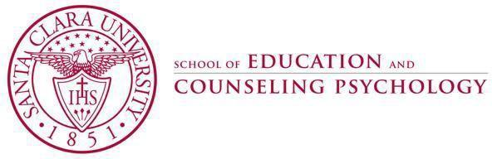

Department of Education MATTC
EDUC 263 (3 Units)
Section #26137

ELEMENTARY METHODS IN SOCIAL STUDIES AND THE ARTS SPRING 2021

Be the change you want to see in the world.
Mahatma Gandhi

Professor: Cheryl Bowen, Ed.D. Office: Room 246, Guadalupe Hall Office Hours: By Zoom Appt Email: cbowen@scu.edu
Course Meeting: Mondays, 4:00-7:00 PM
Classroom:
ONLINE
Mobile Phone: 408 828-1671
Office Phone: 408 554-5487

Mission and Goals of the Department of Education
Rooted in the Jesuit tradition at Santa Clara University, the mission of the Department of Education is to prepare professionals of competence, conscience, and compassion who will promote the common good as they transform lives, schools, and communities. Our core values of reflective practice, scholarship, diversity, ethical conduct, social justice, and collaboration guide both theory and practice. Faculty, staff, and students in the Department of Education:
- Make student learning our central focus
- Engage continuously in reflective and scholarly practice
- Value diversity
- Become leaders who model ethical conduct and a commitment to social justice
- Seek collaboration with others in reaching these goals

MS/SS Teaching Credential Program Learning Goals (PLGs)
The PLGs represent our commitment to individuals who earn their MS/SS credential at Santa Clara University. The MS/SS faculty focus on ensuring each student will begin their teaching career ready to:
- Maximize learning for every student.
- Teach for student understanding.
- Make evidence-based instructional decisions informed by student assessment data.
- Improve your practice through critical reflection and collaboration.
- Create productive, supportive learning environments.
- Apply ethical principles to your professional decision-making

Course Description
In this course, multiple subject credential candidates learn how to design, implement, and evaluate standards-based social science lessons and how to integrate content from the California content standards for visual and performing arts, and the California Common Core. The course emphasizes mastery of instructional strategies that create opportunities for all students, including English learners and students with special needs, to read and write about how to use social studies for social justice and how to incorporate the visual and performing arts as ways to express and visually represent meaningful learning in equity education. Topics include working with curriculum frameworks and content standards, developing curriculum units, and planning lessons that maximize the learning of all students.

Course Objectives

This course will develop students’ knowledge of or skills through the… |  | Standard/Goals Addressed
 |  | DG | PLG | TPE | MMSN TPE
1 | Review and implement the California History Social- Science Curriculum Framework and Content Standards for grades K-8. | 1 | 1, 2 | 3.1
2 | Examination of the various academic disciplines represented in the elementary Social Studies, Visual and Performing Arts curriculum and generation of ideas for how best to engage young learners in the study of Social Studies including accommodations and modifications for students with an identified disability. | 1 | 1 - 5 | 1.3, 1.7 | 1.1, 2.1,
3 | Demonstration of evidence-based principles, and practices for the development of academic language goals, comprehension and knowledge in History-Social Science, Visual and Performing Arts curriculum, making grade-appropriate content comprehensible to all students | 1, 3, 5 | 1 - 6 | 4.4, 4.5,  4.7, 4.8 | 1.2, 3.1,4.2,
including students with disabilities by implementing the
Universal Design for Learning (UDL) Framework in
curricular lesson design.
4 | Use of effective strategies to collaborate and communicate with students, families, colleagues, and the school community to access optimal learning experiences, and appropriate instructional environment for all learners including studies with an identified disability. Use strategies to support positive psychosocial development and behavior for all students including students with disabilities in the Least Restrictive Environment. | 1,3,4,5 | 1,5,6 |  | 1.7, 2.4, 2.8, 2.9, 4.3, 4.7
5 | Creation of a collaboratively developed, standards-based, backward-designed, social justice Social Studies curriculum unit plan that utilizes a performance assessment design process. The unit will implement a system to assess, plan, and provide academic and social skills instruction to support positive behavior in all students, including students who present complex social communication, behavioral and emotional needs and students that need assistive technology. | 1 - 5 | 1-6 | 1.5, 3.4,  5.3 | 2.10, 4.1, 4.2, 4.3, 5.1, 5.2, 5.6
6 | Planning of instruction aligned with the History-Social Science, Visual and Performing Arts, and California Common Core framework/content standards that meets the varying needs of a diverse student population including English learners and students who present physical/medical access issues and demonstrate difficulty acquiring and retaining new information due to poor memory processing as well as neuro behavioral issues. | 1-3 | 1-6 | 3.3 | 4.5
7 | Creation of a performance-based assessment task and rubric that monitors student progress toward learning goals for all students including students with an identified learning disability. | 1 | 1-3 | 4.3, 5.1 | 1.4, 5.1, 5.2, 5.6
8 | Development of a critically reflective teaching disposition that seeks out opportunities for professional growth. | 2 | 4, 5 | 1.5
*DG=Department Goals; PLG=Program Learning Goal; TPE=Teaching Performance Expectation Standard; MMSN = Mild Moderate Support Needs TPEs
Required Text(s) and Readings
- Agarwal-Rangnath, R. (2013). Social Studies, Literacy, and Social Justice in the Common Core Classroom: A Guide for Teachers. New York, NY: Teachers College Press. ISBN: 978-0-8077-5408-5
- Torres, T., & Barber, C. R. (2017). Case Studies in Special Education: A Social Justice Perspective. Springfield, IL: Charles C. Thomas Publisher. ISBN-13: 978-0398091736

- PROFESSIONAL BOOK CLUB SELECTIONS

 | TITLE | YEAR | AUTHOR | PRICE
1 | Planting the Seeds of Equity: Ethnic Studies and Social Justice in the K-2 Classroom | 2020 | Ruchi Agarwal-Rangnath | $29.95
2 | Being the Change: Lessons and  Strategies to Teach Social Comprehension | 2018 | Sara K. Ahmed | $23.52
3 | Black Ants and Buddhists: Thinking Critically and Teaching Differently in the Primary Grades | 2006 | Mary Cowhey | $28.00
4 | Social Justice Talk: Strategies for Teaching Critical Awareness  *eBook recommended – great videos! | 2020 | Chris Hass | $24.00  $21.00 eBook

Document Downloads
- California Department of Education. (2016). History-Social Science Framework for California Public Schools, Kindergarten through Grade 12.
- California Department of Education. (1998) History-Social Science Standards K-12
- California Arts Standards for Public Schools. (2019) PreKindergarten Through Grade Twelve
- California Department of Education. (updated 2013). Common Core State Standards for English Language Arts & Literacy in History/Social Studies, Science, and Technical Subjects, Kindergarten through Grade 12
- California County Superintendents Educational Services Association. (2008). K-6 Visual and Performing Arts Curriculum Guide: Examples of Integrated Lessons

Course Requirements/Assignments
Grades are based on a 430-point total. Distribution of points across assignments is as follows:

Course/Requirements/Assignments |  | Points | Due Date | TPE/MMSN  TPE Assessed
1 | Professional Conduct | 200 | Weekly
2 | Online Module Reading/Reflection | 150 | 4/5, 4/12, 4/19,4/26, 5/3, 5/10 | 2.4, 3.1, 1.7, 2.1, 2.8, 2.9, 2.10, 3.1, 4.1, 4.2, 4.3, 4.7, 5.1, 5.6
3 | Professional Book Club 3-2-1 Response Sheet | 20 | Weekly | 1.1, 1.2, 1.4, 1.7, 2.1, 2.4, 2.8, 2.9, 2.10, 3.1, 4.1, 4.2, 4.3, 4.5, 4.7, 5.1, 5.2, 5.6
4 | Curriculum Unit Plan / PowerPoint Slides  * Signature Assignment | 60 | 6/7 | 1.2, 1.4, 1.5, 1.7, 2.1, 2.4, 2.9, 2.10, 3.1, 4.2, 4.3, 4.5, 4.7, 5.1, 5.6

Asynchronous Modules

In this course, you will be required to complete two asynchronous modules that address special topics to help

you develop your Curriculum Unit Plan.

5/10 | UDL in Social Studies  The purpose of this module is to help you understand how to integrate the Universal Design for Learning (UDL) Framework into your unit plan. The UDL Framework is based on research in the learning sciences, including cognitive neuroscience, that guides the development of flexible learning environments that can:  support access to optimal learning experiences MMSN TPE (Practice TPE 2.4)  adapt, modify, accommodate and differentiate instruction for all students including students with identified disabilities to promote learning in the Least Restrictive Environment. MMSN TPEs (Practice/Assess TPE 3.1, Practice/Assess TPE 1.7, Practice/Assess TPE 2.1, Practice TPE 2.8, Practice/AssessTPE 2.9, Practice/Assess 2.10, Practice/Assess TPE 3.1, Introduce/Practice TPE 4.1, Practice/Assess TPE 4.2, Practice/Asses TPE s TPE 4.3, Practice/Assess TPE 4.4, Practice/Assess TPE 4.7, Introduce/Practice/Assess TPE 5.1, Introduce/Practice/Assess TPE 5.2, Introduce/Practice/Assess TPE 5.6)  adjust teaching strategies for students who present with physical/medical access issues or have difficulty acquiring and retaining new information due to poor memory processing. MMSN TPE (Practice/Assess TPE 4.5)
5/24 | Gender Diverse Social Studies  The purpose of this module is to develop an awareness of how gender diverse social studies learning can be integrated into student’s social studies understanding. Gender diverse social studies is one of the critical changes reflected in the CA HSS Framework requiring students in California to learn the history and contributions of LGBTQ Citizens.  In 2011, California passed Senate Bill 48 (FAIR “Fair, Accurate, Inclusive, and Respectful Education Act”) which is a California law mandating the inclusion of political, economic, and social contributions of persons with disabilities, and lesbian, gay, bisexual and transgender people in social studies teaching.  In 2017 California state law required that in grades 2-12, children’s Social Studies  curriculum will include lessons on gender diversity and the achievements of  lesbian, gay and transgender community in a historical and present-day context.  In this module you will:  watch what happens when you bring gender training to a public elementary school.  reflect on how you feel about teaching gender inclusive social studies.  review the GLSEN curriculum and research study.  learn how to effectively communicate with parents.  develop a book talk for a gender inclusive children’s book.

1. Professional Conduct (200 pts) Due: Weekly

The professional conduct requirement includes the six dimensions described below.

Attendance
Regular attendance at all synchronous class meetings is a requirement in the MATTC program. Each Curriculum Unit Group will sign up for a 1.5 hr. synchronous class timeslot in our Google Drive. Optional make up work is offered pending instructor approval. You must use Zoom to join ALL online classes or attend another section of this class if you make prior arrangements with the instructor.

Each of you will be granted one Emergency Release (ER) per course. Your ER excuses you from one class entirely without any point reduction. To use your ER you must notify me by email or phone BEFORE class. Save your ER for medical issues, family demands, car trouble, etc.

1 unexcused absence – 20 points deducted from your final grade.
2 absences –40 points deducted from your final grade.
3 or more unexcused absences – You will be dropped
Students will not be penalized for absences due to the observance of religious holidays falling on scheduled class days; please give me advance notice of these absences so I can make the necessary accommodations.

Punctuality
Zooming into class on time and ready to learn is a course expectation. Please sign in on the class attendance google doc sheet when you arrive for class to receive credit for your on-time arrival to class. Knowing that there are times when unexpected circumstances arise that may result in late arrival, please note this on the sign in sheet with an “ET” (excused tardy). Depending on the time of your arrival may impact whether or not you receive the full 20 points for your Professional Conduct grade.

Preparation
The quality of our class sessions and the depth of your learning depend directly on your preparation. Please be prepared for class based on the expectations outlined in the course syllabus and by the class norms.

Participation
This requirement includes but is not limited to (a) engaging actively in all discussions and activities (this includes making contributions, listening actively, and withholding contributions to leave space to allow other classmates to participate), (b) completing all in-class learning activities.

Responsible Use of Technology
While our class is in session, please engage in activity that is directly related to what is taking place in our classroom. Electronic devices may be used during class to support learning.

Please note that: There are times that you will be asked to close your laptop or put away some other form of technology during class; when/if this occurs, please respond quickly and without protest to avoid further disruption of the class’s learning. I strongly encourage all of you to assist each other in meeting these expectations for technology use. If someone sitting near you is using technology in an inappropriate manner during class, it is your responsibility to remind that classmate to stop.

Communication
Email using our SCU email address will be our primary means of communication outside of class. You must check your SCU email and our course’s Camino site every day to ensure you maintain a connection with the course content, your classmates, and your instructor

Your Professional Conduct grade will be determined through my ongoing observation and documentation throughout the quarter. If I have reason to feel you are not meeting the expectations spelled out in this syllabus, I will contact you privately to discuss the issue, to clarify the expectations as needed, and to offer my support in helping you reach these expectations.

If I do not contact you with a concern, you can assume your performance is satisfying the course requirements. However, if you would like specific feedback on your professional conduct, you are welcome to contact me any time and I will be glad to share my assessment with you.

One of the hallmarks of a Jesuit education is the practice of reflection. Jesuit institutions have been
2. Online Module Reading/Reflection (150 pts) Due Dates: 4/5, 4/12, 4/19, 4/26, 5/3, 5/10
known over the centuries for teaching people to think critically, to inform their consciences, and to cultivate habits of ongoing reflection and self-evaluation. Online learning is a way that students can practice critical reflection, and refine their classroom management understanding, while also enhancing reading, writing, and communications.

For this assignment you will:
- Individually complete six/1.5-hour, online modules throughout the quarter.
- Learn new information via reading, watching, analyzing, or developing.
- Complete a 1-2 page reflection

DATE | TOPIC | MODULE | POINTS
4/5 | Engaging Our Visions | Module #1/Read CH 1 | 25 pts
4/12 | Inspiring Wonder | Module #2/Read CH 2 | 25 pts
4/19 | Painting the Picture | Module #3/Read CH 3 | 25 pts
4/26 | Application | Module #4/Read CH 4 | 25 pts
5/3 | Connecting the Past to the Present | Module #5/Read CH 5 | 25 pts
5/10 | Facilitating Change | Module #5/Read CH 6 | 25 pts
3. Professional Book Club 3-2-1 Response (20 pts) SIGN UP for Due Date
Individually, you will participate in a professional book club of your choice. Each book club should have no more than 6 members. During the first meeting, members will decide how to divide the book into 6 equitable sections. Each member will facilitate ONE section to discuss using the 3-2-1 template.
Each Discussion Facilitator will complete a personal 3-2-1 Response Sheet BEFORE the book club meeting. During the meeting the facilitator will lead a discussion of what others in the group found interesting in the reading. The facilitator will encourage the group to share their own connections and questions. Toward the end of the discussion, the facilitator will lead the group to develop a Visual Representation of the group’s discussion. The Visual Representation can be a YouTube video, a poster created on a google doc, or an image downloaded from the web. By midnight, the facilitator will have uploaded two documents: a) their own 3-2-1 Response Sheet, and b) the Visual Representation created by their group on Camino for credit.

ADDITIONAL WEEKLY SPECIAL EDUCATION READING:
Each week you will read a chapter from the book Case Studies in Special Education: A Social Justice Perspective. For your book club discussion, you should be prepared to share the following connections:
a. Text to Text – connections between both texts
b. Text to Self – connections with your life or the life of one of your students
c. Text to Curriculum Unit – connections to your unit’s Lesson Sequence or Performance Task.
4. Curriculum Unit Plan/PowerPoint Slides (60 pts) DUE: 6/7
A curriculum is a set of courses or plan of study. Defined as a long-term activity within instructional context, a curriculum unit generally takes the form of a unit study. Unit studies typically revolve around a central theme. Lessons and activities are structured to fit this theme.

Collaboratively created curriculum units are thought to benefit children through memory retention. Most children are able to retain more information from a unit study than from books or lessons alone. Developing a curriculum unit provides teachers the opportunity to custom design meaningful standards-based learning for any grade level and for all students including children who are emerging bilinguals and children with identified learning disabilities.
MMSN TPEs (Practice/Assess TPE 1.2, Practice /Assess TPE 1.4, Practice/Assess TPE 1.7, Practice/Assess TPE 2.1, Practice TPE 2.4, Practice/Assess TPE 2.9, Practice/Assess TPE 2.10, Practice/Assess TPE 3.1, Practice/Assess TPE 4.2, Practice/Assess TPE 4.3, Practice/Assess TPE 4.4, Practice/Assess TPE 4.5, Practice/Assess TPE 4.7, Introduce/Practice/Assess TPE 5.1, Introduce/Practice/Assess TPE 5.2, Introduce/Practice/Assess TPE 5.6)

Integrate the reading in your Professional Book Club and Case Studies in Special Education with the online and asynchronous modules on Camino and the California Content Standards in Social Studies and the Visual and Performing Arts to develop your unit IN CLASS for any theme and grade level.

Your unit lessons should include:
  - Reading and Writing Activities
  - Local or Global Civic Engagement and/or Social Justice Activities
  - UDL Guidelines (MMSN TPEs (Practice TPE 2.4, Practice/Assess TPE 3.1. Practice/Assess TPE 4.4, Practice/Assess TPE 4.5.4, 3.1, 4.5)
  - Assistive Technology MMSN TPE (Introduce/Practice TPE 4.1
  - Strategies for students who have difficulty with memory processing as well as neuro behavioral issues (MMSN TPEs (Practice/Assess TPE 4.5)

For this assignment, you will use the unit plan shared with you on Camino to:
- Establish learning goals (big ideas and key concepts).
- Develop a performance task and rubric to assess student achievement of the learning goals.
- Outline a sequence of 10-15 lessons that engage students in activities and experiences through which they will develop an understanding of the big ideas of the unit and the knowledge and skills necessary to complete the performance task you designed. (Use lesson sequence template shared with you on Camino)
- Reflect on your own learning.
- Share the main points of your unit plan via a PowerPoint slide presentation on June 7th.

REQUIRED: To begin this assignment, your group will need to complete the following steps:
- Choose a grade level (K-8)
- Choose a standard from the California History/Social Studies Standards for that grade level.
- Choose a standard from the California Arts Standards for that grade level.
- Narrow your unit down to ONE Theme.
- Look through Social Studies Units in your selected grade level that have been completed by students who have taken this class in previous years.

REQUIRED FOR FINAL VERSION OF CURRICULUM UNIT PLAN: Parts A, B, C, D, and E.
I will provide ungraded formative feedback for you as you work on the final version of your curriculum unit plan.
April 26th Cover Page, Parts A & B
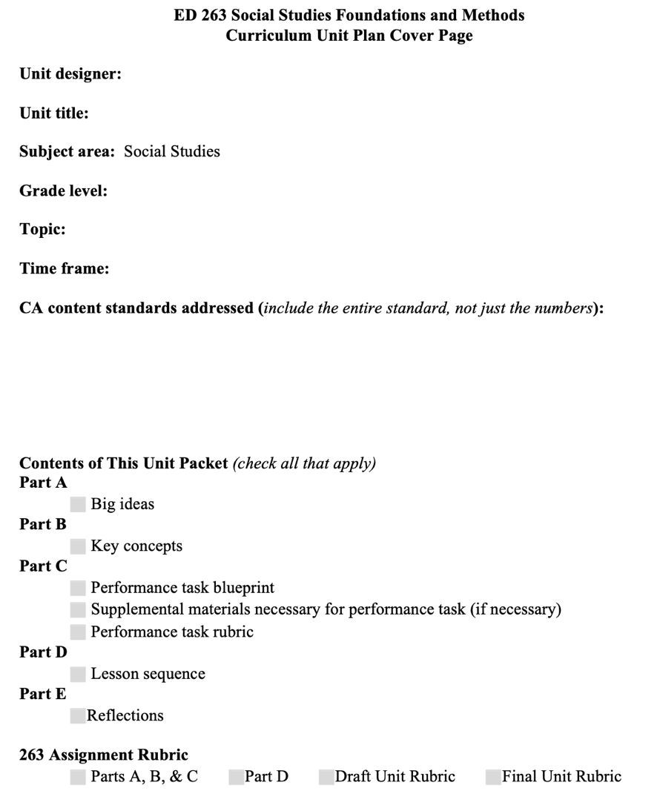

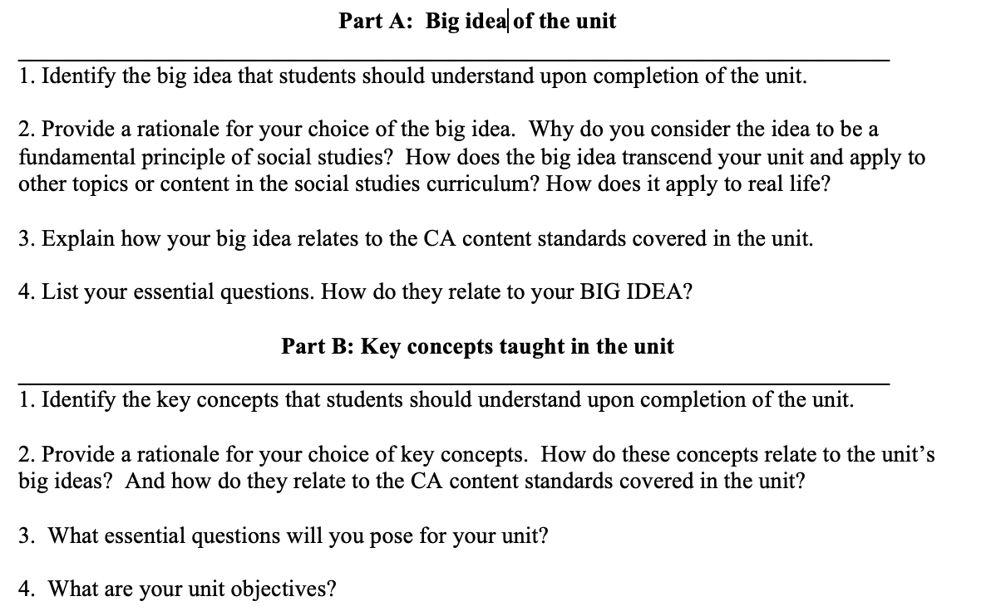

May 10th Part C *Include Assessment Task Blueprint and Rubric
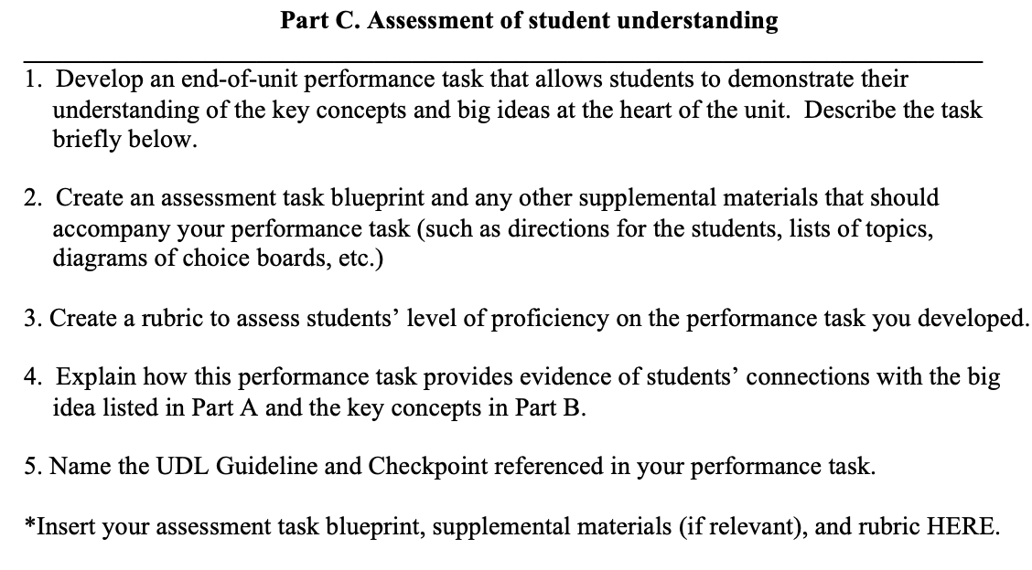

May 31st Part D
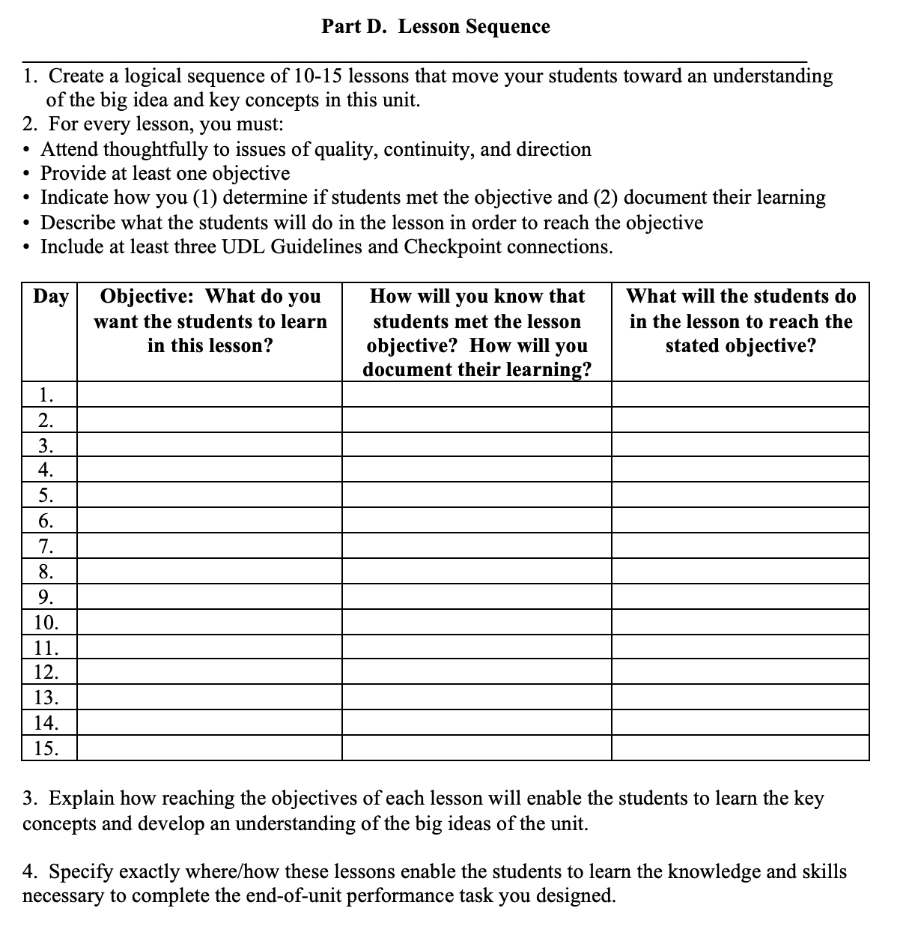

June 7th Completed Unit Plan
*Part E is completed individually. Please name each reflection.
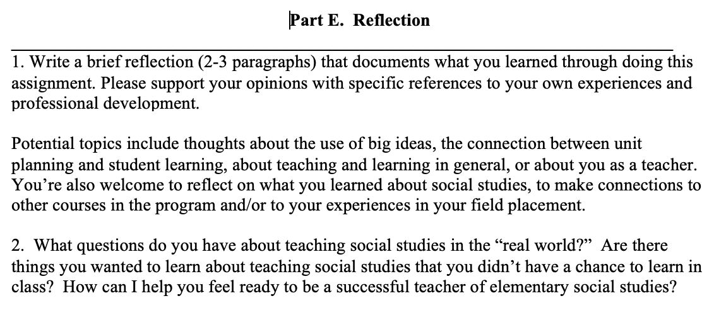

Assessments and Grading Criteria
- All written and oral assignments must reflect graduate-level standards. As a future teacher, you must be able to model communication skills for your students.

A | 94-100 | C+ | 77-79
A- | 90-93 | C | 74-76
B+ | 87-89 | C- | 70-73
B | 84-86 | D+ | 67-69
B- | 80-83 | D | 63-66
- Letter grades are assigned on the standard scale based upon a possible total of 430 points.

- For assignments completed in groups or pairs, only one person needs to submit the document on Camino. All group members will receive the same grade.

- Final grades will reflect students’ contributions (e.g., attendance, class discussions, quality of presentation, ability to lead discussion groups, completion and quality of course assignments), critical thinking and ability/degree to which student integrates theory, research and practice
Disability Accommodations
If you have a disability for which accommodations may be required in this class, please contact Disabilities Resources, Benson 216, as soon as possible to discuss your needs and register for
accommodations with the University. If you have already arranged accommodations through Disabilities Resources, please discuss them with me during my office hours. Students who have medical needs related to pregnancy may also be eligible for accommodations. While I am happy to assist you, I am unable to provide accommodations until I have received verification from Disabilities Resources. The Disabilities Resources office will work with students and faculty to arrange proctored exams for students whose accommodations include double time for exams and/or assisted technology. Disabilities Resources must be contacted in advance to schedule proctored examinations or to arrange other accommodations. The Disabilities Resources office would be grateful for advance notice of at least two weeks. For more information, you may contact Disabilities Resources at 408-554-4109.

Accommodations for Pregnancy and Parenting
In alignment with Title IX of the Education Amendments of 1972, and with the California Education Code, Section 66281.7, Santa Clara University provides reasonable accommodations to studentswho are pregnant, have recently experienced childbirth, and/or have medically related needs. Pregnant and parenting students can often arrange accommodations by working directly with their instructors, supervisors, or departments. Alternatively, a pregnant or parenting student experiencing related medical conditions may request accommodations through Disability Resources.

Discrimination and Sexual Misconduct (Title IX)
Santa Clara University upholds a zero-tolerance policy for discrimination, harassment and sexual misconduct. If you (or someone you know) have experienced discrimination or harassment, including sexual assault, domestic/dating violence, or stalking, I encourage you to tell someone promptly. For more information, please consult the University’s Gender-Based Discrimination and Sexual Misconduct Policy or contact the University's EEO and Title IX Coordinator, Belinda Guthrie, at 408-554-3043, bguthrie@scu.edu. Reports may be submitted online or anonymously through Ethicsmpoint.

Academic Integrity
The University is committed to academic excellence and integrity. Students are expected to do their own work and to cite any sources they use. A student who is guilty of dishonest acts in an examination, paper, or other required work for a course, or who assists others in such acts, will receive a grade of F for the course. In addition, a student guilty of dishonest acts will be immediately dismissed from the University.

Students that violate copyright laws, including those covering the copying of software programs, or who knowingly alter official academic records from this or any other institution, are subject to disciplinary action (ECPPM Graduate Bulletin, 2020-2021)

RESPECT FOR DIVERSITY AGREEMENT

The following agreement is inspired by the work of Santa Clara University’s Racial Justice Coalition and the Showing Up for Racial Justice network.

I agree to value the perspectives of individuals from all backgrounds, reflecting the diversity of all my class colleagues. I broadly define diversity to include race, gender identity, national origin, ethnicity, religion, social class, age, sexual orientation, political preferences, and physical and learning ability. I will strive to make the classroom—in person or virtual—an inclusive learning environment for all learners.

I commit to the following principles and values:
- Respect the dignity and essential worth of all individuals.
- Esteem practices of inclusivity, integrity, and solidarity that celebrate racially diverse identities and experiences.
- Value the courage needed to engage in antiracist dialogue.
- Strengthen agency and empowerment by embracing difference.
- Reject bigotry, discrimination, violence, or intimidation of any kind.
- Practice personal integrity and expect it from others.
- Do the work to become an antiracist educator.

Discussion Norms
I agree to adhere to the following norms for all class discussions including breakout room and asynchronous conversations.

Ground Rules
- This is a safe and brave space.
- Ouch! Oops! If you say something that is hurtful and you realize it, you can say “oops” to acknowledge it. Also, if someone else says something harmful, you can say “ouch”, which lets everyone know that there’s something that needs to be discussed further. Getting Called Out: How to Apologize
- Take space, give space.
- What is said here stays here and what is learned here, leaves here.
- Challenge ideas, not individuals.

Permission Slip
I give myself permission to be imperfect in regard to human diversity and issues of oppression.

It is okay if I do not know all the answers or if at times my ignorance and misunderstandings
become obvious.

I have permission to ask questions that may appear simple or self-explanatory. I have permission to struggle with these issues and be upfront and honest about my feelings.

I have the right to state my opinion.

I do not feel guilty about who I am or what I know.

I will respect the opinions of others, even if they are different from my own.

COURSE CALENDAR

Date | Topic | Assignments
3/29 | INTRODUCTION TO COURSE  - Course Syllabus Review  - Confirm Book Club Sign Ups  - Establish Curriculum Groups  Book Club Meeting #1  - Review week’s reading  - Review individual and group expectations  Instructor Lecture:  Lecture #1 - What is social studies? Why should kids learn social studies? What are the changes in the new CA framework?  Asynchronous Curriculum Group Meeting #1  - Create Curriculum Unit Group Google Folder  - Decide on grade level and topic.  - Review California Social Studies Standards AND California Arts Standards. | Due: 4/5  Module #1 – Read/Reflect  Social Studies, Literacy, and Social Justice  Chapter 1 Engaging Our Visions pp. 1-11  Book Club Homework  - Reading  - Book Club 3-2-1 Response  - Connections with Case Studies in Special Education Chapter 1- To Be (LD) or Not to Be (LD) That Depends MMSN TPEs (Practice/Assess TPE 1.2, Practice/Assess TPE 2.1, Practice/Assess TPE 2.9, Practice/Assess TPE 4.2, Introduce/Practice/Assess TPE 5.2)
4/5 | “YOU ARE THERE” SOCIAL STUDIES  Instructor Lecture:  Lecture #2 – “You Are There” Social Studies  Book Club Meeting #2  - Book Club Discussion & Visual Representation Sharing  - Upload the group’s Visual Representation AND your 3-2-1 Response Sheet on Camino.  Asynchronous Curriculum Group Meeting #2  * Decide on which California Social Studies Standards and California Arts Standards you want to use. | Due: 4/12  Module #2 – Read/Reflect  Social Studies, Literacy, and Social Justice  Chapter 2 Inspiring Wonder pp. 13-37  Book Club Homework  - Reading  - Book Club 3-2-1 Response  - Connections with Case Studies in Special Education Chapter 2 - The Plight of the Slow Learner (MMSN TPEs (Practice/Assess TPE 1.4, Practice/Assess TPE 2.1, Practice/Assess TPE 2.9, Practice/Assess TPE 4.2, Introduce/Practice/Assess TPE 5.2)

4/12 | UNDERSTANDING BACKWARDS DESIGN | Due: 4/19
 | Book Club Meeting #3  - Book Club Discussion & Visual Representation Sharing  - Upload the group’s Visual Representation AND your 3-2-1 Response Sheet on Camino. | Module #3 – Read/Reflect  Social Studies, Literacy, and Social Justice  Chapter 3 Painting the Picture pp. 38-75
Asynchronous Curriculum Group Meeting #3
* Decide on Social Studies Grade Level and Theme
* Use the California Social Studies Standards AND California Arts Standards to work on unit plan Part A & Part B in shared Google Doc.
4/19 | DESIGNING A SOCIAL STUDIES CURRICULUM UNIT | Due: 4/26  Module #4 – Read/Reflect  Social Studies, Literacy, and Social Justice  Chapter 4 Application pp. 76-99  Book Club Homework  - Reading  - Book Club 3-2-1 Response  - Connections with Case Studies in Special Education Chapter 4 - Disability, Disadvantage, or Discrimination (MMSN TPEs (Practice/Assess TPE 1.2, Practice/Assess TPE 1.7, Practice TPE 2.4, Practice/Assess TPE 2.9, Practice/Assess TPE 2.10, Practice/Assess TPE 4.2, Practice/Assess TPE 4.7, Introduce/Practice/Assess TPE 5.1)
Book Club Meeting #4
- Book Club Discussion & Visual Representation Sharing
- Upload the group’s Visual Representation AND your 3-2-1 Response Sheet on Camino.
Instructor Lecture:
Lecture #4 – Using Backward Design with YOUR Curriculum Unit.
Asynchronous Curriculum Group Meeting #4
* Explore Bowen’s Social Studies Resources related to the social studies theme of your unit.
- Use related chapters in Social Studies, Literacy and Social Justice, your book club reading, the Social Studies AND California Arts Standards to COMPLETE Part A & Part B.

Upload Cover Sheet, and Parts A&B on Camino for Feedback by 4/26

4/26 | ASSESSING STUDENT LEARNING IN SOCIAL STUDIES  Book Club Meeting #5  - Book Club Discussion & Visual Representation Sharing  - Upload the group’s Visual Representation AND your 3-2-1 Response Sheet on Camino.  Instructor Lecture:  Lecture #5  How Do I Assess Student Learning in Social Studies?  Asynchronous Curriculum Group Meeting #5  Use Bowen’s Social Studies Resources, Google Resources Folder, previous Final Curricular Units, related chapters in Social Studies, Literacy, and Social Justice, and your book club book to work on unit plan  - Part C – Assessment of Student Learning  - Performance Task Blueprint | Due: 5/3  Module #5 – Read/Reflect  Social Studies, Literacy, and Social Justice  Chapter 5 Connecting the Past to the Present pp. 100-117  Book Club Homework  - Reading  - Book Club 3-2-1 Response  - Connections with Case Studies in Special Education Connections with Case Studies in Special Education Chapter 5 - Issues in bilingual Assessment and Special Education Eligibility MMSN TPEs (Practice/Assess TPE 4.2, Introduce/Practice/Assess TPE 5.2)
5/3 | PLANNING SOCIAL STUDIES LESSONS | Due: 5/10
 | Book Club Meeting #6  - Book Club Discussion & Visual Representation Sharing  - Upload the group’s Visual Representation AND your 3-2-1 Response Sheet on Camino.  Instructor Lecture:  Lecture #6  How Do I Plan and Sequence a Social Studies Lesson?  Asynchronous Curriculum Group Meeting #6  Use Bowen’s Social Studies Resources, Google Resources Folder, previous Final Curricular Units, related chapters in Social Studies, Literacy, and Social Justice, and your book club book to COMPLETE unit plan  - Part C – Assessment of Student Learning  - Performance Task Blueprint  Upload Part C on Camino for Feedback by 5/10 | Module #6 – Read/Reflect  Social Studies, Literacy, and Social Justice  Chapter 6 Facilitating Change pp. 118-137

5/10 | ONLINE CLASS MODULE  UDL in Social Studies  Independently COMPLETE the UDL Module on Camino. No online class meeting! (MMSN TPE – 2.4, 3.1, 4.5) |  |  | Due: 5/17  Book Club Homework  - Reading  - Book Club 3-2-1 Response  - Connections with Case Studies in Special Education Chapter 6 - Fall Through the Cracks: Two Cases of IEPs Gone Awry MMSN TPEs (Introduce/Practice TPE 1.1, Practice/Assess TPE 3.1, Introduce/Practice 4.1, Practice/Assess TPE 4.2, Practice/Assess TPE 4.4, Practice/Assess TPE 4.5)
5/17 | CREATING INTERACTIVE CURRICULAR UNITS IN SOCIAL STUDIES  Book Club Meeting #7  - Book Club Discussion & Visual Representation Sharing  - Upload the group’s Visual Representation AND your 3-2-1 Response Sheet on Camino.  Instructor Presentation:  Lecture #7  Creating Interactive Curricular Units in Social Studies  Asynchronous Curriculum Group Meeting #7  - Develop and Share on Google Docs  - Part D Lesson Sequence  - Part E Reflection  Upload Parts A-D on Camino for Feedback by 5/31 |  |  | Due: 5/24  To Prepare for next week’s online class  - Read: DeSanctis, A. (July, 2016). Seven: In California, the right age to begin learning about LGBT history. National Review.  - Read: Garlen, J.C., Kuh, L. & Colman, B. (2017). Teaching for social justice in the early childhood classroom. Teachers College Record online.  - Read: Hyland, N.E. (2010). Social justice in early childhood classrooms. Young Children

5/24 | ONLINE CLASS  Gender Diverse Social Studies  Independently COMPLETE the Gender Diverse Social Studies Module on Camino.  No online class meeting! | Due: 6/7  Curriculum Unit Project Planning Homework  * Create PowerPoint Slide presentation of Unit  Book Club Homework  - Reading  - Connections with Case Studies in Special Education Chapter 7-8 - What is Specially Designed Instruction? AND RTI-Response to Intervention or Rushing to Identify? MMSN TPEs (Introduce/Practice TPE 1.1, Practice TPE 2.8, Practice/Assess, TPE 3.1, Introduce/Practice TPE 4.1, Practice/Assess TPe 4.2, Introduce/Practice/Assess TPE 5.2, Introduce/Practice/Assess TPE 5.6)
5/31 | NO CLASS
6/7 | CURRICULAR UNIT SHARING  Book Club Meeting #8  - Book Club Discussion & Visual Representation Sharing  - Upload the group’s Visual Representation AND your 3-2-1 Response Sheet on Camino.  Present Final Curriculum Unit PowerPoint Slides

Evidence of MMSN TPEs - (Introduce/Practice TPE 1.1, Practice/Assess TPE 1.2, Practice/Assess TPE 1.4, Practice/Assess TPE 1.7, Practice/Assess TPE 2.1, Practice TPE 2.4, Practice TPE 2.8, Practice/Assess TPE 2.9, Practice/Assess TPE 2.10, Practice/Assess TPE 3.1, Introduce/Practice TPE 4.1, Practice/Assess TPE 4.2, Practice/Assess TPE 4.3, Practice/Assess TPE 4.4, Practice/Assess TPE 4.5, Introduce TPE 4.7, Introduce/Practice/Assess TPE 5.1, Introduce/Practice/Assess TPE 5.2, Introduce/Practice/Assess TPA 5.6)
through connections with readings from Case Studies in Special Education.

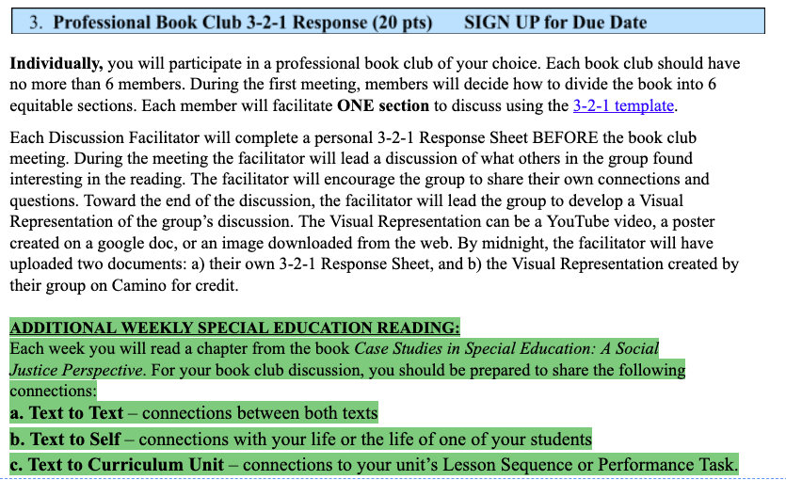

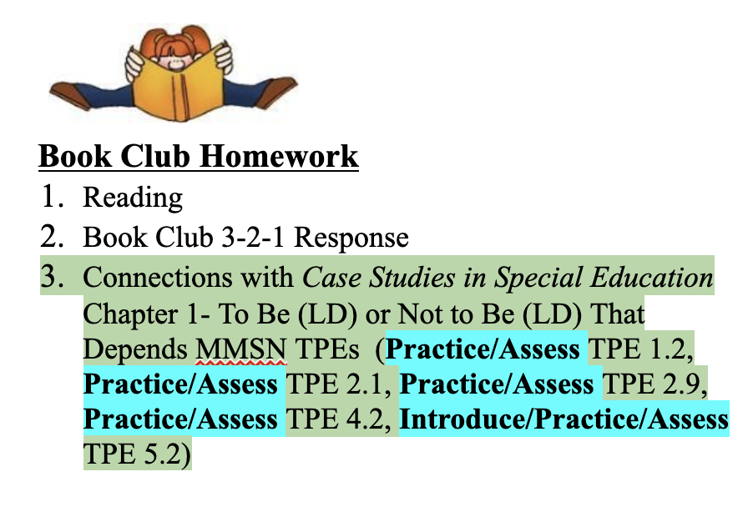
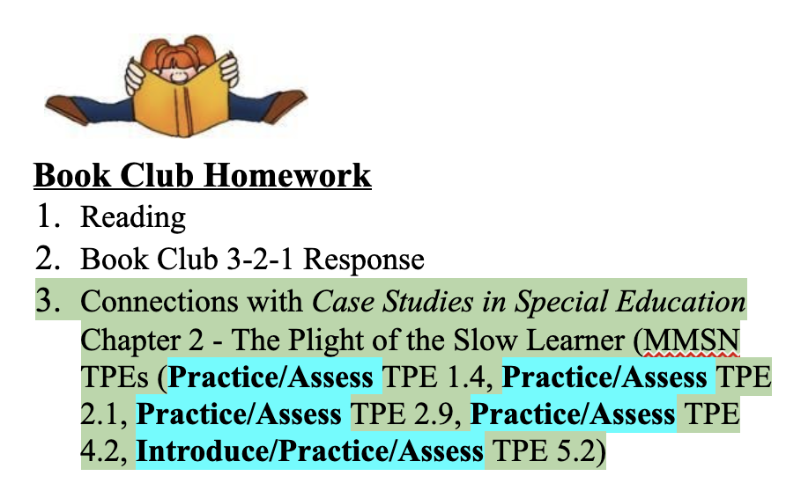
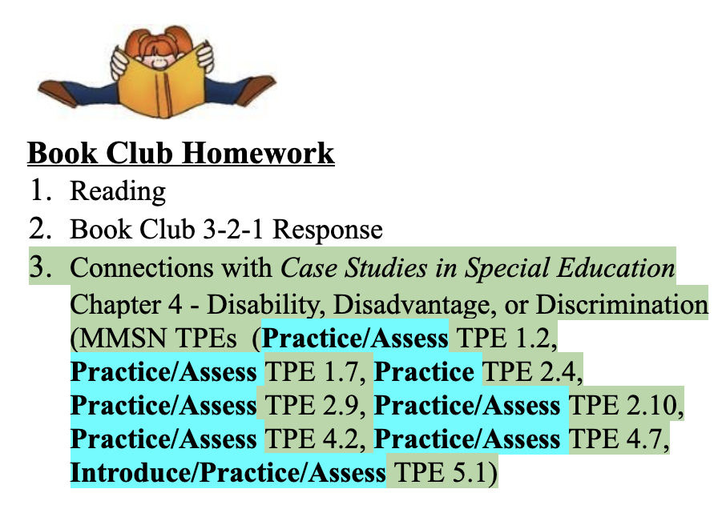
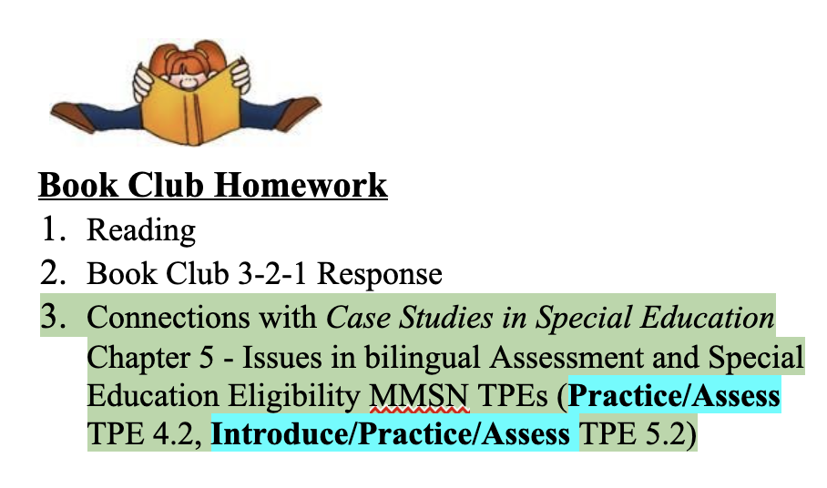
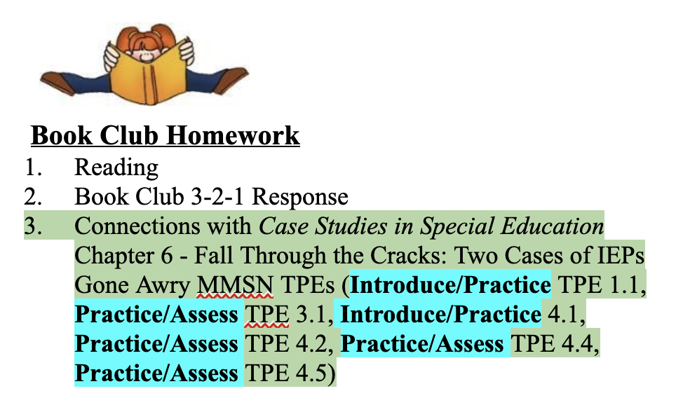
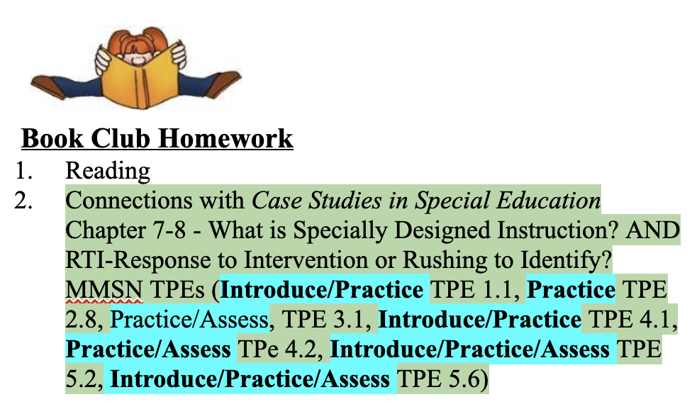
Evidence of MMSN TPEs - (Practice TPE 2.4, Practice/Assess TPE 3.1, Practice/Assess TPE 1.7, Practice/Assess TPE 2.1, Practice TPE 2.8, Practice/Assess TPE 2.9, Practice/Assess TPE 2.10, Practice/Assess TPE 3.1, Introduce/Practice TPE 4.1, Practice/Assess TPE 4.2, Practice/Assess TPE 4.3, Practice/Assess TPE 4.4, Practice/Assess TPE 4.7, Introduce/Practice/Assess TPE 5.1, Introduce/Practice/Assess TPE 5.2, Introduce/Practice/Assess TPE 5.6) through Asynchronous Module
UDL in Social Studies

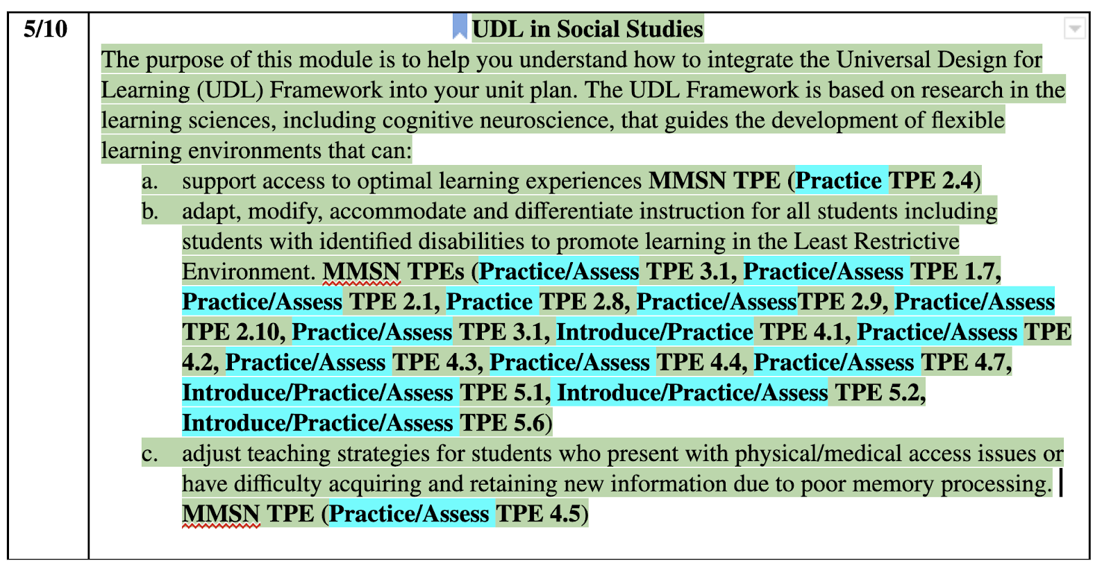

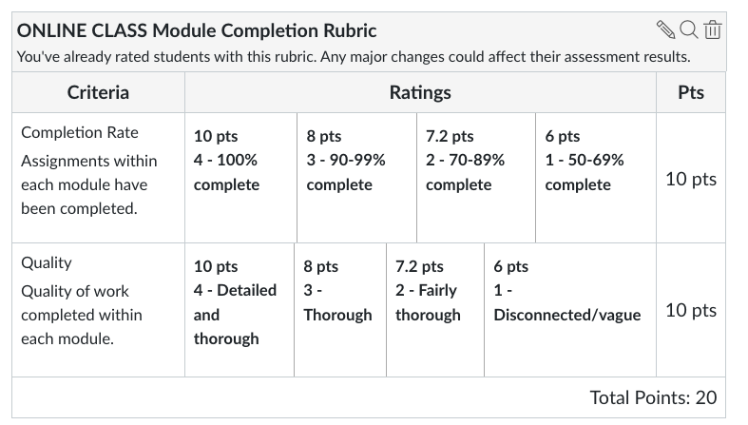
Evidence of MMSN TPEs - (Practice/Assess TPE 1.2, Practice/Assess TPE 1.4, Practice/Assess TPE 1.7, Practice/Assess TPE 2.1, Practice TPE 2.4, Practice/Assess TPE 2.9, Practice/Assess TPE 2.10, Practice/Assess TPE 3.1, Practice/Assess TPE 4.2, Practice/Assess TPE 4.3, Practice/Assess TPE 4.4, Practice/Assess TPE 4.5, Practice/Assess TPE 4.7, Introduce/Practice/Assess TPE 5.1, Introduce/Practice/Assess TPE 5.2, Introduce/Practice/Assess TPE 5.6) through the Curriculum Unit signature assignment.

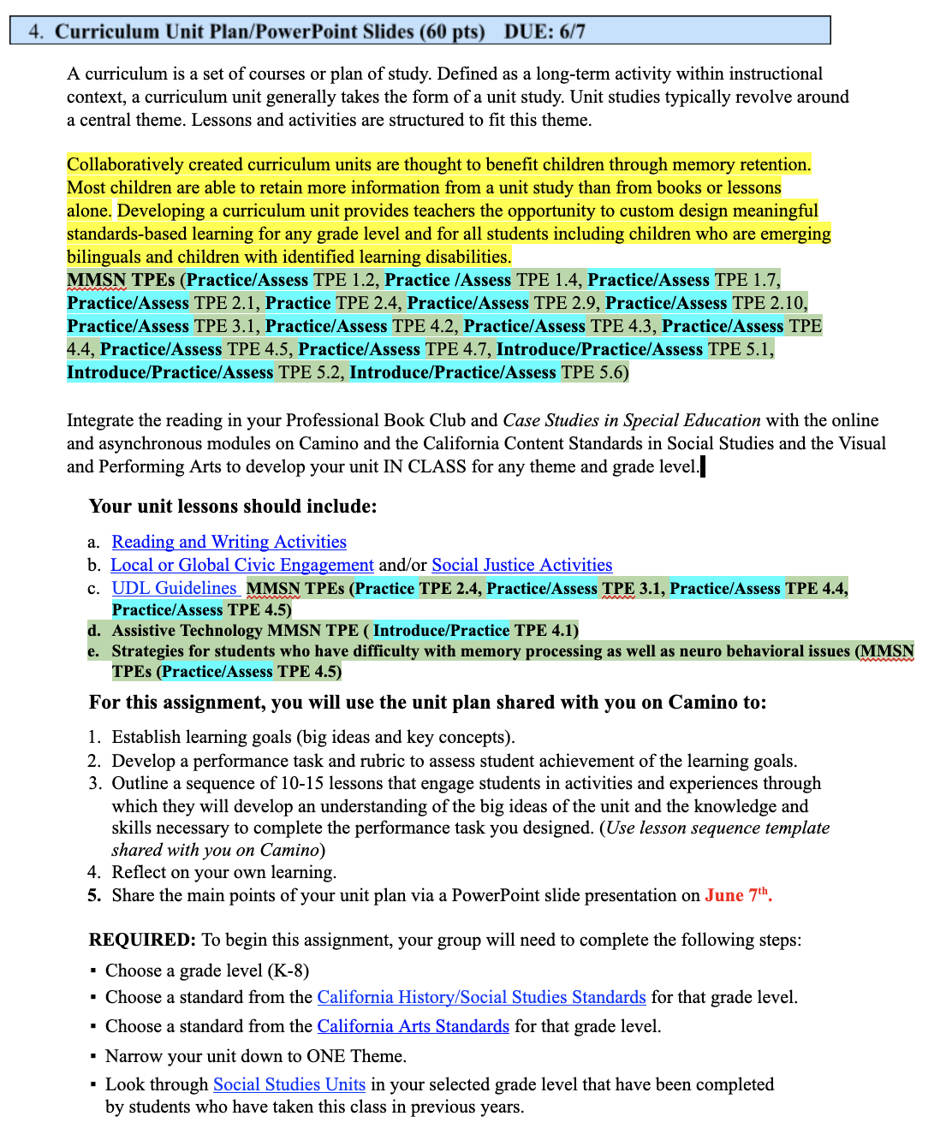

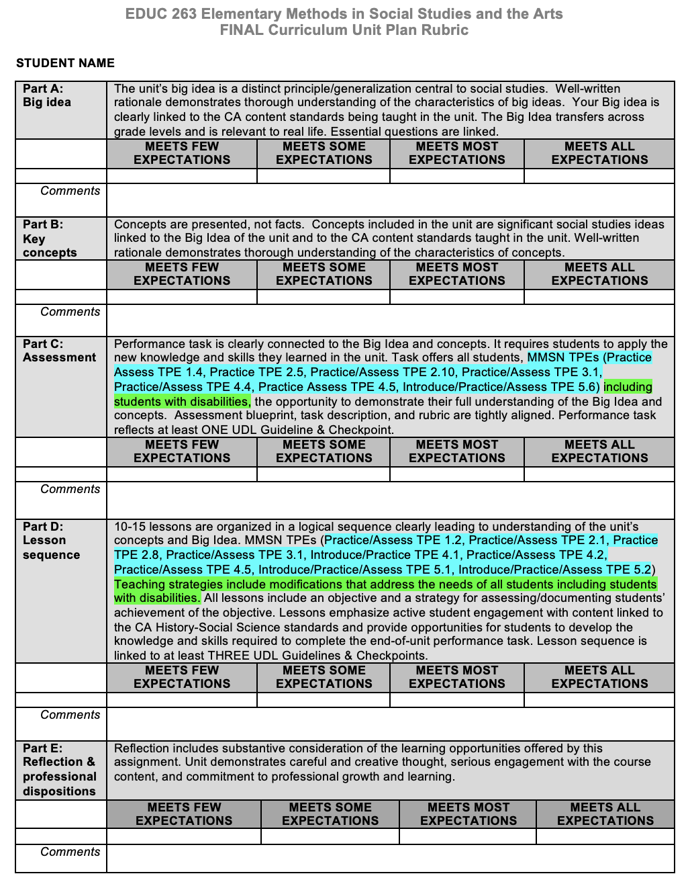

C12. Syllabus 264

Department of Education
MATTC
EDUC 264 (3 units)
Elementary Methods in Science, Health, & PE
Spring 2022
Professor: Dr. Kathy Stoehr Course Meeting: Mondays 5:00–8:00 pm
Office: Guadalupe Hall #251 Classroom: GH Room 202
Office Hours: Mondays 4:00-4:50 pm Phone: (408) 551-3497 Office
or by appt. (832) 978-7444 Cell
Email: kstoehr@scu.edu

Mission and Goals of the Department of Education
Rooted in the Jesuit tradition at Santa Clara University, the mission of the Department of Education is to prepare professionals of competence, conscience, and compassion who will promote the common good as they transform lives, schools, and communities. Our core values of reflective practice, scholarship, diversity, ethical conduct, social justice, and collaboration guide both theory and practice.

Faculty, staff, and students in the Department of Education:

- Make student learning our central focus
- Engage continuously in reflective and scholarly practice
- Value diversity
- Become leaders who model ethical conduct and a commitment to social justice
- Seek collaboration with others in reaching these goals

MS/SS Teaching Credential Program Learning Goals (PLGs)
The PLGs represent our commitment to individuals who earn their MS/SS credential at Santa Clara University. The MS/SS faculty focus on ensuring each student will begin their teaching career ready to:

- Maximize learning for every student.
- Teach for student understanding.
- Make evidence-based instructional decisions informed by student assessment data.
- Improve your practice through critical reflection and collaboration.
- Create productive, supportive learning environments.
- Apply ethical principles to your professional decision-making

The PLGs guide our program. Therefore, all MS/SS teaching credential program course objectives are cross-referenced with the PLGs. (A fully elaborated version of the MS/SS PLGs can be found in the Teacher Candidate Handbook, Pre-Service Pathway.)

Course Objectives
This course will develop students’ knowledge of or skills with… |  | Standard/Goals Addressed
 |  | DG | PLG | TPE | MMSN TPE
1 | Become more familiar with the scope and sequences of elementary science, health, and physical education in terms of content and processes based on state and national standards, focusing on a balanced approach that addresses all aspects of scientific/health/PE conceptual development at the elementary level. | 1 | 1,2
2 | Continue to develop the skills and disposition necessary to make instructional decisions (e.g., task selection and adaptation, opportunities for collaborative learning and scientific inquiry, differentiation) that promote a positive climate for learning and meet the instructional and socio-emotional needs of diverse learners--English Learners, students with identified disabilities | 1,2 | 1,2,5 | 1.3,1.8,3.1,3.2,3.4,4.7,5.2,6.1,6.5 | 1.1, 1.2, 1.4, 2.4, 3.2, 4.1, 4.2, 4.3 4.4
3 | Gather data about student progress toward content standards by using instructional strategies that assess student learning throughout the learning process. | 1 | 1,2,3 | 3.2,3.4,5.2
4 | Learn how to prepare, teach, and analytically reflect on elementary school science investigation lessons in which your students ask questions, make predictions, gather evidence, develop explanations, and communicate their ideas in lessons, which are built around models of how people learn. Adopt an asset-based view of students and families, particularly from populations that have traditionally been positioned as low status in science learning. | 1 | 1,2,3,4,5 | 1.8,3.1,3.2,4.7,5.2,6.1,6.5 | 2.1, 2.8, 2.9, 2.10 3.2, 4.4, 4.7, 5.1, 5.2
5 | Access, evaluate, and incorporate into your teaching practice a variety of resources from the National Science Teachers Association (NSTA) and other supplementary sources to engage all students, including students with identified disabilities, in rich, complex, and multi-dimensional science learning. | 1,2 | 1,2,3,4 | 3.1,3.2,3.4,6.1 | 2.4, 2.9, 2.10, 3.2, 4.3, 4.4, 4.7, 5.1, 5.2, 5.6
*DG=Department Goals; PLG=Program Learning Goal; TPE=Teaching Performance Expectation Standard; TPA=Teaching Performance Assessment; MMSN=

Course Description
This course is designed to assist multiple subject credential candidates in developing the skills necessary to design and carry out science, health, and physical education instruction, demonstrations and laboratory experiences for students in elementary and middle school programs. We will build on current research and best practice in order to foster science/health/PE learning in K-8 students. The process of creating content, developing curriculum, and applying standards to generate meaningful lessons are emphasized with an additional area of emphasis being placed on assessment and collaboration. Scientific inquiry, project-based instruction (PBI), Common Core integration, and Next Generation Science Standards (NGSS) will be emphasized along with best practices in the STEM/Health/PE model. The course also focuses on organizing science/health/physical instruction to meet the needs of students with disabilities in LRE. What does it mean by LRE in the context of secondary science learning? What does the field say about the equitable and justice-oriented learning opportunities for students with different learning goals and needs, including those with disabilities? How do we frame ‘disabilities’ in science classrooms? Which approaches would you take to support academic achievement not only of general students but also of those in different learning needs? How can you facilitate students to learn and with and from one another?

Course Requirements/Assignments
Major Course Assignments
Course Requirements/Assignments |  | Grade % | TPE | MMSN TPE*
1 | Noticing students’ presence in science classrooms (NSP) | 30 | 1.1, 1.3, 2.5, 6.1 | 1.1, 1.3
2 | Exploring pedagogical moves (EPM) | 30 | 1.3, 1.5, 4.4, 4.7, 5.2, 5.3, 6.1 | 1.2, 1.7, 4.1, 4.2
3 | Planning and implementing your science lesson (PSL) | 40 | 1.3, 1.5, 1.8, 3.2, 3.3, 4.4, 4.7, 5.2, 5.3, 6.1 | 1.1, 1.2, 1.4, 2.1, 2.8, 2.10, 3.1, 4.2, 4.4, 4.5, 5.1, 5.2, 5.6
Additional details about respective assignments will be discussed in class and posted on Camino.
* See end of this syllabus for assignment and rubric aligned with MMSN TPEs.

Noticing students’ presence in science classrooms
This assignment focuses on noticing students as crucial and rightful constructors, critics, and users of science/P.E. knowledge and practices. You will read research papers and practice briefs about students with disabilities’ and teachers’ experiences in elementary science/PE classrooms and reflect on how their stories contribute to your own development as a secondary science/PE teacher. This assignment entails two components: my science story, and well-remembered events.

NSP component 1:my science story. This assignment component is intended to position ourselves, science teachers, as lifelong and ultimate learners of science. You will write down your daily discovery and questions of science, which will help refine understanding content (and pedagogical content) knowledge and how the discovered and interesting science is experienced in the context of your personal life. This contextuality will help you understand that science students learn shapes and is shaped by students’ lived cultural lives. Through this assignment component, you are encouraged to
- report your science knowledge and practices deepened and expanded (as to model how you hope your students engage with science in their daily lives, and
- report your science pedagogical knowledge, which means your knowledge as science teachers about varying ways students would understand and explain scientific phenomena, paying attention to the scientific understanding and explanations of ELL students and students with identified/unidentified special needs.

Introduce/Practice MMSN TPE 1.1, 4.1

NSP component 2: well-remembered events. One of the hallmarks of a Jesuit education is the practice of reflection. This assignment component offers you to keep engaging in critical reflections of your experiences as a science teacher. You document and reflect on how the students you have encountered via field placements (or your personal educational experiences) position themselves and are positioned in elementary science/PE classrooms. We engage in this assignment as we read, discuss, and reflect on theoretical and practical papers, share placement classroom observations, and further communicate with your master teacher and students. This is a three-part paper that includes
- descriptions of events (three events at minimum),
- accounts of why the events were memorable,
- connections of the events to the literature and resources from this course (and other courses, if any),
- discussions of what impact the events might have on your identity work as a science/P.E. teacher
In this report, pay particular attention to:
- how various aspects of your background (e.g., linguistic, cultural, racial, socio-economic, parental involvement, and/or identified disabilities) may have impacted your identification of these events as well-remembered,
- discuss instances in which special needs students’ learning can be at stake in elementary science/P.E. classrooms and how such instances can be addressed.
Practice/Assess MMSN TPE 1.2, 4.2, 5.1, 5.2, 5.6

Exploring pedagogical moves
This assignment focuses on exploring, implementing, and reflecting on pedagogical moves/strategies you can integrate into your science teaching. You may share other pedagogical moves and strategies you/your master teacher have used effectively. This assignment entails two components: master teacher interview, health education inquiry, and pedagogical moves presentation. Additional details about this assignment will be discussed in class and posted on Camino.

EPM component 1: master teacher interview.
The purpose of this assignment component is to explore the learning environment for science that your mentor teacher has created in your classroom. You are encouraged to:
- develop question prompts you will use in the master teacher interview. Some example questions are,
  - how does the teacher think about and work on science teaching?
  - what are the biggest challenges in teaching science in the teacher’s classroom(s) at the given school environment?
  - how has the teacher established a culture of intellectual respect?
  - does the physical layout allow all students to participate equitably in science?
  - how has the teacher supported students with identified disabilities?
  - what materials for learning science are available in your MT’s classroom and/or school? how does the physical and material space allow equitable learning opportunities for ELL students and students with different learning goals and needs?
- conducting interview with MT teacher,
- reflecting on the interview and clearly stating how you will create your future classrooms drawing on your learning from the interview.

Introduce/Practice MMSN TPE 1.7; Practice/Assess MMSN TPE 1.2, 2.1

EPM component 2: pedagogical moves presentation. This assignment component is aimed to identify and enact pedagogical moves in support of students’ engagement in science learning, including science events such as a science field trip. You are encouraged to:
- choose specific content areas you wish to better understand and instruct,
- identify and develop pedagogical moves that can help effectively instruct the content areas,
- identify modifications and supports for ELs and students with identified disabilities that do not lower the cognitive demand of the science, health, or PE task.
- suggest ways to leverage those needs for adaptations as learning opportunities for general students in your science classrooms.
- implement a set of pedagogical moves/strategies in class
- if any, share instructional strategy you/your master teacher have used effectively.

Practice/Assess MMSN TPE 2.8, 2.9, 2.10

EPM component 3: health education inquiry. Students will work in small groups to investigate a health issue or concern that pertains to K-6 students. The issue must be relevant to the student population they teach and must accommodate all students’ needs including students with disabilities. Each group will present their inquiry to the class and reflect upon how this assignment informs their teaching of health education.

Practice/Assess MMSN TPE 3.1, 3.2

Planning and implementing your lesson
This assignment gives you the opportunity to design a lesson plan within one unit of your choice (considering the curriculum implemented in your placement classroom), implement the plan in the classroom, and reflect on the implementation. This assignment helps you practice TPA’s lesson cycle (plan-enact-reflect-apply) in support of your student teaching and for your long-term career as an elementary science/PE teacher. This assignment entails two components: science lesson plan, and P.E. lesson plan. Additional details about this assignment will be discussed in class and posted on Camino.

PIL component 1. Science lesson plan: Signature Assignment: This is an individual assignment supported by forming peer-review groups. Tasks will include:
After teaching the lesson, a written reflection of the experience will be completed.
- aligning a lesson with the specific curricular context of your placement classroom and with NGSS and 5-E instructional model;
- determining where the proposed lesson falls within the science curriculum for the chosen/assigned grade level;
- proposing learning objectives and associated assessment plans to support students’ academic and language learning;
- developing student activities and associated learning materials by analyzing demographic information of your students, and knowledge/expertise they bring to the classroom;
- identifying appropriate adaptations to be made in this lesson to meet the needs of English Language Learners and students with identified and unidentified special needs;
- demonstrating the lesson to the class and receiving constructive feedback, and
- reflecting on the demonstration, particularly if and how it can provide students with disabilities equitable access to the content and experiences aligned with the state-adopted core curriculum, particularly students with head injuries through memory processing tasks that support retaining of information.
- Introduce/Practice MMSN TPE 1.1, 1.4, 5.1; Practice/Assess MMSN TPE 1.2, 2.1, 2.4, 2.8, 2.9, 2.10

PIL component 2: P.E. lesson plan: This assignment provides students with the opportunity to revise and reflect upon a P.E. lesson taught in the fall to the students in their classroom placements. Students will peer edit the redesigned lesson plans before completing the final assignment paying particular attention to how they would teach this lesson in the future to support students with disabilities. Students who did not teach a P.E. lesson in the fall will create a lesson that utilizes the SCU lesson plan template. Students will have a peer edit their lesson plan before turning in a finalized plan.

Introduce/Practice MMSN TPE 5.2, 5.6; Practice/Assess MMSN TPE 4.2, 4.4, 4.7

Assessments & Grading Criteria
Final grades will reflect your contributions to our community’s growth as science teachers, including but not limited to attendance, engagement in class discussions, completion and quality of course assignments, critical and reflective thinking for integrating theory, research and practice.

Attendance and punctuality
- As indicated above, absence and lack of punctuality can immediately affect your final grades. Attendance and participation in all class meetings is required. If you are going to be absent from class, you must email or call me to inform me of your absence. You will still be responsible for any missed content.
- Refer to ‘Professional Conduct and Performance Policies’ below.
Assignments and participation
- Your work will be graded according to the criteria specified on the rubrics for each assignment. Grades are based on the quality of work and professional conduct, rather than how one student’s work compares to that of his/her peers. Grade concerns will be addressed individually outside of class time. Please contact me via email as soon as a concern arises.
- All assignments are expected on their due dates. I cannot be responsible for papers submitted at other times or in other formats. Unless we have made special arrangements beforehand, late assignments will be subject to a loss of points.
- All written and oral assignments must reflect graduate-level standards. As a future teacher, you must be able to model communication skills for your students.
- For any assignments done in pairs/small groups, both partners/all group members will receive the same grade, unless otherwise stated.

Final letter grades are assigned on the standard scale based upon a possible total of 100 points (once cumulative course points are converted).
A | 94-100 | C+ | 77-79
A- | 90-93 | C | 74-76
B+ | 87-89 | C- | 70-73
B | 84-86 | D+ | 67-69
B- | 80-83 | D | 63-66

Professional Conduct and Performance Policies
If I have reason to feel you are not meeting all the expectations spelled out below, I will contact you privately to discuss the issue, to clarify the expectations as needed, and to offer my support in helping you reach those expectations. If I do not contact you with a concern, you can assume you are satisfying these requirements. However, if you would like specific feedback on your professional conduct during the quarter, you are welcome to contact me at any time and I will be glad to share my assessment with you.

Regular attendance at all class meetings is a requirement in this program. Ten points will be deducted from your final grade for the course for each class session you missed. Each of you will be granted one Emergency Release (ER) per course. Your ER excuses you from one class session with half the grade penalty (loss of 5 points instead of 10). To use your ER you must notify me by email or phone BEFORE class. Save your ER for medical issues, family demands, car trouble, etc.

Students will not be penalized for absences due to the observance of religious holidays that fall on our scheduled class day; please give me advance notice of these absences so I can make the necessary accommodations. All other absences are unexcused and will affect your grade.

Punctuality. Coming to class (and returning from breaks) on time is another course requirement. Your first lateness will be excused; your second lateness will cause 1 point to be deducted from your final course grade; your third lateness will cause an additional 4 points to be deducted. More than three late arrivals indicate a serious problem; this situation will be dealt with at the instructor’s discretion. Attendance and punctuality are the only policies with the immediate potential to impact your course grades. Your instructor through ongoing observation and documentation gathers data documenting your adherence to the remaining policies listed here.

If an instructor has reason to feel you are not meeting all the expectations spelled out below, s/he will contact you privately to discuss the issue, to clarify the expectations as needed, and to offer his/her support in helping you reach those expectations. If your instructor does not contact you with a concern, you can assume you are satisfying these requirements. However, if you would like specific feedback on your professional conduct during the quarter, you are welcome to contact your instructor at any time and s/he will be glad to share his/her assessment with you.

As we will read about and study in this course, everyone’s learning is enhanced by the quantity and quality of the interactions in the learning environment. Hence, your participation in whole class discussions, group work and pair group is essential for the success of this course. While a class is in session, you should not engage in any activity not directly related to what is taking place in the classroom. Instructors reserve the right to ask you to close your laptop or put away some other form of technology at their discretion; when/if this occurs, please respond quickly and without protest to avoid further disruption of the class’s learning. Instructors also reserve the right to ignore your inappropriate use of technology in class and simply deduct points from your final grade. If you would like more detailed clarification about the expectations regarding appropriate and inappropriate in-class technology use, please feel free to contact your instructor for further information.

Note: Points lost due to poor attendance and/or lack of punctuality will be deducted from your final grade. A student with excellent grades on assignments and other aspects of professional conduct can earn a poor course grade as a result of excessive absence or chronic lateness.

Canvas/Camino Course Management System
To access course materials and participate in On-line activities, please be sure to review Canvas (also known as Camino). Reminders, tools, readings and assignment descriptions will be made available through this on-line course management system. Your SCU username and password gets you access to Canvas.

Disability Accommodations Procedure
If you have a disability for which accommodations may be required in this class, please contact Disabilities Resources, Benson 216, http://www.scu.edu/disabilities as soon as possible to discuss your needs and register for accommodations with the University. If you have already arranged accommodations through Disabilities Resources, please discuss them with me during my office hours. Students who have medical needs related to pregnancy may also be eligible for accommodations.

While I am happy to assist you, I am unable to provide accommodations until I have received verification from Disabilities Resources. The Disabilities Resources office will work with students and faculty to arrange proctored exams for students whose accommodations include double time for exams and/or assisted technology. (Students with approved accommodations of time-and-a-half should talk with me as soon as possible). Disabilities Resources must be contacted in advance to schedule proctored examinations or to arrange other accommodations. The Disabilities Resources office would be grateful for advance notice of at least two weeks. For more information, you may contact Disabilities Resources at 408-554-4109.

Accommodations for Pregnancy and Parenting
In alignment with Title IX of the Education Amendments of 1972, and with the California Education Code, Section 66281.7, Santa Clara University provides reasonable accommodations to students who are pregnant, have recently experienced childbirth, and/or have medically related needs. Pregnant and parenting students can often arrange accommodations by working directly with their instructors, supervisors, or departments. Alternatively, a pregnant or parenting student experiencing related medical conditions may request accommodations through Disability Resources.

Discrimination and Sexual Misconduct (Title IX)
Santa Clara University upholds a zero-tolerance policy for discrimination, harassment and sexual misconduct. If you (or someone you know) have experienced discrimination or harassment, including sexual assault, domestic/dating violence, or stalking, I encourage you to tell someone promptly. For more information, please consult the University’s Gender-Based Discrimination and Sexual Misconduct Policy at http://bit.ly/2ce1hBb or contact the University's EEO and Title IX Coordinator, Belinda Guthrie, at 408-554-3043, bguthrie@scu.edu. Reports may be submitted online through https://www.scu.edu/osl/report/ or anonymously through Ethicspoint https://www.scu.edu/hr/quick-links/ethicspoint/

Academic Integrity
The University is committed to academic excellence and integrity. Students are expected to do their own work and to cite any sources they use. A student who is guilty of dishonest acts in an examination, paper, or other required work for a course, or who assists others in such acts, will receive a grade of F for the course. In addition, a student guilty of dishonest acts will be immediately dismissed from the University. Students that violate copyright laws, including those covering the copying of software programs, or who knowingly alter official academic records from this or any other institution, are subject to disciplinary action (ECP Graduate Bulletin, 2013-2014).

Readings and resources
While there is no required textbook for this course, you are expected to have access to our course website on Camino in order to obtain specific readings, weekly PowerPoint slides, and other resources.
Introduce/Practice MMSN TPE 1.1, 1.4, 1.7, 4.1, 5.1, 5.2, 5.6

Download and/or access electronically:
- Current California Science Standards (K-12) (1998)--http://www.cde.ca.gov/be/st/ss/documents/sciencestnd.pdf
- National Science Teachers Association-- http://www.nsta.org/
- Next Generation Science Standards—
http://www.nextgenscience.org/next-generation-science-standards
- Next Generation Science Standards (NGSS) for California Public Schools (adopted 9/4/13)--http://www.cde.ca.gov/pd/ca/sc/ngssstandards.asp
- NGSS Information for California Science Teachers--http://www.cascience.org/csta/ngss.asp
- English Language Development (ELD) Standards for California Public Schools--http://www.cde.ca.gov/sp/el/er/eldstandards.asp
- Current California Content Standards for Health Education(K-12) (2008)-- http://www.cde.ca.gov/be/st/ss/documents/healthstandmar08.pdf
- Current California Content Standards for Physical Education (K-12) (2005)-- http://www.cde.ca.gov/be/st/ss/documents/pestandards.pdf

Note: Supplemental readings may be added during the quarter in response to students’ interests and/or needs; these readings will either be made available on our Course Website or distributed in class.

Recommended Course Materials
Abruscato, J., & DeRosa, D.A. (2010). Teaching children science: A discovery approach. (7th ed.). Boston, MA: Pearson Education.
Bybee, R.W. (2015). The BSCS 5E instructional model: Creating teachable moments. Arlington, VA: NSTA Press.
Bybee, R.W. (2013). Translating the NGSS for classroom instruction. Arlington, VA: NSTA Press.
Burgstahler, (2012) Working Together: Science Teachers and Students with Disabilities
Bang, M., Warren, B., Rosebery, A. S., & Medin, D. (2012). Desettling expectations in science education. Human Development, 55(5-6), 302-318.
Calabrese Barton, A., Kim, W., & Tan, E. (2020). Co-Designing for Rightful Presence in Informal Science Learning Environments. Asia-Pacific Science Education, 6(2), 285-318. https://doi.org/10.1163/23641177-BJA10015
Kim, W. (2019). Teacher as change agent for consequential learning: One Korean teacher’s autoethnography on the dance-with-science project, Forum for International Research in Education, 5(2), 79-96. https://doi.org/10.32865/fire201952156
Krajcik, J.S., & Czerniak, C.M. (2014). Teaching science in elementary and middle school: A project-based approach (4th ed.). New York, NY: Routledge.
Michaels, S., Shouse, A., & Schweingruber, H. (2007). Ready, set, science! Putting research to work in K-8 science classrooms. Washington, DC: National Academies Press.
Larmer, J., Ross, D., Mergendoller, J.R., & Buck Institute for Education (2009). PBL starter kit: To-the-point advice, tools, and tips for your first project. Novato, CA: Buck Institute for Education.
National Research Council (NRC). (2012). A framework for K-12 science education: Practices, crosscutting concepts, and core ideas. Washington, DC: National Academies Press.
NOTE: You can download this publication for free at:
http://www.nap.edu/catalog/13165/a-framework-for-k-12-science-education-practices-crosscutting-concepts
National Academies of Sciences, Engineering, and Medicine (2015). Science teachers’ learning: Enhancing opportunities, creating supportive contexts. Committee on Strengthening Science Education through a Teacher Learning Continuum. Board on Science Education and Teacher Advisory Council, Division of Behavioral and Social Science and Education. Washington, DC: National Academies Press.
NOTE: You can download this publication for free at:
http://www.nap.edu/catalog/21836/science-teachers-learning-enhancing-opportunities-creating-supportive-contexts
The Common Core State Standards for English Language Arts & Literacy in History/Social Studies, Science, & Technical Subjects: http://www.corestandards.org/read-the-standards/

Major reference websites
Next Generation Science Standards
2016 California Science Framework
Teaching Tools for (STEM) Education
California Department of Education website, specialized programs
Seven case studies of diverse groups
Social Justice Mathematics and Science Curricular Resources for K-12 Teachers
Universal Design Framework
Working Together: Science Teachers and Students with Disabilities
Family Involvement in the Ed Dev. Of Youth with Disabilities

Course Schedule (subject to change)

Course Meeting | Course  Topics | Course  Readings | Course  Assignments
Week 1  April 9th | Course Overview  Visions of Science Teaching  NGSS 101  Introduction to Science Notebooks  Air Investigation  Interview with Master Teacher  Signature Assignment – 5E Science Lesson Plan  Introduce MMSN TPE 1.1, 1.2, 4. | Ready Set Science Chapter 1 – A New Vision of Science Education | Introductory Survey  Science Well Remembered Event (WRE)
Week 2  April 16th | *Online Class  NGSS – A Deeper Examination  5E framework of Science Teaching  Engage, Experience/Explore, Explain, Elaborate,  and Evaluate with Evidence  Teaching Science to Students with Disabilities  Practice/Assess MMSN TPE 1.2, 2.1, | NGSS Videos  Vincent, Cassel, & Milligan (2008) Will it Float? (A 5E Lesson)  5E Videos  Kahn et al. (2017). A Tale of Two Courses: Exploring Teacher Candidates’ Translation of Science & Special Education Methods Instruction into Inclusive Science Practices  Introduce MMSN TPE 1.1, 1.2, 4.1  - Exploring NSTA Resources for Students with Cognitive Disabilities  - Burgstahler, (2012) Working Together: Science Teachers and Students with Disabilities | Due April 15th at 11:00 pm Science Well-Remembered Event (WRE)
Week 3  April 23rd | Discussion of WREs  Introduce Science Talk Activity  CCSS-ELA for Science & Technical Subjects  Science Lesson Work Time  Life Science Lesson | Campbell et al. (2016) What We Call Misconceptions May Be Necessary Stepping Stones Towards Making Sense of the World  Rosebery & Ballenger (2008) Creating a Foundation Through Student Conversation | Due April 22nd at 11:00 pm  NGSS Video Discussion Post  Reflection of 5E Readings and Videos  Bring to class a hard copy or electronic copy of your WRE
Week 4  April 30th | Discussion of Master Teacher Interviews  Funds of Knowledge in Science  Engaging with Students’ Ideas  Physical Education Standards for CA Schools  Science Lesson Work Time  Practice/Assess MMSN TPE 1.2, 2.1,2.8, 2.9, 2.10, 3.1, 3.2 | Ready Set Science Chapter 3, Foundational Knowledge & Conceptual Change  Everett & Moyer (2009) Literacy in the Learning Cycle | Due April 29th at 11:00 pm  Master Teacher Interview  Bring to class a hard copy or electronic copy of your MT interview
Week 5  May 7th | Funds of Knowledge in Science  Families and Science Learning  Experience with Data Collection  Sense-making with Science Data  PE Lesson Work Time  Group 1 Science Lesson  Introduce/Practice MMSN TPE 1.1, 1.4, 1.7 | Ready Set Science Chapter 5, Making Thinking Visible: Talk and Argument  Pang (2014) Culture Matters  - NSTA (2009) Parents of Children with Disabilities Involvement in Science Learning  - Parent engagement of students with disabilities (Engaging Parents of Students with Special Needs)  Practice/Assess MMSN TPE 1.2, 2.1,2.8, 2.9, 2.10 | Due May 6th at 11:00 pm  Science Talk Write Up  Bring to class a hard copy/electronic copy of your Science Talk Write Up
Week 6  May 14th | Explaining with Claims and Evidence  Safety During Laboratory Practices  Managing the Inquiry-based Classroom  PE Lesson Work Time  Health Education Inquiry  Group 2 Science Lesson | Miller et al. (2014) NGSS for English Language Learners  Jackson et al. (2016) Claims & Evidence  Inquiry in Science & in Classrooms | First Science Notebook Check
Week 7  May 21st | Developing Collaboration in the Science  Classroom for ALL Students Including Students with Disabilities  Project-Based Instruction  Integration with Science Education  Group 3 Science Lesson  Practice/Assess MMSN TPE 1.2, 2.1, 2.4, 2.8, 2.9, 2.10, | Colley (2008) Project Based Science Instruction  Scaffolding students with Disabilities  One of seven case studies of diverse groups https://www.nextgenscience.org/appendix-d-case-studies  Practice/Assess MMSN TPE 4.2, 4.4, 4.7
Week 8  May 28th | Science Field Trip Exploration | Leary (1996) Field Trip Tips | Due June 3rd at 11:00 pm  PE Lesson Plan  Bring a hard copy or electronic copy to share in class
Week 9  June 4th | Teaching with Science Trade Books  Science Fairs and Competitions  Science for All Students  P.E. Lesson Discussions  Group 4 Science Lesson  Practice/Assess MMSN TPE 1.2, 2.1, 2.4, 2.8, 2.9, 2.10 | Robertson (2007) What Makes for a Good Science Fair Project  Kahn et al. (2014) Let’s Get Physical: Making Science Accessible for Students with Physical Disabilities  Practice/Assess MMSN TPE 4.2, 4.4, 4.7 | Due June 9th at 11:00 pm  Health Education Inquiry  Bring a hard copy or electronic copy to share in class
Week 10  June 11th | Assessing Student Progress in Inquiry-Based and  PBI Science Classrooms  Using Technology to Support Scientific Investigations  Group 5 Science Lesson | Creghan & Creghan (2013) Assessing for Achievement  Kruse & Wilcox (2017) Building Technological Literacy with Philosophy and Nature of Technology | Due Friday June 13th Science Field Trip Plan  Signature Science Lesson Plan; Science Noteboo

Assignment Excerpts with MMSN additions:

Assignment modified 1. Noticing students’ presence in science classrooms
1. modified assignment components:
1) my science story: instructional prompts modified for MMSN purpose are as follows.
- report your science knowledge and practices deepened and expanded (as to model how you hope your students engage with science in their daily lives, and
- report your science pedagogical knowledge, which means your knowledge as science teachers about varying ways students would understand and explain scientific phenomena, paying attention to the scientific understanding and explanations of ELL students and students with identified/unidentified special needs.

Introduce/Practice MMSN TPE 1.1, 4.1

2) well-remembered events: instructional prompts modified for MMSN purpose are as follows.
- descriptions of events (three events at minimum),
- accounts of why the events were memorable,
- connections of the events to the literature and resources from this course (and other courses, if any),
- discussions of what impact the events might have on your identity work as a science/P.E. teacher
In this report, pay particular attention to:
- how various aspects of your background (e.g., linguistic, cultural, racial, socio-economic, parental involvement, and/or identified disabilities) may have impacted your identification of these events as well-remembered,
- discuss instances in which special needs students’ learning can be at stake in elementary science/P.E. classrooms and how such instances can be addressed.
Practice/Assess MMSN TPE 1.2, 4.2, 5.1, 5.2, 5.6

2. Rubric applied to assessing the assignment
Criteria | Ratings
My science story  Introduce/Practice MMSN TPE 1.1, 4.1 | reports 10 science stories that entails:  1) how the stories were shaped in the context of your personal life,  2) how the stories can differ from those of your students, particularly students with different learning goals and needs (including identified disability and IEP goals, focus of 504 plan or Multi-Tiered System of Supports [MTSS]).  15pts | reports 7-9 science stories that entails:  1) how the stories were shaped in the context of your personal life,  2) how the stories can differ from those of your students, particularly students with different learning goals and needs (including identified disability and IEP goals, focus of 504 plan or Multi-Tiered System of Supports [MTSS]),  Or report 10 science stories that entails two of 1), 2), and 3).  12pts | reports 4-6 science stories that entails:  1) how the stories were shaped in the context of your personal life,  2) how the stories can differ from those of your students, particularly students with different learning goals and needs (including identified disability and IEP goals, focus of 504 plan or Multi-Tiered System of Supports [MTSS]),  Or report 7-9 science stories that entails two of 1), 2), and 3).  9 pts | reports 1-3 science stories that entails:  1) how the stories were shaped in the context of your personal life,  2) how the stories can differ from those of your students, particularly students with different learning goals and needs (including identified disability and IEP goals, focus of 504 plan or Multi-Tiered System of Supports [MTSS]),  Or report 4-6 science stories that entails two of 1), 2), and 3).  5pts
Well-remembered events  Practice/Assess MMSN TPE 1.2, 4.2, 5.1, 5.2, 5.6 | identifies 3 and more well-remembered events, which entail  1) detailed reasoning and reflections of the moments  2) connection to literature,  3) plans for applying learning from the events into future classroom teaching  15 pts | identifies 2 well-remembered events, which entail  1) detailed reasoning and reflections of the moments  2) connection to literature,  3) plans for applying learning from the events into future classroom teaching, or identify 3 events that entail two of 1), 2), and 3).  12 pts | identifies 1 well-remembered events, which entail  1) detailed reasoning and reflections of the moments  2) connection to literature,  3) plans for applying learning from the events into future classroom teaching, or identify 2 events that entail 1 or 2 of 1), 2), and 3).9 pts | is lacking accounts of well-remembered events  5 pts

Exploring pedagogical moves
This assignment focuses on exploring, implementing, and reflecting on pedagogical moves/strategies you can integrate into your science teaching. You may share other pedagogical moves and strategies you/your master teacher have used effectively. This assignment entails two components: master teacher interview, health education inquiry, and pedagogical moves presentation. Additional details about this assignment will be discussed in class and posted on Camino.

1. modified assignment components:
1) master teacher interview: instructional prompts modified for MMSN purpose are as follows.
- develop question prompts you will use in the master teacher interview. Some example questions are,
  - how does the teacher think about and work on science teaching?
  - what are the biggest challenges in teaching science in the teacher’s classroom(s) at the given school environment?
  - how has the teacher established a culture of intellectual respect?
  - does the physical layout allow all students to participate equitably in science?
  - how has the teacher supported students with identified disabilities?
  - what materials for learning science are available in your MT’s classroom and/or school? how does the physical and material space allow equitable learning opportunities for ELL students and students with different learning goals and needs?
- conducting interview with MT teacher,
- reflecting on the interview and clearly stating how you will create your future classrooms drawing on your learning from the interview.
Introduce/Practice MMSN TPE 1.7; Practice/Assess MMSN TPE 1.2, 2.1

2) pedagogical moves presentation: instructional prompts modified for MMSN purpose are as follows.
- choose specific content areas you wish to better understand and instruct,
- identify and develop pedagogical moves that can help effectively instruct the content areas,
- identify modifications and supports for ELs and students with identified disabilities that do not lower the cognitive demand of the science, health, or PE task.
- suggest ways to leverage those needs for adaptations as learning opportunities for general students in your science classrooms.
- implement a set of pedagogical moves/strategies in class
- if any, share instructional strategy you/your master teacher have used effectively.

Practice/Assess MMSN TPE 2.8, 2.9, 2.10

3) health education inquiry: instructional prompts modified for MMSN purpose are as follows.
- investigate a health issue or concern that pertains to K-6 students.
- design a lesson module to accommodate all students’ needs including students with disabilities.
- present the inquiry to the class and reflect upon how this assignment informs their teaching of health education.

Practice/Assess MMSN TPE 3.1, 3.2

Planning and implementing your lesson
1. modified assignment components:
1) science lesson plan: instructional prompts modified for MMSN purpose are as follows.
- determine where the proposed lesson falls within the science curriculum for the chosen/assigned grade level;
- state learning objectives and associated assessment plans to support students’ academic and language learning;
- develop student activities and associated learning materials by analyzing demographic information of your students, and knowledge/expertise they bring to the classroom;
- identify appropriate adaptations to be made in this lesson to meet the needs of English Language Learners and students with identified and unidentified special needs;
- [after demonstration of your lesson plan] reflect on how your lesson can provide students with disabilities equitable access to the content and experiences aligned with the state-adopted core curriculum, particularly students with head injuries through memory processing tasks that support retaining of information.

Introduce/Practice MMSN TPE 1.1, 1.4, 5.1; Practice/Assess MMSN TPE 1.2, 2.1, 2.4, 2.8, 2.9, 2.10

2) P.E. lesson plan: instructional prompts modified for MMSN purpose are as follows.
- create a lesson that utilizes the SCU lesson plan template.
- peer edit the redesigned lesson plans before completing the final assignment paying particular attention to how they would teach this lesson in the future to support students with disabilities.
- develop student activities and associated learning materials by analyzing demographic information of your students, and knowledge/expertise they bring to the classroom;

Introduce/Practice MMSN TPE 5.2, 5.6; Practice/Assess MMSN TPE 4.2, 4.4, 4.7

2. Area of change in a comprehensive rubric (applied to each lesson plan)

Component and Standard | Exceeds Standards | Meets Standards | Approaches Standards | Does not Meet Standards
Introduction  Introduce/Practice MMSN TPE  1.1, 1.4, 5.1, 5.2, 5.6 | describes clearly and precisely the following aspects:  1) how the lesson is connected to 5-E model and NGSS-informed science knowledge and practices (for P.E., connected to California Physical Education Framework);  2) whether and how the connection offers a rationale in choosing students’ activities and assessment plans;  3) how assessment will be adapted for and center on ELL students and students with health/mental care needs.  12pts | describes two of 1), 2), and 3) clearly and precisely.  9pts | generally describes each of three aspects without showing specific plans.  6pts | is lacking details. Assessment plans are not clear about how they can ensure fair evaluation for students with different learning goals and needs.  3pts
Student activities  Practice/Assess MMSN TPE 1.2, 2.1, 2.4 | describes students’ activities and rationales of how the activities can meet learning objectives by providing evidence of the following aspects:  1) how the activities are connected to NGSS and ELD learning objectives (for P.E., connected to California Physical Education Framework),  2) instructional prompts and materials to facilitate students’ activities and assessments; and  3) instructional prompts and materials for students with different learning goals and needs (including Els and students with identified disabilities)  10pts | describes two of 1), 2), and 3) clearly and precisely.  7.5pts | generally describes each of three aspects without showing specified evidence.  5pts | is lacking details. Evidence for adaptation is unclear about how to ensure equitable learning opportunities for students with different learning goals and needs.  2.5pts
Reflective and equitable assessment for students’ growth  Practice/Assess MMSN TPE 2.8, 2.9, 4.2, 4.4, 4.7 | describes assessment plans and rationales of how the plan assesses both growth of students’ learning and effectiveness of your teaching approach, by providing evidence of the following aspects:  1) how the assessments reflect learning objectives of the lesson by connecting the assessment items to NGSS and ELD learning objectives (for P.E., connected to California Physical Education Framework),  2) how the assessment content and format you presented are student-friendly, related to their daily lives and classroom activities they engaged in, promoting high-order thinking; and  3) how the assessment content and format you presented are respectfully adapted to different learning goals, needs, and activities of students (including Els and students with identified disabilities)  10pts | describes two of 1), 2), and 3) clearly and precisely.  7.5pts | generally describes each of three aspects without showing specified evidence.  5pts | is lacking details. Evidence for adaptation is unclear about how to ensure equitable learning opportunities for students with different learning goals and needs.  2.5pts
Reflections on areas of improvements and adaptations  Practice/Assess MMSN TPE 2.1, 2.4, 2.8, 4.2, 4.4, 4.7 | identifies specific areas of improvements and provide detailed plans of what changes can be made to improve each of the identified areas. Clearly identifies specific adaptations to better serve EL students and students with identified disabilities.  8pts | identifies specific areas of improvements and provide detailed plans of what changes can be made to improve some of the areas.  identifies some plans of adaptations to better serve EL students and students with identified disabilities.  6pts | identifies areas of improvements without entailing specific strategies to improvement the areas.  4pts | is lacking details. Reflections are unclear about how to improve the lesson implemented so as to serve the learning opportunities for students with different learning goals and needs  2pts

Department of Education
MATTC
Education 240-Mild/Moderate Disabilities [3 quarter units]

Fall 2022
Professor: Harold Jules Hoyle Ph.D. Course Meeting: Tuesdays, 5:00-8:00 PM
Office: Room 241, Guadalupe Hall Classroom: Online
Office Hours: By Appointment
Email: hhoyle@scu.edu Office Phone: 408 554-6010

Mission and Goals of the Department of Education

Rooted in the Jesuit tradition at Santa Clara University, the mission of the Department of Education is to prepare professionals of competence, conscience, and compassion who will promote the common good as they transform lives, schools, and communities. Our core values of reflective practice, scholarship, diversity, ethical conduct, social justice, and collaboration guide both theory and practice.

Faculty, staff, and students in the Department of Education:

- Make student learning our central focus
- Engage continuously in reflective and scholarly practice
- Value diversity
- Become leaders who model ethical conduct and a commitment to social justice
- Seek collaboration with others in reaching these goals

MS/SS Teaching Credential Program Learning Goals (PLGs)
The PLGs represent our commitment to individuals who earn their MS/SS credential at Santa Clara University. The MS/SS faculty focus on ensuring each student will begin their teaching career ready to:
- Maximize learning for every student.
- Teach for student understanding.
- Make evidence-based instructional decisions informed by student assessment data.
- Improve your practice through critical reflection and collaboration.
- Create productive, supportive learning environments.
- Apply ethical principles to your professional decision-making

The PLGs guide our program. Therefore, all MS/SS teaching credential program course objectives are cross-referenced with the PLGs. (A fully elaborated version of the MS/SS PLGs can be found in the Teacher Candidate Handbook, Pre-Service Pathway.)

Respect for Diversity
It is my intent that students from all diverse backgrounds and perspectives be well served by this
course, that students’ learning needs be addressed both in and out of class, and that the diversity
that students bring to this class be viewed as a resource, strength and benefit. It is my intent to
present materials and activities that are respectful of diversity: gender, sexuality, disability, age,
socioeconomic status, ethnicity, race, and culture. Your suggestions are encouraged and
appreciated. Please let me know ways to improve the effectiveness of the course for you
personally, or for other students or student groups. In addition, if any of our class meetings
conflict with your religious events, please let me know so that we can make arrangements for
you.

Gender Inclusive Language
This course affirms people of all gender expressions and gender identities. If you go by a
different name than what is on the class roster, please let me know. Using correct gender
pronouns is important to me, so I encourage you to share your pronouns with me and correct me
if I make a mistake. If you have any questions or concerns, please do not hesitate to contact me.
For more on personal pronouns see www.mypronouns.org

Land Acknowledgment
Santa Clara University occupies the unceded ancestral homeland of the Ohlone and Muwekma-Ohlone people.

Wellness Statement
This is a very strange time. And we are all anxious. So, take care, especially now. Do your best in this class (and all of your classes). And cut yourself a break. Be kind to others and yourself. Get plenty of sleep, drink lots of water, move, get outside, and pay attention to beauty that isn’t coming to you on a screen. Eat good food; enjoy friends and family; look for opportunities to connect with others in new ways; pray, meditate or otherwise attend to your spirit. And ask for help when you need it. Lots of folks, including me, are here to support you. These resources may be especially helpful:

https://www.scu.edu/wellness/
The Wellness center provides resources to aid and promote student well-being. It is home to
three student groups: the Peer Health Educators, the Violence Prevention Educators, and the
Collegiate Recovery Program.

https://www.scu.edu/cowell/counseling-and-psychological-services-caps/
Santa Clara students are provided counseling sessions at no cost with Counseling and
Psychological Services. Due to COVID-19, in Fall 2020 these services will be offered remotely.
See website for details and eligibility.

https://www.scu.edu/osl/culture-of-care/
If you are concerned for the mental or physical welfare of one of your peers, the Compassionate
and Responsive Educators website provides resources for recognizing and helping someone in
distress.

Course Description
The 240 course is designed to build competence in the educator as a consumer of clinical information. Students administer and interpret educational assessment instruments and learn how to synthesize the results with existent clinical information to build a clear behavioral picture of learning function and dysfunction in children and youth with mild/moderate disabilities. This is a difficult and time-consuming course.

Course Objectives
The candidate will: |  | Standard/Goals Addressed
 |  | DG # | PLG # | TPE # | MMSN TPE#
1 | articulate the philosophical, biological, legal (Furthering federal, state, and local policies) and educational dimensions and implications of the concept of disability and IEP and 504 plans. | 1 | 1, 2 | 4.3, 5.1 | 1.1, 1.2, 1.4, 5.3, 5.4, 6.4
2 | articulate, differentiate and critique categorical and non-categorical understandings of disability, especially the notion of mild/moderate disabilities including physical disabilities. | 1, 2, 5 | 1, 2, 3, 4,  5 | 1.4, 4.1, 4.3, 5.1, 5.2, 5.3 | 1.2, 1.4, 5.1, 5.2
3 | articulate the concepts, characteristics, history, legal(IDEA/Section 504) and professional definitions of intellectual disability, learning disabilities, attention deficits, autism, and emotional/behavioral disorders. | 1, 2, 5 | 1, 2, 3, 4,  5 | 1.4, 4.1, 4.3 | 2.6, 5.2, 5.4
4 | articulate the concepts, characteristics, notions and applications of the neurodevelopmental, genetic, cognitive, perceptual, language, academic, social and emotional dimensions of human learning and behavior. | 1, 2, 5 | 1, 2, 3, 4,  5, 6 | 1.4, 4.1, 4.3, 5.1, 5.2, 5.3 | 2.6, 3.1, 3.2, 5.1, 5.2
5 | understand the meaning, professional use, and application of key vocabulary in special education(IDEA/Section 504) sufficient to define terms on a written or oral test, supply the term in writing given the definition, and use terms correctly in professional conversations. | 1, 2 | 1, 2, 5, 6 | 1.5, 6.1 | 2.2, 2.3, 2.4, 2.6, 6.5
6 | reflect on his/her personal experience learning, with schooling and in personal behavioral change, and write a self-analysis that details the neurodevelopmental, genetic, cognitive, perceptual, language, academic, social and emotional variables and dimensions of his/her own experience. | 4, 5 | 4, 6 | 5.4, 5.5 | 2.2, 2.8, 4.5
7 | articulate the concepts, characteristics, notions and school and life implications of childhood neurodevelopmental and genetic disorders, particularly, Attention Deficit/Hyperactivity Disorder, Anxiety Disorders, Autism, Asperger Disorder and other Pervasive Developmental Disorders, Down Syndrome Fragile X Syndrome, HIV/AIDS, Learning Disabilities, Seizure Disorders, Sickle Cell Disease, Giles de la Tourette Syndrome, Williams Syndrome and physical disabilities. | 4 | 6 | 6.5 | 2.11, 3.3, 4.5. 6.6
8 | articulate the practical aspects of being a SPED specialist related to (a) managing IEPs and facilitating IEP meetings and (b) collaborating with other support systems (e.g., paraprofessionals, families, other organizations) | 1, 3 | 1, 2, 3, 4,  5 | 4.1, 4.3, 5.6, 5.7, 5.8 | 1.4, 1.5, 1.6, 2.7, 4.4, 5.6, 6.1, 6.2,
*DG=Department Goals; PLG=Program Learning Goal; TPE=Teaching Performance Expectation Standard

Required Texts:
Lerner, Janet [2015]. Learning disabilities, Theories, diagnosis and teaching strategies, 9th Edition. Boston, MA: Houghton Mifflin.

- Learn all vocabulary in Lerner chapters 1-2, 6-10 and 15, as well as vocabulary introduced in class.

- Participate fully in all three hours of all eleven classes

- Midterm Examination of three hours on the first four sessions of class in short answer format with vocabulary questions where candidates may have to supply either the definition, or from the definition of the term.

- Final Examination of three hours on all sessions of class in short answer format with vocabulary questions where you may have to supply either the definition, or from the definition the term, a case study you will need to analyze, and a Self-Analysis where candidate will reflect on his/her personal experience learning, with schooling and in personal behavioral change, and write a self-analysis that details the cognitive, perceptual, language, academic, social and emotional variables and dimensions of his/her own experience. The neurodevelopmental, and genetic concepts in the class will not be on the final and will be covered in the last session. A 15% penalty will be assigned to the course grade should the candidate miss the final session.

Course Requirements/Assignments

Course/Requirements/Assignments |  | Points | TPEs Assessed | TPE MMSN
1 | Weekly Literature Circle & Assignments | 20% | 1.3, 1.5, 1.7, 4.5, 4.8 | 1.1, 1.2, 1.4, 1.6, 2.11, 3.1, 3.2, 3.3, 4.6, 5.1, 5.2, 5.3, 5.4, 6.4
2 | Personal Learning Reflections | 20% | 1.5, 4.8 | 2.2, 2.8, 4.5
3 | Collaborative Teaching Assignment | 20% | 5.1, 5.2, 5.3, 5.4, 5.5, 5.6, 5.7, 5.8 | 2.2, 2.3, 2.4, 2.6, 2.8, 4.6 6.1, 6.2, 6.5
4 | IEP/504 Plan Signature Assignment | 40% | 1.5, 3.1, 3.3, 3.4, 4.3, 5.1, 5.3 | 1.4, 1.5, 1.6, 2.7, 4.4, 5.6, 6.1, 6.2, 6.6

1.Weekly Literature Circle and Assignments: 20%
MMSE Introduce, Practice 1.1, 1.2, 1.4, 1.6, 2.11, 3.1, 3.2, 3.3, 4.6, 5.1, 5.2, 5.3, 5.4, 6.4
You will participate in weekly literature circles based on the subject area you are teaching as a student teacher. The Literature Circle is a common discussion routine used during content area reading instruction. Students come together in small temporary groups formed by an article assigned that meet on a regular and predictable schedule to (re) read and discuss readings. Students use notes to guide both their reading and discussion and this discussion is generated by students. The teacher’s role in literature circles is that of facilitator.

Topics Include:
Autism and Curriculum
Students with Physical Disabilities
Traumatic Brain Injury
ADHD and Curriculum
Assessment and Identified Disabilities
Dyslexia, Dysgraphia, and Dyscalculia

See end of syllabus document for rubric to assess literature circle assignment.

2. Personal Learning Reflection 20%
MMSE Introduce, Practice 2.2, 2.8, 4.5

This course component focuses on gaining experience with using a variety of instructional strategies including behaviorally based, accommodations. By the due dates listed in the Course Calendar, you will implement a variety of instructional strategies in your placement classroom, documenting your experiences. Much of this documentation is dependent on student responses, so save student artifacts (i.e., written work, responses on a poster, etc.) when you do/see something particularly noteworthy. You may also share another instructional strategy you/your master teacher have used effectively. Additional details about this assignment will be discussed in class and posted on Camino.

3. Collaborative Teaching Assignment 20%
MMSE Introduce, Practice 2.2, 2.3, 2.4, 2.6, 2.8, 4.6 6.1, 6.2, 6.5
This course component focuses on gaining experience interacting with other professionals on your campus. You will work with SPED teachers, speech pathologist, occupational therapist, emotional/behavior management specialists at your placement, documenting your experiences with all students including English learners and students with identified disabilities. Much of this documentation is dependent becoming familiar with the rap around services provided to students with identified disabilities, IEPs, and 504 plans. Additional details about this assignment will be discussed in class and posted on Camino.

4. IEP/504 Plan Signature Assignment 50% DUE:
MMSE INtroduce, Practice, Assess 1.4, 1.5, 1.6, 2.7, 4.4, 5.6, 6.1, 6.2, 6.6

Develop an IEP or a 504 Plan. Your Program of Plan will incorporate strategies assessment data and instructional accommodations tailored to the needs of the student. You will write goals and objectives for students who are English language learners students with identified disabilities (head injuries), and/or for advanced learners who need accelerated and enriched strategies. Include specific demographic information based on the students you are teaching.

See below for rubric assessing this assignment.

Assessments and Grading Criteria

All written and oral assignments must reflect graduate-level standards. As a future teacher, you must be able to model communication skills for your students.
Attendance and participation in all class meetings is required. If you are going to be absent from class, you must email or call me to inform me of your absence. You will still be responsible for any missed content.
Final grades will reflect students’ contributions (e.g., attendance, class discussions, quality of presentation, ability to lead discussion groups, completion and quality of course assignments), critical thinking and ability/degree to which student integrates theory, research and practice.

This course is grounded in the premise that students are intrinsically motivated to deepen their thinking and enrich their teaching. With diligence and the support of instructors and peers, all students have the potential to earn outstanding grades. Student work will be graded according to the criteria specified on the rubrics for each assignment. The following guidelines drive the scores on all of the assignment rubrics.

Grading will be criterion referenced. This means that grades are based on the quality of work and professional conduct, rather than how one student’s work compares to that of his/her peers. Grade concerns will be addressed individually outside of class time. Students should contact their instructors via email as soon as a concern arises.

Camino Course Management System

Canvas/Camino Course Management System
To access course materials and participate in Online activities, please be sure to review Canvas (also known as Camino). Reminders, tools, readings and assignment descriptions will be made available through this online course management system. Your SCU username and password gets you access to Canvas.

Office of Accessible Education

If you have a documented disability for which accommodations may be required in this class,
please contact the Office of Accessible Education (oae@scu.edu, http://www.scu.edu/oae) as
soon as possible to discuss your needs and register for accommodations with the University. If
you have already arranged accommodations through OAE, please be sure to request your
accommodations through your my OAE portal and discuss them with me during my office hours
within the first two weeks of class.
To ensure fairness and consistency, individual faculty members are required to receive
verification from the Office of Accessible Education before providing accommodations. OAE
will work with students and faculty to arrange proctored exams for students whose
accommodations include double time for exams and/or assistive technology. Students with
approved accommodations of time-and-a-half should talk with me as soon as possible. The
Office of Accessible Education must be contacted in advance (at least two weeks’ notice
recommended) to schedule proctored examinations or to arrange other accommodations.
In light of COVID-19, unless otherwise stated, exams will be administered online. Students with
approved testing accommodations should contact me (at least two weeks’ notice recommended)
prior to an exam date to notify me of their intent to use their testing accommodations on the
upcoming exam to ensure their accommodations are effectively implemented.

Accommodations for Pregnancy and Parenting

Santa Clara University does not discriminate against any student on the basis of pregnancy or
related medical conditions. Absences due to medical conditions relating to pregnancy and child-
birth will be excused for as long as deemed medically necessary by a student’s doctor, and
students will be given the opportunity to make up missed work. Students needing
accommodations can often arrange accommodations by working directly with their instructors,
supervisors, or departments. Students needing accommodations can also seek assistance with
accommodations from the Office of Office of Accessible Education (OAE) or from the Office of

Equal Opportunity and Title IX Office.
The following link provides information for students and faculty regarding pregnancy rights. https://www.scu.edu/title-ix/resources/pregnancy/pregnancy.

Discrimination and Sexual Misconduct (Title IX)

Santa Clara University upholds a zero-tolerance policy for discrimination, harassment and sexual misconduct. If you (or someone you know) have experienced discrimination or harassment, including sexual assault, domestic/dating violence, or stalking, I encourage you to tell someone promptly.

For more information, please consult the University’s Gender-Based Discrimination and Sexual Misconduct Policy at http://bit.ly/2ce1hBb or contact the University's EEO and Title IX Coordinator, Belinda Guthrie, at 408-554-3043, bguthrie@scu.edu. Reports may be submitted online through https://www.scu.edu/osl/report/ or anonymously through Ethicspoint https://www.scu.edu/hr/quick-links/ethicspoint/

Academic Integrity

The Academic Integrity pledge is an expression of the University’s commitment to fostering an
understanding of -- and commitment to -- a culture of integrity at Santa Clara University. The
Academic Integrity pledge, which applies to all students, states:

“I am committed to being a person of integrity. I pledge, as a member of the Santa Clara
University community, to abide by and uphold the standards of academic integrity
contained in the Student Conduct Code.”

Students are expected to uphold the principles of this pledge for all work in this class. For more
information about Santa Clara University’s academic integrity pledge and resources about
ensuring academic integrity in your work, see www.scu.edu/academic-integrity.

Discrimination, Harassment and Sexual Misconduct (Title IX)
SCU faculty are committed to helping create a safe and open learning environment for all
students. If you (or someone you know) have experienced any form of discrimination,
harassment or sexual misconduct, including sexual assault, dating or domestic violence, or
stalking, know that help and support are available, I encourage you seek support and report
incidents to the Director of Equal Opportunity and Title IX Coordinator, Belinda Guthrie, at 408-
554-3043, bguthrie@scu.edu. For more information about reporting options and resources at
Santa Clara University and in the community, please visit https://www.scu.edu/title-ix/. If you
wish to speak with a confidential resource, please visit https://www.scu.edu/title-
ix/resources/student/

Class Session | Topics | Readings Due | Other Tasks
Class #1 | Course overview  - Introduction to Methods  - Description of Assignments  - Disability Foundations in History and Law, Biology and Psychology of Learning | Learner Chapter 1
Class #2 | - Disability Foundations in History and Law, Biology and Psychology of Learning-2 | Learner Chapter 10
Class #3 | - IDEA, IEP, 504 | Learner Chapter 2
Class #4 | - Autism and Curriculum  - ADHD and Curriculum | Learner Chapter 7
Class #5 | Traumatic Brain Injury  Working with professionals | Ernst, Wi., Gallo, A., Sellers, A., Mulrine, J., MacNamara, L.,  Abrahamson, A., Kneavel, M., Knowledge of Traumatic Brain Injury among Educators.Exceptionality; Apr-Jun2016, Vol. 24 Issue 2, p123-136, 14p  Learner Chapter 11-12
Class #6 | - Students with Physical Disabilities  - Assessment and Identified Disabilities | Learner Chapter 5, 8
Class #7 | - Dyslexia, Dysgraphia, and Dyscalculia | Learner Chapter 13-14
Class #8 | - Working with Families | Learner Chapter 4
Class #9 | - Social, Emotional, and behavioral Disorders | Learner Chapter 6
#10 | - Presentations  - Narrative evaluations

Literature Circle Discussion Rubric MMSE Introduce, Practice 2.2, 2.8, 4.5

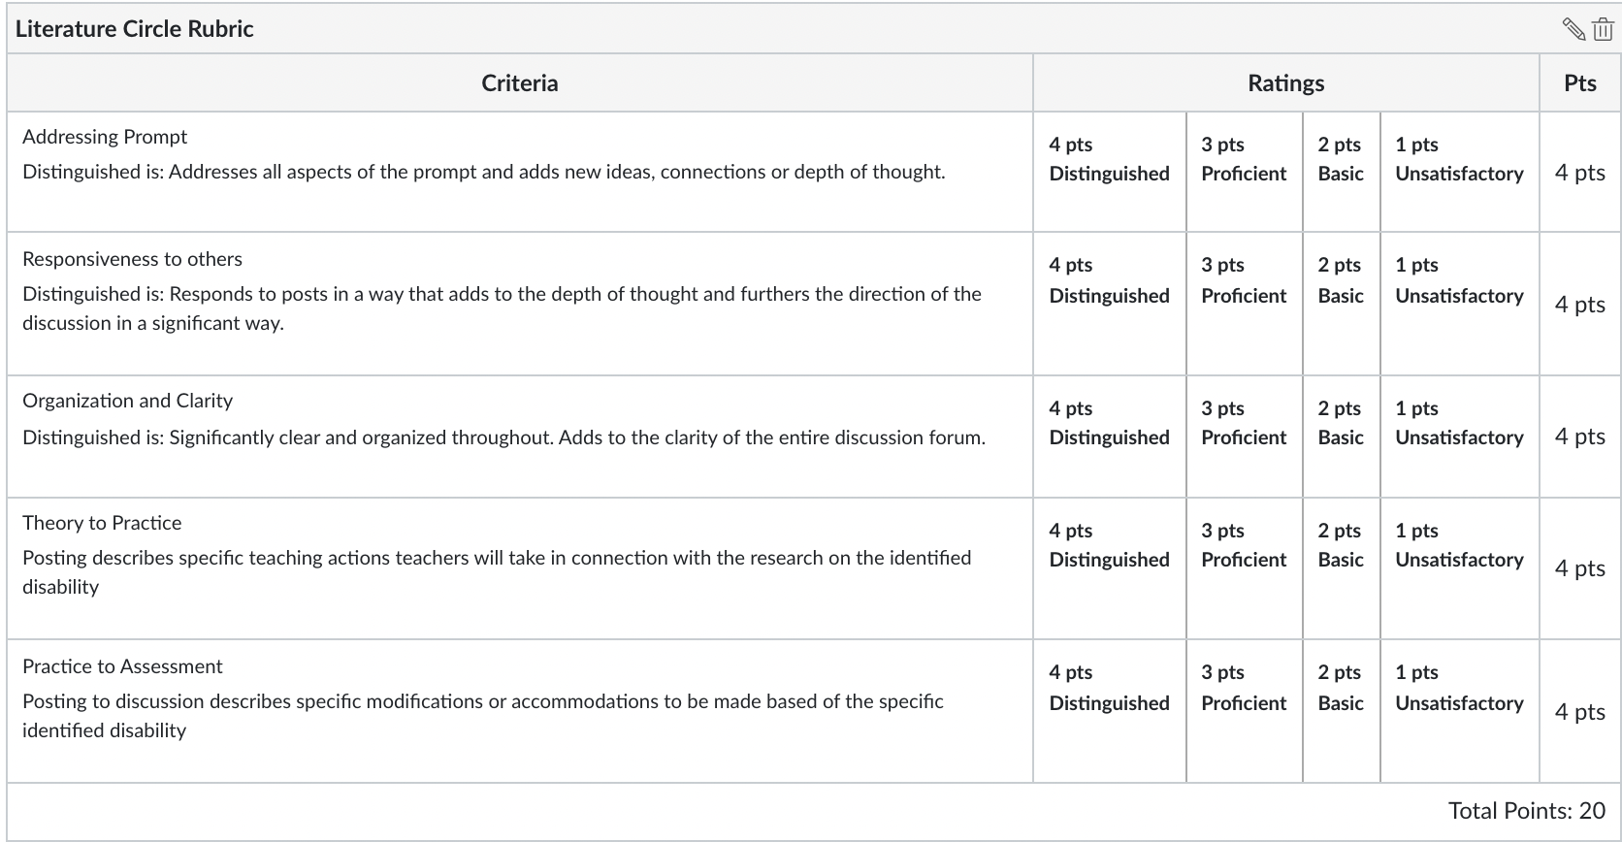
Collaborative Teaching Assignment
MMSE Introduce, Practice 2.2, 2.3, 2.4, 2.6, 2.8, 4.6 6.1, 6.2, 6.5
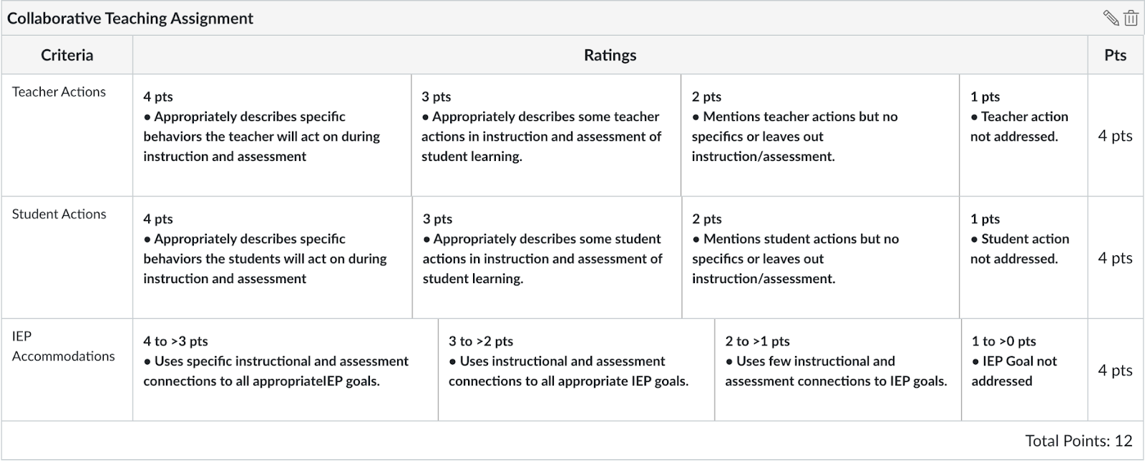

IEP Plan Assignment 4 Rubric
MMSE INtroduce, Practice, Assess 1.4, 1.5, 1.6, 2.7, 4.4, 5.6, 6.1, 6.2, 6.6

EDUC 240 IEP/504 Assignment Rubric
Level | Principles & Guidelines | IEP Elements | Organization & Language | Presentation
Exceeds Expectations | IEP/504 template including Objectives and goals  Collaborating with other agency professionals the variety of interventions  Creating short and long-term goals that are responsive to the unique needs of the students with identified disabilities  Knowing how to appropriately administer assessments according to the established protocols for each assessment and student with an identified disability | ·Presents all of the required IEP/504 elements  . Monitoring developing and Supporting student progress toward learning goals as identified in the academic content standards and the IEP/Individual Transition plan  Know the impact of loss of previous disabilities and the impact on students. | ·Organization of ideas is clear and logical with smooth transitions  · Utilizes precise academic vocabulary appropriately (free of “likes”)  ·Elocution has clear authoritative & enthusiastic voice | · Free of spelling, punctuation, grammar, pronunciation errors  · Active/attentive participation  · Body language (eye contact, poise, movement) demonstrates self-confidence that holds attention of audience  · Uses audio/visual aids without trouble that enhances presentation
Meets Expectations | · IEP/504 template principles including are mostly evident in the lesson plan presentation  Most aspects of collaborating with other agency professionals the variety of interventions included  Short and long-term goals that are responsive to the unique needs of the students with identified disabilities are mostly present  Knowing many of the steps to appropriately administer assessments according to the established protocols for each | · Presents most of the required elements clearly & concisely, allowing audience to follow line of reasoning | · Organization of ideas is logical  · Utilizes mostly precise academic vocabulary appropriately (few “likes”)  · Elocution is clear and can be heard by most classmates | · Minor spelling, punctuation, grammar, pronunciation errors  · Mostly Active/attentive participation  · Body language demonstrates self-confidence  · Uses audio/visual aids without trouble
Approaching Expectations | · IEP/504 template principles including are somewhat evident in the lesson plan presentation  Some aspects of collaborating with other agency professionals the variety of interventions included  Some short and long-term goals that are responsive to the unique needs of the students with identified disabilities are present  Knowing some of the steps to appropriately administer assessments according to the established protocols for each | · Presents some of the required elements clearly & concisely | · Organization of ideas is somewhat logical  · Utilizes mostly precise academic vocabulary appropriately (some “likes”)  · Elocution is low and can be heard by some classmates | · Some spelling, punctuation, grammar, pronunciation errors  · Some Active/attentive participation  · Body language demonstrates some self-confidence  · Uses some audio/visual aids with trouble
Minimum Expectations | · · IEP/504 template principles and guidelines are vaguely evident in the lesson plan presentation  Collaboration not included  Short term and long term goals not addressed  Assessment accommodations not addressed | · Presents few of the required elements | · Logic to organization makes it difficult to follow  · Utilizes everyday vocabulary  · Elocution is low and cannot be heard by most classmates | · Several spelling, punctuation, grammar, pronunciation errors  · Off task behavior  · Body language demonstrates little self-confidence  · Doesn’t use audio/visual aids

