Department of Electrical Engineering
Celebrating Engineering Week
Winter Quarter 2010
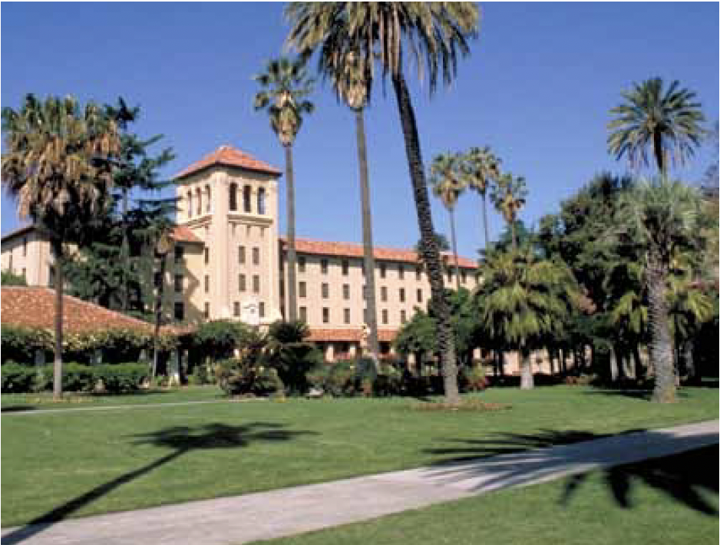
Smart Reliability

DDr. Khosrow Moslehi ABB Inc
.
Feb 18, 2010
4:10 – 5 p.m.

RRoom MPR
Bannan Engineering Santa Clara University

Abstract
Increasing complexity of power grids, growing demand, and requirement for greater grid reliability, security and efficiency as well as environmental and energy sustainability concerns continue to highlight the need for a quantum leap in harnessing communication and infomation technologies. This leap toward a “smarter” electricity grid is now widely referred to as “smart grid”. This seminar reviews the grid reliability challenges and the impact of major smart grid resources such as renewables, demand response, storage. A grid-wide IT architectural framework, based on a distributed autonomous architecture and a set of coordinated closed loop controls, is presented to meet these challenge.

Biography
Khosrow Moslehi received his PhD from the University of California at Berkeley. He is the Director of Product Development at ABB Network Management in Santa Clara, California. Dr. Moslehi has over 25 years of experience in research and development in power system analysis and optimization, system integration and architecture, and electricity markets. He has been active in various aspects of smart grid research since 2000

